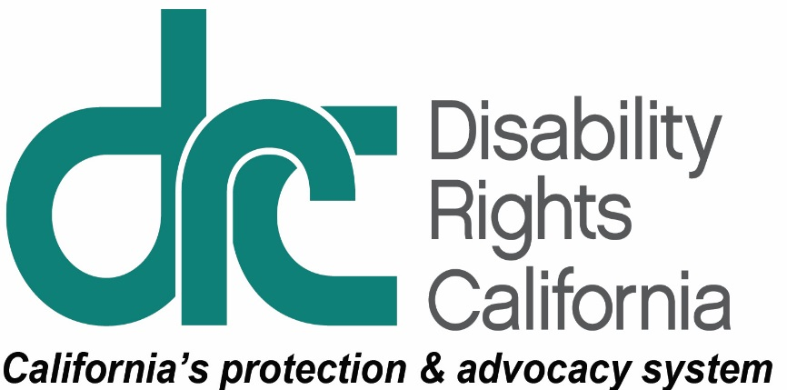 **Office of Clients’ Rights Advocacy**

1831 K Street

Sacramento, CA 95811

Tel: (916) 504-5820

TTY: (877) 669-6023

Toll Free: (800) 390-7032

Fax: (916) 504-5821 www.disabilityrightsca.org

MEMORANDUM

TO: Katie Hornberger, Director

FROM: Ibrahim Saab, Supervising Attorney for Outreach

Paula Sandoval, OCRA Outreach Coordinator

Eva Casas-Sarmiento, OCRA Managing Attorney

RE: Semi-Annual OCRA Outreach Report July – December 2020

DATE: January 15, 2021

Never has it been more critical for OCRA and others in the developmental services community to reach out to underrepresented target communities in new ways. This semi-annual report covers outreach activities OCRA conducted in the midst of a pandemic. The COVID-19 pandemic and other societal factors have disrupted people’s lives and schedules – for both OCRA staff and for clients, families, and service providers. Despite challenges connecting with others under the shelter in place order, OCRA has worked diligently to reach families by conducting virtual trainings, virtual legal clinics, virtual public forums, and individual welfare calls to present and past clients.

This report provides information on the outreach trainings and presentations completed between July 1, 2020 and December 31, 2020. During this period, OCRA staff conducted 199 outreach activities to 6,443 individuals. OCRA also had 17 outreach activities scheduled, but canceled for reasons directly related to the pandemic. For example, 12 outreach events canceled due to the collaborator’s difficulty to gather virtually and scheduling challenges. Another 5 outreach activities canceled for other unforeseen reasons such as staff or collaborator illnesses. This is a reduction from the 259 outreaches conducted to 10,630 individuals between July 1, 2019 and December 31, 2019.

Although there was a decrease in the number of trainings and individuals served, OCRA took proactive measures to work with community leaders to identify creative ways to connect with underserved communities. For example, OCRA hosted public forums and legal clinics where community members identified ways OCRA could better meet their needs. Because of these discussions, OCRA will conduct more interactive substantive trainings where individuals can learn about specific topics instead of listening to general presentations in a traditional lecture model. OCRA will work with other units at DRC to post pre-recorded substantive trainings for people to access at a time convenient to them. OCRA is also excited about our upcoming statewide Self-Advocacy Virtual Conference targeted directly to consumers. We hope these efforts will result in an increase in intakes and awareness of OCRA services during a difficult time.

Below are examples of the different types of outreach presentations and trainings offices provided, including self-advocacy, target and general.

# Self-Advocacy Trainings

Each OCRA office leads at least one self-advocacy training per contract year. Self-advocacy topics include emergency preparedness, self-advocacy, clients’ rights, rights to money management, voting rights, community living options, and employment rights and options. Here is an example.

## “Hands Off My Money” in Action.

“You don’t need to give away your money! You do not make enough money to be giving any of it out!” said a mother to her son during a recent OCRA *Hands Off My Money* training. “That is almost true,” said Clifford Black, Clients’ Rights Advocate, to the group. He explained, “Some of you work very hard for your money, and it is yours to spend how you wish. However, there are people that will try and take advantage of your kindness. You must be careful when deciding who and when to give money away.” During this *Hands off My Money* training, OCRA guided attendees to perform several skits about personal loans, identity theft, and how to avoid telemarketing. Attendees were committed to their roles and had fun taking on new characters during the skits. If anyone says learning cannot be fun, then they were not at this training.

# Target Outreach

OCRA’s target communities throughout the state are the Asian community, including Chinese, Japanese, Korean, Vietnamese, Hmong, Filipino, and Polynesian, the African-American community, the Latino community, and the Native American community. Of the 199 outreaches completed during this reporting period, approximately 35% of the activities and trainings were directed to the multi-ethnic and linguistically diverse communities mentioned above. Here are highlights of our target activities and trainings.

## OCRA Hosted Information is Power Webseries.

OCRA developed the Information is Power: Services for People with Developmental Disabilities Webinar Series for Spanish-speaking clients and their families when the in-person conference we had planned was canceled due to COVID-19. This series of outreach trainings were all conducted via Zoom across the state between July 23, 2020 and September 3, 2020. The topics of these substantive trainings covered many areas of services and supports that our clients and their families could access during the COVID-19 pandemic. One of these sessions was presented by Mario Espinoza, Clients’ Rights Advocate, and Celeste Palmer, Associate Clients’ Rights Advocate, regarding Special Education. They summarized a student's rights to special education services, the Individual Education Plan (IEP) process, and practical tips and timelines for getting special education services from school districts. Attendees received helpful materials to supplement all the information in the training. They received publications, including “How to Obtain an Independent Educational Evaluation at Public Expense” and several chapters from the “Special Education Rights and Responsibilities” manual. Presenters also gave contact information for OCRA offices across the state. OCRA is happy to announce that following the presentation of this virtual conference, individual offices received many calls for more information and assistance from Spanish-speaking regional center clients and their families throughout the state.

## Families Learn About OCRA and How to Navigate and Advocate for their Children in School.

As the sun set in August 2020, families were making their way to their dining tables, home offices, and comfy living room couches to log into Zoom. Consumers and parents of consumers of the North Los Angeles Regional Center were getting ready to participate in the Black & African American Family Support Group. Rachel Leach, Clients’ Rights Advocate, was thrilled to be talking to a new group of parents and consumers. OCRA created a combined training on “What is OCRA?” and “Navigating Special Education during COVID-19.” Consumers and parents came prepared to ask hard-hitting questions, talk about the IEP process, and learn more about advocating during and after these unprecedented times. Rachel gave an introduction on OCRA, including what areas of law OCRA assists with, and the important goal of advocating for the expressed wishes of consumers. OCRA then discussed parents’ rights throughout the IEP process, compliance with IEPs, and several tips to employ during the IEP. Those tips ranged from drafting a follow-up email that includes what was discussed during the IEP, reviewing notes before the end of the IEP, reducing cross-talking, and allowing for open communication. Rachel also discussed tips for making distance learning accessible during COVID-19. This was an incredible opportunity to have a small group training and to interact virtually with consumers and parents.

## OCRA Connects with the African-American Community Through Zoom.

OCRA staff serving Westside Regional Center clients is trying to serve the African-American community at parity. Local OCRA staff plan to achieve this by reaching more clients and families who have not heard of OCRA. The hope is the new clients and families learn about OCRA and then call for legal help. Kristen Evans, Clients’ Rights Advocate, and Katie Meyer, Supervising Clients’ Rights Advocate, joined the Level Up! meeting. Level Up! is a support and resource group for African-American consumers and family members. It was refreshing to learn the attendees had family members of all ages, from toddlers to adults. Kristen presented materials about What is OCRA? Kristen and Katie then answered questions about OCRA’s services. While there were some familiar faces, there were also many people who were not familiar with OCRA. Kristen and Katie stayed for the rest of the meeting, which included presentations by others in the community about resources and tips to navigate disability issues.

## OCRA Celebrates the End of 2020 with a Virtual Fiesta.

Monolingual Spanish-speaking families throughout the state were eager to join OCRA for a year-end celebration. The event was co-sponsored by the Latinx parent-led group, “Living Inside the Puzzle.” There was diverse representation from various parts of Latin America. The 50 attendees shared traditions and stories about spending the holiday season with families. They also shared recipes for tamales, pozole, and desserts. The participants described challenges accessing services for loved ones during COVID-19, made suggestions for additional personal protective equipment, and shared ideas and strategies to remain safe. OCRA also used this opportunity to reaffirm their ongoing commitment to serving the Latinx community and encouraged the participants to contact OCRA for help during these difficult times. Each family received a goodie bag from OCRA to ring in the new year. OCRA has scheduled several events with the group in 2021.

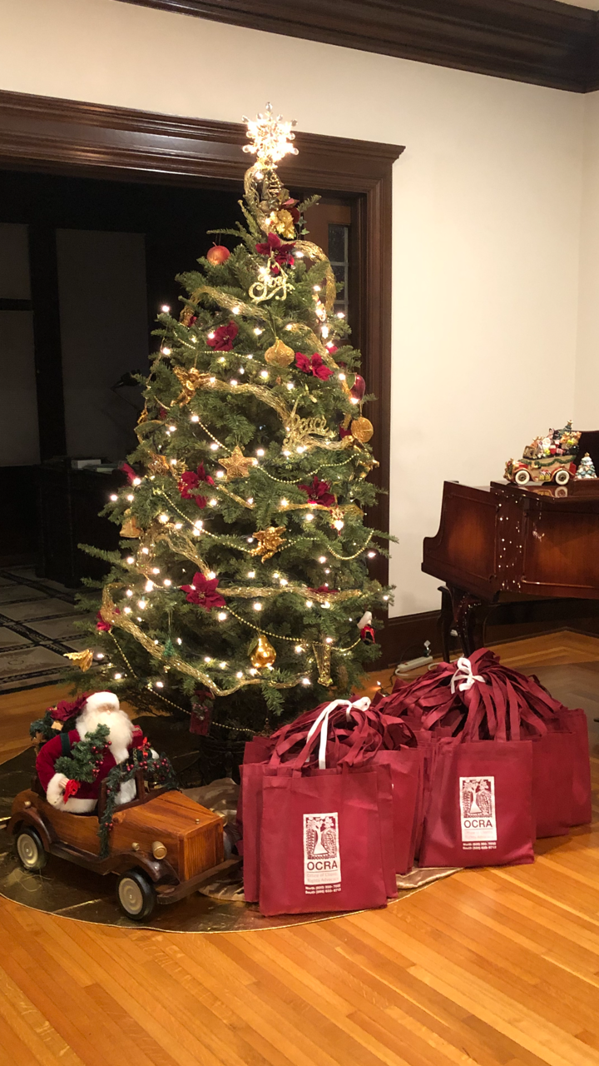 Photo: Brightly decorated Christmas Tree with a driving Santa Claus sitting next to bundles of OCRA goodie bags.

# Conclusion

OCRA’s close ties in local communities help clients access critical disability-related services and supports from regional centers and other agencies. With the additional burdens brought on by the pandemic, OCRA has also worked hard to gather and provide information on other important needs like food, clothing, shelter, COVID-19 testing, and personal protective equipment. As policies and rules change, OCRA remains committed to keep up with the changes and providing trainings to persons served by the regional center system. OCRA continues to work with new and existing community partners and will tailor materials to meet their needs.