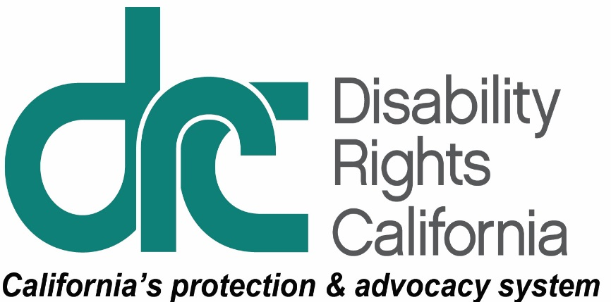
Office of Clients’ Rights Advocacy
1831 K Street
Sacramento, CA 95811
Tel: (916) 504-5820
TTY: (877) 669-6023
Toll Free: (800) 390-7032
Fax: (916) 504-5821
www.disabilityrightsca.org

MEMORANDUM
TO: Katie Hornberger, Director
FROM: Jazmin Romero, OCRA Outreach Coordinator (South)
Christine Hager, OCRA Outreach Coordinator (North)
RE: Semi-Annual OCRA Outreach Report July – December 2017
DATE: January 17, 2018

This report provides information on the outreach presentations completed between July 1, 2017 and December 31, 2017. During this review period, OCRA staff conducted 187 outreach trainings. These presentations were provided to 6,073 attendees. These numbers have decreased from the same reporting period of 2016. We believe the decreased presentations are due to the new target outreach plans. Every two years, OCRA staff review the census data, regional center data, and OCRA data and decide which underserved community to target with outreach. This requires the staff to forge new relationships and develop connections within their new target communities. The last reporting period was the end of the previous two-year outreach plan, so offices had established relationships and were giving presentations to large, known audiences. Below are examples of the different types of outreach each office provides including self-advocacy, general, and target.

Self-Advocacy Trainings
Each OCRA office conducts at least one self-advocacy training per contract year. Self-Advocacy topics include: emergency preparedness, self-advocacy, client’s rights, rights to money management, voting rights, community living options, and employment rights and options.

Clients’ Rights Bingo for Individuals Who Are Blind.
In September 2017, OCRA provided a training on clients’ rights by playing a Clients’ Rights Bingo game with five individuals who are blind or have visual disabilities at Sonoma Developmental Center. Before the game started, Cherri Alcantara, Community Integration Clients’ Rights Advocate, talked with participants about their basic rights. Then, it was time to play Clients’ Rights Bingo!
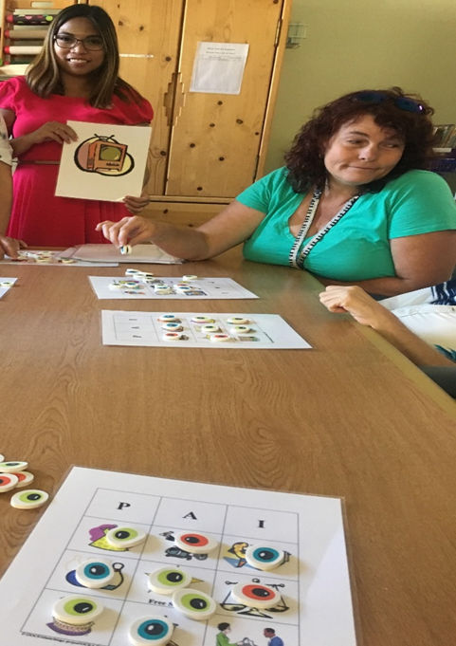
Each person received a bingo card with photos of different basic rights. As the game progressed, participants learned about their rights such as the right to worship or go to church, right to receive mail, right to be in a relationship, and the right to be out in the community. The staff also joined in on the fun by participating and assisting the clients to place the bingo chips on their cards. Excitement rose as each client got closer to getting bingo. The fun continued when each client won and received bingo prizes, including tote bags and candies. Having a small group of participants allowed everyone to learn more about their rights. Clients’ Rights Bingo was such as a success that the unit supervisor said the word spread and other clients from different units would like to attend future trainings.
Photo: Cherri Alcantara leads the bingo game at Sonoma Developmental Center. A staff member is pictured assisting a client with putting markers on her bingo card.

Apartment, Group Home, or With Family…Where to Live?
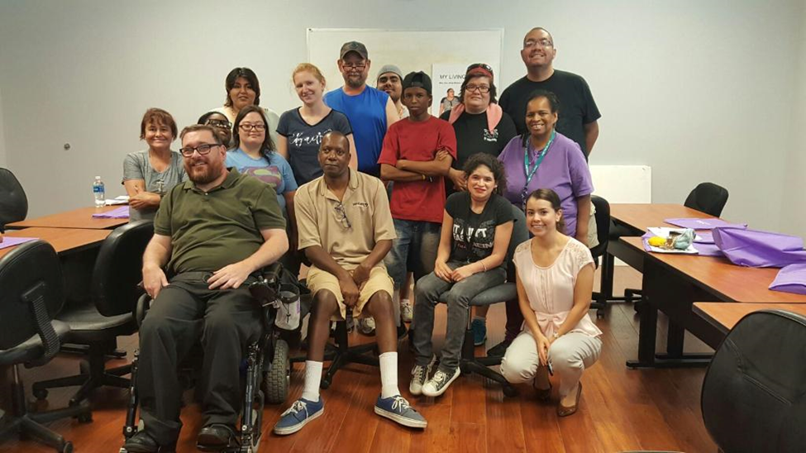
When considering housing options, we all must consider a variety of factors. What is our budget? Where would we like to live? Do we like the city or a more rural area? Do we want a roommate? Do we want pets? Would we want to cook for ourselves? What do we like to do on our free time that we would like to do at our new home? Inland Regional Center clients attending the Exceed Work Program in Perris had a chance to think about these and many other questions related to living options.
Photo: Scott Barron, Peer Advocate and Irene Padilla, Clients’ Rights Advocate, with members of Exceed Work Program.
Peer Advocate, Scott Barron, Assistant Clients’ Rights Advocate, Jazmin Romero, and Clients’ Rights Advocate, Irene Padilla from OCRA visited the Exceed program on July 20, 2017 to hold a training about living options. The trainers displayed a series of pictures that show examples of living options and discussed the different options with the participants. Participants were eager to share their experiences related to their current and former living situations. Many preferred to have their own room and only one or two housemates. Everyone enjoyed learning about and discussing the various living options.

General Outreach

OCRA Participates in Employment Summit to Inspire the Hiring of People with Disabilities.
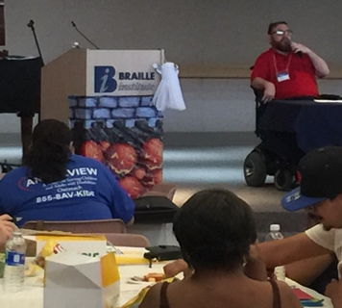
In October 2017, OCRA was excited and ready to participate for the first time in the Employment Summit at the Braille Institute in Rancho Mirage. The Employment Summit was organized for small business owners and entrepreneurs to inspire them to hire people with disabilities. The Summit discussed tax benefits, work ethic, and cost-effective accommodations for people with disabilities. Most importantly, the Employment Summit brought together employers and people with disabilities into the same room to dispel myths about hiring people with disabilities.
OCRA’s Peer Advocate, Scott Barron, interacted with 60 attendees, which included
businesses, consumers, and the Department of Rehabilitation to inspire to hire through the event. OCRA also staffed an information table and participated in a peer panel discussion. OCRA provided information on employment like “Your Right to Competitive Integrated Employment,” “Educational Training and Services through the California Department of Rehabilitation,” and “How the Client Assistance Program (CAP) can help you.” The most inspiring moment of the event was when the peer panelists discussed their challenges to obtain gainful employment. OCRA’s peer advocate shared his story about going to 70 interviews with a college degree, but no one took him seriously. The panelists were honest about their struggles and work environment challenges due to employer misconceptions. Their experiences shocked the audience. It was an eye-opening event for everyone.
Photo: Scott Barron, Peer Advocate, presenting at the Employment Summit.

OCRA Staffs a Transition Fair Table at Glendale High School.
OCRA enjoys participating in large-scale outreach events to connect with as many transition-age students and their families as possible. In September 2017, Hannah Liddell, Clients’ Rights Advocate, and Ada Hamer, Associate Clients’ Rights Advocate, represented OCRA and other Disability Rights California (DRC) units at the Transition Fair hosted by Glendale High School. There were between 50 and 75 people in attendance. Staff brought brochures from DRC, the Client Assistance Program, and OCRA, as well as many publications in English and Spanish. Staff were lucky to have a large table because the amount of materials to help transition-age students completely covered it!

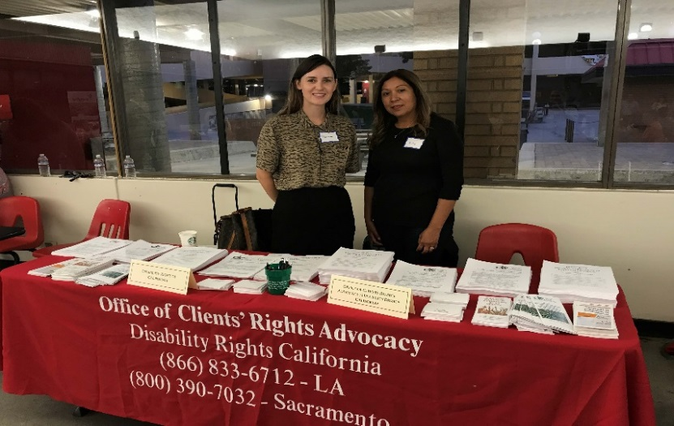
Hannah and Ada were excited not only to meet with other vendors who assist regional center clients such as Ability First, Westview, and Build, but to connect with new families from the Glendale area. Many parents of regional center children stopped by, asked about OCRA and
Photo: Hannah Liddell, Clients’ Rights Advocate and Ada Hamer, Associate Clients’ Rights Advocate at the OCRA table.
DRC, and took brochures and business cards. Staff encouraged students and family members to call OCRA for help. Staff enjoyed meeting so many new families and introducing them to Disability Rights California and OCRA.

Target Outreach
OCRA’s target communities include: the Latino community; the Asian community including Chinese, Japanese, Korean, Vietnamese, Hmong, Filipino, and Polynesian; the African-American community; and the Native American community.

Empowering the Asian Community.
Helping Hands East Bay is a new nonprofit family support group that, like OCRA, is targeting Regional Center of the East Bay’s Asian-American community. They hit the ground running and so far have already put on three conferences for the Asian-American disability community. OCRA staff have participated in all three of the conferences.
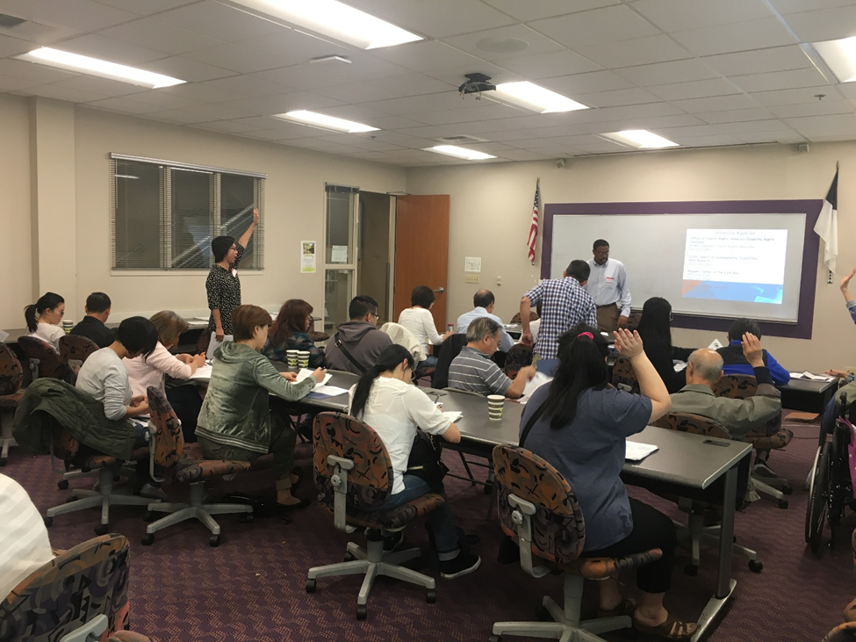
The most recent was Empowering Asian Families 3, held on September 23, 2017 in Hayward. OCRA participated in planning and gave a training on Client’s Rights and the Denial of Rights Process. Arthur Lipscomb, Clients’ Rights Advocate, with the help of interpreters, presented and handed out materials on clients’ rights in English, Cantonese, and Vietnamese. OCRA believes that making materials available in the community’s language is an important part of outreach. The people in the audience smiled as they saw the materials available in their language and seemed to agree. Attendees participated and asked questions, which made the session very interactive.
Photo: Arthur Lipscomb, Clients’ Rights Advocate presenting on Clients’ Rights.

Fairview Residents Pledged to Stop Bullying.
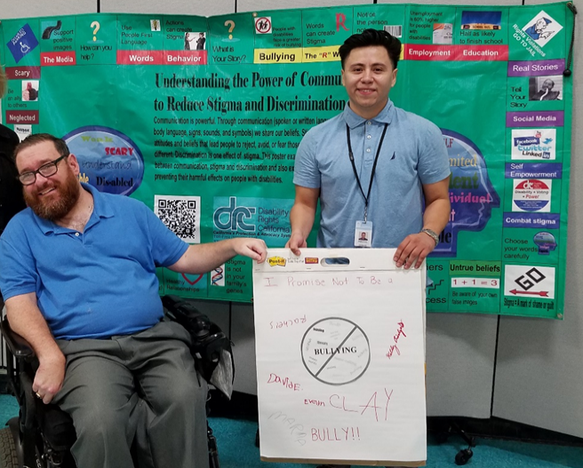
On November 16, 2017, OCRA was invited to Fairview Developmental Center (FDC) to conduct a “Self-Esteem and Bullying” training to 30 residents. OCRA created the “Self-Esteem and Bullying” training specifically for this audience and presented the training for the first time to
Fairview residents. OCRA introduced the “Stigma & Discrimination” poster to show residents that bullying is part of stigma and discrimination. Furthermore, to combat stigma and discrimination, OCRA encouraged residents to “celebrate being you.” After a discussion on what is self-esteem and bullying with examples, OCRA encouraged the residents to share their personal experiences on bullying, whether as victims or as bullies. The audience responded with meaningful insight. For example, one resident shared that a peer wanted money to be his friend. By sharing relatable personal stories, they encouraged each other to participate in the discussion. In addition, OCRA created and performed two skits on bullying to demonstrate how bullying impacts and negatively affects others. The skit also demonstrated how to positively react and address bullying. FDC residents shared that watching the skits made them feel sad, scared, manipulated, and terrified but after discussion they felt better. At the conclusion of the training, everyone voluntarily signed a pledge to stop any bullying. This left everyone feeling empowered and able to respond appropriately to any bullying.
Photo: Scott Barron, Peer Advocate and Support Staff

OCRA Empowers Parents at a Legal Clinic for Fiesta Educativa.
OCRA always jumps at the chance to collaborate with Fiesta Educativa since they are such a valuable resource for the Latino/Hispanic community. In November 2017, Hannah Liddell, Clients’ Rights Advocate, and Ada Hamer, Assistant Clients’ Rights Advocate, participated in a legal clinic at a large conference for Fiesta Educativa. Several other attorneys from the community participated in the clinic, including two who specialize in immigration issues. OCRA handled various legal questions, including regional center, special education, and IHSS and met with 12 parents and families to provide individual advice. After going through the basic intake process, Hannah and Ada were happy to provide advice to each client, as well as giving them OCRA’s contact information in case they needed a higher level of service. Hannah and Ada were excited to chat with the staff of other advocacy organizations, say hello to Frank D. Lanterman Regional Center staff (who had a table), and meet new families. They even saw some past clients at the conference, who were happy to see OCRA staying involved in their community. Everyone seemed to enjoy the enthusiastic atmosphere of Fiesta Educativa and OCRA looks forward to future collaboration with them.

OCRA Staffs a Table at the Annual Bi-National Health and Wellness Fair in Napa.
Yulahlia Hernandez, Clients’ Rights Advocate for North Bay Regional Center consumers, and Cherri Alcantara, Community Integration Clients’ Rights Advocate, teamed up to attend the Annual Bi-National Health and Wellness Fair at Kaiser Permanente in Napa. The Bi-National Health and Wellness Fair is an event geared towards the Latino population to provide information and services relating to health, such as immunizations, eye exams, and dental exams. This year, the fair highlighted legal workshops regarding immigrants’ rights. The event also featured raffles, a taco truck, free haircuts for children, and Aztec dancers. Throughout the event, people stopped by the OCRA table to get brochures, flyers, and stickers for the kids. OCRA answered questions about SSI, special education, and the various services available for people with developmental disabilities. Overall, the event was a great opportunity to engage with the Latino community and for the community to learn about OCRA.
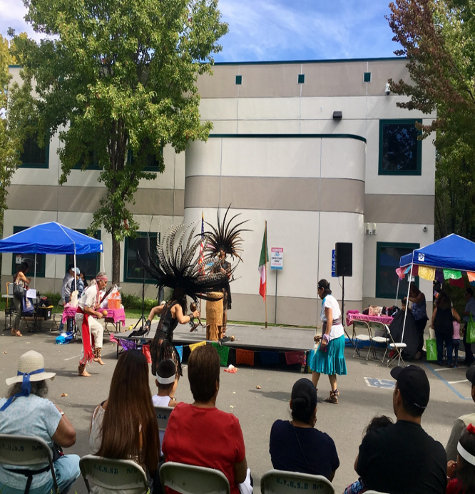
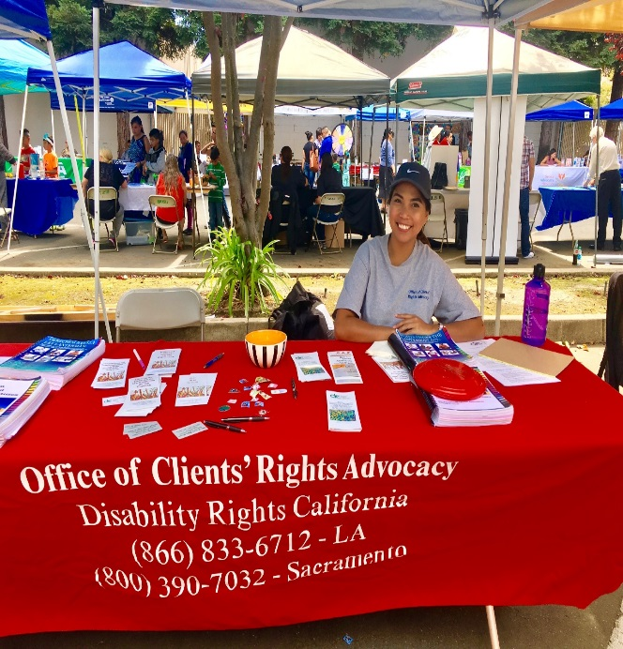
Photo: Aztec Dancers perform at the fair.
Photo: Cherri Alcantara, at the OCRA table.

Conclusion
OCRA continues to build relationships within the community by networking and providing trainings to persons served by the regional center system. We are excited about the opportunity to reach new groups through our new target outreach plans.
Thank you for the opportunity to coordinate outreach presentations and trainings statewide for OCRA.

