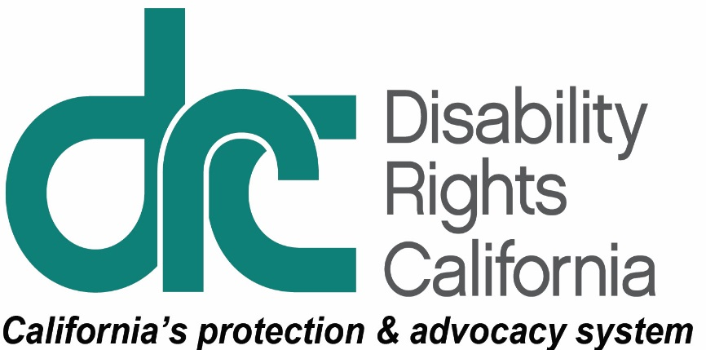
Office of Clients’ Rights Advocacy
1831 K Street
Sacramento, CA 95811
Tel: (916) 504-5820
TTY: (877) 669-6023
Toll Free: (800) 390-7032
Fax: (916) 504-5821
www.disabilityrightsca.org

MEMORANDUM

TO: Katie Hornberger, Director

FROM: Jazmin Romero, OCRA Outreach Coordinator (South)

Christine Hager, OCRA Outreach Coordinator (North)

RE: Semi-Annual OCRA Outreach Report July – December 2016

DATE: January 18, 2017

This report provides information on the outreach presentations completed between July 1, 2016 and December 31, 2016. During this review period, OCRA staff conducted 251 outreach trainings. These presentations were provided to 8,572 attendees. These numbers have increased from the last semi-annual reporting period. We believe it is due partly to OCRA’s continued commitment to networking and building relationships within the community and partly to a large number of Voting Rights and Where To Live self-advocacy trainings this period. Below are examples outreaches, including self-advocacy, general, and target presentations.

Self-Advocacy Trainings
Each OCRA office conducts at least one self-advocacy training per contract year. Self-Advocacy topics include: emergency preparedness, self-advocacy, client’s rights, rights to money management, voting rights, community living options, and employment rights and options.

Are You Prepared for an Emergency? Learning to Think, Plan, and Do.

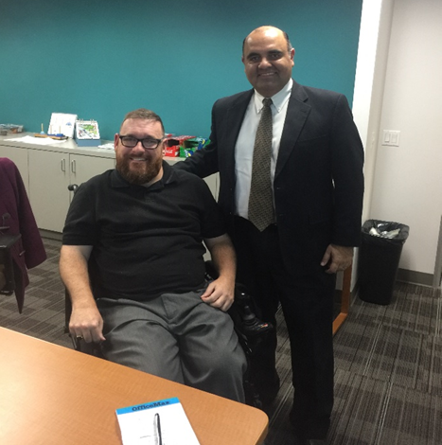
Fire! Earthquake! Have you ever experienced a fire, earthquake, power outage, or another emergency? Were you prepared or could you have been better prepared? On December 2, 2016, members of A.R.C. asked themselves these questions.

Scott Barron, Peer Advocate, and Mario Espinoza, Clients’ Rights Advocate, presented “Disaster Preparedness and Public Safety” to a group of 16 individuals. The group was interested to learn how to, “Think, Plan, and Do” to

Photo: Scott Barron, Peer Advocate
Mario Espizoza, Clients’ Rights Advocate

better understand how to plan for an emergency or disaster. In order to apply what they were learning, OCRA went over emergency scenarios like fires, earthquakes, and power outages. OCRA also had sample emergency kits with gloves, canned food, water, medications, back-up mobility devices, and first aid supplies to show the group. OCRA made sure everyone knew that each emergency kit would look different depending on their individual needs. OCRA also shared helpful tips like preparing multiple emergency kits for different locations, checking expiration dates, and rotating supplies to ensure items are used before expiration dates. Throughout the training, the group was critically thinking about what to do and asked questions like, “is there a good radio station that provides updates on emergencies?” At the end, “Feeling Safe and Being Safe” emergency contact magnets and DVDs were distributed to encourage the group to continue to, “Think, Plan, and Do.” After the training, attendees said they are able to prepare for an emergency and felt confident in their ability to, “Think, Plan, and Do.”

Voting Rights Training for VMRC Self-Advocates in 2016.

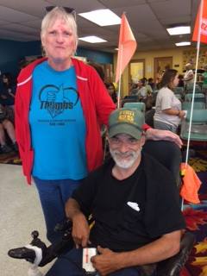
During August, September and October of 2016, OCRA provided Voting Rights Training to 1,017 self-advocates and service providers. Voting Rights trainings were presented over a three month period in 17 different locations throughout the San Joaquin, Stanislaus, Tuolumne and Calaveras Counties. Attendees learned about voting rights and were provided the opportunity to register to vote.
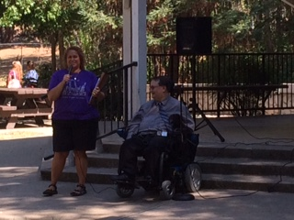
Photo: A special thanks to WATCH Self-Advocates, Jill Ames and Bill Tracy for hosting OCRA in Tuolumne County in September!

Christine Hager and Leinani Walter of the OCRA Modesto office shared clients’ rights information and resources about how OCRA can help people advocate for their choices and service needs. In August, OCRA also collaborated with Fred Nisen from Disability Rights California to provide Voting Rights Training for the Self-Advocacy Council 6 Area Photo: Leinani Walter and Meeting at Turner Park in San Andreas. Fred Nisen

Voting Training with DD Council.

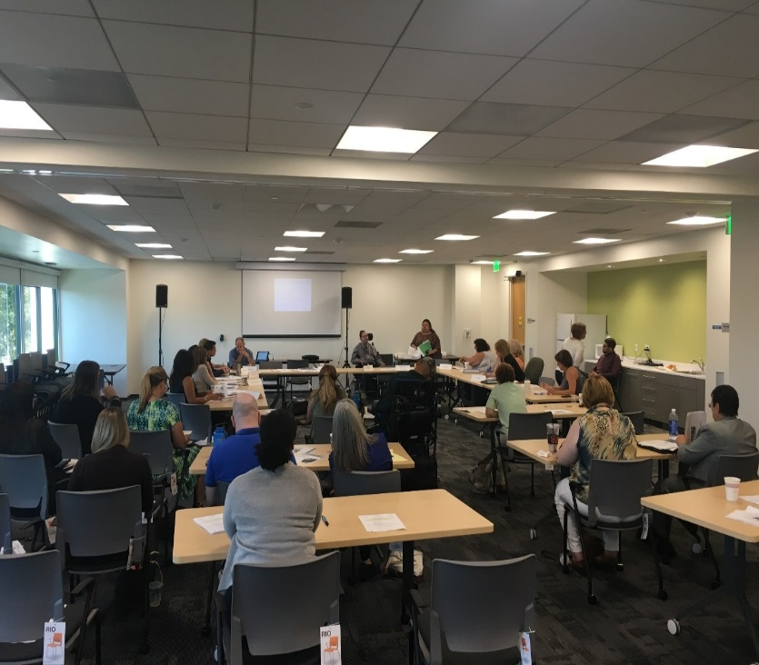
With the 2016 Presidential election in full swing, OCRA teamed up with regional office staff to provide a voting self-advocacy training for consumers and their service providers. On Wednesday, September 28, 2016, the Contra Costa DD Council gathered at the Regional Center of the East Bay’s new Concord office to learn about voting rights for persons with disabilities as well as a new law which recently went into
Photo: Fred Nisen Presenting the Training

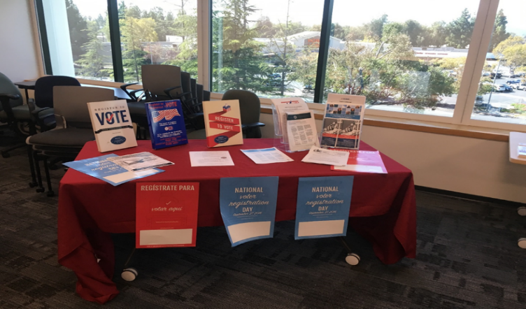
effect allowing conserved individuals to restore their right to vote. Arthur Lipscomb, Client’s Rights Advocate and Fred Nisen, Supervising Attorney, gave a presentation about voting rights including information about registering to vote, voting privately, voting in an accessible manner, and restoring the right to vote. The group was very passionate about their rights and had lots of questions and comments about their right to vote. One person came to the event specifically to register to vote and was able to do so online that day. Arthur and Fred distributed handouts providing additional information about the DRC voting rights hotline and sample language to use to
petition the court to restore the
right to vote.
Photo: Table with Voting Materials

General Outreach
OCRA Presents at Statewide Public Defender Conservatorship Workshop.

Thanks to a connection between the OCRA office serving North Bay Regional Center consumers and a Solano County public defender, OCRA helped coordinate and then presented at a workshop for public defenders of several California counties. Stephen Zollman, OCRA’s Northern California Community Integration CRA, worked with the public defender, an appellate lawyer, and Dr. Lee Coleman, MD, to help organize this workshop.
Stephen, along with other members of OCRA’s Community Integration Team, Eva Casas-Sarmiento and Jennifer Alfaro, presented information about conservatorship and ways that OCRA can assist public defenders as they help their clients to move out of restrictive settings. The public defenders were excited that OCRA, being statewide, could be helpful even in counties that were far away from their offices and the committing court. Even more exiting is that the county public defenders’ offices involved in the training want to continue an ongoing relationship with OCRA staff. Eva, Jennifer, and Stephen are presenting the public defenders’ concerns about placements for clients who have both mental health and developmental disabilities to a mental health working group at Disability Rights California. Stephen is working with the Solano County Public Defender’s Office on next year’s training. It was encouraging to see so many lawyers in the criminal justice system who try to make sure that clients with developmental disabilities live in the least restrictive environment
OCRA Attends the Community Options Fair at Fairview Developmental Center.

Jennifer Alfaro, Clients’ Rights Advocate for Community Integration, Scott Barron, Peer Advocate, and Jacqueline Miller, Clients’ Rights Advocate for Regional Center of Orange County (RCOC) consumers staffed a resource table at Fairview Developmental Center (FDC) on September 15, 2016. Raymond Kwong, Multicultural Affairs Advocate from the Disability Rights California San Diego Regional Office also had a table at this event. The Fair was organized by the State Council on Developmental Disabilities in collaboration with FDC to provide consumers and their families with information on the types of services available in the community to assist them with the transition process.

Attendees included 117 consumers, 51 staff, and 12 families. The Department of Developmental Services, Department of Rehabilitation, Orange County Public Defender’s Office, Special Olympics, and several regional centers had resource tables at the fair. Nearly 40 community service providers gave information on different community services for consumers such as placement options, day programs, employment opportunities, independent living services, college programs, community integration, and advocacy services. Consumers were provided a Passport to Community Living to assist them with discussing community service options with individuals at the resource tables, and getting their questions answered about living in the community. The goal was for each consumer to visit at least 15 tables and get their passport stamped.

OCRA staff discussed the types of services available to meet the needs of consumers living in the community, transition services to help prepare consumers for living in the community, and advocacy services to learn about their rights if denied services. Several consumers recognized Scott Barron from his previous self-advocacy trainings and stopped to talk with him. Several FDC and regional center staff came by to talk with Jennifer Alfaro about community placement for consumers. Jacqueline Miller met several new FDC community placement staff members, vendors, and RCOC staff, who are working on developing the new homes in the community.

OCRA Presents Two Sessions on the Alternatives to Conservatorships at Tri-Counties Regional Center.

At the invitation of Tri-Counties Regional Center’s Rainbow Family Resource Center in Ventura County, OCRA presented two training sessions on Alternatives to Conservatorships for regional center consumers and their families. Katherine Mottarella, Supervising Clients’ Rights Advocate presented the training session in English and Irma Wagster, Supervising Clients’ Rights Advocate, presented the Spanish-only training. The training was based on a publication developed by OCRA staff and focused on whether attendees had considered the alternatives to conservatorship. Community members in both sessions had many questions for the presenters and several called the OCRA office serving TCRC consumers after the training for additional information. At the conclusion of the training, Rainbow Family Resource Center staff asked OCRA to return soon for another training.

Target Outreach
OCRA’s target communities include: the Latino community; the Asian community including Chinese, Japanese, Korean, Vietnamese, Hmong, Filipino, and Polynesian; the African American community; and the Native American community.
Back to Basics with Fiesta Familiar.
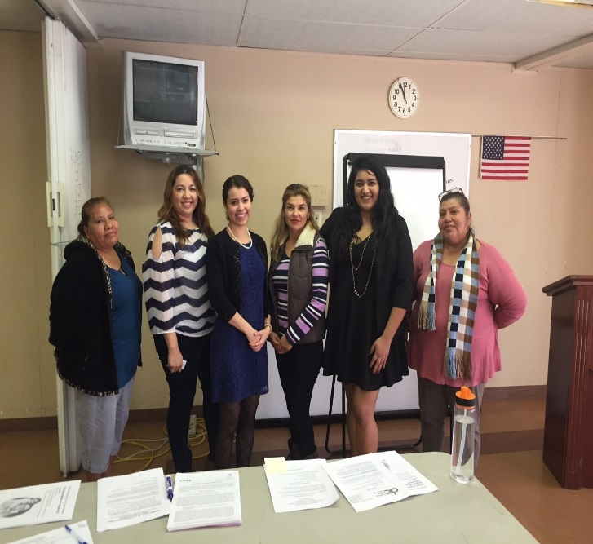
How do you ask for something you don’t know exists? Who do you ask for help when you don’t know you need help? What do you do when the person you ask says, “No.” The family members and consumers of Fiesta Familiar Riverside had these and many other questions at a training about regional center eligiblity, appeals, and services held at Saint Martha Catholic Church in Murrieta on December 10, 2016.

Photo: Irene Padilla with Fiesta Familiar Members

While many of the participants had family members who were already regional center consumers, very few understood why their family members had been found eligible and how each consumer’s specific needs determine the available services. Irene Padilla, Clients’ Rights Advocate for Inland Regional Center consumers, prepared a structured presentation, which she adapted to the participants’ questions. The improptu training format resulted in a lively discussion where the participants learned how to apply the rights under the Lanterman to each others’ eligibility, appeals, and service request issues. With plenty of group participation, the members of Fiesta Familiar Riverside learned both the basics of the Lanterman Act and advocacy tips for success.

Spanish-Speaking Parents Learn about IHSS Rights.

Seven parents of children who are Far Northern Regional Center clients gathered to learn about In-Home Supportive Services (IHSS) from OCRA. The parents belong to a Spanish-language support group. They meet monthly to hear from a speaker, eat dinner together, and have their children socialize.

OCRA began with an overview of our agency, explaining the free legal and advocacy services we provide for consumers and their families. OCRA then provided information about IHSS eligibility and rights. Most of the families were unaware of IHSS and were very interested to learn about this program. OCRA staff gave each attendee several Spanish-language Disability Rights California publications on IHSS for future reference. Client families were encouraged to access OCRA services for advocacy support as needed with IHSS and other agencies. The families, none of whom had accessed OCRA services prior to the training, did indeed reach out. OCRA subsequently provided hands-on advocacy with IHSS for two of the families. Educational advocacy was also a need, with OCRA providing guidance to one family and hands-on advocacy for another, attending multiple IEP meetings.

Families Use the Power of Math to Understand They Can Work and Still Keep SSI Benefits.
The Office of Clients’ Rights Advocacy (OCRA) enjoys collaborating with Children’s Hospital of Los Angeles to provide advocacy and training to their regional center families. Hannah Liddell, Clients’ Rights Advocate, and Assistant CRA, Ada Hamer, Assistant Clients’ Rights Advocate, recently conducted a training for the Behavior Group for seven Spanish-speaking families. Parents wanted to learn how their children with disabilities could work and keep their SSI benefits. Throughout the years, OCRA has noted a common misconception among regional center families - they are afraid that if the SSI recipient works, they automatically lose their SSI benefits. OCRA corrected this misconception through the power of math by showing, step-by-step on the blackboard, how Social Security calculates income to determine the benefit amount. Hannah and Ada proved that even though the SSI benefit may decrease through work, the person’s total income will increase.
OCRA was excited to help regional center families discard the misconception that work automatically terminates SSI. Participants took lots of notes and wrote down equations on their handouts. Afterward, the surveys indicated that families felt a lot more confident that their children could work without endangering their SSI. Hannah and Ada provided business cards and OCRA brochures to encourage consumers and family members to call if they need help. Overall, it was a fun, productive and math-filled evening!
Annual Conference for Spanish-Speakers Serves 200 Participants.

OCRA participated in the 10th Annual Celebración de Familias Excepcionales Conference held on Saturday, September 24, 2016. This conference provides Spanish-speaking regional center consumers and their families with valuable information, through its various speakers, workshops, and resource tables. There were 200 people in attendance! The keynote speaker was neuropsychologist Dr. Jose L. Fuentes who gave a presentation on behavioral issues and using strategies to get to the root of behavioral problems. The conference held several workshop sessions on various topics such as IHSS, Regional Center Services and Eligibility, Self-Determination/FMS, and Transition and ILS. OCRA staff serving Kern and Central Valley regional center consumers collaborated in staffing a booth and answering questions. OCRA provided information on Social Security overpayments, special education rights, regional center services, and rights of people with developmental disabilities.

Conclusion

OCRA continues to build relationships within the community by networking and providing trainings to persons served by the regional center system. Thank you for the opportunity to coordinate outreach presentations and trainings statewide for OCRA.

