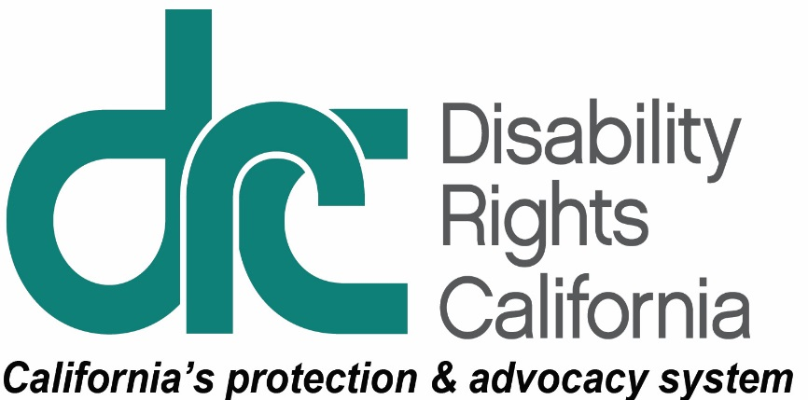
Office of Clients’ Rights Advocacy
1831 K Street
Sacramento, CA 95811
Tel: (916) 504-5820
TTY: (877) 669-6023
Toll Free: (800) 390-7032
Fax: (916) 504-5821
www.disabilityrightsca.org

MEMORANDUM

TO: Katie Hornberger, Director

FROM: Mary Melendrez, OCRA Outreach Coordinator (South)

Christine Hager, OCRA Outreach Coordinator (North)

RE: Semi-Annual OCRA Outreach Report July – December 2015

DATE: January 15, 2016

This report covers outreach presentations completed between July 1, 2015 and December 31, 2015. During this review period, OCRA staff conducted 178 outreach trainings. These presentations were to 6840 attendees. We recognize these numbers have slightly decreased from the same reporting period of 2014 and it is likely because we changed how we track attendees to accurately count outreach trainings. We now count the number of attendees at large conferences who come to the OCRA table/booth for publications or to talk to staff, rather than counting the total number of conference participants. Below are examples of the different types of outreach each office provides including self-advocacy, general, and target presentations.

Self-Advocacy Trainings
Each OCRA office conducts at least one self-advocacy training per contract year. Self-Advocacy topics include: emergency preparedness, self-advocacy, client’s rights, rights to money management, voting rights, community living options, and employment rights and options.

The Power of Voting. Over 200 self-advocates from 5 counties met to learn about the power of voting from Tho Vinh Banh and Marinda Reed, Sacramento Regional Office, Alexis Turzan, American Civil Liberties Union, and OCRA’s Christine Hager, Assistant CRA. Christine assisted with the main presentation - an interactive format for all to learn about their right to vote and the power of their vote. Self-Advocates participated in a mock vote and received handouts about voting. Christine also staffed a table to answer additional questions and assist people with registering to vote.
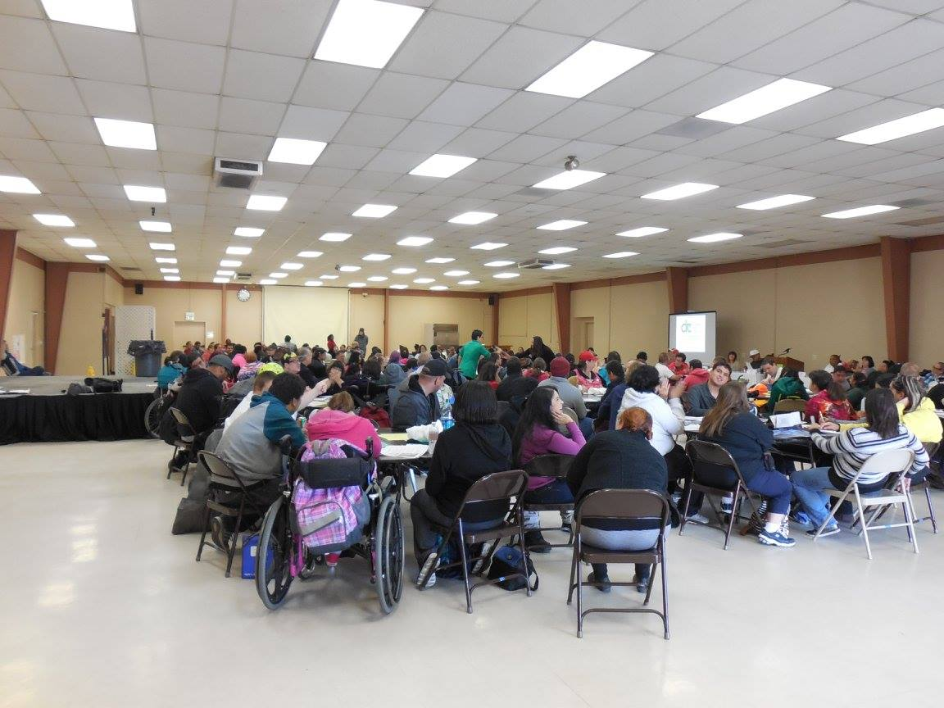

General Outreach
Special Education Community Advisory Committee Resource Fair.
Resource fairs are a great way for OCRA to provide information about our advocacy services. Many parents of special education students need advocacy assistance to navigate the educational system and access generic resources. The Vallejo Community Advisory Committee (CAC) holds a yearly resource fair to help families and students access local community services.
OCRA had a table at the CAC Resource Fair at Vallejo Unified School District on August 27, 2015. Annie Breuer, Assistant CRA of OCRA’s North Bay Regional Center office provided information regarding regional center services, special education, Social Security, and OCRA services. Over 40 individuals attended the fair. Special education students, their family members, and school staff discovered OCRA as a potential resources for assistance.
OCRA and DOR Team Up to Serve the Community. The Department of Rehabilitation (DOR) helps Californians with disabilities obtain and retain employment and maximize their equality and ability to live independently in their communities. They do this by tailoring their services to each person to ensure a greater chance of success. Some of the people with disabilities who seek assistance from DOR may also qualify to receive services from the Kern Regional Center. On Thursday, December 10, 2015, OCRA met with DOR staff members at their Bakersfield location to provide them with information on regional center eligibility criteria, services, and appeal rights for people who are denied eligibility to receive regional center services. Clients’ Rights Advocate Mario Espinoza shared this information through a presentation on regional center services. DOR staff members were very receptive to the information being presented because they interact with people who have disabilities on a regular basis, but were not familiar with the process of applying for regional center services. They also admitted that they were not familiar with the types of services regional center clients could receive. This outreach training was very interactive - DOR staff members asked many questions both during and after the presentation. OCRA provided everyone at this outreach presentation with business cards and brochures to contact OCRA if their clients need help with regional center services in the future.

Target Outreach
OCRA’s target communities include: the Latino community, the Asian community including Chinese, Japanese, Korean, Vietnamese, Hmong, Filipino, and Polynesian; the African American community, and Native American community.

Special Lives Without Limits. On October 24, 2015, Visalia Family Resource Center hosted its annual festival. Over 200 hundred people with disabilities and their families gathered to celebrate their lives. Many of the attendees were regional center clients living in the southern part of the Central Valley Regional Center catchment area. The event had food, music, fun activities, and lots of disability-related information and resources from all over the area. Maricruz Magdaleno, Bilingual ACRA, in collaboration with regional office staff, hosted a table and provided general information to attendees about public benefits, special education, and regional center services. Many were monolingual Spanish-speakers. Clients and family members were thankful to receive information and learn that OCRA is available as a resource to them, as many were not familiar with OCRA before the festival.
Asian-American Family Support Group. After several years of successfully targeting Spanish-speaking parent groups, the OCRA office that serves Regional Center of the East Bay client the office turned its attention to the underrepresented Asian-American population. OCRA set out with an ambitious goal to work with a local parent support group called Friends of Children With Special Needs (FCSN) to do three different trainings within a three month period. First, Arthur Lipscomb, CRA, and Will Leiner, Supervising CRA, met with the group to give a training on the always-popular topic of special education. It was a potpourri of information, but the audience was lively and engaged throughout. The next training scheduled covered transition services for 16 – 22 year olds. OCRA saw a mixture of new and familiar faces as they covered what happens when children become young adults. For the final training, OCRA covered multiple subjects, including the “DD Waiver” and the “Affordable Care Act.” OCRA looks forward to working with this group again.
Filipino Parent Support Group Training. The Filipino parents in this close-knit group have known each other for many years. They have watched their children grow together and have shared their children’s challenges and triumphs for services and benefits. As a group, they came up with the idea for each family to create a journal to record their child’s growth and development into adulthood. The journal will follow their adult child and will be made available for others to have the information they need to help continue to provide care.
The group recently extended invitations to other parent support groups to join them at their meetings. Over the years, this group has developed a great network of resources and they wanted to share their speakers and trainings with others. The OCRA office serving the San Gabriel/Pomona Regional center consumers was invited to present a training on what is OCRA, transition from high school, and the self-determination program. This was an opportunity for OCRA to meet the families from other groups and to introduce OCRA. Members with older children that have exited high school shared their experiences. Families with children approaching this transition learned about changes and how to prepare. Aimee Delgado, CRA, presented a brief overview of the self-determination program, which cleared up some misconceptions. These meetings are informal and always end in the enjoyment of delicious food prepared by different members.
OCRA’s Community Integration CRAs. OCRA continues to expand its outreach efforts by reaching out to persons served by the regional center system who currently live in locked facilities. OCRA has Northern and Southern California Community Integration CRAs, Pilar Gonzalez and Jennifer Alfaro, who specifically focus on outreach trainings for this population. The Community Integration CRAs also assist people with developmental disabilities to move out of locked facilities like institutions for mental disease and developmental centers. Their outreach plan is to both educate consumers living in restrictive settings and those that support them on recent laws affecting people in locked facilities and how OCRA may assist. In the past, OCRA conducted trainings on “What is OCRA” and “Developmental Centers and Institutions for Mental Disease” for the Los Angeles County Public Defender’s Office. OCRA also staffed booths at developmental center events like the self-advocacy fair and opportunity fair. OCRA also held an outreach activity on moving into the community for people who were living in a locked facility. Currently, OCRA is planning to conduct trainings on the rights of people with developmental disabilities for the Office of the Public Guardian and at the statewide conference for California’s Association of Public Administrators, Public Guardians and Public Conservators. In addition, OCRA plans to conduct trainings on community living options, the IPP process, and voting rights for people living in a developmental center.
Thank you for the opportunity to coordinate outreach presentations and trainings statewide for OCRA.

