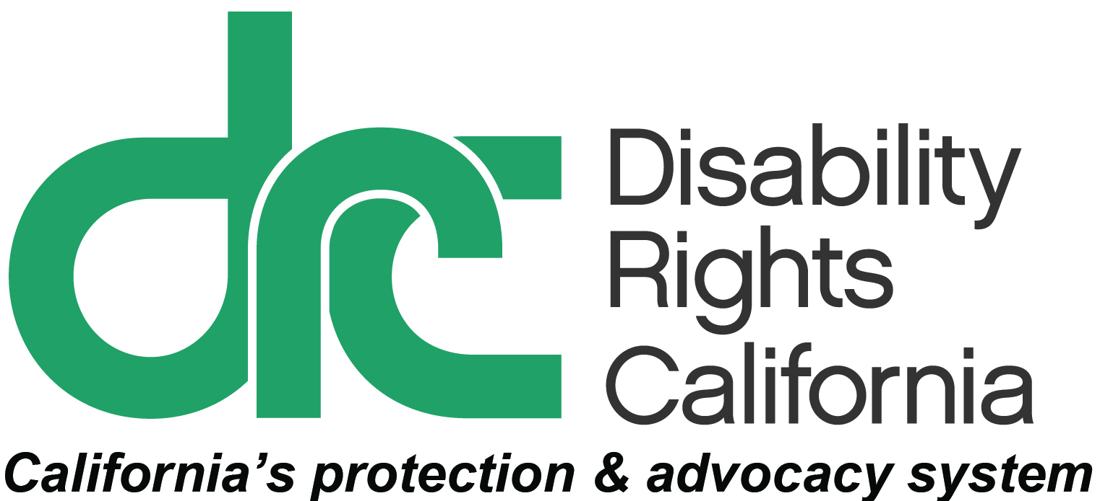
Office of Clients’ Rights Advocacy
1831 K Street
Sacramento, CA 95811
Tel: (916) 504-5820
TTY: (877) 669-6023
Toll Free: (800) 390-7032
Fax: (916) 504-5821
www.disabilityrightsca.org

MEMORANDUM

TO: Katie Hornberger, Director

FROM: Kendra McWright, OCRA Outreach Coordinator (South)

Christine Hager, OCRA Outreach Coordinator (North)

RE: Semi-Annual OCRA Outreach Report July – December 2014

DATE: January 31, 2015

This report covers outreach presentations completed between July 1, 2014 and December 31, 2014. During this review period, OCRA staff conducted 207 outreach trainings. These presentations were to 8,196 attendees. This is a small decrease in the number of participants from this same time period from last year. Each office works with their target community to ensure creativity and flexibility in order to individually focus on the needs of each target community. Below we have provided a breakdown of the different types of outreach each office provides including self-advocacy, general, and target presentations. Below are examples of these trainings.

Self-Advocacy Trainings
Each OCRA office conducts at least one self-advocacy training per contract year. Self-Advocacy topics include: emergency preparedness, self-advocacy, client’s rights, rights to money management, voting rights, community living options, and employment rights and options. Last year, OCRA hired a Peer Advocate to work throughout the state with regional center consumers educating them on their rights in a variety of settings. These settings include but are not limited to developmental centers, day programs, support groups, conferences, and People’s First meetings. The Peer Advocate collaborates with the individual offices of OCRA to ensure a focused, needs-based impact on the individuals served by the regional center.

Self-Advocacy Clients’ Rights Bingo
On December 9, 2014, OCRA provided a Clients’ Rights training to individuals at South Bay Vocational Center, a day program in Harbor City. After a warm welcome from staff and a tour of the program, we discussed rights with The Client Council. Through the Bingo game, we discussed rights including: your right to receive and send unopened mail, your right to use the telephone and have private conversations, and your right to have your own food. As the training progressed, participants began to feel more comfortable and opened up about their enjoyment of the day program and love for work. During the training we also discussed the Individual Program Plan(IPP) process and I asked questions to see if the group understood what is discussed at their IPP meetings. The group seemed to be well informed, had lots of positive energy, was very upbeat. The Client Council asked me to come back and present on disaster preparedness to the entire day program. Scott Barron, Peer Advocate.
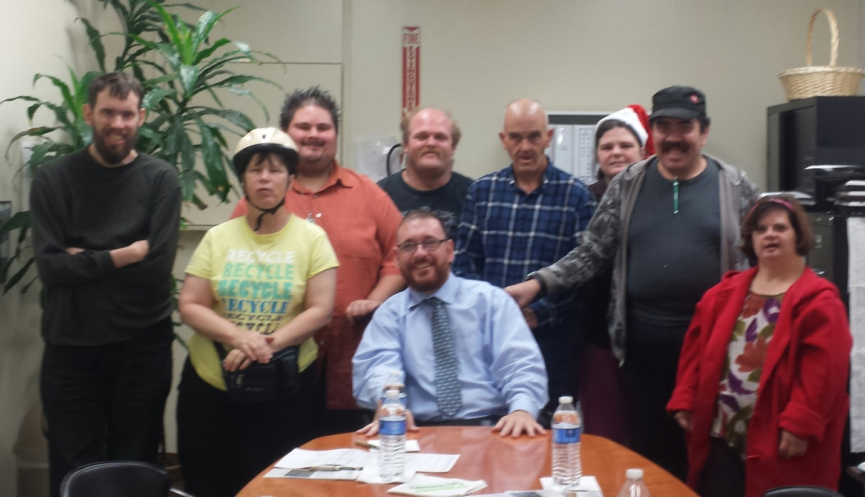

General Outreach
What is OCRA?: The OCRA office serving clients of Golden Gate Regional Center gave a presentation to The Arc of San Francisco on November 18, 2014, regarding what services our office provides and an overview of Clients’ Rights. The Arc of San Francisco is a non-profit community organization that serves adults with developmental disabilities in San Francisco and San Mateo counties. The supervising staff at The Arc requested our presence so that we could partner together to better serve regional center consumers. Questions were asked about debt, employment, and Social Security. Staff expressed concern with predatory lending and how to assist the people they serve in managing their finances. We discussed SSI, SSDI, and overpayment notices. Christine Tarrant, Assistant CRA and Katie Spielman, CRA, Golden Gate Regional Center.

Regional Center Eligibility Clinics: The OCRA office serving consumers of Inland Regional Center provides Regional Center Eligibility Clinics to consumers, parents, and other interested parties who are seeking eligibility for regional center services. This offices holds a clinic for English-speaking attendees on a monthly basis and for Spanish-speaking attendees as needed. At each clinic, the Clients’ Rights Advocate provides attendees with information about the law related to the regional center eligibility criteria; as well as a detailed explanation of the application, due process, and hearing preparation. Families learn what is needed to show that an individual qualifies for regional center services and how to best prepare for due process, and also have an opportunity to ask questions and discuss their personal experiences. In general, families are interested in learning about this topic in order to access appropriate services for their children. Veronica Cervantes, CRA, Inland Regional Center.

Targeted Outreach
OCRA’s target communities include: the Latino community, the Asian community including the Hmong and Vietnamese community, the African American community, and the Native American community.

Fiesta Educativa: The OCRA office serving San Andreas Regional Center consumers conducts outreach in the community to train parents and advocates about their legal rights and the legal rights of their children. They recently held a training on special education rights and responsibilities at Mayfair Community Center. The event was sponsored by Fiesta Educativa, who also provided Spanish translation for the presentation. They had more families than expected on a weeknight at dinnertime. Many parents brought their children. One of the main topics they discussed was students’ right to obtain related services through the IEP process. Parents also shared how OCRA has helped them in the past. For example, one parent shared how OCRA assisted her child after the school had repeatedly called the police to the school for disability-related behaviors. This training underscores the need to provide a forum for people to share and learn. Filomena Alomar, Assistant CRA and Rita Defilippis, CRA, San Andreas Regional Center

Community trainings on new IHSS overtime rules: The month of November 2014 was a stressful month for many clients who received notices in the mail from the Department of Social Services. These notices informed clients of major changes in the IHSS program that will take effect in January 2014. Unfortunately, many clients and their families did not understand the content of the notices and needed more advice on how the changes will affect them. Many clients thought the notices they received in the mail were informing them that their IHSS hours would again be reduced. After receiving several calls from panicked clients, OCRA joined with three local parent support groups to conduct trainings explaining the upcoming 2015 IHSS overtime changes in the law. OCRA held trainings at Miller Children’s Hospital and Tichenor Orthopedic Clinic, both in Long Beach. OCRA was scheduled to give another training on January 20, 2014 for a Spanish-speaking parent support group called “Angeles Sin Fronteras” in Signal Hill. However, with the federal court ruling the landscape of IHSS changed again and the training was rescheduled. Eva Casas-Sarmiento, CRA, Harbor Regional Center.

OCRA has a tradition working to meet the needs of our targeted communities. With our Peer Advocate we continue this tradition reaching out to persons served by the regional center system and creating outreach trainings that are engaging and accessible to all audiences. Thank you for the opportunity to coordinate outreach presentations and trainings statewide for OCRA.

