I. INTRODUCTION

The Office of Clients’ Rights Advocacy (OCRA) provides statewide services to regional center consumers through a contract (HD119002) between Disability Rights California (DRC) and the California Department of Developmental Services (DDS). OCRA is currently in the third year of a five year contract. This semi-annual report covers July 1, 2013, through December 31, 2013.

OCRA has completed another successful year of service delivery. OCRA obtained positive results for numerous clients as evidenced in the attached statistics and Advocacy Report. During the past year, OCRA resolved 5,038 issues for consumers, an increase over the same period last year. OCRA also participated in 200 trainings in the first half of the fiscal year, presenting to approximately 9,703 people.

As a result of changes in the state law, there is a significant increase in service requests for clients living in restrictive settings. Often these cases take more time to resolve. These changes include notification to OCRA when a consumer is admitted to an IMD, there is a request for an extended stay for a consumer under age 21 in an IMD, a consumer files a petition for a writ of habeas corpus, or a comprehensive assessment for a consumer living in a developmental center is being reviewed at an IPP meeting. This is in addition to last years requirements related to notification of the CRA regarding admissions of new consumers to Fairview Developmental Center and the completion of comprehensive assessments for people residing in IMDs. These cases are time intensive and often require months of advocacy to successfully resolve. This a change from many of the types of cases previously handled by OCRA which could be resolved by attending a single IEP or IPP meeting or IHSS in-home assessment. Although the cases may be difficult, OCRA is excited about these new opportunities to secure community living for our consumers. This increase is expected to be even more significant in the coming years.

Although the financial outlook for the state is improving, people with developmental disabilities and their families are still faced with the challenges of trying to obtain services from agencies that have received less funding. As this struggle continues, OCRA’s work has grown even more vital. Ensuring that people receive appropriate service in the community remains a challenge. To succeed, OCRA staff have worked hard to develop positive working relationship with DDS, regional centers, and local generic agencies. With support from those agencies serving people with developmental disabilities, OCRA’s efforts to help ensure the rights of people with developmental disabilities throughout the State of California continues to be successful.

OCRA currently operates 22 offices throughout the State of California, most of which are staffed by one CRA and one Assistant CRA. This enables our staff to be accessible and best understand the local community. A list of the current staff and office locations is attached as Exhibit A and on our website at http://www.disabilityrightsca.org/about/OCRA.htm.

II. PERFORMANCE OBJECTIVES

Disability Rights California’s contract with DDS requires performance objectives as established in Exhibit A, Page 14, Paragraph M, of the contract. Each of the specific required outcomes is discussed in the following Sections A through F. The contract does not set specific numbers for performance for the outcomes.

Services are provided in a manner that maximizes staff and operational resources.

OCRA has consistently provided a high volume of service. This continued during the first half of the fiscal year. OCRA handled 5,038 issues for regional center consumers during this reporting period. These issues included obtaining benefits from a variety of generic services, obtain less restrictive living arrangements, educating people about their rights and addressing systemic problems. The statistics, attached as Exhibit B, are discussed below and show the wide variety of issues and the large number of cases handled by OCRA staff, as does a copy of the advocacy report, covering July through December, 2013, included as Exhibit C.

1) Advocacy Reports.

OCRA staff take great pride in their cases. Each advocate regularly submits a summary of at least one case that has practical value to their supervisor. In an effort toward brevity, the case summaries have been greatly reduced to reflect just a sampling of the types of cases that OCRA handled. A longer Advocacy Report is available upon request. The summaries from July 1, 2013, through December 31, 2013, are compiled and attached as Exhibit C.

These advocacy examples demonstrate the variety of the cases OCRA handles. Recent changes to law have increased the demand for assistance by people living in restrictive settings. The transition to Medi-Cal Managed Care has also resulted in increased cases. Generic resources like IHSS, SSI, and special education continue to be areas of need by OCRA callers. All of these cases show the impact and importance of OCRA.

A few examples of the advocacy:
I.R. Moves From Locked Setting to the Community.
I.R. is a 42-year-old woman who had been living in a locked setting since 2007. I.R. wanted to live in the community. She had made tremendous progress in her program. OCRA assisted I.R. and her parents in requesting that regional center find an appropriate community placement. After several IPP meetings and a letter to regional center administrators, I.R. was placed in a small community group home. I.R. is now living in her new group home, has her own bedroom, has made new friends and is living a more independent life.

School Provides Plethora of Services after OCRA’s Representation at IEP Meetings.

When OCRA first met J.M., she was non-verbal, had significant behaviors, and was academically at a standstill. After repeated and great difficulties at school, her mother was attempting to home-school her. However, it was acknowledged by all that J.M. had stopped gaining academic skills altogether. Despite the loss of skills, the school had determined there was no need for updated assessments. The communication device that had previously been approved had not been purchased by the school.

OCRA attended the IEP and successfully advocated for the school to place J.M. back in the classroom. It was agreed that J.M. would begin summer school the very next week. The school agreed to assess J.M. in the areas of augmentative communication, occupational therapy, academics, and complete a functional behavior assessment. Pivotal to J.M.’s success, the school also conceded that J.M. would need a 1:1 aide throughout the day.

As a result of all the assessments that were done, the school agreed to provide J.M. with direct speech therapy, occupational services for fine motor skills and adaptive physical therapy. J.M. has the use of an iPad which is loaded with software to assist her with communication. A new behavioral support plan was put into place to address her behaviors, which decreased substantially since she was placed in the classroom with proper supports and services. Currently, J.M. is mainstreamed for a portion of her day and, with the direct support of her 1:1 aide, she has been quite successful.

L.S. Keeps EPSDT Nursing Hours.

L.S. had been receiving in-home private duty nursing care for about five years to care for her G-tube and other specialized needs. Medi-Cal’s EPSDT program funded the nursing hours in the home. When California’s Department of Health Care Services, required that all people with disabilities must choose a Medi-Cal managed care plan, L.S.’s mother chose the local public managed care plan. The managed care plan was not aware of L.S.’s case or her needs.

One day, the nursing agency informed L.S.’s mother that the managed care plan was no longer going to fund the nursing hours. The plan had “denied” the hours. The plan based the “denial” on the medical necessity standard for adults, which is incorrect since L.S. a 6-year-old and should receive services under the more flexible EPSDT standard.

OCRA filed for a hearing against the plan for terminating the nursing hours without proper notice. The day before hearing, OCRA negotiated a settlement with the medical director of the plan in which the plan agreed to pay claims for nursing back to the date that Medi-Cal last paid and the plan took over L.S.’s Medi-Cal. The plan also authorized nursing for another six month period, agreed to re-evaluate the medical necessity of the service using the correct EPSDT medical necessity standard, and inform the appropriate parties of its decision about any subsequent service authorizations 30 days prior to the effective date.

OCRA Helps Adult Client Reduce SSDI Child Support Garnishment.

T.M. is the non-custodial parent of an adult child. OCRA staff assisted T.M. in contacting the County Department of Social Services Child Support Unit to request a reduction of the child support arrears being garnished from T.M.’s monthly SSDI check.

T.M. contacted OCRA who assisted him in providing supporting documentation. The County agreed to issue an amended wage garnishment order to reduce the withholding on T.M.’s monthly check from $245 to $50.05 per month. This amended amount is the California state maximum allowable deduction (5%) based upon T.M.’s receipt of SSDI. The reduction became effective January 1, 2014.

This is just a sampling of the vast array of cases OCRA has handled during the reporting period and the positive result for consumers and families.

2) Analysis of Consumers Served.

OCRA handled a total of 5,038 cases from July 1, 2013, through December 31, 2013. Included as Exhibit B is the complete compilation of data for the fiscal year.

The data has been compiled by:

- Age
- County
- Disability
- Ethnicity
- Gender
- Living Arrangement
- Type of Problem (Problem Codes)
- Service Level

The largest number of consumers served by age, 1,347 during this time period, was individuals in the 4-to-17 years-old age group. The next largest is the 23-40 age group with 867 people served, consistent with the data last year. The ratio of males to females served also remains consistent. For those cases where gender is recorded, OCRA has traditionally served more males than females, 64 percent of the consumers served being male and 36 percent being female in this reporting period. This representation of males in the system is consistent with historical trends related to people with developmental disabilities and the continuing research into autism and other disorders.

The percentage of consumers residing in the parental or other family home remains by far the largest number of consumers served with 3,524 consumers living in the family home or 70 percent of the cases handled. The next largest group served is those living independently, with OCRA serving 688 people or 14 percent with this living arrangement. OCRA represented one new consumer admitted to Fairview Developmental Center pursuant to Welfare & Institutions Code §4418.7. Staff also participated in IPP meetings for twenty-two other consumers at Sonoma Developmental Center, Fairview Developmental Center, and Lanterman Developmental Center. OCRA also represented twenty-six consumers residing in IMDs, and other restrictive settings.

OCRA strives to effectively serve all regional center clients across California. OCRA’s statistics on the ethnicity of consumers served for the year show OCRA’s continuing commitment and success in serving underserved communities. For example, 35.8% of consumers served by OCRA identified as Hispanic/Latino. This is slightly higher than the 35.6% of regional center consumers identified as Hispanic/Latino. The same is true for those consumers identifying as African American, 10.9% of consumers served by OCRA and 9.41% of regional center consumers. To further this goal, OCRA staff carefully reviewed the Purchase of Service (POS) Data collected by regional centers under Welfare & Institutions Code § 4519.5. OCRA staff will also attend upcoming local stakeholder meetings. OCRA will continue to monitor the POS Data and participate where appropriate.

3) Analysis of Consumers Assisted with Moving to a Less
Restrictive Living Arrangement.

Given the changes to the law regarding OCRA notification about people living in restrictive settings such as developmental centers, IMDs, and MHRCs, it is important to review the casework in this area. During this review period, one consumer was placed at Fairview Developmental Center. OCRA has directly represented this consumer along with continued representation of the four consumers placed last year to ensure successful transition back to the community. This involved reviewing records, interviewing and developing a relationship with the consumer, attending meetings and court dates, and continuous advocacy for movement back to the community.

Following the mandatory notification of OCRA regarding comprehensive assessments for people residing in IMDs and MHRCs, OCRA has represented in twenty-six (26) cases. OCRA learned of these cases through a variety of sources. Although regional centers are expected to notify OCRA, some of these cases came through other referrals. This may have been a result of regional centers misunderstanding the requirements of the law. OCRA staff continue to meet with their regional centers to develop a structure for notification regarding these cases and cases under the recent changes to the law. For the cases where OCRA provided direct representation staff spent considerable time advocating for less restrictive options. In many other cases, OCRA provided counsel and advice to consumers, family members, and public defenders. In both the developmental center and IMD cases, OCRA has been successful in getting many consumers moved into the community.

4) Outreach/Trainings.

OCRA provides community training to both notify people about the availability of OCRA assistance and educate people about their rights. OCRA provides outreach to a wide variety of people. These groups include direct consumers, family members, regional center staff and vendors, and community members. These trainings include but are not limited to, consumers’ rights, abuse and neglect issues, IHSS, special education, voting rights, SSI, living options, and alternatives to conservatorships, among other topics.

During the last fiscal year, OCRA presented at 200 trainings with a total attendance of approximately 9,703 people at the various trainings. This represents a tremendous amount of work and staff time. Staff also developed two new training modules: Where to Live (see Self-Advocacy Training below) and Integrative Competitive Employment (ICE). These trainings focus on educating consumers about their rights and options they have. Materials are included as Exhibit M.

OCRA has appointed Kendra McWright as the Southern California Outreach Coordinator and Christine Hager as the Northern California Outreach Coordinator. The coordinators advise staff in implementation of their target outreach plans. These are two year plans based upon an evaluation of the original outreach plans’ results, new census data and figures from DDS regarding the ethnicity of consumers served by each regional center. A new plan started July 1, 2013. The outreach plan guides staff in reaching out to traditionally underserved communities. Each OCRA office target at least three outreaches per year to a specific group of persons who are underrepresented in the office’s catchment area. A detailed report on target outreach and training is included as
Exhibit D.

OCRA is very excited about creating new Peer Advocate positions. Peer Advocates are people with developmental disabilities who will provide community trainings, coaching to clients, and assist staff in developing consumer friendly trainings. These staff are enhancing out outreach and training in many ways. We are also working with the Peer Advocates to develop new and innovative trainings to ensure that consumers are aware of their rights.

- Issues and complaints are resolved expeditiously and at the lowest level of appropriate intervention.

OCRA staff continue to successfully resolve matters informally. From July 1, 2013, through December 31, 2013, OCRA resolved 5,038 issues for consumers. Of those served, all but 33 were resolved informally. This means that more than 99 percent of all the matters that OCRA handled were resolved informally. Data showing this is attached as Exhibit E.

Collaborative and harmonious working relationships are fostered.

OCRA staff have done a wonderful job of collaborating with the local regional centers, stakeholders, and community members. Some examples of collaboration include serving on Behavioral Modification Review Committees, Risk Assessment Committees, County Coordinating Councils, Supported Life Training Planning Committees, Appeals and State Hearings Interagency Collaborative, Autism Taskforce, Transitions Coalition, and assorted others. Many staff also meet regularly with regional center staff and community partners to share ideas and expertise.

This philosophy of collaboration is not only incorporated into Disability Rights California’s contract with DDS, but is also recognition that some of the most effective advocacy takes place because of interpersonal relationships and informal advocacy. The success of this philosophy is demonstrated by the number of calls OCRA receives from varied sources, by its ability to resolve matters informally, and by its recognition as an excellent resource for people with developmental disabilities.

1) Memorandums of Understanding.

OCRA has established Memorandums of Understanding (MOUs) with each regional center that addresses that center’s individual needs, concerns, and method of operation. Generally, MOUs are updated as needed, however, in an effort to ensure that all MOUs are current given recent changes in the law, the OCRA Director has met with more regional centers lately. The meetings have been collaborative and positive. OCRA has very good working relationships with many centers. During this time period MOUs were updated at Central Valley Regional Center, North Los Angeles County Regional Center, and South Central Regional Center. Meetings are scheduled with additional centers in the spring. Copies of all MOUs have been forwarded to DDS. The status of each revised MOU is listed in Exhibit F.

2) Meeting with Association of Regional Center Agencies

(ARCA).

Catherine Blakemore, Executive Director, Disability Rights California, Katie Hornberger, Director, OCRA, and Eileen Richey, Executive Director, Association of Regional Center Agencies, met on November 8, 2012. At that time, several issues were discussed and it was determined that further meetings would be planned as needed. Since that time, Ms. Hornberger met with Ms. Richey and other ARCA staff regarding possible collaboration on future issues with generic service agencies with which consumers frequently interact. Ms. Hornberger will continue to collaborate and meet with ARCA.

Consumers and families are satisfied with the services provided.

Disability Rights California recognizes the importance of consumer satisfaction. OCRA is committed to serving consumers and family members in a manner and with results that ensure consumer and family satisfaction with the services provided.

1) Consumer Satisfaction Survey.

OCRA measures consumer satisfaction by use of an instrument developed jointly by staff, the OCRA Consumer Advisory Committee, and DDS.

From the results of the most recent survey, it is clear that consumers remain generally satisfied with the services provided by OCRA.

Seven hundred fifty-one (751) were mailed out. Two hundred fifty-three (253) returned the surveys. This represents a thirty-four (34) percent return rate. This return rate represents a six (6) percent increase over the same time period last year.

Of those responding to the questions, 96 percent of the responders felt they were treated well by the staff, 90 percent understood the information they were provided, 91 percent believed their CRA listened to them, 87 percent believed they were helped by the CRA, 88 percent report receiving a call back within two days, and 91 percent would ask for help from OCRA again. See Exhibit G, which discusses the results of OCRA’s survey.

The OCRA management team call back all responders who request a call back and those with any negative responses that have supplied contact information. In this way we are able to remedy any concerns and provide additional support to consumers.

The percentage of responders believing they were helped by OCRA, 87 percent, continues to be lower than desired. To better understand this number we examined the data by regional center. One regional center was particularly low and they also have very high numbers of callers. To provide additional assistance to this office we hired a part-time bilingual assistant. Hopefully with this additional staffing callers will be able to feel helped.

2) Letters of Appreciation.

OCRA consumers and family members often take the time to write letters of appreciation. These kind words and the time it took to send them represent the high value of the work performed by OCRA staff.

Below is just a sampling of the many letters received.

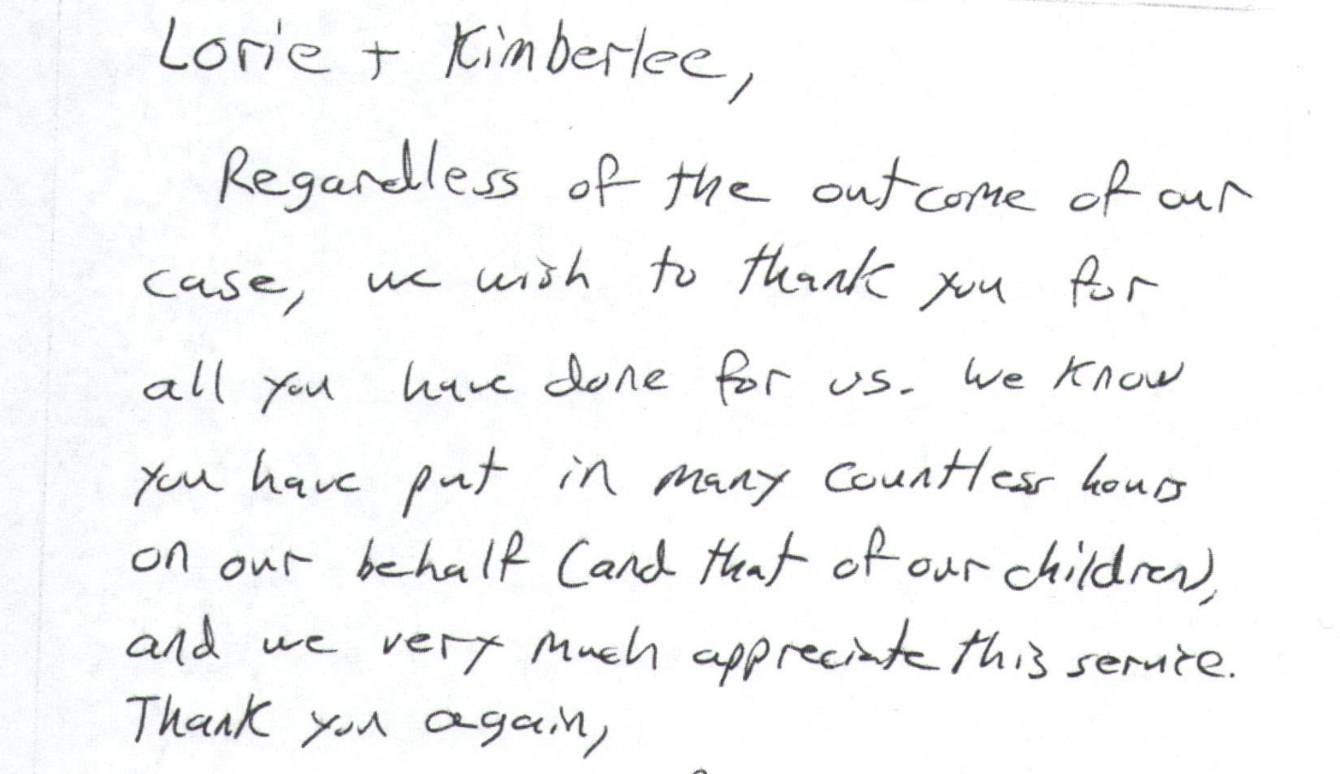

To whom it may concern,

I would like to share the wonderful experience that I personally had in one of Ms. Saab’s workshop in regards to IHSS. I needed direction & guidance through my own IHSS process. Mr. Saab & Aida were wonderful & very informative with all the question I had. They were very detailed & explained everything step by step. I’m am so grateful for the workshop & all Mr. Saab & Aida do. I will definitely attend again & recommend them to anyone who may need more information about IHSS.

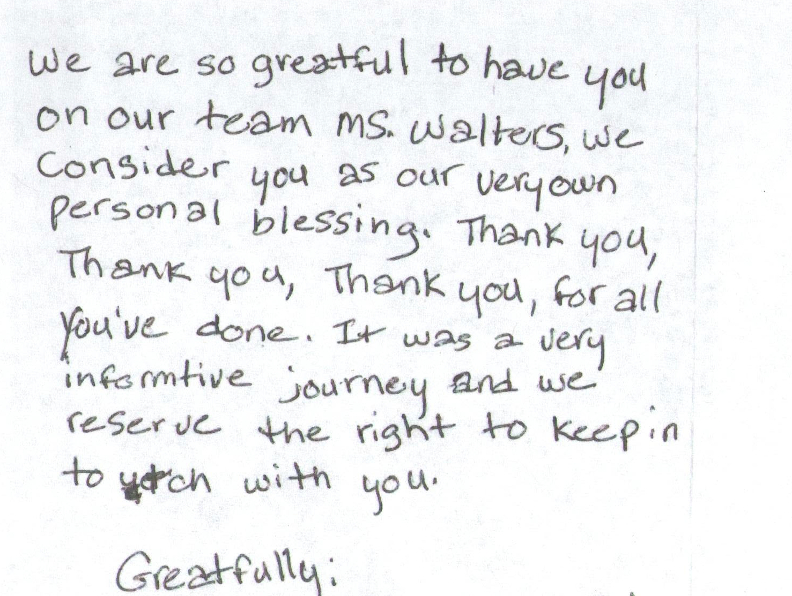

Thank you for your hard work to remedy this grave issue. Ms. JXXXX is THRILLED, giving me a big hug as soon as I arrived at her home yesterday. A huge weight has been lifted from her. I hope you never hear of such a concern again. I thank you immensely!!

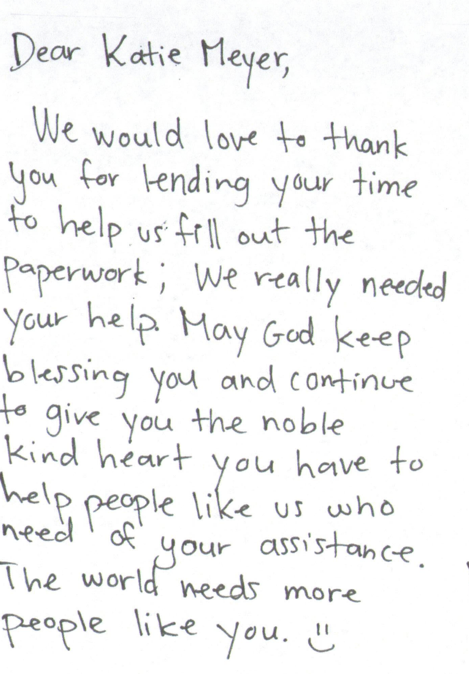

Dear Yulahlia & Annie,

Mitch and I both want you to know how much we appreciate you both so much. You both have done so much to help not just us but Joe. We have truly never meet two more dedicated advocates than the two of you. I really hope that some day I will be able to give back in some way to your organization all your time and dedication you have given to us. Again, thank you and may you both have a very blessed and wonderful Christmas.

3) Cases will be handled in a timely manner.

Consumers and families contact OCRA because something has gone wrong for them. It may be that they are losing a government benefit, being forced to move to a new more restrictive environment, or another urgent situation. Therefore, it is important that OCRA staff be responsive. For this reason, OCRA has, since its establishment, had a policy that all calls will be returned as soon as possible, but not later than closing of the next business day. OCRA measures its performance in this area by use of its consumer satisfaction survey; see Exhibit G, discussed more fully above.

OCRA is concerned that only 88 percent of responders report a call back within two days. While this is a slight improvement over the last fiscal year, it is still not good enough. This increase is likely due to the hiring of a bilingual support person to help with callers at the busiest offices in the state. To continue this improvement we are developing a new electronic phone log system. This will help the management team and staff better track incoming calls and ensure that people are called back timely.

The provision of clients’ rights advocacy services is coordinated in consultation with the DDS contract manager, stakeholder organizations, and persons with developmental disabilities and their families representing California’s multi-cultural diversity.

OCRA works through the OCRA Advisory Committee to ensure that this performance outcome is achieved. Attached as Exhibit H is a list of the members of the Disability Rights California Board of Director’s OCRA Advisory Board Committee effective January, 2014.

Public members of the Advisory Committee are appointed by the Board of Directors. In the selection process, the Board considers geographical diversity, both rural and urban and north and south, type of developmental disability represented, and ethnic background, in addition to the qualifications of the individual applicants. Cheryl Hewitt, a consumer of San Andreas Regional Center and self advocate was recently appointed as a public member.

The Board OCRA Advisory Committee provides valuable insight to the OCRA staff. A wide variety of topics are addressed at the meetings and board members become better self-advocates as a result of having been on the committee. Members and staff exchange information about the types of problems people need assistance with and relevant types of training needed in the community. The minutes for the September 20, 2013, meeting are included as Exhibit H.

DDS staff is invited and encouraged to participate in the next meeting, which is set for March 7, 2014, in San Diego.

Self-advocacy training is provided for consumers and families at least twice in each fiscal year.

Welfare and Institutions Code, Section 4433 (d)(5), requires that the contractor providing advocacy services for consumers of regional center services provide at least two self-advocacy trainings for consumers and family members. Disability Rights California’s contract with DDS mirrors this language. OCRA strongly believes in the importance of self-advocacy and requires each of its offices to provide at least one self-advocacy training for consumers per year, far exceeding the two mandated trainings. Many offices provide additional trainings, currently eight offices have already given more than the required one training per year. These trainings serve a vital role in educating consumers about their rights and how to stand up for themselves. A list of Self-Advocacy Trainings held last year are in Exhibit I.

The new Peer Advocates, mentioned in Section II.A.4, are developing new self-advocacy materials and providing community trainings. Consumers are able to identify with the Peer Advocates and are responding very well to the trainings. The Peer Advocates are also providing self-advocacy training to consumers in restrictive settings like Sonoma Developmental Center and Sierra Vista.

Staff may present from any of the approved self-advocacy trainings. To date, OCRA has developed six separate packets of information for OCRA staff to use in the mandated trainings in addition to the DDS Consumer Safety materials and the living arrangement options materials developed by DDS as part of the settlement in Capitol People First. This includes a new training on least restrictive housing options that was introduced to staff in December 2013 after being piloted by staff in both northern and southern California, see above in Outreach. Materials are attached in Exhibit M with a sample of the new Clients Rights Bingo game.

Samples of the OCRA self-advocacy packets (all are in both English and Spanish), were provided separately in a binder marked OCRA Training Materials with the 2007-2008 Annual Report. In discussions with DDS’s Contract Manager, it was decided that OCRA should not submit duplicate training packets in this year’s annual report. As always, OCRA welcomes comments from DDS on any training packets.

III. TITLE 17 COMPLAINTS

CCR, Title 17, Section 50540, sets forth a complaint procedure whereby a regional center consumer, or his or her authorized representative, who believes a right has been abused, punitively withheld or improperly or unreasonably denied, may file a complaint with the Clients’ Rights Advocate. The Complaint process is similar to that established by Welfare & Institution Code, Section 4731. However, the later law offers more consumer protections. There were no Title 17 Complaints filed during the last fiscal year, as noted on Exhibit J.

IV. DENIAL OF CLIENTS’ RIGHTS

CCR, Title 17, Section 50530, sets forth a procedure whereby a care provider may deny one of the basic rights of a consumer if there is a danger to self or others or a danger of property destruction caused by the actions of a consumer. The Clients’ Rights Advocate must approve the procedure and submit a quarterly report to DDS by the last day of each January, April, July, and October. OCRA is including the reports concurrently with the contractual date to provide OCRA’s reports. If this is not acceptable to DDS, OCRA will submit duplicate reports as requested. Attached as Exhibit K is the current log of Denials of Rights from the OCRA Offices.

V. CONSUMER GRIEVANCES

Exhibit A, Paragraph 12, of the contract between DDS and Disability Rights California requires OCRA to establish a grievance procedure and to inform all clients about the procedure. DDS has approved the grievance procedure developed by OCRA. The procedure is posted prominently in both English and Spanish at each office. Additionally, the grievance procedure is included in all letters to consumers or others who contact OCRA, when an office declines to provide the requested service to that person.

There was only one grievance filed by a consumer or their families during the first half of the fiscal year. OCRA agreed to provide additional services to the consumer. Attached as Exhibit L is a chart detailing the grievances filed against OCRA during this period.

VI. COLLECTION OF ATTORNEYS FEES

OCRA does not charge consumers, their families or advocates fees for services nor does OCRA seek to recover costs from these individuals. Clients’ Rights Advocates who are licensed to practice law in California, or Assistant, Associate, or unlicensed Clients’ Rights Advocates, all of whom work under the supervision of an attorney, can collect attorney’s fees and costs similar to those collected by private attorneys or advocates for special education cases or other cases where there are statutory attorney’s fees. OCRA collects fees only in special education cases or Writs of Mandamus. Fees and costs may be negotiated at mediation or can be received in those cases where an Administrative Law Judge has made a determination that the petitioner is the prevailing party. Fees are collected from the opposing party, which is normally a school district. Costs include any expenses to the Petitioner or OCRA for suing, such as filing fees or costs of expert evaluations. Neither Disability Rights California nor OCRA ever collect attorney’s fees from consumers.

OCRA did not collect any attorney fees this time period.

VII. CONCLUSION

OCRA continued to provide exceptional service to people with developmental disabilities throughout the state. OCRA handled over 5,038 cases in the first half of the fiscal year, an increase over the same time period last year. Additionally, OCRA provided 200 trainings to 9,703 consumers, family members, regional center staff and vendors, and interested community members. All while meeting each of its performance objectives. OCRA looks forward to continuing to work with people with developmental disabilities and helping access the services and supports they need to live the most independent and productive lives possible.

OCRA is providing the letters of appreciation with the wording from the originals, including any grammatical errors, unless otherwise indicated. We have also edited client names.

