LEGISLATION & PUBLIC
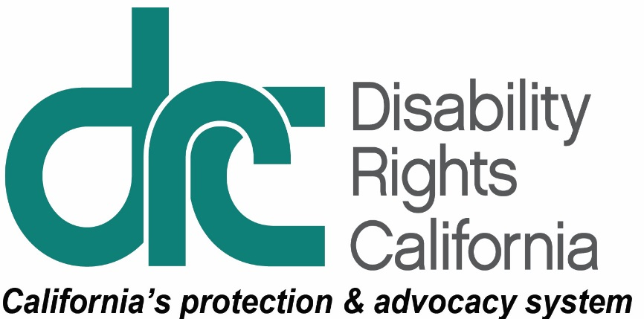
INFORMATION UNIT
1831 K Street
Sacramento, CA 95811-4114
Tel: (916) 504-5800
TTY: (800) 719-5798
Toll Free: (800) 776-5746
Fax: (916) 504-5807
www.disabilityrightsca.org

Principles: Out-of-Home Placement for Children and Youth
Publication #1021 - Adopted 9/20/2003, Amended 12/5/2014; Amended 3/9/2018

BACKGROUND:
Disability Rights California (DRC) adopted these principles to guide our policy work and ensure that children and youth disabilities are able to live with their families in the community with needed services and supports. DRC opposes public policy initiatives that inappropriately place children and youth in out-of-home placements. DRC supports those that increase access to community supports and services, facilitate transition back to home or community based environments and provide access to appropriate services when living out-of-home including while incarcerated or in foster care. We support laws and policies to develop and expand the availability of creative and flexible service models, such as Wraparound, and enhanced service coordination.

PRINCIPLES:

State law and policies should ensure:
- A coordinated and comprehensive service delivery system no matter how the child or youth comes into the system.
- Children and youth receive all necessary services to ameliorate or address conditions related to their disabilities.
- Positive and coordinated behavioral intervention services and supports are provided where the child lives, at school, and in the community.
- Behavioral interventions meet state requirements and best practice standards.
- Appropriate use of psychotropic medication only upon physician order, and, with informed consent from a legal guardian or with court approval.
- Behavioral restraint or seclusion are only used as safety measures of last resort when a person’s behavior poses an imminent risk of serious physical harm. Restraint or seclusion should never be used as a substitute for a behavioral intervention plan or for punishment, discipline, coercion, retaliation, or staff convenience.
- Restraint and seclusion should only be used by properly trained staff and only with the degree of force and the amount of time necessary for the imminent danger of serious physical harm to dissipate.
- The following is never used: prone restraint, any intervention that restricts a student’s breathing, chemical restraint, mechanical restraint.
- Data regarding the use of seclusion and restraint is collected and publicly reported.
- Incidents of seclusion or restraint causing serious injury or death are reported to Disability Rights California.

Out-of-Home Placements

Any out of home placements should:
- Be integrated and support full access to the greater community.
- Be selected by the individual.
- Ensure individual rights of privacy, dignity and respect, and freedom from coercion and restraint.
- Optimize autonomy and independence in making life choices.
- Facilitate choice regarding services and who provides them.

In provider-owned or controlled settings, the individual should have:
- A lease or other legally-enforceable agreement providing similar protections.
- Privacy in the unit including lockable doors, choice of roommates and freedom to furnish or decorate the unit.
- An individual schedule control including access to food at any time.
- Access to visitors at any time.
- Architectural access to the facility.

Out-of-State Placements
Children and youth with disabilities should live in California with appropriate services and not be placed in out-of-state placements where they are less able to engage with their family and participate in their community. If a child or youth is currently out-of-state, there should be a plan to transition them back to California with appropriate services and supports.
Before an out-of-state placement is made, a comprehensive assessment must be conducted and a determination by the child or youth’s treatment team that his or her needs cannot be met in California. This includes documentation that other less restrictive interventions have been tried such as outpatient therapy, family counseling, case management, family preservation efforts, special education classes, or nonpublic schooling. An out-of-state placement should only be made to a facility that complies with California standards. The out-of-state placement should be time-limited with a return-to-home transition plan.
Any extension of out-of-state placement must be based on a new, comprehensive assessment of the child or youth’s needs; review of available options; and determination the needs cannot be met in California. Any extension of the out-of-state placement should be time limited with a return-to-home transition plan.
California should develop new and innovative service options so children and youth can stay in their community and provide financial resources to develop and sustain these service options. For example, California allows counties to provide Wraparound services, which uses funding to provide family-centered services in the community instead of placing children and youth in group homes. Any new service options should meet the Centers on Medicaid and Medicare Services (CMS) Home and Community Based Services regulations.

Access to Appropriate Education Services
The least restrictive educational environment for children and youth living in out-of-home community placements is a regular, public school classroom with needed supplementary services and supports.
State law and policies should ensure youth with disabilities receive special education and related services to support them regardless of living situation or involvement in the child welfare or juvenile justice systems, including youth between the ages of 18 and 21 who are incarcerated in county jails.

Court-Ordered Placement
Any court-ordered placements should address the child’s educational, health, and mental health or other disability related needs.

For example, California law prohibits the use of electric shock and aversive treatment. See. http://leginfo.legislature.ca.gov/faces/codes_displaySection.xhtml?lawCode=EDC&sectionNum=56521.2 See also Welf. & Inst. Code section 4094.5. “Return to Main Document”
https://www.federalregister.gov/documents/2014/01/16/2014-00487/medicaid-program-state-plan-home-and-community-based-services-5-year-period-for-waivers-provider. “Return to Main Document”

