DRA written below a red arc with the text "Disability Rights Advocates, A non-profit corporation"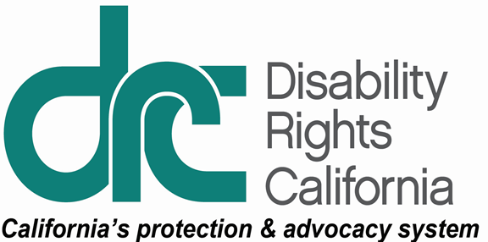

**For Immediate Release:**

February 22, 2018

**Media Contacts:**

Pat McConahay, Disability Rights California, (916) 504-5938

Freya Pitts, Disability Rights Advocates, (510) 665-8644

WATCHDOG GROUPS CHARGE THAT KERN COUNTY JUVENILE CORRECTIONS DISCRIMINATES AGAINST YOUTH WITH DISABILITIES AND FILE SUIT IN FEDERAL COURT

*County is Cooperating Fully with Investigation*

Today, Disability Rights California (“DRC”) and Disability Rights Advocates (“DRA”) released a 50-page report on their 6-month investigation of the treatment of youth with disabilities at the County Juvenile Hall and other county correctional facilities. The investigation uncovered what the groups describe as “abuse and neglect” of youth with mental and behavioral disabilities in county facilities. According to the report, in 2017, youth with disabilities were disproportionately subjected to pepper spray, restraints and solitary confinement. The report also alleged that youth were denied their special education rights and provided with inadequate mental health treatment.

In addition to the Kern County Juvenile Hall, the report addresses conditions in the Crossroads Juvenile Correctional Treatment Facility and in Camp Erwin Owen. The two watchdog groups conducted confidential interviews of 50 youth in these three facilities and reviewed more than 10,000 pages of documents.

“The County has responded very responsibly to our investigation,” said attorney Melinda Bird of Disability Rights California. “We are pleased that the County and the Superintendent of Schools have already made some changes and agreed to bring in several independent experts to assess the County system and make recommendations for reform.”

The full report and the County and Superintendent of Schools’ responses are available on the DRC website at <http://www.disabilityrightsca.org/JailsReports/index.htm> and on the DRA website at <http://www.dralegal.org>.

The investigation report alleges that last year, non-violent youth were pepper sprayed, placed in dangerous prone restraints, and held for days or weeks in solitary confinement for up to 23 hours per day. Students with disabilities did not receive minimally adequate special education services and were removed from school without due process and required safeguards.

DRA attorney Freya Pitts said, “We hope that our investigation and the involvement of the experts will lead to meaningful reform, and that the young people with disabilities in Kern County’s care will soon be receiving the supports and services they need.”

In association with the investigation and report, DRC and DRA also filed a civil rights lawsuit in federal court in Fresno, California on behalf of three youth confined in the Juvenile Hall and Crossroads facilities. The defendants are the County of Kern, its Probation Chief TR Merickel, the Kern County Superintendent of Schools, and its Superintendent Mary Barlow. DRC, DRA, the County, and the Superintendent of Schools have agreed to a stay of the federal lawsuit while the experts study the Kern County system and make recommendations.

Disability Rights California advocates, educates, investigates, and litigates to advance the rights, dignity, equal opportunities, and choices for all people with disabilities.

Disability Rights Advocates is a leading national nonprofit disability rights legal center. Its mission is to advance equal rights and opportunity for people with all types of disabilities nationwide. DRA represents people with the full spectrum of disabilities in complex, system-change, class action cases, including in the areas of criminal and juvenile justice. In 2015, for example, DRA reached a landmark settlement requiring dramatic reform for incarcerated youth in *G.F. et al. v. Contra Costa County et al.* For more information, visit [www.dralegal.org](http://www.dralegal.org).