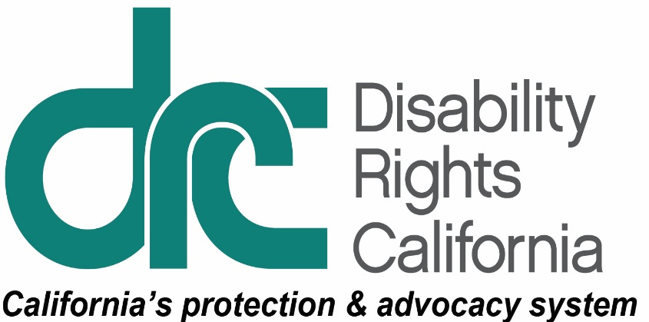
1831 K Street
Sacramento, CA 95811
Tel: (916) 504-5800
TTY: (800) 719-5798
Intake Line: (800) 776-5746
Fax: (916) 504-5901
www.disabilityrightsca.org

News Release
For Immediate Release
Contact: Pat McConahay, Communications Director
Disability Rights California
(916) 504-5938
Pat.McConahay@disabilityrightsca.org

Californians with Disabilities Face Illegal Barriers to Voter Registration

Civil Rights Organizations Demand Secretary of State Alex Padilla Remedy Election Law Violations
(Sacramento, CA – June 20, 2018) The American Civil Liberties Union Foundation of Northern California and Disability Rights California today sent a demand letter to Secretary of State Alex Padilla demanding increased access to voter registration services for low-income Californians and Californians with disabilities.
State and federal law requires that public assistance offices and state-funded programs primarily engaged in providing services to persons with disabilities must offer voter registration services to applicants and clients at every agency and office in the state. Today’s letter serves as official notification that Secretary Padilla’s office has failed to designate offices that serve millions of Californians each year as “Voter Registration Agencies” (VRAs) as required by the National Voter Registration Act (NVRA) and California’s Election Code.
According to the letter, state programs that should offer voter registration services but are currently not designated as VRAs include the Department of Social Services-Office of Services to the Blind, the Department of Rehabilitation-Deaf and Hard of Hearing Services, Local Educational Agency special education offices, the California Community College Disabled Student Programs and Services, Local Area Agencies on Aging, financial aid programs administered by the California Student Aid Commission and more.
“We have tried in vain to work with Secretary Padilla to remedy this issue for years,” said Raúl Macías, Voting Rights Project Manager and Attorney with the ACLU Foundation of Northern California. “Voting is a fundamental right and California should be doing everything it can to make registration widely available to all of our state’s citizens.”
“Many people with disabilities do not have contact with the DMV and do not have access to voter registration assistance without visiting a voter registration agency,” said Fred Nisen, Supervising Attorney for Voting Rights with Disability Rights California. “There are 124,000 community college students with disabilities, many of whom are not registered and do not have a reason to go to the DMV.”
Analysis of NVRA data released today by the ACLU Foundation of Northern California and Disability Rights California shows that California is systematically failing to provide disabled people access to voter registration services. While the number of California voters registered by public assistance agencies has increased in recent years, registration at disability services offices has flagged. Review of Secretary Padilla’s NVRA data reveals that registrations declined substantially at disability agencies over the last five years, with 2017 being the lowest year of registrations in eight years. In 2017, seventeen California counties did not register a single voter at a disability service agency in the entire year.
The ACLU Foundation of Northern California and Disability Rights California noted in today’s demand letter that the organizations will pursue litigation if Secretary Padilla does not take immediate steps to comply with state and federal law.
Disability Rights California is a non-profit organization founded in 1978. We protect the rights of people with disabilities. Visit disabilityrightsca.org.

