LEGISLATION & PUBLIC
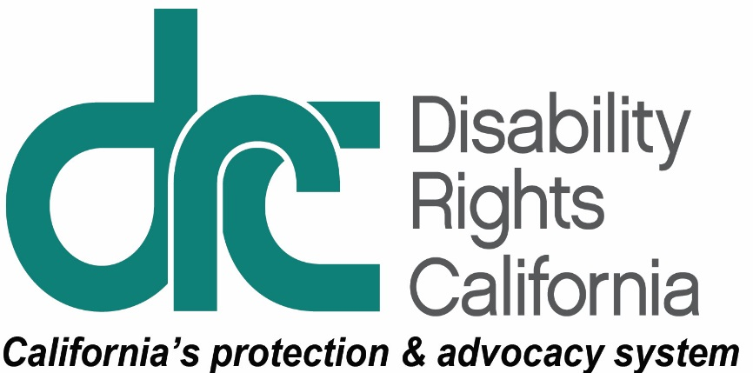
INFORMATION UNIT
1831 K Street
Sacramento, CA 95811-4114
Tel: (916) 504-5800
TTY: (800) 719-5798
Intake Line: (800) 776-5746
Fax: (916) 504-5807
www.disabilityrightsca.org
For Immediate Release
Contact: Pat McConahay
Pat.McConahay@disabilityrightsca.org
(916) 504-5938

Children with disabilities file federal class action lawsuit challenging California’s failure to arrange for Medi-Cal in-home nursing care
May 24, 2018 – Two children with significant disabilities filed a federal class action lawsuit today against the California Department of Health Care Services (DHCS), claiming that the state has failed to fulfill its commitment to provide them with sufficient Medi-Cal in-home nursing services to keep them safely at home.
Plaintiff Ivory N. is seven years old and lives with her adoptive family. Due to her cerebral palsy and epilepsy, she needs help with all of her daily needs, uses a wheelchair, and receives food and nutrients through a feeding tube. She requires round the clock care, including 63 hours per week of in-home nursing care as prescribed by her doctor and approved by the Medi-Cal program. But DHCS has not met its legal obligation to supply those hours and her parents are barely staying afloat. Her adoptive mother thinks the state can do better. “Ivory is a happy, headstrong, joyous little girl. She is not the problem. The problem is the state’s failure to provide our little girl with the services she needs. We need help.”
Ivory’s story is not unique. More than 4,000 Medi-Cal-eligible children have been approved by the state to receive Medi-Cal in-home nursing care. Yet the state lacks an effective system for arranging for needed nursing, placing the burden on families to recruit nurses and, when they are unsuccessful, provide the care themselves. This creates an unacceptable risk of medical complications, hospitalization, and placement outside of the family home. According to DHCS’ own study, 29 percent of authorized Medi-Cal nursing hours go unstaffed.
Plaintiffs are represented in this lawsuit by Disability Rights California, the National Health Law Program, and Western Center for Law and Poverty. The case, Ivory N. v. Kent, seeks to hold the state accountable to arrange for legally required services to children with complex medical needs. Ivory is joined in this action by five-year-old James, who is also only receiving a fraction of his state-approved nursing hours.
Sarah Somers, an attorney with the National Health Law Program, has litigated similar cases across the nation. “Under federal Medicaid law, states are required to do more than simply authorize services. They have an affirmative obligation to arrange for those services to be provided to the children who need them.”
“The state’s failure to arrange for in-home nursing also creates an enormous strain on families, which in turn can lead to job loss, broken relationships, and caregiver burnout,” says William Leiner, an attorney with Disability Rights California. “Some parents are forced to face the unfathomable possibility that their children may need to leave the family home to obtain needed nursing care.”
Robert Newman, General Counsel with Western Center on Law and Poverty, sees a moral, legal, and fiscal imperative for the state to act. “Increasing the risk of hospitalization or out of home placement for children with disabilities not only violates federal law and the Supreme Court’s Olmstead decision, but it is a cruel and expensive way to provide long term care.”
Plaintiffs in this lawsuit seek nothing more than for the state to meet its legal obligation to make sure that they and others like them receive the services that the state itself has already determined they need. To learn more about this case and the Plaintiffs, read the complaint here https://www.disabilityrightsca.org/cases/ivory-n-v-kent.
###
Disability Rights California advocates, educates, investigates, and litigates to advance the rights, dignity, equal opportunities, and choices for all people with disabilities. For more information, visit www.disabilityrightsca.org.
Founded in 1969, the National Health Law Program (NHeLP) protects and advances the health rights of low-income and underserved individuals and families. NHeLP advocates, educates and litigates at the federal and state levels. Our lawyers and policy analysts stand up for the rights of the millions of people who struggle to access affordable, quality health care. We are guided by the belief—a challenge—that each generation should live better than the last. www.healthlaw.org
Western Center on Law and Poverty brings about system wide public and private sector policy changes that help millions of low-income Californians at a time, focusing on the issues of affordable housing, healthcare, public benefits, racial justice, economic equity and access to justice. www.wclp.org.

