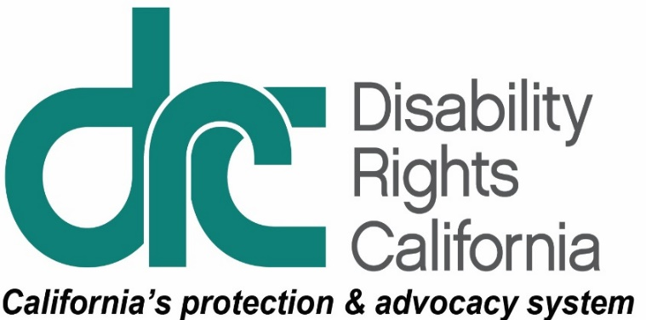
M,1831 K Street
Sacramento, CA 95811
Tel: (916) 504-5800
TTY: (800) 719-5798
Intake Line: (800) 776-5746
Fax: (916) 504-5901
www.disabilityrightsca.org
News Release
For Immediate Release
Contact: Pat McConahay, Communications Director
Disability Rights California
(916) 878 7401 cell
(916) 504-5938 direct
Pat.McConahay@disabilityrightsca.org

Fresno County juvenile system leads in education reform

DRC report finds more work to be done
(Fresno, CA – July 2, 2018) Youth with disabilities released from the Juvenile Justice system face daunting obstacles when they return to their homes, schools and communities. A study by the State Department of Education found that almost 80% of young people detained in juvenile halls in California were not enrolled in a local school district within thirty days after they were released from detention.
A report released today found Fresno County Probation and the Superintendent of schools have implemented educational reforms that address the problem of reentry, and have created an exemplary special education program for youth in Fresno County Juvenile Justice Campus.
Disability Rights California (DRC), with the Youth Law Center (YLC), based this finding on an inspection of the Fresno County Juvenile Justice Campus. View the inspection report.
The report explains that the County Superintendent of schools has a coordination agreement with Probation; holds regular transition reentry meetings for youth; and proactively invites superintendents from local school districts to regular planning meetings regarding justice-involved youth. Special education students are promptly identified and receive individualized, evidence-based teaching inside the hall.
“But the work is not done,” said Tifanei Ressl-Moyer, DRC legal fellow for the Mental Health Practice Group. “The system’s leadership must take additional steps to protect youth with disabilities from discrimination and custodial practices that place them at risk of harm.”
The report highlights several areas where JJC officials need to make changes to serve youth better, including adopting alternatives to using pepper spray on the youth in the facility. DRC also found that JJC needed to provide accommodations for youth with disabilities in its “behavior modification” programs, which fail to identify and address behaviors that are the result of a disability, chronic stress or trauma. Probation staff has no system to identify youth with disabilities and offer accommodations.
DRC also found:
- A lack of communication between education staff and probation staff regarding the disability-related needs of youth
- A disproportionately high number of Black youth with disabilities ensnared in the Fresno County juvenile justice system
- An insufficient system for identification of youth with mental health needs
In response to the DRC report, the Probation Department announced new steps to address a number of DRC and YLC’s concerns. The county’s written response is included with the report and is found on DRC’s website. View the response.
DRC and YLC commend the Probation Department on its efforts to address the findings in the report, and look forward to seeing these plans advance and ensure the protection of youth with disabilities in the juvenile justice system.
Disability Rights California is a non-profit organization founded in 1978. We protect the rights of people with disabilities. Visit disabilityrightsca.org.

