# Similarities and Differences between Traditional Regional Center Service Provision and the New Self-Determination Program

|  |  |  |
| --- | --- | --- |
|  | **Traditional Regional Center Service Provision** | **Self-Determination Program** |
| Eligibility - Age | All ages | Everyone over age 3. Under age 3 must be eligible for Lanterman Act services (not Early Start) |
| Eligibility – Living Arrangement | All settings | Must live in community. Can use SDP in developmental center or licensed long-term health facility if you are expected to move to the community within 90 days |
| Planning Process | Individual Program Plan (IPP) - Meeting where goals are established and services and supports are decided | Person Centered Plan (PCP)  – A group of people focus on an individual and that person's vision of what they would like to do in the future. The IPP team shall use the Person Centered Planning process to develop the IPP and the Individual Budget. |
| Frequency of planning process | IPP at least every three years, annually at most regional centers, or within 30 days of a request | PCP at least annually but as often as needed. Still hold IPPs with service coordinator at regional center. |
| Who decides what services and who provides them? | Regional Center and IPP Team | Consumers and/or their families |
| Who pays the bills? | Regional Center | Financial Management Service (FMS) |
| Responsibilities of consumers and families | Participate in IPPs | Attend formal information session, orientation and trainings on the Self- Determination Program; Active in creating plan; Active in designing individual budget; Active in selecting services and supports; Work with FMS to ensure monthly and annual budgets are kept; Monitor and supervise staff and agencies hired. |

|  |  |  |
| --- | --- | --- |
|  | **Traditional Regional Center Service Provision** | **Self-Determination Program** |
| Do services have to be provided by vendors of the regional center? | Yes, except in very limited circumstances. | No, except for the FMS |
| Who finds the service providers? | Regional Center | Consumer, Family, Independent Facilitator, Financial Management Services, Friends, etc |
| Does regional center monitor the quality of a service provider? | Yes | No. Consumers and families with assistance of facilitator evaluate quality of services. |
| What kind of services can be arranged? | Subject to restrictions of the legislature and preferences of regional center. | Must be matched by federal funds, which includes a wide range of services. Services allowed also include suspended or limited services, such as social/recreational programs, camp, non-medical therapies, and respite. |
| Are services that are available through generic agencies like schools or Medi-Cal paid by regional center or through my budget? | No | No |
| Can you change service providers? | Yes, if regional center agrees | Yes |
| Do I have appeal rights? | Yes | Yes |

*Copyright Autism Society of Los Angeles, 2015*

Select Languag



C **i** thecasdpnetwork.org

**T**

INSPIRE ICO NNECTI EMPOWER

**SDP**

**K**

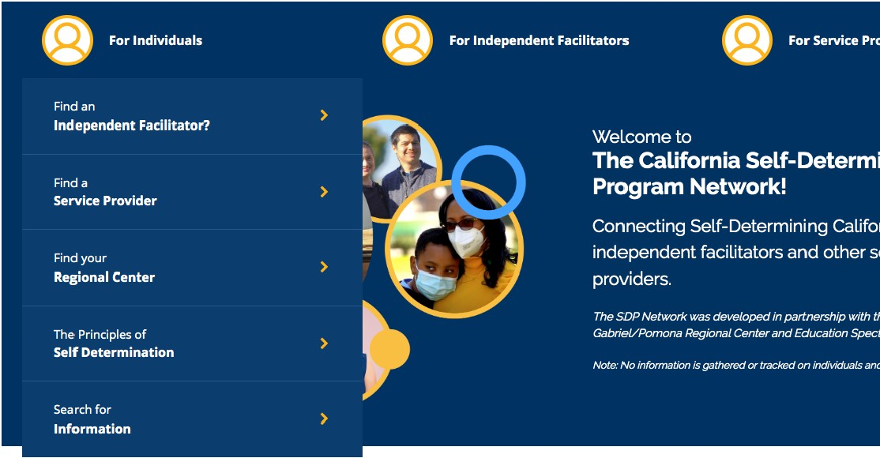

**public partnerships**

**Inspire. Empower. Connect.**

Cahforn,a Self Detecm;oatioo ecogcam e,ooeern Meel

**@j**

**Possible Questions for IndependentFacilitators**

1. How muchdo you knowabout California's Self-Determination Program? You*want to make* sure *they understand the principles of self-determinationand how the program* is *different from the traditional regional center system. For example, the SOPparticipant* is in *chargeof who getshired andsupervisingstaff and agencies. Billsgo to an FMS.*Services *must providecommunity inclusion. Provider does not need to be a vendor* or *havea contract withtheregional center.*

### What experience haveyou had as an Independent Facilitator?

1. Have *you* hadanytraining to beanIndependent Facilitator?
2. Have *you ever* facilitateda person-centered plan?
   * Howmany?
   * What is *your* style?
   * How do *you* prepare?

### How welldoyouknow my community?

* + Are you aware of activities in myarea that I might beinterested in?

1. How would yougo about helpingme to findservicesto helpme meet mygoals?
2. How will you helpmefigure out mybudget?
3. Canyou advocate for me at my IPP?
   * At my l EP?
   * Toget benefits,such as 551 or IHSS?
4. Do you also help manage workers?
   * How do *you* do that?

### How would you helpme if I am unhappywiththejobthatoneofmyworkers is doing?

1. How will you keepin touchwithother members of my support team?
2. I havecertain thingsthat arereally important to me,like .Aye services to meet my specific needs andpreferences?
3. Are you willingto negotiatea price based on myspecific needs?
4. How muchwill you charge for my services?
5. When areyou available to start?
6. How will you keepin touchwithother members of my support team?

oulli toadapt your

C i dds.ca.gov/initiatives/ sdp/financial-management-service-contact-list/  v **f** *'!#* **D** 181 About Calend ar Careers New s Room Contact Us @I Translate <) Displ ay Sett ings

Co•nsumers

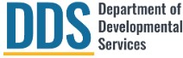

(i)

Services

Regional Centers Vendors

'"

In tiatives Transparency Search

'

.Home Jnit ic1ti ves Self-Det.erminc1ti onProgram( SDP) **Financial Management Service (FMS) Contact List**

**Financial Management Service (FMS) Contact List**

***Please select your Regional Center below to see which FMS providers are currently available.*** If you would like to work with an FMS provider not listed underyour RegionalCenter, pleasecontact your RegionalCenter.

More informationabout the different FMS models can be found in the FMS Model Comparison chart Viewthe FMS Model Comparison Chart in English, Spc1ni sh, Arc1b i c, Hmong, Japanese, Korean, Laotic1n , Russic1n , Simplified Chinese, Traditionc1[ Chinese, Tagalog, or Vietnc1.m ese

The roles andrequirements for the FMS provider can be found in the FinancialManagement Service Information directive. To viewthis directive in English and other languages, visit theProgram Dir ectivespage, find thedrop down for "Financial Management Services- December 2018" and select your preferred language.



II North LA II Redwood Coast I

--

I East Bay 11 Orange County II San Andreas 11 San Diego 11 San Gabriel/ Pomona 11 South Centra l LA 11 Tri-Counties I Valley Mounta in I Westside I

### Acumen Aveanna SupportServices{FormerlyPremier HealthcareServices)

**Available FMS Services**

### Cambrian FMS

**Available FMS Services**

Bill Payer and Sole Employer

**Languages Spoken**

English and Spanish

**Available FMS Services**

Bill Payer and Co-Employer (with nursing through home health agency only)

Bill Payer, Sole Employer and Co-Employer

**Lan guages Spoken**

English, Spanish, VietnameseT, agalog, Farsi

### Aveanna Support Services{Formerly Premier HealthcareServices)

Acumen

**Available FMS Services**

Bill Payer and Sole Employer

**Languages Spoken**

English and Spanish

**Contact Phone Number**

Yvette Torres - 424-210-8810

**Email Contact**

[yvett et@acumen2.net](mailto:yvettet@acumen2.net)

**Available FMS Services**

Bill Payer and Co-Employer (with nursing through home health agency only}

Current lynot accepitngnew referralsuntil January 2024

**Languages Spoken**

English, Spanish,Vietnamese, Cantonese, Mandarin and Trieu Chau

**Contact Phone Number**

Northern California: 866-979-1182 Southern California: 310-215-1730

**Email Contact**

Northern California: [SJSD](mailto:SJSDP@aveanna.com)[P@aveanna.com](mailto:P@aveanna.com) Southern California: [FMSlnfo@aveanna.com](mailto:FMSlnfo@aveanna.com)

### Cambrian FMS

**Available FMS Services**

Bill Paye,r Sole Employer and Co-Employer

**Languages Spoken**

English, Spanish, VietnameseT, agalog, Farsi

**Contact Phone Number**

Paul Quiroz - 877-390-4300

**Email Contact**

Paul Quiroz - Paul!:]@CFMSl. com

# Types of Financial Management Services for Self-Determination Program Participants

## As discussed in the [FMS FAQs](https://www.dds.ca.gov/initiatives/sdp/frequently-asked-questions/) on the Department’s website, each participant in the Self-Determination Program must use a regional center vendored Financial Management Services (FMS) provider. There are three types of FMS providers: 1. Bill Payor or Fiscal Agent, this model is used when goods or services are purchased from a business; 2. Co-Employer, this model is used when the participant wants to share some of the employer roles and responsibilities with an FMS and 3. Sole Employer, also known as the Fiscal/Employer Agent), this model is used when a participant wants to be the direct employer of those providing services.

This chart shows how tasks and responsibilities are divided between you and your FMS provider.

|  |  |  |  |
| --- | --- | --- | --- |
|  | **Type of FMS Model** | | |
| **Tasks** | **Bill Payer** | **Co- Employer** | **Sole Employer** |
| **Pays for items and services identified in your spending plan from other businesses or vendors** | **FMS** | **FMS** | **FMS** |
| **Who Hires Individuals Who Provide Services To You?** | | | |
| * Decide skills needed | **N/A** | **You with help from the FMS** | **You with help from FMS** |
| * Decide wages and benefits | **N/A** | **You and FMS** | **You with help from FMS** |
| * Interviews applicants | **N/A** | **You** | **You** |
| * Verifies worker’s eligibility for employment qualifications | **N/A** | **You and FMS** | **You and FMS** |
| * Decides who to hire people that work for you | **N/A** | **You and FMS** | **You with help from FMS** |
| * Arranges for needed background checks as described in [Self- Determination Service Provider Background Checks directive](https://www.dds.ca.gov/wp-content/uploads/2019/11/SDP_BackgroundChecks_20191101.pdf) | **N/A** | **FMS and the worker you want to hire** | **FMS and the worker you want to hire** |
| * Verifies provider passes background check | **N/A** | **FMS** | **FMS** |

1

|  |  |  |  |
| --- | --- | --- | --- |
|  | **Type of FMS** | | |
| **Tasks** | **Bill Payer** | **Co- Employer** | **Sole Employer** |
| **Who is the employer?** | **The business/vendor providing the item/service** | **You and FMS** | **You** |
| **Supervision and Timesheet Approval** | | | |
| * Schedules the worker | **N/A** | **You** | **You** |
| * Supervises the work | **N/A** | **You** | **You** |
| * Approves timesheets | **N/A** | **You** | **You** |
| **Worker Pay and Taxes** | | | |
| * Pays the worker | **N/A** | **FMS** | **FMS** |
| * Pays required government taxes | **N/A** | **FMS** | **FMS** |
| * Obtains tax reporting number | **N/A** | **FMS** | **You** |
| * Files all tax reporting | **N/A** | **FMS** | **FMS** |
| **Insurance and Compliance** | | | |
| * Obtains Liability Insurance | **N/A** | **FMS** | **You** |
| * Obtains Worker’s   Compensation Insurance | **N/A** | **FMS** | **You** |
| * Ensures compliance with employment laws | **N/A** | **You and FMS** | **You and FMS** |
| * Verifies services are HCBS compliant with documentation from the RC prior to payment | **N/A** | **FMS** | **FMS** |
| **Manages Budget** | | | |
| * Makes sure participant has funds for the entire year. | **You and FMS** | **You and FMS** | **You and FMS** |
| * Provides monthly spending report to participant and service coordinator | **FMS** | **FMS** | **FMS** |

The regional center can provide additional information about the kinds of FMS providers. A list of FMS providers is available on the [FMS Contact List](https://www.dds.ca.gov/initiatives/sdp/financial-management-service-contact-list/) webpage. Additionally, your regional center can help you locate FMS providers. The participant and their family should consider speaking with more than one FMS about their services.

The cost for FMS services is negotiated between the participant and the FMS provider, but may not exceed the [maximum rates](https://www.dds.ca.gov/wp-content/uploads/2019/02/SDP_FMSRates_20190201.pdf) posted on the Department of Developmental Services’ website. The costs for these services are paid from the participant’s individual budget; however, the individual budget cannot be increased to cover the cost of the FMS.

2





8

i disabilityvoicesunited.org/resources/publications/

**DISABILITY**

**VOICES UNITED**

**Donate**

Take Action

**a111aaa11**

Together we willbeheard

Issues Voices **Resources** Events About Us Contact

blicati

Please note: our small team ships your orders by hand! Please allow 2-3 weeks for shipping.

**Updated 2023 Edition Now Available**

A guide to California's Self­ Determination Program.

Updated in January 2023, it discusses all parts of the SOP, from person-centered

planning to budgets and more.

$25, including tax and shipping

BUY NOW