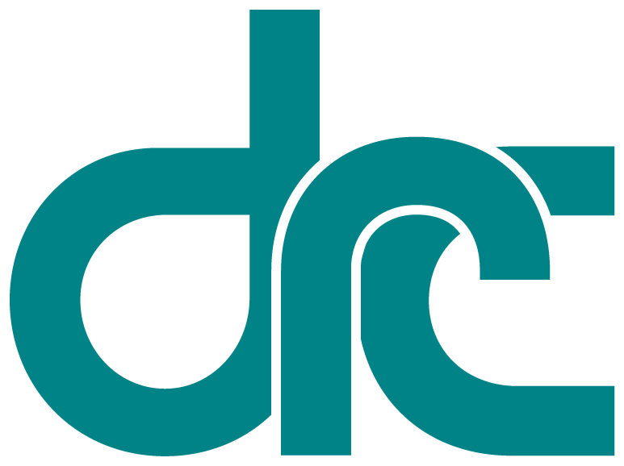
 | Disability  Rights  California | Office of Clients’ Rights Advocacy  3602 Inland Empire Blvd., Suite B-100  Ontario, CA 91764  San Bernardino, CA 92408  Tel: (909) 383-1133  TTY: (877) 669-6023  Fax: (909) 383-1113  www.disabilityrightsca.org
Serving Consumers of
Inland Regional Center
MEMORANDUM

TO: Katie Hornberger, Director

FROM: Kendra McWright, OCRA Outreach Coordinator (South)
Christine Hager OCRA Outreach Coordinator (North)

RE: Semi-Annual OCRA Outreach Report
July – December 2013

DATE: 7/31/2026

OCRA makes it a priority to conduct outreach and trainings to targeted communities each year. During this review period, OCRA staff conducted 200 outreach trainings and presentations to 9,703 attendees. This number represents an increase from this same time period from last year. Below we have provided a breakdown of the distinct types of outreach staff provide (self-advocacy trainings, general and targeted outreach) statewide. OCRA staff contributed their thoughts as to why the highlighted outreaches were unique and/or impactful.

Self-Advocacy Trainings

Each OCRA office conducts at least one self-advocacy training per contract year. Many offices do more than the required training, for example eight offices have already completed at least two self-advocacy trainings during this reporting period. Self-Advocacy topics include: emergency preparedness, self-advocacy, client’s rights, rights to money management, voting rights, community living options, and employment rights and options. This year, OCRA is proud to unveil a new self-advocacy training module for staff to present to the community at self-advocacy trainings: Where to Live.
Where to Live is an interactive presentation that provides information on clients’ rights and living options for people living in large facilities. It is about reaching consumers who need to hear about their rights and that is more important than the exact size of the facility. Consumers receive a booklet focused on options of where and how the person wants to live. The trainers take the audience through a sample story about a person who is thinking about moving but isn’t sure where they want to live. The audience helps decide what the sample person likes and wants in their life, i.e. a job, help with cooking, neat and tidy roommates, pets and quiet space. The focus in on options and choices, clients’ rights—there are no right or wrong answers, and answers can change throughout a persons life depending upon their circumstances and preferences. This is a fun and interactive training with a take-home workbook to use in IPP meetings and to help participants make decisions about where to live!

The Right to Make Our Own Choices: The OCRA staff at the office serving clients of Central Valley Regional Center led a discussion about the rights of adults to make choices about their lives and the rights they have to services while playing an interactive BINGO game. Forty-seven regional center clients and adult transition program students attended this OCRA breakout session at the 4th Annual Self-Advocacy Conference in Clovis on November 15, 2013. Clients had a great time and were able to win prizes while learning. The game was developed by OCRA as a means to open a discussion about our rights, to make clients aware of what rights they have, and to have fun while doing so.

Self-Advocacy Abuse Training: The OCRA office serving consumers of the North Los Angeles County Regional Center gave a presentation to the self- advocacy group at Jay Nolan Community Services on September 26, 2013 on abuse prevention. The purpose of this interactive training was to educate the participants about how to identify abuse and strategies to reduce the risk of abuse and remain safe. The training identified various types of abuse including physical, sexual, emotional and financial abuse. Throughout the training, various scenarios were given, and the participants had the chance to discuss how they would handle that particular situation. In addition, the training provided information about who to contact if they felt that they were being treated inappropriately such as law enforcement, their regional center service coordinator and/or their care provider. By the end of the training, the audience expressed appreciation for the information, and indicated a greater understanding of how to prevent abuse in the future.

Outreach Trainings and Presentations Statewide (General Outreach)

Staff worked to create and maintain contacts in their respective communities; including seeking out new and integrative outreach opportunities to ensure that OCRA is reaching-out to all members of our catchment areas.

Staff also developed a new training about Integrated Competitive Employment (ICE) to educate people about work and higher education options. The game of ICE, uses the board game theme: “Game of Life”. A poster was developed as a visual tool to discuss information on employment services and higher education as it relates to people with disabilities. The participants can explore the board and learn about the services from the Department of Rehabilitation (DOR) or learn about higher education. The poster is also a valuable tool to teach individuals. It can lead discussions, and be used as an interactive and dynamic visual aid to cater to a variety of audiences.

Targeted Outreach

Organizationally, OCRA has made a commitment to actively reach out to and serve people with developmental disabilities from traditionally underserved communities. The 2013-2014 year is the first year of our new two year plan. Each office reviewed their demographic data and compared it to that of their regional center to determine which community was underserved and thus would become the new targeted community. As a result of this process, a few offices changed their target community and have begun the process of making new contacts and providing outreach. OCRA’s target communities include: the Latino community, the Asian community including the Hmong and Vietnamese community, the African American community, and the Native American community. OCRA continues to build lasting relationships of trust with leaders and members in communities typically underserved by the regional center and other social service agencies.

Bi-National Health and Wellness Fair of Napa County: The OCRA office serving consumers of North Bay Regional Center and Sacramento Regional office staff provided information about OCRA, DRC and Client Assistance Program (CAP) advocacy services at the Bi-National Health and Wellness Fair of Napa County on September 22, 2013. At the fair families were offered immunizations, free health screenings and information about housing, employment, immigration, services for people who have disabilities and much more. Through a booth at the fair we provided a variety of information to Spanish speaking families in Napa County. Families learned about In Home Support Services, Social Security appeal rights, how to access Department of Rehabilitation services, and information about special education. The event also had activities for children and an interactive dance class at the end. Overall, people at the fair seemed to be interested in learning more about their right to access services. The fair was a great way to meet local community members.

Ask a Lawyer Evening: The OCRA office serving consumers of Harbor Regional Center recently provided two presentations, titled: Ask a Lawyer and The Lanterman Act on a few of the new changes to the Lanterman Act. The trainings specifically focused on Welfare and Institutions Code § 4519.5 (disparity data fact sheets) and SB 555 (information available in native language) to Spanish-speaking support groups. The presentations were very well received. Many of the audience members felt that seeing the data regarding the Purchase Of Service expenditures broken down by ethnicity seemed to confirm their long-held belief that the system is not serving Latinos appropriately and fairly. In addition, finding out that SB 555 passed gave the audience hope that things might get better if they act to assert their rights. Information about who to contact for help was also distributed.

We are excited to see what the next six (6) months brings as we provide outreach to our communities with a focus on serving those communities that have been traditionally underserved.

Thank you for the opportunity to coordinate outreach presentations and trainings statewide for OCRA.

