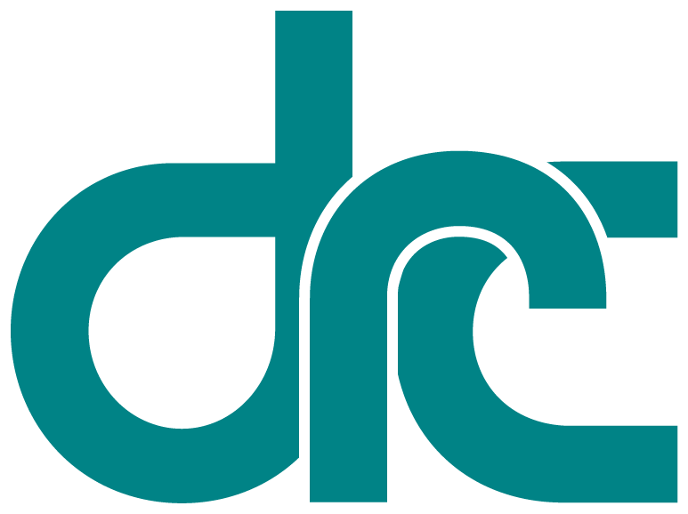
 | Disability  Rights  California | Office of Clients’ Rights Advocacy  567 W. Shaw Avenue, Suite C-3  Fresno, CA 93704  Tel: (559) 271-6604  TTY: (877) 669-6023  Fax: (559) 271-6606  www.disabilityrightsca.org
Serving Consumers of
Central Valley Regional Center
MEMORANDUM

TO: Katie Hornberger, Director

FROM: Kendra McWright, Outreach Coordinator North
Beatriz Reyes, Outreach Coordinator South

RE: Annual OCRA Outreach Report
June 2012 – June 2013

DATE: August 1, 2013

In an effort to respond to the growing demand for information, OCRA presents outreach to our communities in the areas of General, Targeted, and Self-Advocacy trainings. During the 2012 -2013 fiscal year, OCRA has presented 368 outreach presentations impacting approximately 13,197 consumers, families, service providers, and community members. This year our offices presented the same number of outreach presentations as the 2011-2012 outreach plan year; however, the number of persons impacted represents a decrease. This lower number represents a change in focus on our part to present to smaller groups of individuals to ensure that our information is understood, questions are answered fully, and that or offices are able to respond to their communities in a meaningful way. OCRA is proud of our accomplishments in outreach and we view each presentation as an expression of our strong commitment to inform the communities that we serve. The remainder of this report discusses in detail the work performed in each of the above mentioned categories.

Self-Advocacy Trainings
Each OCRA office has a goal to conduct at least one self-advocacy outreach presentation per year. Each year many of our offices go above and beyond this minimum requirement, presenting two or three presentations directly to consumers. During the 2012-2013 plan year OCRA met its self-advocacy goal by providing well over our minimum required number of self-advocacy presentations. These presentations focused on topics such as: emergency preparedness, clients’ rights, voting rights, money management, and community living options. Below is a description of a couple of the presentations provided by OCRA:

Health Care Updates for Persons With Disabilities. Clients’ Rights Advocates from the Eastern Los Angeles Regional Center and the San Gabriel Pomona Regional Center offices of OCRA met with members of the Chinese Parents Association for the Disabled at a public library in Hacienda Heights to provide a substantive training on “Healthcare Law Updates for Persons with Disabilities”. Attendees included regional center clients and their families. A wide range of information was covered about the changes that would occur for persons with disabilities due to the Medi-Cal Managed Care mandatory enrollment system and the Affordable Care Act, including: what counties were subject to the Medi-Cal managed care mandatory enrollment, how one could request an exemption, what services managed care provided, what to do in the event that there is a disagreement with the managed care, benefits for persons with disabilities due to the Affordable Care Act, and information about the Exchange.

Clients’ Rights Bingo at People’s First. The Tri-Counties Office of OCRA presented a rousing game of Clients’ Rights Bingo to the Ventura Chapter of People’s First, Angel’s With a Voice. Clients in attendance were well versed in their rights and generated a great discussion about the topics covered. After a discussion of each right held by person’s living in a facility, a game of Bingo was played, with each participant having had the opportunity to ask questions, engage in discussion, and come away a winner.

Statewide Outreach Presentations (General Outreach)

OCRA is required to conduct at least 160 outreach presentations per contract year. This year, OCRA has surpassed our goal by presenting 368 presentations. As described above these 368 presentations are divided into 3 categories one of which is General Outreach. A description of a few of these presentations follows:

University Center for Developmental Disabilities Parent Support Group. OCRA attended a meeting of the UCDD Parent Support Group at Cal State San Bernardino. Clients’ Rights Advocate, Veronica Cervantes, gave a brief “What is OCRA?” presentation and a substantive training on the effects of SB 946, which requires private health insurance plans to provide coverage for behavioral health treatment for individuals with autism and pervasive developmental delay. Because every parent in the group has a child with autism, they were very interested and had many questions about funding responsibilities such as co-pays and deductibles. All of the parent’s questions were answered and they each received information about the topic for future reference.

Believe in Yourself with Some Holiday Cheer! On December 3, 2012, Leinani Walter, Christine Hager, Gail Gresham of the Office of Clients’ Rights Advocacy in Stockton and Daniel Meadows and Marinda Reed of Disability Rights California Peer Self Advocacy Unit in Sacramento collaborated to provide a newly developed training called “Ten Keys to Believing in Yourself and Knowing Your Rights”. Over 88 consumers and staff attended the two trainings throughout the day at the Allen Short Center (ASC) day program in Stockton. Consumers participated by sharing their own expertise on self-advocacy with personal stories and comments. Many people who participate in the ASC program are accomplished artists who definitely “Believe” in themselves through their beautiful artwork. Conducting this winter outreach amongst beautiful displays of artwork in painting, clay pottery and sculpture made this winter outreach an inspiring and amazing experience for all!

Targeted Outreach

As an organization, OCRA maintains as a priority a goal to connect with traditionally underserved communities. At the start of each two year outreach cycle, each OCRA office selects their target community by analyzing demographic data from both their regional center and their OCRA office. Once their target community is selected, each office works to create and maintain contacts with their selected target community. This year marked the final year of this two year process. The examples below discuss two of these outreach presentations.

Casa Allegra Board, Service Providers and Consumers. OCRA attended a meeting of the Casa Allegra Board, Consumers and their Service Providers at Casa Allegra in San Rafael. Clients’ Rights Advocate, Aruti Patel, gave a brief “What is OCRA?” presentation and explained the types of services we provide. Next Ms. Patel gave an overview of Voters' Rights. She brought in a voting table with privacy borders and a sample ballot. Consumers were able to practice voting. The CRA also distributed voter registration material. Both Consumers and their Service Providers learned a great deal about the process and their rights to vote.

Celebracion de Familias Excepcionales. The Kern office of OCRA participated in the Celebracion de Familias Excepcionales event by providing both a booth with information about OCRA and two substantive presentations about Special Education. The event brought out over 450 people from the surrounding counties of Fresno, Kern, Inyo, Los Angeles, and Mono. This was OCRA’s second year presenting at this wonderful event and both the booth and substantive presentations were well received.

Conclusion

As an organization we are proud to report the above statistics and report that we have surpassed all of our goals. We look forward to the 2012-2013 Outreach plan year.

Thank you for the opportunity to coordinate outreach presentations and trainings for OCRA.

