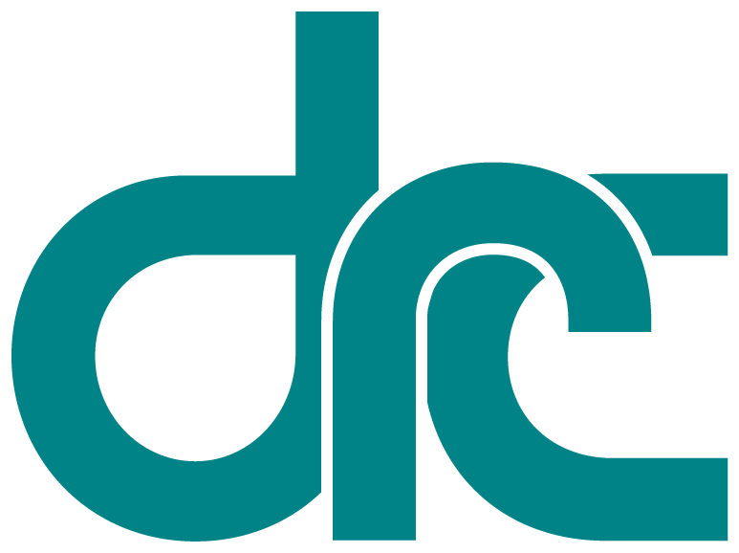
 | Disability  Rights  California | Office of Clients’ Rights Advocacy  567 W. Shaw Avenue, Suite C-3  Fresno, CA 93704  Tel: (559) 271-6604  TTY: (877) 669-6023  Fax: (559) 271-6606  www.disabilityrightsca.org
Serving Consumers of
Central Valley Regional Center
MEMORANDUM

TO: Katie Hornberger, Director

FROM: Kendra McWright, Outreach Coordinator South

Christine Hager, Outreach Coordinator North

RE: Annual OCRA Outreach Report

July 2013 – June 2014

DATE: July 31, 2014
OCRA presents outreach to our communities in the areas of General, Targeted, and Self-Advocacy trainings. Our commitment to educating the communities we serve is an important part of the work performed by OCRA. During the 2013-2014 fiscal year, OCRA has presented 454 outreach presentations impacting approximately 19,939 consumers, families, service providers, and community members. This is a 23% increase in the number of trainings from the previous year and 51% increase in the number of people attending these presentations. OCRA staff should be commended for completing more than half of this year’s outreach training during the second half of the fiscal year, reaching more than 10,000 people in 6 months.

Self-Advocacy Trainings
Each OCRA office has a goal to conduct at least one self-advocacy outreach presentation per year. Self-Advocacy presentations are those directly to adults and transition age youth served by the regional center and generally focus on their individual rights in a variety of areas. Each year many of our offices go above and beyond this minimum requirement, presenting two, three, and sometimes up to eleven presentations directly to consumers. During the 2013-2014 plan year OCRA met its self-advocacy goal by providing well over our minimum required number of self-advocacy presentations. These presentations focused on topics such as: emergency preparedness, clients’ rights, voting rights, money management, community living options and the right to integrated competitive employment. Below is a description of a couple of the presentations provided by OCRA:
The OCRA office serving clients of Lanterman Regional Center organized a self-advocacy training at Ability First in Pasadena. Ability First provides programs and services to children and adults with physical and developmental disabilities. Our training was a game of “Self-Advocacy Bingo” with a group of consumers who had just finished working at their day program. The game consists of laminated photographs of individuals with disabilities performing various activities, such as bowling, cooking, getting married, and more. The bingo cards we handed out had those same photographs in miniature where, in a typical bingo game, the numbers would be. Each time we held up a photograph we would say, “What is this person doing?” And the consumers would answer and then we would discuss the basic right that the photograph represented.
Our goal for this presentation was to ensure that each consumer understands their rights, is able to identify when those rights are being compromised, and to assist in the development of new goals (such as living independently) that they may not have previously considered. The Bingo game allowed us to connect with consumers in a way we don’t usually get to, by having fun and playing a game. The participants really enjoyed the game, and each consumer got a prize when they got a bingo – an insulated lunchbag. The Ability First administrator asked if we could come back, and we look forward to having another Self-Advocacy Bingo this year.
The OCRA office serving consumers of the Regional Center of the East Bay provided a comprehensive self-advocacy training to consumers attending the Creative Growth Center. The training covered: “Introduction to OCRA”, “Your personal Rights”, and “Conservatorships”. Many regional center consumers have questions regarding their personal rights in general and conservatorships in particular. The audience found the training to be very educational. They left comments such as, “I learn how to get help with my rights.” and “The training met my needs by learning what to do and what are my rights”.

Statewide Outreach Presentations (General Outreach)
Through our contact with the Department of Developmental Services (DDS) OCRA is required to conduct outreach presentations each contract year. We have set a goal for ourselves of 160, representing approximately 3 presentation per staff member. This year, OCRA has far surpassed our goal by presenting 454 outreaches. As described above, these 454 presentations are divided into 3 categories one of which is General Outreach. A description of a few of these presentations follows:
Facilitation—A Successful Partnership! On May 10, 2014, Christine Hager of the Office of Clients’ Rights Advocacy in Stockton and Kristina Franzone of the Self-Advocacy Council VI in Stockton collaborated to provide a session at the Supported Life Institute’s Annual Self Advocacy Conference in Sacramento. “Facilitation-A Successful Partnership” focused on speaking up for yourself and your needs and the role of a facilitator. Approximately 21 people attended the session and the speakers continue to receive requests to bring the information to organizations utilizing facilitation.
OCRA Trainings in Coordination with the Regional Center. Many offices of OCRA work with their respective regional centers to train new and seasoned service coordinators in a number of different legal areas including public benefits and Rights in Facilities. It is the goal of these trainings to create a knowledge of public benefits and individual rights so that each service coordinator has the knowledge needed to assist consumers in accessing public benefits and ensuring that those served are able to access their rights in the community. For example, the Tri-Counties Regional Center office of OCRA worked with TCRC’s benefits coordinator to present on Social Security, the differences between Supplemental Security Income and Title II benefits as well as eligibility and helpful hints on gathering evidence to support a claim for benefits.
The North LA Regional Center Office of OCRA worked in coordination with the NLARC to provide new staff trainings in the areas of conservatorships and its alternatives as well as clients’ rights. These trainings foster positive relationships between OCRA and the regional center and help to ensure that regional center consumers are able to access their rights in the community.

Targeted Outreach
OCRA places a high priority on focusing our outreach towards traditionally underserved communities. At the start of each two year outreach cycle, each OCRA office selects their target community by analyzing demographic data from both their regional center and their OCRA office. Once an offices’ target community is selected, that office works to create and maintain contacts with their selected target community by presenting outreach presentations and trainings. This year marked the first year of this two year process. The examples below highlight two of these outreach presentations.
IHSS Training for Spanish Speaking Parent Group. In-Home Supportive Services (“IHSS”) is an essential service to many of our clients. IHSS helps individuals with disabilities remain safely in their homes while trusted providers – often family members – are paid to assist them with everyday tasks, such as grocery shopping, bathing and grooming, and housework.
Many non-native English speakers find it difficult to navigate the IHSS system to learn more about whether their family members are eligible for IHSS or how they can help them obtain increased service hours through the program. With this in mind, OCRA’s Sacramento staff collaborated with staff members from DRC’s Sacramento regional office to bring a training to Apoyo de Padres, a Spanish-speaking parent group, on February 4, 2014.
OCRA staff members Asa Marie Standfeldt and Ramona Landeros and DRC staff member Anne Hadreas presented the IHSS training – along with an overview of OCRA – to the group entirely in Spanish. Parents were engaged in the training, with many asking questions and sharing stories about their experiences accessing (or trying to access) IHSS. Attendees were able to ask their questions and receive answers in Spanish right then and there. More importantly, however, they discovered OCRA as a potential resources to reach out to for help in the future.
OCRA Westside Open House. Katie Meyer and Luisa Delgadillo held an open house to celebrate their new office location. OCRA Director, Katie Hornberger and Supervisor, Katherine Mottarella were also present to host visitors to OCRA. OCRA targeted their advertisement of this open house towards their target community, the African-American community, and those vendors that traditionally serve these communities. Approximately 80 people attended the open house.
Visitors included regional center consumers, regional center staff, supervisors, the executive director, family members of regional center consumers, vendors of the regional center, OCRA staff, attorneys from other legal aid organizations, Disability Rights California board members, and tenants in the building. OCRA served light refreshments and cake to attendees. OCRA also provided visitors with information about OCRA services and our new contact information. Visitors also asked lots of questions and posed for photographs.
The training was such a success that other OCRA offices are going to hold similar open houses for the community. OCRA is working hard to tell the disability community about OCRA services!
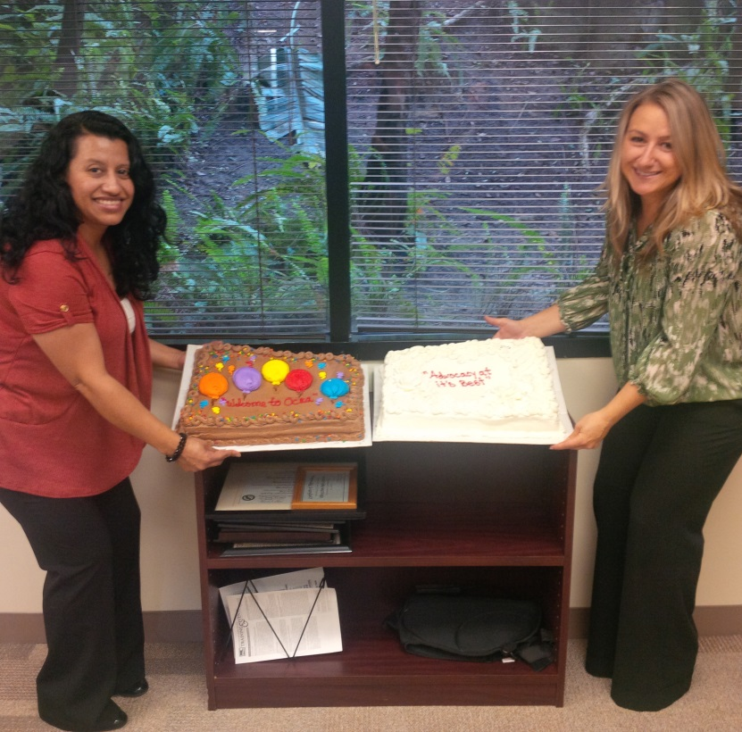

Conclusion
As an organization we are proud to report that we have surpassed our outreach goals. We look forward to the 2014-2015 Outreach plan year.
Thank you for the opportunity to coordinate outreach presentations and trainings for OCRA.

