OCRA ANNUAL REPORT
(July 1, 2016 – June 30, 2017)

TABLE OF CONTENTS
PAGE
I. INTRODUCTION 3
II. PERFORMANCE OBJECTIVES 4
A. Services are provided in a manner that maximizes staff and operational resources. 4
1) Advocacy Reports. 4
2) Analysis of Consumers Served. 6
3) Analysis of Consumers Assisted with Moving to a Less Restrictive Living Arrangement. 8
4) Outreach/Trainings. 10
B. Issues and complaints are resolved expeditiously and at the lowest level of appropriate intervention. 11
C. Collaborative and harmonious working relationships are fostered. 11
1) Memorandums of Understanding. 12
2) Meeting with Association of Regional Center Agencies (ARCA). 12
D. Consumers and families are satisfied with the services provided. 13
1) Consumer Satisfaction Survey. 13
2) Letters of Appreciation. 14
3) Cases will be handled in a timely manner. 17
E. The provision of clients’ rights advocacy services is coordinated in consultation with the DDS contract manager, stakeholder organizations, and persons with developmental disabilities and their families representing California’s multi-cultural diversity. 18
F. Self-advocacy training is provided for consumers and families at least twice in each fiscal year. 18
III. TITLE 17 COMPLAINTS 21
IV. DENIAL OF CLIENTS’ RIGHTS 21
V. CONSUMER GRIEVANCES 21
VI. COLLECTION OF ATTORNEYS FEES 22
VII. RECOMMENDATIONS FOR ENHANCEMENT OF SERVICES 22
VIII. CONCLUSION 23

EXHIBIT LIST
EXHIBIT A OCRA Staff Roster
EXHIBIT B OCRA Statistics
EXHIBIT C Advocacy Report January 2017 – June 30, 2017
EXHIBIT D Outreach and Training Report
EXHIBIT E Report by Service Level
EXHIBIT F Memorandum of Understanding
EXHIBIT G Consumer Satisfaction Surveys
EXHIBIT H OCRA Advisory Committee and Meeting Minutes
EXHIBIT I Self-Advocacy Trainings
EXHIBIT J Title 17 Complaints
EXHIBIT K Denial of Rights
EXHIBIT L Consumer Grievance Report
EXHIBIT M Annual Attorney Fees Report

(Under Separate Cover)
OCRA SELF-ADVOCACY TRAINING EVALUATION BINDER

I. INTRODUCTION

Disability Rights California provides state-wide clients’ rights advocacy services for regional center consumers pursuant to a multi-year contract, with the Department of Developmental Services (DDS) through the Office of Clients’ Rights Advocacy (OCRA). The contract was renewed effective July 1, 2016, for a 5-year period ending June 30, 2021. OCRA is currently in the first year of this five year contract. This annual report covers July 1, 2016, through June 30, 2017.

During the past year, OCRA resolved 10,538 issues for 6,644 consumers, which represents an increase from last year in both clients served (6,589 last year) and issues handled (10,144 last year). OCRA staff continue to achieve positive results for clients who have a variety of legal issues as evidenced in the attached statistics and Advocacy Report. OCRA also participated in 556 trainings during the last fiscal year, presenting to approximately 17,753 people. OCRA presented 68 more trainings and reached more people than last year. See section II.A.4 for details.

OCRA operates offices throughout the state, most of which are staffed by one CRA and one Assistant CRA. This enables our staff to be accessible and to better understand the needs of the local community. During the past fiscal year, OCRA hired two new Supervising CRAs, one in northern and one in southern California. A previous Supervising CRA became a “floating CRA” to provide extra support to offices that are busier or have a CRA on leave. OCRA hired new Clients’ Rights Advocates and Assistant Clients’ Rights Advocates (ACRAs) for consumers of several different regional centers. Two new Community Integration CRAs started in April 2017; one serving southern California and one serving northern California. OCRA now has a team of four community integration CRAs. A list of the current staff and office locations is attached as Exhibit A.

All OCRA offices operate under the same core advocacy principles and standards. However, the staff in the offices remain flexible to meet the needs of the local regional center’s consumers. For example, some offices hold office hours inside different regional center locations in order to be accessible to consumers and regional center staff at those locations. Other OCRA staff members travel to different locations to meet with consumer family member groups in remote locations. OCRA staff listen and learn about the needs of regional center client communities and make efforts to meet those needs.

II. PERFORMANCE OBJECTIVES

Disability Rights California’s contract with DDS requires performance objectives as established in Exhibit A, Page 14, Paragraph M, of the contract. Each of the specific required outcomes is discussed in the following Sections A through F. The contract does not set specific numbers for the performance outcomes.

Services are provided in a manner that maximizes staff and operational resources.

OCRA continues its tradition of serving a large number of people with developmental disabilities. OCRA handled 10,538 issues for regional center consumers during the past fiscal year. OCRA successfully represented and educated people on many different legal issues and helped to remedy systemic problems. The statistics, attached as Exhibit B and discussed below, show the wide variety of issues and the large number of cases handled by OCRA staff. The advocacy report, covering January through June 2017, included as Exhibit C, tells the stories and the positive impact our work had on consumers’ lives.

1) Advocacy Reports.
OCRA’s wonderful service to the community and the impact of that work is best demonstrated in our cases. Advocates regularly submit summaries of cases or outreaches that have practical value and demonstrate a good outcome or teach a lesson. In an effort toward brevity, the stories are just a brief summary to reflect a sampling of the types of cases that OCRA handled. A longer Advocacy Report is available upon request. Cases for the first half of the fiscal year were summarized in the summer and fall 2016 Advocacy Report, which was previously submitted in the Semi-Annual Report. The summaries from January 2017, through June 2017, are compiled and attached as Exhibit C. The report uses fictional first names of clients to improve readability while maintaining confidentiality.

These advocacy stories show the extraordinary value and diversity of OCRA’s work. Many of these cases reflect resolution of systemic problems through direct representation, involvement on committees or the effective relationships OCRA has with regional center and other agencies. The variety of cases we handle and trainings we provide often are responsive to the calls that we receive. For example, during this past reporting period, OCRA staff provided direct representation in a range of different problem areas from healthcare issues to regional center services and community placement. Here are some examples of regional center advocacy.

Mark’s Early Start Services are Restored.

Mark is a toddler who receives early intervention services through the regional center’s Early Start program. When his family moved to a new regional center, these services were automatically reduced by half. OCRA informally negotiated with regional center staff to increase his services to meet his needs. The regional center agreed to authorize the previous amount of services. Mark will now be able to make progress towards his developmental milestones.

OCRA Helps Multiple Clients Obtain ILS in Their Family’s Home.

Ever since the law changed allowing regional centers to fund Independent Living Skills (ILS) for adult consumers living in their family’s homes, OCRA has made it a priority to provide information about ILS to clients. Specifically, OCRA has targeted the Latino community to provide information about ILS through outreach and trainings. Over a period of months, OCRA received calls from clients who had asked for ILS in their family’s home, but service coordinators told them the regional center could not fund the services. OCRA prioritized these cases and helped a number of clients by contacting the regional center on their behalf to advocate for ILS in the family home. One example is Lucia, whose mother contacted OCRA regarding Lucia’s right to obtain ILS in her home. When Lucia contacted the regional center to request ILS, the regional center told her that ILS is only available for people who were over the age of 22, because the school should be providing services instead. OCRA contacted the regional center on Lucia’s behalf and explained that the law allows for clients who live in family homes to obtain ILS. The regional center agreed to fund ILS and Lucia is learning skills to become more independent.

Judge Orders Regional Center to Restore Rent Subsidy.

Chen and Biyu are mother and daughter who have lived together their entire lives. They and their extended family are monolingual Mandarin speakers. The regional center had subsidized their apartment rent for several years, but then suddenly ended it. The regional center did not provide adequate notice informing Chen and Biyu that their subsidy was ending. Chen and Biyu’s extended family struggled for months to financially support them. OCRA represented Chen and Biyu at a fair hearing against the regional center. The administrative law judge agreed that the regional center failed to provide adequate notice and ordered the regional center to reimburse the family for the money spent to pay the rent of Chen and Biyu.

Sandra Gets Supported Living Assessment.

Under California law, regional center consumers cannot remain in a locked IMD for longer than 180 days. However, Sandra has been at a locked IMD in southern California for two years now after her placement in the community failed. She requested placement in a specialized care facility and the regional center ran a statewide search for an appropriate home. Unfortunately, none of the group homes with open beds could effectively meet her needs. OCRA stepped in to advocate for Sandra at her IPP meetings and requested supported living services as an alternative to placement in a group home. At Sandra’s last IPP meeting, the regional center agreed to fund a supported living assessment and has since identified and contracted with an agency to do the assessment.

Daniel Continues to Receive Needed Services in the Home.

Daniel received attendant care in his family’s home while his parents worked for many years. This was the only service he received from the regional center. Daniel developed aggressive behaviors and needed intensive behavioral services. Unfortunately, instead Daniel received a notice of action to terminate the attendant care services. OCRA helped Daniel’s father file an appeal and then attended the informal meeting with the regional center on behalf of Daniel. At the informal meeting, OCRA explained all of Daniel’s needs and the care that he will need to remain living with his father in the family home. The regional center agreed that Daniel will continue to receive attendant care until he transitions to around-the-clock intensive behavioral services in the home.

2) Analysis of Consumers Served.
OCRA handled 10,538 cases from July 1, 2016, through June 30, 2017. Exhibit B contains the complete compilation of data for the fiscal year.
The data has been compiled by:

1. Age
2. County
3. Disability
4. Ethnicity
5. Race
6. Gender
7. Living Arrangement
8. Type of Problem (Problem Codes)
9. Service Level

Please note that the reports included here are in non-table format so that they are accessible to individuals who use screen-readers. Although the data is still contained in grids, each row of the table is self-explanatory as read from left to right and does not require the navigational reference of a table header row for context.

Consistent with previous years, the largest number of consumers OCRA served by age during this time period, 2,695 out of 6,644, were individuals in the 4-to-17 years-old age group. The next largest was the 23-40 age group with 1608 people served. OCRA served 830 people in the 51-years and over age group, which is a significant increase from last year. This increase is likely due to regional centers more consistently sending, and OCRA reviewing, comprehensive assessments from people moving out of developmental centers. The largest number of individuals age 51 years and over were from OCRA offices serving consumers moving from Sonoma Developmental Center, which has an older population.

For those cases where gender is recorded, OCRA has traditionally served more males than females, with 64.2 percent of the consumers served being male and just over 35.8 percent being female in this reporting period. These numbers are almost exactly the same as the percentage served by regional centers, according to the DDS Fact Book, 15th Edition. In January 2016, regional centers served 64.3 percent male compared to 35.7 percent female. The Fact Book attributes the growing gender imbalance, in large part, to the growing Autism population, which is currently over 80 percent male.

OCRA’s statistics on the ethnicity of consumers served for the year show OCRA’s continuing commitment and success in serving underserved communities. For example, approximately 39.5 percent of consumers served by OCRA identified as Hispanic/Latino. This is a higher percentage than last year, and higher than the 37.4 percent of regional center consumers identified as Hispanic/Latino in January 2016, taken from the DDS Fact Book, 14th Edition.

African-American and Asian consumer data is under the report for “race” and has been separated from “ethnicity” in our reporting system and for this annual report. African-American consumers represent 9.1 percent of regional center consumers, but a slightly lower 8.6 percent of consumers served by OCRA. Asian consumers make up 6.5 percent of regional center consumers, but a slightly lower 6 percent of consumers served by OCRA. To further the goal to successfully serve the African-American, Asian, and all underserved communities, OCRA staff continue to do targeted outreach, see section 4 below, and carefully review the Purchase of Service (POS) Data collected by regional centers under Welfare & Institutions Code Section 4519.5. OCRA staff attended most local stakeholder meetings, joined local committees, and held internal discussions to further study and impact possible changes to reduce disparities again this year.

The percentage of consumers residing in the parental or other family home remains by far the largest number of service requests for consumers served by OCRA, with 7,655 service requests showing consumers living in the family home or 72.6 percent of the cases handled. The next largest group served is those living independently, with 1,155 service requests or 10.9 percent with this living arrangement. This is a decrease from last year, in which over 11.5 percent of consumers served by OCRA lived independently.

This year, OCRA served almost double the number of consumers whose living arrangement was developmental center (446) compared to last year (244) and four times more than two years ago (112). This is likely because OCRA continues to receive and review more comprehensive assessments and attend more IPP meetings for consumers residing in developmental centers.

3) Analysis of Consumers Assisted with Moving to a Less Restrictive Living Arrangement.

Laws require regional centers to notify OCRA about people living in restrictive settings such as Developmental Centers, IMDs, and MHRCs, and people whose community placements are at risk of failing. Given these notification requirements, the planned closure of the Developmental Centers, and OCRA involvement in reviewing comprehensive assessments and attendance at IPP meetings, it is important to review OCRA’s work in this area.

Assistance or representation in cases involving restrictive settings can include reviewing records, interviewing and developing a relationship with the consumer, attending meetings, negotiating through phone calls, drafting and filing documents for court, attending court dates, special education advocacy, and continuous advocacy for movement back to the community or additional services to be able to stay in the community.

During this review period, OCRA staff reviewed 437 comprehensive assessments for consumers in developmental centers or IMDs. This is a significant increase from the 228 that OCRA staff reviewed last year. OCRA staff attended a variety of meetings – Individual Program Plan meetings, Semi-Annual Review meetings, Transition Planning Meetings, Transition Review Meetings, 5-day or 30-day meetings held after a consumer is placed in the community, deflection meetings, meet-and-greets between consumers and providers, Individual Education Program meetings, or other “special” meetings. During this review period, OCRA staff attended 236 meetings on behalf of consumers in restrictive settings or at risk of losing their community placements. This is an increase over the 112 meetings OCRA staff attended last year, as well as a better variety of meetings, as we see more consumers move into the community.

OCRA is notified about and has the opportunity to be involved in, all cases referred for a 4418.7 assessment and admitted to the acute crisis units at Fairview and Sonoma Developmental Centers. OCRA staff represent almost all consumers in the acute crisis unit from the time they are admitted (or before) to their meeting 30 days after they have moved into the community. OCRA staff have also been involved in five cases statewide for whom a 4418.7 referral was made to the regional project for possible placement in a restrictive setting, but the client was able to remain in the community. OCRA staff have also attended six court hearings for clients in restrictive settings during this review period.

Finally, OCRA staff have been involved in five different time-intensive cases where a consumer had been living in the community, went into a hospital, and has been “stuck” in that hospital setting even though they don’t meet criteria to remain there because there is no placement in the community that can meet their needs. OCRA staff attend meetings, make phone calls, try to bring resources together, ask for assessments and discharge plans, help with accessing denied resources, and use other strategies to help the consumers return to community living.

As noted above, OCRA now has a team of four community integration CRAs to assist local CRAs with these often difficult cases. These community integration CRAs have formed relationships and have been involved with many different community groups and meetings to discuss concerns of the many consumers, family members, regional center staff, and developmental center staff involved in the closures. These CRAs also offer and provide training to public defenders, public guardians, developmental center staff, and regional center staff about community integration laws and regulations.

4) Outreach/Trainings.
Outreach and Training serve two important purposes: 1) notifying people about the availability of OCRA assistance and 2) educating people about the law and their rights. OCRA provides training on many different issues to a wide variety of people. Training audiences include direct consumers, family members, regional center staff and vendors, and community members. Training topics include but are not limited to, consumers’ rights, abuse and neglect issues, IHSS, Medi-Cal, regional center issues, special education, voting rights, SSI, rights in the community, and alternatives to conservatorships. OCRA staff are creating new self-advocacy training materials.

During the last fiscal year, OCRA presented 556 outreach trainings, reaching approximately 17,753 consumers, families, service providers, and community members. This number represents a 13.94% increase in trainings from the previous outreach year and a 10.69% increase in the number of people attending these trainings. OCRA continues to create and present new trainings for the disability community in English, Spanish, and other languages. OCRA often uses publications from the DRC website as part of the training. DRC translates all self –advocacy publications posted on our website into the California threshold languages.

In order to provide assistance to individuals from traditionally underserved communities, OCRA has developed target outreach plans. Each OCRA office targets at least three outreaches per year to a specific group of persons who are underrepresented in the office’s catchment area. OCRA’s Jazmin Romero and Christine Hager served as the Outreach Coordinators this fiscal year. They advise staff in implementation of their target outreach plans. These are two-year plans based upon an evaluation of prior outreach plans’ results, new census data, and information from DDS regarding the ethnicity of consumers served by each regional center. This fiscal year was the second year of a two-year cycle. In June 2017, OCRA staff completed outreach plans for the next two years. Because of changing data, twelve OCRA offices changed their target communities from the previous plan, including six offices that will target two communities. OCRA’s Jackie Dai served as Outreach Coordinator for the Asian community in an effort to improve our service to this community. Several offices have identified the Asian community as their target for outreach. A detailed report on outreach and training is included as Exhibit D.

Issues and complaints are resolved expeditiously and at the lowest level of appropriate intervention.

From July 1, 2016, through June 30, 2017, OCRA resolved 10,538 issues for consumers. Of those, all but 33 were resolved informally. These numbers are consistent with previous years, in that 99 percent of all the matters that OCRA handled were resolved without using hearings or court. Data showing this is attached as Exhibit E.

Collaborative and harmonious working relationships are fostered.

OCRA staff continue to collaborate with the local regional centers, stakeholders, and community members. Some examples of collaboration include serving on regional center Diversity Committees, Behavioral Modification Review Committees, Risk Assessment Committees, County Coordinating Councils, Supported Life Training Planning Committees, county customer service and appeals and hearings meetings, State Hearings Division Stakeholder meeting, Fiesta Educativa, RCOC/OC Behavioral Health, Criminal Task Force, Healthcare Task Force, Adult Transition Task Force, and many others.

All CRAs are participating in meetings with their regional centers’ Self-Determination Program Local Advisory Committees. Several OCRA offices offered to conduct trainings to attendees of the POS Disparity Meetings that regional centers held during this fiscal year. The regional centers and OCRA created flyers announcing this collaboration in an effort to attract more people who might not attend a meeting to go over statistics, but would if it were linked to a substantive training of interest.

Many OCRA staff provide training to regional center staff and vendors and meet regularly with regional center staff and community partners to share ideas and expertise on many subjects. Many OCRA offices meet regularly with regional center managers to resolve systemic and individual client issues informally rather than through a hearing or complaint, when possible. This philosophy of collaboration is not only required by Disability Rights California’s contract with DDS, but is also recognition that some of the most effective advocacy takes place because of interpersonal relationships and informal advocacy. The success of this philosophy is demonstrated by the number of calls OCRA receives from varied sources, by its ability to resolve matters informally, and by its recognition as an excellent resource for people with developmental disabilities and their families.

1) Memorandums of Understanding.
OCRA has established Memorandums of Understanding (MOUs) with each regional center that addresses that center’s individual needs, concerns, and method of operation. Generally, MOUs are updated as needed, including when the law changes. Meetings to review MOUs have been productive and positive. OCRA has very good working relationships with almost all regional centers. During this fiscal year, MOUs were updated at Alta California Regional Center, North Los Angeles County Regional Center, and Far Northern Regional Center. Copies of all MOUs have been forwarded to DDS. The status of each revised MOU is listed in Exhibit F.

2) Meeting with Association of Regional Center Agencies (ARCA).

ARCA and OCRA meet regularly to discuss various issues. Katie Hornberger, OCRA Director, met with ARCA four times during this fiscal year: August 11, 2016, November 17, 2016, January 25, 2017, and May 2, 2017 and was joined at some meetings by Catherine Blakemore. ARCA and OCRA also serve on committees together and regularly phone and email each other to discuss issues that arise.

Consumers and families are satisfied with the services provided.
Disability Rights California recognizes the importance of consumer satisfaction. OCRA is committed to serving consumers and family members in a manner and with results that ensure consumer and family satisfaction with the services provided. Survey results show positive consumer satisfaction over the past fiscal year. A member of the OCRA management team calls back all responders who request a call back, whether their responses were positive or negative. An OCRA management team member also calls all responders who gave a negative response and their contact information. In this way, we are able to remedy any concerns and provide additional support to consumers.

1) Consumer Satisfaction Survey.
OCRA measures consumer satisfaction by use of a survey developed jointly by staff, the OCRA Consumer Advisory Committee, and DDS. One thousand seven hundred and fifteen (1,715) surveys were mailed out. Two hundred and eleven (211) people returned surveys. This represents a 12 percent return rate. This is significantly lower than the last reporting period, the first half of the fiscal year, which was 22 percent. We are reviewing the timeline of when the surveys were sent and service levels of the service requests. We will continue to monitor and make adjustments as need be.

Of those responding to the questions, 95 percent of the respondents who answered the questions felt they were treated well by the staff. One respondent wrote, “treated by the staff very good satisfied with services. I was helped problem and understand they helpful disability people.” 89 percent of the respondents believed their call was returned within two days. This is lower than last year’s 97 percent. Two factors may have contributed to the decline. First, several OCRA offices had changes in staffing that may have affected call-back times. Second, OCRA transitioned to a computer Skype calling for incoming and outgoing calls and this may have temporarily contributed to the delay in call back time due to technological glitches with incoming calls and accessing voicemail boxes. Throughout the transition, OCRA management stressed the importance of timely callbacks to staff. “Hannah Liddell was very attending. She called me back and emailed me promptly. Probably the best help I have had in a long time. I was in a horrible situation and Hannah explained to me that I don’t have to deal w/that.” 94 percent of the respondents reported that they understood the information they received, which is lower than last year’s 97 percent. One respondent said, “I had a difficult situation and they helped me understand how to best move forward. They also explained some very technical issues in a way I understood.”

95 percent of respondents felt their Clients’ Rights Advocate listened to them, which is the same as last year. One person wrote, “Just want to express my great gratitude with OCRA. Thanks to this organization I live independently. Mary Melendrez (former staff) listened to my problem and found the solution to my situation. Please, keep hiring people who can work with disabled persons, not everyone can see beyond a disability. I was seeking for help for years but no one listen before Mary Melendrez.” 88 percent of respondents felt they were helped with their question or problem, which is a drop from last year’s 97 percent. OCRA has been translating publications into all the California threshold languages, which may help ensure that people have good advocacy information in their language. OCRA hopes that providing advocacy information in many languages will ensure that more people feel helped. Many callers ask OCRA for direct representation, but may be able to self-advocate with the rights tools to resolve their issue. They may feel they didn’t receive the level of assistance they wanted but instead were given those tools to resolve their issue. OCRA’s use of publications and additional staff may help more callers in the future feel that they were helped. 94 percent said they would ask their Clients’ Rights Advocate for help again, which is the same as last year. One respondent said, “I felt heard and relieved that there was an advocate on my son’s & my side to help us through our difficult time. Thank you!” Another said, “Brittnee did a wonderful job. If I ever need help in the future I would definitely ask for Brittnee. She took her time to explain everything & asked if I had questions.” See Exhibit G, which discusses the results of OCRA’s survey.

From the overall survey results, it is clear that most consumers are satisfied with the services provided by OCRA. However, we will continue to strive to improve.

2) Letters of Appreciation.
OCRA consumers and family members often take the time to write letters of appreciation. These kind words come in the form of cards, letters, notes, and emails. The time it took to send them represents the high value of the work performed by OCRA staff. Below is just a sampling of the many letters received. OCRA is providing the letters of appreciation with the wording from the originals, including any grammatical errors, unless otherwise indicated. We have also edited client names.

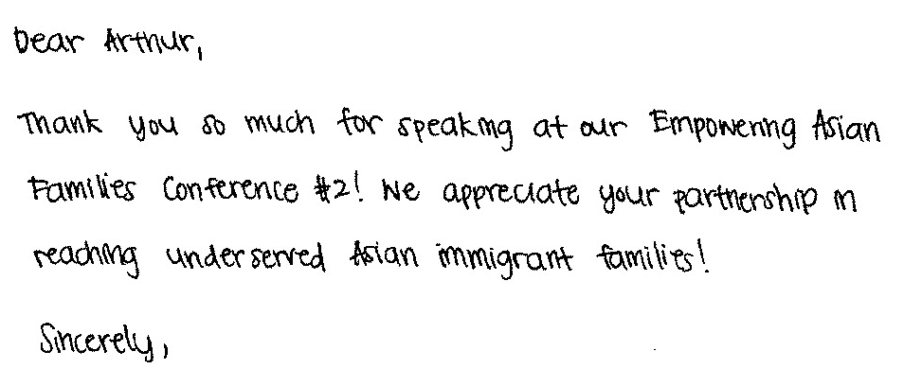

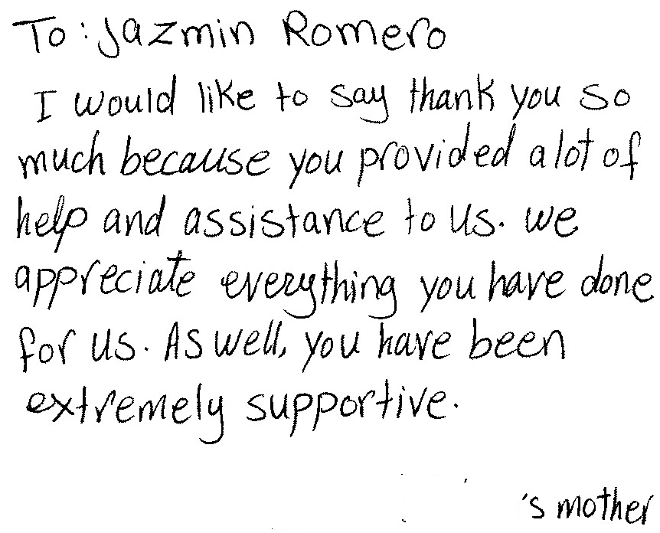
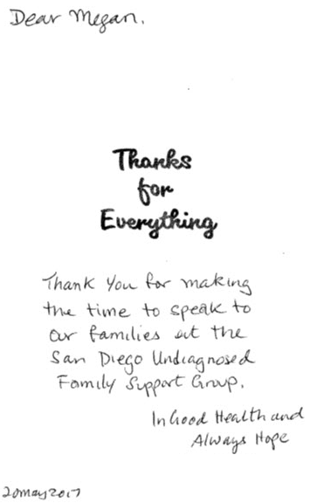

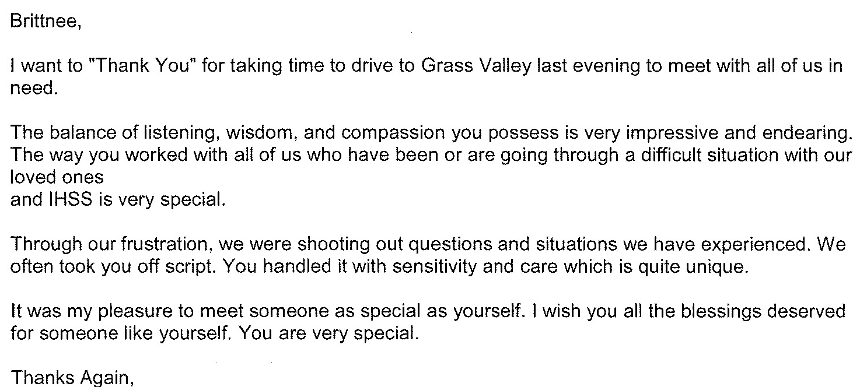
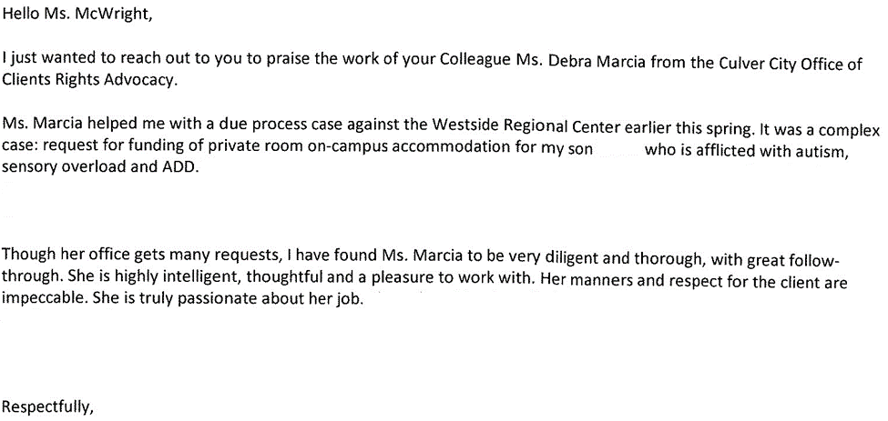

3) Cases will be handled in a timely manner.
Consumers and families contact OCRA because something has gone wrong for them. It may be that they are losing a government benefit or their housing, or are facing another urgent situation. It is important that OCRA staff be responsive. For this reason, OCRA has, since its establishment, had a policy that all calls will be returned as soon as possible, but not later than the close of the next business day. OCRA staff note this policy on the outgoing voicemail message that callers hear when reaching the office voicemail. OCRA staff also note in the intake when a client has a deadline they must meet or a timeline they must follow for their legal issue, such as a timeline to file an appeal. By documenting this in the intake, advocates advise clients they must appeal timely or comply with another timeline, and can prioritize cases that have a closer deadline.

OCRA also measures its performance in this area by use of its consumer satisfaction survey; see Exhibit G, discussed more fully above. OCRA statistics show that 89 percent of all callers to OCRA received a call back within two days during the last fiscal year. This percentage is lower than last year, but still good, considering OCRA continues to increase the number of cases it handles each year. OCRA continues to use Bilingual ACRAs for northern and southern California to assist with overflow intake and when staff are out of the office. OCRA also uses temporary CRAs and ACRAs in offices with higher volume to ensure timely service. OCRA also began using an additional CRA to help high volume offices or offices that have a vacancy and need to be staffed during the hiring process. We are optimistic that this statistic will continue to improve as we add another additional CRA in 2017-2018 and fill all of our vacancies with regular employees.

The provision of clients’ rights advocacy services is coordinated in consultation with the DDS contract manager, stakeholder organizations, and persons with developmental disabilities and their families representing California’s multi-cultural diversity.
OCRA works through the OCRA Advisory Committee to ensure that this performance outcome is achieved. Attached as Exhibit H is a list of the members of the Disability Rights California Board of Director’s OCRA Advisory Committee effective June 30, 2017.

Public members of the Advisory Committee are appointed by the Board of Directors. In the selection process, the Board considers geographical diversity, both rural and urban and north and south, type of developmental disability represented, and ethnic background, in addition to the qualifications of the individual applicants.

The OCRA Advisory Committee provides valuable insight to the OCRA staff. A wide variety of topics are addressed at the meetings and board members become better self-advocates as a result of having been on the committee. Minutes for the meeting held on December 16, 2016, were provided with the Semi-Annual Report. The minutes for the May 5, 2017 meeting are included as Exhibit H. DDS staff is invited and encouraged to participate in the next meeting, which is set for Thursday, September 14, 2017, in Redondo Beach, CA.

Self-advocacy training is provided for consumers and families at least twice in each fiscal year.
Welfare and Institutions Code, Section 4433(d)(5), requires that the contractor providing advocacy services for consumers of regional center services provide at least two self-advocacy trainings for consumers. Disability Rights California’s contract with DDS mirrors this language. OCRA strongly believes in the importance of self-advocacy and requires each of its 21 offices to provide at least one self-advocacy training for consumers per year, far exceeding the two mandated trainings. Many offices provide more than one training per year. This fiscal year, OCRA staff provided 68 self-advocacy presentations statewide, which is significantly more than the 42 provided last fiscal year.

Staff may present from any of the approved self-advocacy trainings. To date, OCRA has developed six separate packets of information for OCRA staff to use in the mandated trainings in addition to the DDS Consumer Safety materials and the living arrangement options materials developed by DDS. OCRA is developing new self-advocacy training materials to submit to DDS for approval. Samples of the OCRA self-advocacy packets (all are in both English and Spanish), were provided separately in a binder marked OCRA Training Materials with the 2007-2008 Annual Report. In past discussions with DDS’s Contract Manager, it was decided that OCRA should not submit duplicate training packets in this year’s annual report. As always, OCRA welcomes comments from DDS on any training packets.

OCRA is required to report in its Annual Report an evaluation of the self-advocacy trainings. OCRA has randomly selected consumer training satisfaction evaluations for inclusion in this Annual Report. Almost without exception, consumers are pleased with OCRA trainings. A list of Self-Advocacy Trainings held last year are in Exhibit I.

Here is a sampling of consumers’ comments on the self-advocacy training satisfaction evaluations. OCRA is providing the comments with the wording from the originals, including any grammatical errors, unless otherwise indicated.

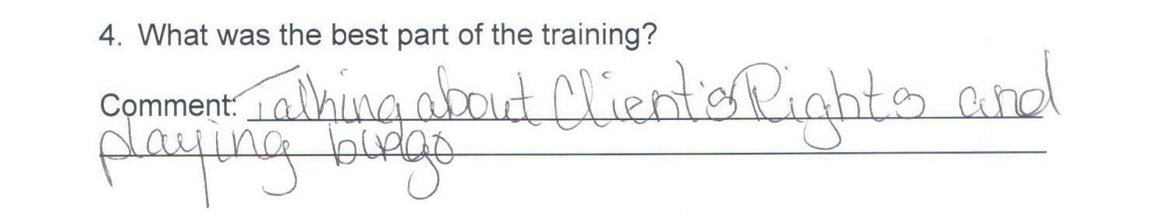

III. TITLE 17 COMPLAINTS
CCR, Title 17, Section 50540, sets forth a complaint procedure whereby a regional center consumer, or his or her authorized representative, who believes a right has been abused, punitively withheld or improperly or unreasonably denied, may file a complaint with the Clients’ Rights Advocate. The Complaint process is similar to that established by Welfare & Institution Code, Section 4731. However, the later law offers more consumer protections. There were no Title 17 Complaints filed during the last fiscal year, as noted on Exhibit J.

IV. DENIAL OF CLIENTS’ RIGHTS
CCR, Title 17, Section 50530, sets forth a procedure whereby a care provider may deny one of the basic rights of a consumer if there is a danger to self or others or a danger of property destruction caused by the actions of a consumer. The Clients’ Rights Advocate must approve the denial and submit a quarterly report to DDS by the last day of each January, April, July, and October. OCRA is including the reports concurrently with the contractual date to provide OCRA’s reports. If this is not acceptable to DDS, OCRA will submit duplicate reports as requested. Attached as Exhibit K is the current log of Denials of Rights from the OCRA offices.

V. CONSUMER GRIEVANCES
Exhibit A, Paragraph 12, of the contract between DDS and Disability Rights California requires OCRA to establish a grievance procedure and to inform all clients about the procedure. DDS has approved the grievance procedure developed by OCRA. The procedure is posted prominently in both English and Spanish at each office. The grievance procedure has also been translated into Arabic, Armenian, Chinese (Simplified), Farsi, Hmong, Japanese, Khmer, Korean, Laotian, Russian, Tagolog, Thai, and Vietnamese. OCRA staff offer the grievance procedure in all letters to consumers or others who contact OCRA, when an office declines to provide the requested service to that person.

During the past fiscal year, OCRA handled 10,538 matters. There were seven first level grievances filed by consumers or their family members. Two proceeded to the second level and one of those went to the third level. Information concerning each grievance has previously been submitted to DDS. Attached as Exhibit L is a chart detailing the grievances filed against OCRA during this period.

VI. COLLECTION OF ATTORNEYS FEES
OCRA does not charge consumers, their families or advocates fees for services nor does OCRA seek to recover costs from these individuals. Clients’ Rights Advocates who are licensed to practice law in California, or Assistant, Associate, or unlicensed Clients’ Rights Advocates, all of whom work under the supervision of an attorney, can collect attorney’s fees and costs similar to those collected by private attorneys or advocates for special education cases or other cases where there are statutory attorney’s fees. OCRA collects fees only in special education cases or Writs of Mandamus. Fees and costs may be negotiated at mediation or can be received in those cases where an Administrative Law Judge has made a determination that the petitioner is the prevailing party. Fees are collected from the opposing party, which is normally a school district. Costs include any expenses to the Petitioner or OCRA for suing, such as filing fees or costs of expert evaluations. Neither Disability Rights California nor OCRA ever collect attorney’s fees from consumers.

OCRA collected $8250.00 in attorney’s fees from a special education matter this fiscal year, see Exhibit M.

VII. RECOMMENDATIONS FOR ENHANCEMENT OF SERVICES
The contract between DDS and Disability Rights California requires that on an annual basis Disability Rights California make recommendations to DDS as to potential methods of enhancing the services that OCRA provides for regional center consumers.

The support of DDS through the years has made it possible for OCRA to effectively and efficiently serve consumers. However, the demand for OCRA services continues to increase along with the increased number of cases involving people living in restrictive settings. OCRA must continue to look at providing additional staffing to better serve all clients, given the continuing increase in cases that we handle each year. For those individuals at IMDs and developmental centers, OCRA now has a team of four CRAs to assist this special population. With the closure of the developmental centers, this need will continue to grow and OCRA anticipates hiring more staff to assist this population.

The important Peer Advocate position and the future addition of a new Peer Advocate for the North continue to be needed as the peer perspective is a unique one and many consumers need mentorship and a positive example. OCRA also recognizes the need to serve diverse communities with varying language needs, which means continuing to recruit and hire staff who speak diverse languages.

In an increase in numbers of clients served OCRA staff also participate on more committees, such as the Self Determination Local Advisory Committees. To ensure that we can continue to provide high quality services we plan to hire at least one more additional CRA to help busier offices and ensure the disability community is well-served by OCRA. As such, OCRA would appreciate additional resources to increase staffing to meet these unique needs while continuing to provide the high level of service to those consumers already living in the community.

VIII. CONCLUSION
OCRA has continued to provide exceptional service to people with developmental disabilities throughout the state. OCRA handled 10,538 cases for 6,644 clients last year, an increase over the previous year in the number of clients served and a slight decrease in issues handled for those clients. Additionally, OCRA provided 556 trainings to approximately 17,753 consumers, family members, regional center staff and vendors, and interested community members - all while meeting each of its performance objectives. OCRA looks forward to continuing to work with people with developmental disabilities and helping access the services and supports they need to live the most independent and productive lives in the least restrictive environment.

