OCRA ANNUAL REPORT
(July 1, 2015 – June 30, 2016)

TABLE OF CONTENTS
PAGE
I. INTRODUCTION 3
II. PERFORMANCE OBJECTIVES 4
A. Services are provided in a manner that maximizes staff and operational resources. 4
1) Advocacy Reports. 4
2) Analysis of Consumers Served. 7
3) Analysis of Consumers Assisted with Moving to a Less Restrictive Living Arrangement. 9
4) Outreach/Trainings. 10
B. Issues and complaints are resolved expeditiously and at the lowest level of appropriate intervention. 11
C. Collaborative and harmonious working relationships are fostered. 11
1) Memorandums of Understanding. 12
2) Meeting with Association of Regional Center Agencies (ARCA). 12
D. Consumers and families are satisfied with the services provided. 13
1) Consumer Satisfaction Survey. 13
2) Letters of Appreciation. 14
3) Cases will be handled in a timely manner. 18
E. The provision of clients’ rights advocacy services is coordinated in consultation with the DDS contract manager, stakeholder organizations, and persons with developmental disabilities and m their families representing California’s multi-cultural diversity. 18
F. Self-advocacy training is provided for consumers and families at least twice in each fiscal year. 19
III. TITLE 17 COMPLAINTS 21
IV. DENIAL OF CLIENTS’ RIGHTS 21
V. CONSUMER GRIEVANCES 21
VI. COLLECTION OF ATTORNEYS FEES 22
VII. RECOMMENDATIONS FOR ENHANCEMENT OF SERVICES 22
VIII. CONCLUSION 23

EXHIBIT LIST
EXHIBIT A OCRA Staff Roster
EXHIBIT B OCRA Statistics
EXHIBIT C Advocacy report July 2015 – June 30, 2016
EXHIBIT D Outreach and Training Report
EXHIBIT E Report by Service Level
EXHIBIT F Memorandum of Understanding
EXHIBIT G Consumer Satisfaction Surveys
EXHIBIT H OCRA Advisory Committee and Meeting Minutes
EXHIBIT I Self-Advocacy Trainings
EXHIBIT J Title 17 Complaints
EXHIBIT K Denial of Rights
EXHIBIT L Consumer Grievance Report
EXHIBIT M Annual Attorney Fees Report

(Under Separate Cover)
OCRA SELF-ADVOCACY TRAINING EVALUATION BINDER

I. INTRODUCTION

Disability Rights California provides state-wide clients’ rights advocacy services for regional center consumers pursuant to a multi-year contract, HD119002, with the Department of Developmental Services (DDS) through the Office of Clients’ Rights Advocacy (OCRA). This Annual Report is submitted pursuant to Exhibit A, Paragraph 13.O, for Fiscal Year 2015-2016, July 1, 2015 – June 30, 2016, the final year of this five year contract.

During the past year, OCRA resolved 10,144 issues for 6,589 consumers, which represents an increase (.2%) in clients served, and an increase in the number of cases of people in institutions which are more time intensive. This follows a 9% increase last year. OCRA staff continue to achieve positive results for clients who have a variety of legal issues as evidenced in the attached statistics and Advocacy Report. OCRA also participated in 488 trainings during the last fiscal year, presenting to approximately 16,039 people. These numbers represent both more trainings and approximately 1,300 more people reached than last year. See section II.A.4 for details.

OCRA currently operates offices throughout the state, most of which are staffed by one CRA and one Assistant CRA. This enables our staff to be accessible to better understand the needs of the local community. During this fiscal year, OCRA changed its service delivery to Redwood Coast Regional Center (RCRC) consumers by closing OCRA’s office in Ukiah and hiring a full-time CRA in Eureka to serve consumers in all four RCRC counties in addition to the part-time CRA in the Eureka office. RCRC management agrees this model will better serve RCRC consumers in all catchment areas.

During the past fiscal year, OCRA hired new Assistant Clients’ Rights Advocate (ACRA) serving consumers of Kern Regional Center, South Central Los Angeles Regional Center, Alta California Regional Center, and a new ACRA for Golden Gate Regional Center will be starting on July 1, 2016. OCRA also hired a new CRA for Golden Gate Regional Center consumers, who was the previous Community Integration CRA serving northern California. A new Community Integration CRA serving northern California started in May 2016. OCRA also hired a Peer Trainer for northern California, who will do similar work to our Peer Advocate in southern California. Both the trainer and advocate are regional center consumers. A new CRA started in December 2015 to provide extra support to offices that are busier or have a CRA on leave. A list of the current staff and office locations is attached as Exhibit A.

All OCRA offices operate under the same core advocacy principles and standards. However, the staff in the offices remain flexible to meet the needs of the local regional center’s consumers. For example, some offices hold office hours inside different regional center locations in order to be accessible to consumers and regional center staff at those locations. Other OCRA office staff members travel to different locations to meet with support groups that are in remote locations. OCRA staff listen and learn about the needs of the regional center client communities and make efforts to meet those needs.

II. PERFORMANCE OBJECTIVES

Disability Rights California’s contract with DDS requires performance objectives as established in Exhibit A, Page 14, Paragraph M, of the contract. Each of the specific required outcomes is discussed in the following Sections A through F. The contract does not set specific numbers for the performance outcomes.

Services are provided in a manner that maximizes staff and operational resources.

OCRA continues its tradition of serving a large number of people with developmental disabilities. OCRA handled 10,144 issues for regional center consumers during the past fiscal year. OCRA successfully represented and educated people on many different legal issues and helped to remedy systemic problems. The statistics, attached as Exhibit B and discussed below, show the wide variety of issues and the large number of cases handled by OCRA staff. The advocacy report, covering January through June, 2016, included as Exhibit C, tells the stories and the positive impact our work had on consumers’ lives.

1) Advocacy Reports.

OCRA’s wonderful service to the community and the impact of that work is best demonstrated in the cases. Advocates regularly submit summaries of cases or outreaches that have practical value and demonstrate a good outcome or teach a lesson. In an effort toward brevity, the stories are just a brief summary to reflect a sampling of the types of cases that OCRA handled. A longer Advocacy Report is available upon request. Cases for the first half of the fiscal year were summarized in the summer and fall 2015 Advocacy Report, which was previously submitted in the Semi-Annual Report. The summaries from January, 2016, through June, 2016, are compiled and attached as Exhibit C. The report now uses fictional first names of clients to improve readability while maintaining confidentiality.

These advocacy stories show the extraordinary value and diversity of OCRA’s work. Many of these cases reflect resolution of systemic problems through direct representation, involvement on committees or the effective relationships OCRA has with regional center and other agencies. The variety of cases we handle and trainings we provide often are responsive to the calls that we receive. For example, during this past reporting period, OCRA staff provided direct representation in a range of different problem areas from non-discrimination to regional center services and community placement. Our outreach and training reached consumers and families as well as a variety of community partners.

Clients Transitioning out of Early Start Receive Proper Notices of Action.
Chin-Hae received Early Start services from the regional center before age three. When he turned three, his parents received a letter from the regional center telling them that he had aged out of Early Start and was not eligible for services under the Lanterman Act. They did not receive information about their right to appeal, such as the deadline to appeal, where to find advocacy assistance, or the appeal form. OCRA discovered that many other Early Start consumers also did not receive appeal information when they were found not to be eligible for services under the Lanterman Act. OCRA worked with the regional center staff who serve Early Start clients to ensure that they were aware of the requirements for a proper notice of action under the Lanterman Act. The regional center agreed to send complete notices of action to all children in the Early Start program when they turn three and are found not to be eligible for services under the Lanterman Act. Chin-Hae’s family received a proper notice that informed them of their appeal rights and the reason for the denial. Other children will receive such notices in the future, ensuring that their families are aware of their right to appeal. OCRA will continue to review cases where clients are denied regional center eligibility.
A Young Boy is Spared Expulsion.
Dale is described as “a very sweet boy subject to occasional ‘meltdowns.’” His mother called OCRA with concerns about inappropriate restraint in school and a delay in putting behavioral services in place. The immediate focus switched, however, when the school suspended Dale and said he would be expelled because he “brandished” a pocket knife at school. School personnel claimed they had no choice under the law but to expel him. OCRA researched the exact language of the relevant California Education Code sections. Citing those provisions, OCRA explained to the school that expulsion was not required because the knife did not meet the applicable size definition and Dale did not “brandish” it, he only gave it to someone after they asked for it. After reconsidering, the school concluded that the knife did not fall within the Education Code definition, so a brief suspension was an adequate disciplinary response. Dale was welcomed back to school with new behavioral services in place.
Hector Gets a New Speech Device.
Hector has Medi-Cal through a managed care plan (MCP). Hector’s doctor requested a speech-generating device for him, which the MCP denied. OCRA researched Hector’s right to have Medi-Cal fund the speech device and advised his mother to file an appeal. OCRA negotiated with the MCP to determine which speech device would be appropriate to meet Hector’s needs. After many conversations with Hector’s educational speech and language pathologist and the MCP hearing representative, the MCP agreed to fund an iPad with the appropriate software to meet Hector’s needs. Hector has already received his new device and is learning to use it to communicate.
Harvey Will Not Be Evicted From His Home.
Harvey is an older man with a significant cognitive disability. He has lived his entire life in his home with his mother and two siblings. Harvey’s mother has Alzheimer’s disease, and was being cared for at home by Harvey’s siblings until her condition worsened and the County Public Guardian stepped in. The Public Guardian became conservator of Harvey’s mother and her estate, removed her from her home, placed her in a care facility, and intended to sell the home. The Public Guardian sent Harvey an eviction notice and his regional center case manager asked OCRA to assist him. The situation seemed at first to be a complicated estate planning issue until an attorney from the regional office, with a background in housing, got involved. After determining that the regional center, as Harvey’s representative payee, had been paying his rent timely to the Public Guardian, OCRA informed their attorney that the eviction notice was unlawful under the city’s Just Cause for Eviction Ordinance. As a result, the attorney for the Public Guardian rescinded the eviction notice and Harvey continues to live in his lifetime home.
We post advocacy and outreach stories on our website, Facebook, and Twitter at least weekly, often daily. These stories are a quick and easy way for DDS and the public to see summaries of our work and better understand the rights of people with disabilities.

2) Analysis of Consumers Served.

OCRA handled 10,144 cases from July 1, 2015, through June 30, 2016. Exhibit B contains the complete compilation of data for the fiscal year.
The data has been compiled by:

1. Age
2. County
3. Disability
4. Ethnicity
5. Race
6. Gender
7. Living Arrangement
8. Type of Problem (Problem Codes)
9. Service Level

Please note that the reports included here are in non-table format so that they are accessible to individuals who use screen-readers. Although the data is still contained in grids, each row of the table is self-explanatory as read from left to right and does not require the navigational reference of a table header row for context.

Consistent with previous years, the largest number of consumers OCRA served by age during this time period, 1,378 out of 6,589, were individuals in the 4-to-17 years-old age group. The next largest was the 23-40 age group with 864 people served, almost exactly the same as last year. OCRA served 365 people in the 51-years and over age group, again almost exactly the same number as last year. OCRA’s age statistics remain fairly constant.

For those cases where gender is recorded, OCRA has traditionally served more males than females, with 63.7 percent of the consumers served being male and just over 36.3 percent being female in this reporting period. These numbers are very similar to the percentage served by regional centers, according to the DDS Fact Book, 13th Edition. In January 2015, regional centers served 64.0 percent male compared to 36.0 percent female. The Fact Book attributes the growing gender imbalance, in large part, to the growing Autism population, which is currently over 80 percent male.

OCRA’s statistics on the ethnicity of consumers served for the year show OCRA’s continuing commitment and success in serving underserved communities. For example, approximately 38 percent of consumers served by OCRA identified as Hispanic/Latino. This is a higher percentage than the 36.7 percent of regional center consumers identified as Hispanic/Latino in January 2015, taken from the DDS Fact Book, 13th Edition.

African-American and Asian consumer data is under the report for “race” and has been separated from “ethnicity” in our reporting system and for this annual report. African-American consumers represent 9.3 percent of regional center consumers, but a slightly higher 9.36 percent of consumers served by OCRA. Asian consumers make up a growing 6.5 percent of regional center consumers, but a slightly lower 6 percent of consumers served by OCRA. To further the goal to successfully serve the Asian community and all underserved communities, see section 4 below.

OCRA staff continue to do targeted outreach, and carefully review the Purchase of Service (POS) Data collected by regional centers under Welfare & Institutions Code Section 4519.5. OCRA staff attended most local stakeholder meetings and joined local committees to further study and impact possible changes to reduce disparities again this year.

The percentage of consumers residing in the parental or other family home remains by far the largest number of service requests for consumers served by OCRA, with 7,214 service requests showing consumers living in the family home or about 71 percent of the cases handled. The next largest group served is those living independently, with 1,172 service requests or just over 11.5 percent with this living arrangement. This is an increase from last year, in which 10 percent of consumers served by OCRA lived independently. This year, OCRA served more than double the number of consumers whose living arrangement was developmental center (244) compared to last year (112). This is likely because OCRA is receiving and reviewing more comprehensive assessments and attending more IPP meetings for consumers residing in developmental centers.

3) Analysis of Consumers Assisted with Moving to a Less Restrictive Living Arrangement.

Because of laws requiring regional centers to notify OCRA about people living in restrictive settings such as Developmental Centers, IMDs, and MHRCs, and the planned closures of developmental centers, OCRA staff do important casework in this area.

OCRA staff continue to review comprehensive assessments for consumers who have been living in developmental centers and who have been placed in IMDs. OCRA staff reviewed approximately 228 comprehensive assessments for clients living in developmental centers and approximately 20 comprehensive assessments for clients living in IMDs. OCRA staff work with regional centers to receive copies of the comprehensive assessments and work internally to determine which IPP meetings to attend and which clients to represent. OCRA staff continue to represent clients at IPP meetings at Fairview and Sonoma Developmental Centers, Canyon Springs, IMDs such as College Hospital, California Psychiatric Transitions, Community Care Facility (The Bungalows), and other restrictive settings. Representation can include reviewing records, interviewing and developing a relationship with the consumer, attending meetings, drafting and filing documents for court, attending court hearings, special education advocacy while in the institution, and advocacy for movement back to the community. OCRA staff attended approximately 97 IPP, semi-annual review, or transition meetings for clients living in developmental centers and approximately 15 IPP meetings for clients placed in IMDs.

OCRA’s role in IPP and semi-annual review meetings is to ensure that community placement options are discussed and consumers living at developmental centers know their options for community living. This is often difficult when many consumers have lived in developmental centers most of their life. OCRA’s role in transition review meetings is to ensure the client’s choices for day programming, work, and social activities are documented and ensure a smooth transition into community living. With the development of developmental center closure plans, development of community homes and supported living agencies are being developed and vendored. OCRA has been involved in many cases where clients have successfully moved into the community.

During this fiscal year, approximately 14 consumers were placed in the Acute Crisis Units at Sonoma and Fairview Developmental Centers. OCRA is involved in some level with all of these consumers, unless the consumer objects to OCRA representation. OCRA staff also attended meetings for one client who was referred to the Acute Crisis Unit at Sonoma Developmental Center, but who was ultimately not placed there after the team found a community option to meet that client’s needs.

The northern and southern California community integration CRAs have formed relationships and have been involved with many different community groups and meetings to discuss concerns of the many consumers, family members, regional center staff, and developmental center staff involved in the closures. These CRAs also offer and provide training to public defenders, public guardians, developmental center staff, and regional center staff about community integration laws and regulations.

4) Outreach/Trainings.

Outreach and Training serve two important purposes: 1) notifying people about the availability of OCRA assistance and 2) educating people about their rights. OCRA provides training on numerous issues to a wide variety of people. Training audiences include direct consumers, family members, regional center staff and vendors, and community members. These trainings include but are not limited to, consumers’ rights, abuse and neglect issues, IHSS, Medi-Cal, special education, voting rights, SSI, rights in the community, and alternatives to conservatorships, among other topics. OCRA is currently creating new “Microenterprise” self-advocacy training materials.

During the last fiscal year, OCRA presented at 488 trainings with a total attendance of approximately 16,039 people at the various trainings. This represents an increase from last year in both the number of trainings given and the number of people attending these trainings. OCRA continues to create and present new trainings for the disability community in English, Spanish, and other languages. OCRA often uses publications from the DRC website as part of the training. We have now translated nearly all of the publications posted on our website into the California threshold languages. We have a new Peer Trainer, Brennen Wheeler, located in the Modesto office. The Peer Trainer will provide training, support, and mentorship to staff, consumers, and community members.

In order to provide assistance to individuals from traditionally underserved communities, OCRA has developed target outreach plans. Each OCRA office targets at least three outreaches per year to a specific group of persons who are underrepresented in the office’s catchment area. OCRA’s Mary Melendrez and Christine Hager served as the Outreach Coordinators this fiscal year. They advise staff in implementation of their target outreach plans. These are two-year plans based upon an evaluation of prior outreach plans’ results, new census data and information from DDS regarding the ethnicity of consumers served by each regional center. This fiscal year was the first year of a two-year cycle. OCRA’s Jackie Dai continues to serve as Outreach Coordinator for the Asian community in an effort to improve our service to this community. Several offices have identified the Asian community as their target for outreach. A detailed report on outreach and training is included as Exhibit D.

Issues and complaints are resolved expeditiously and at the lowest level of appropriate intervention.

From July 1, 2015, through June 30, 2016, OCRA resolved 10,144 issues for consumers. Of those, all but 18 were resolved informally. Last year, OCRA handled all but 24 informally. These numbers are consistent with previous years, in that more than 99 percent of all the matters that OCRA handled were resolved without using hearings or court. Data showing this is attached as Exhibit E.

Collaborative and harmonious working relationships are fostered.

OCRA staff continue to collaborate with the local regional centers, generic agencies, stakeholders, and community members. Some examples of collaboration include serving on regional center Diversity Committees, Behavioral Modification Review Committees, Risk Assessment Committees, RCOC/OC Behavioral Health, DS Taskforce Implementation Workgroup, Criminal Task Force, Healthcare Task Force, Adult Transition Task Force, County Coordinating Councils, county customer service and appeals and hearings meetings, State Hearings Division Stakeholder meeting, Supported Life Training Planning Committees, Fiesta Educativa and many others. All CRAs are participating in meetings with their regional centers’ Self-Determination Program Local Advisory Committees. Many OCRA staff provide training to regional center staff and vendors or meet regularly with regional center staff and community partners to share ideas and expertise on many subjects. Several OCRA offices offered to conduct trainings to attendees of the POS Disparity Meetings that regional centers held during this fiscal year. The regional centers and OCRA created flyers announcing this collaboration in an effort to attract more people who might not attend a meeting to go over statistics, but would if it were linked to a substantive training of interest.

This philosophy of collaboration is not only required by Disability Rights California’s contract with DDS, but is also recognition that some of the most effective advocacy takes place because of interpersonal relationships and informal advocacy. The success of this philosophy is demonstrated by the number of calls OCRA receives from varied sources, by its ability to resolve matters informally, and by its recognition as an excellent resource for people with developmental disabilities and their families.

1) Memorandums of Understanding.

OCRA has established Memorandums of Understanding (MOUs) with each regional center that addresses that center’s individual needs, concerns, and method of operation. Generally, MOUs are updated as needed, including when the law changes. Meetings to review MOUs have been productive and positive. OCRA has very good working relationships with almost all regional centers. During this fiscal year, MOUs were updated at Central Valley Regional Center, North Los Angeles County Regional Center, Regional Center of the East Bay, and San Diego Regional Center. Copies of all MOUs have been forwarded to DDS. The status of each revised MOU is listed in Exhibit F.

2) Meeting with Association of Regional Center Agencies (ARCA).

ARCA and OCRA meet regularly to discuss various issues. Katie Hornberger, OCRA Director, with DRC’s Executive Director, Catherine Blakemore met with ARCA twice during this review period: February 19, 2016 and October 30, 2015. Ms. Hornberger is also a member of the ARCA Equity Committee. ARCA and OCRA also serve on committees together and regularly phone and email each other to discuss issues as they came up.

D. Consumers and families are satisfied with the services provided.

Disability Rights California recognizes the importance of consumer satisfaction. OCRA is committed to serving consumers and family members in a manner and with results that ensure consumer and family satisfaction with the services provided. Survey results show positive consumer satisfaction over the past fiscal year. If someone returns a survey and is not satisfied or wants a call back, a Supervising CRA calls the respondent and attempts to resolve their issue with OCRA service.

1) Consumer Satisfaction Survey.

OCRA measures consumer satisfaction by use of a survey developed jointly by staff, the OCRA Consumer Advisory Committee, and DDS. Two thousand one hundred and thirty-eight (2,138) surveys were mailed out. This is slightly more than last years’ two thousand and fifty-four (2,054) surveys mailed out. Two hundred and sixty-five (265) people returned the surveys, which represents a 12 percent return rate.

Of those responding to the questions, 97 percent felt they were treated well by the staff. One respondent said, “Celeste is an outstanding advocate. She is both skilled and compassionate in her work. She quickly helped us with a complicated situation regarding Social Security that made a significant difference in my son’s quality of life.” 97 percent believed their call was returned within two days. A respondent said, “Promptly and with respect, care, concern.” 97 percent reported that they understood the information they received. One respondent said, “Excellent service. I received valuable and clear instructions and explanations on our rights in regards to protective supervision. As a result, we have gotten approved on PS from IHSS. Thank you so much for your help.” 95 percent felt they were listened to. Another respondent said, “Gracias por escuchar mis preguntas y su interes en mi hijo gracias. (Thank you for listening to my questions and your interest in my son thanks.).” A respondent also said, “Very very helpful. I felt so alone as I have never done this. Jackie Dai save me lots of information. I learned so so much. God bless you!! I will continue to call to get help as needed.” 97 percent felt they were helped with their question/problem and 94 percent said they would ask their Clients’ Rights Advocate for help again. A respondent also said, “Kimberlee was very professional, helpful and understanding. Returned calls and e-mails promptly. Seemed very knowledgeable. I would absolutely like to work with her in the future if/when needed.” See Exhibit G, which discusses the results of OCRA’s survey.

A member of the OCRA management team calls back all responders who request a call back, whether their responses were positive or negative. An OCRA management team member also calls all responders who gave a negative response and their contact information. In this way, we are able to remedy any concerns and provide additional support to consumers.

The sharpest increase was in the percent of people who indicated that they received a call back within two days, rising from 88 percent last year to 97 percent this year. All OCRA offices now use an electronic phone call log that is detailed and accessible to the OCRA management team. This likely contributed to the increase in responders reporting their call was returned within two days. From the overall survey results, it is clear that most consumers remain satisfied with the services provided by OCRA.

2) Letters of Appreciation.

OCRA consumers and family members often take the time to write letters of appreciation. These kind words come in the form of cards, letters, notes, and emails. The time it took to send them represents the high value of the work performed by OCRA staff. Below is just a sampling of the many letters received. OCRA is providing the letters of appreciation with the wording from the originals, including any grammatical errors, unless otherwise indicated. We have also edited client names.

(Thank you again for all you have done. You truly have helped to provide a safe, productive future for ___.)

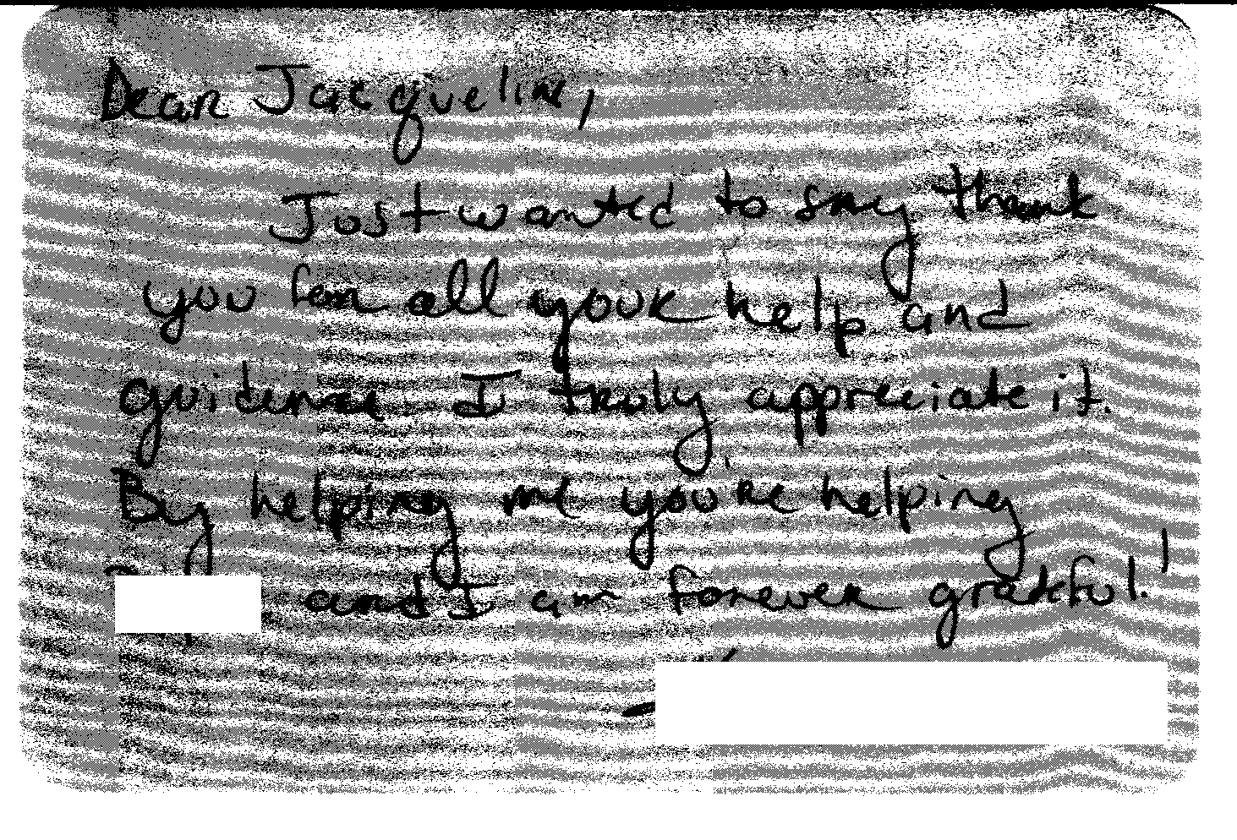
(Dear Jacqueline,
Just wanted to say thank you for all your help and guidance. I truly appreciate it. By helping me you’re helping ___ and I am forever grateful.)

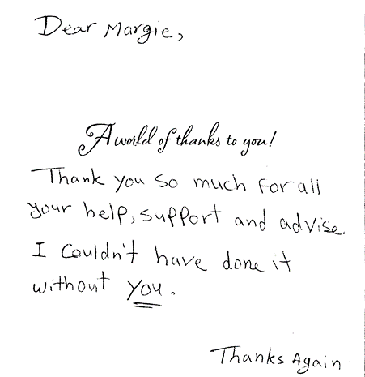

(Dear Margie,
Thank you so much for all your help, support and advise. I couldn’t have done it without you.)

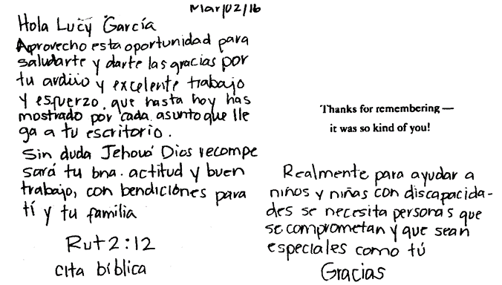

(Hello Lucy Garcia,
I am taking this opportunity to say hello and thank you for your arduous and excellent work and effort that to this day you have shown for each issue that arrives at your desk. Without a doubt Jehova God will compensate your good attitude y good work, and blessings to you and your family.
Ruth 2:12 biblical cite In reality, to help girls and boys with disabilities there needs to be people with commitment and special like you. Thank you!)

(Hi Annie & jullua
I really appreciate both of you!!! from the bottom of my heart.
If wishes come through immediately.
I would wish you become the world wealthiest.
What you did was too much that I had to cry.
You are one in a lifetime.)

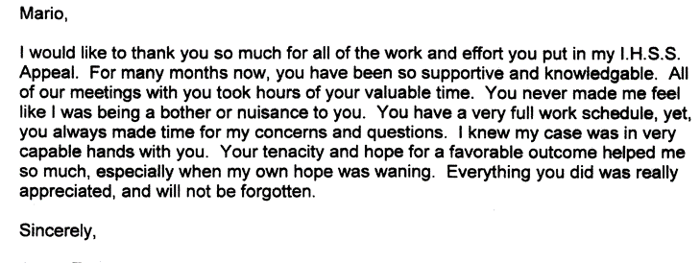
(Mario,
I would like to thank you so much for all of the work and effort you put in my I.H.S.S. Appeal. For many months now, you have been so supportive and knowledgeable. All of our meetings with you took hours of your valuable time. You never made me feel like I was being a bother or nuisance to you. You have a very full work schedule, yet, you always made time for my concerns and questions. I knew my case was in a very capable hands with you. Your tenacity and hope for a favorable outcome helped me so much, especially when my own hope was waning. Everything you did was really appreciated, and will not be forgotten.
Sincerely,)

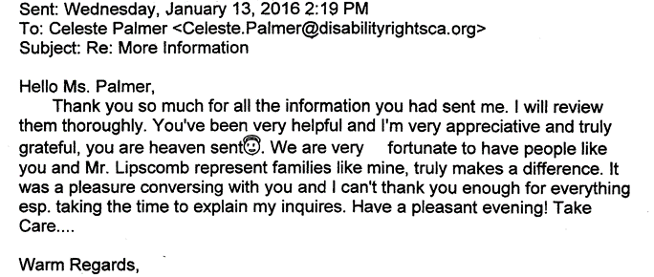
(Hello Ms. Palmer,
Thank you so much for all the information you had sent me. I will review them thoroughly. You’ve been very helpful and I’m very appreciate and truly grateful, you are heaven sent. We are very fortunate to have people like you and Mr. Lipscomb represent families like mine, truly makes a difference. It was a pleasure conversing with you and I can’t thank you enough for everything esp. taking the time to explain my inquires. Have a pleasant evening! Take Care…Warm Regards,)

3) Cases will be handled in a timely manner.

Consumers and families contact OCRA because something has gone wrong for them. It may be that they are losing a government benefit or their housing, or are facing another urgent situation. It is important that OCRA staff be responsive. For this reason, OCRA has, since its establishment, had a policy that all calls will be returned as soon as possible, but not later than the close of the next business day. OCRA staff note this policy on the outgoing voicemail message that callers hear when reaching the office voicemail.

OCRA measures its performance in this area by use of its consumer satisfaction survey; see Exhibit G, discussed more fully above. OCRA statistics shows that 97 percent of all callers to OCRA received a call back within two days during the last fiscal year. This percentage is remarkable, considering OCRA continues to increase the number of cases it handles each year. OCRA continues to use two Bilingual ACRAs for northern and southern California to assist with overflow intake and when staff are absent. OCRA also uses temporary CRAs and ACRAs in offices with higher volume to ensure timely service. One respondent said, “Ocra service has been a great help and very pleased to work with Kendra and Gina. They share a client’s problems seriously and responds on timely manners, leading to solving the issues mostly time!”

The provision of clients’ rights advocacy services is coordinated in consultation with the DDS contract manager, stakeholder organizations, and persons with developmental disabilities and m their families representing California’s multi-cultural diversity.

OCRA works through the OCRA Advisory Committee to ensure that this performance outcome is achieved. Attached as Exhibit H is a list of the members of the Disability Rights California Board of Director’s OCRA Advisory Committee effective June 30, 2016.

Public members of the Advisory Committee are appointed by the Board of Directors. In the selection process, the Board considers geographical diversity, both rural and urban and north and south, type of developmental disability represented, and ethnic background, in addition to the qualifications of the individual applicants.

The OCRA Advisory Committee provides valuable insight to the OCRA staff. A wide variety of topics are addressed at the meetings and board members become better self-advocates as a result of having been on the committee. Minutes for the meeting held on September 18, 2015, were provided with the Semi-Annual Report. The minutes for the March 11, 2016, meeting are included as Exhibit H. DDS staff is invited and encouraged to participate in the next meeting, which is set for September 16, 2016, in Manhattan Beach, CA. OCRA will be hosting an input session for stakeholders at this meeting.

F. Self-advocacy training is provided for consumers and families at least twice in each fiscal year.
Welfare and Institutions Code, Section 4433(d)(5), requires that the contractor providing advocacy services for consumers of regional center services provide at least two self-advocacy trainings for consumers. Disability Rights California’s contract with DDS mirrors this language. OCRA strongly believes in the importance of self-advocacy and requires each of its offices to provide at least one self-advocacy training for consumers per year, far exceeding the two mandated trainings. Many offices provide more than one training per year. This fiscal year, OCRA staff provided 46 self-advocacy presentations statewide, which is almost double the number provided last fiscal year.

Staff may present from any of the approved self-advocacy trainings. To date, OCRA has developed six separate packets of information for OCRA staff to use in the mandated trainings in addition to the DDS Consumer Safety materials and the living arrangement options materials developed by DDS. OCRA is currently revising the Microenterprise self-advocacy training materials. Samples of the OCRA self-advocacy packets (all are in both English and Spanish), were provided separately in a binder marked OCRA Training Materials with the 2007-2008 Annual Report. In past discussions with DDS’s Contract Manager, it was decided that OCRA should not submit duplicate training packets in this year’s annual report. As always, OCRA welcomes comments from DDS on any training packets.

Because this fiscal year falls partly in an election year, OCRA staff have presented more Voting trainings to consumers than in other years. OCRA’s Peer Advocate has also participated in committees in Los Angeles County to improve voting access for people with disabilities.

OCRA is required to report in its Annual Report an evaluation of the self-advocacy trainings. OCRA has randomly selected consumer training satisfaction evaluations for inclusion in this Annual Report. Almost without exception, consumers are pleased with OCRA trainings. A list of Self-Advocacy Trainings held last year are in Exhibit I.

Here is a sampling of consumers’ comments on the self-advocacy training satisfaction evaluations. OCRA is providing the comments with the wording from the originals, including any grammatical errors, unless otherwise indicated.

“It met my needs because I didn’t know this knowledge.”

“Very educational and fun!”

“It answered all my questions about my rights.”

“The real-life examples were very interesting!”

“It explained everything I needed to know.”

How did this training meet your needs?
“By helping me prepare for emergency.”
“Allowed me to understand the rights of adults.”

Did you learn something from this training?
“Standing up for yourself.”
“Taught me how to protect my finances.”

“It helped me plan for a disaster.”

“I feel safer now.”

“Answered about voting in primary vs. general. I want to vote now.”

III. TITLE 17 COMPLAINTS
CCR, Title 17, Section 50540, sets forth a complaint procedure whereby a regional center consumer, or his or her authorized representative, who believes a right has been abused, punitively withheld or improperly or unreasonably denied, may file a complaint with the Clients’ Rights Advocate. The Complaint process is similar to that established by Welfare & Institution Code, Section 4731. However, the later law offers more consumer protections. There were no Title 17 Complaints filed during the last fiscal year, as noted on Exhibit J.

IV. DENIAL OF CLIENTS’ RIGHTS

CCR, Title 17, Section 50530, sets forth a procedure whereby a care provider may deny one of the basic rights of a consumer if there is a danger to self or others or a danger of property destruction caused by the actions of a consumer. The Clients’ Rights Advocate must approve the denial and submit a quarterly report to DDS by the last day of each January, April, July, and October. OCRA is including the reports concurrently with the contractual date to provide OCRA’s reports. If this is not acceptable to DDS, OCRA will submit duplicate reports as requested. Attached as Exhibit K is the current log of Denials of Rights from the OCRA offices.

V. CONSUMER GRIEVANCES
Exhibit A, Paragraph 12, of the contract between DDS and Disability Rights California requires OCRA to establish a grievance procedure and to inform all clients about the procedure. DDS has approved the grievance procedure developed by OCRA. The procedure is posted prominently in both English and Spanish at each office. The grievance procedure has also been translated into Arabic, Armenian, Chinese (Simplified), Farsi, Hmong, Japanese, Khmer, Korean, Laotian, Russian, Tagolog, Thai, and Vietnamese. OCRA staff offer the grievance procedure in all letters to consumers or others who contact OCRA, when an office declines to provide the requested service to that person.

During the past fiscal year, OCRA handled 10,144 matters. There were three first level grievances filed by consumers or their family members. None of those proceeded to the second level or higher. Information concerning each grievance has previously been submitted to DDS. Attached as Exhibit L is a chart detailing the grievances filed against OCRA during this period.

VI. COLLECTION OF ATTORNEYS FEES

OCRA does not charge consumers, their families or advocates fees for services nor does OCRA seek to recover costs from these individuals. Clients’ Rights Advocates who are licensed to practice law in California, or Assistant, Associate, or unlicensed Clients’ Rights Advocates, all of whom work under the supervision of an attorney, can collect attorney’s fees and costs similar to those collected by private attorneys or advocates for special education cases or other cases where there are statutory attorney’s fees. OCRA collects fees only in special education cases or Writs of Mandamus. Fees and costs may be negotiated at mediation or can be received in those cases where an Administrative Law Judge has made a determination that the petitioner is the prevailing party. Fees are collected from the opposing party, which is normally a school district. Costs include any expenses to the Petitioner or OCRA for suing, such as filing fees or costs of expert evaluations. Neither Disability Rights California nor OCRA ever collect attorney’s fees from consumers.

OCRA collected $1,200 in attorney’s fees from a special education matter this fiscal year, see Exhibit M.

VII. RECOMMENDATIONS FOR ENHANCEMENT OF SERVICES

The contract between DDS and Disability Rights California requires that on an annual basis Disability Rights California make recommendations to DDS as to potential methods of enhancing the services that OCRA provides for regional center consumers.

The support of DDS through the years has made it possible for OCRA to effectively and efficiently serve consumers. However, the demand for OCRA services continues to increase along with the increased number of cases involving people living in restrictive settings. OCRA must continue to look at providing additional staffing to better serve all clients, given the continuing increase in cases that we handle each year. For those individuals at IMDs and developmental centers, OCRA has hired two additional CRAs to assist this special population. With the closure of developmental centers, this need will continue to grow and OCRA anticipates hiring two more CRAs to assist this population. The importance of the Peer Advocate and Peer Trainer continues to increase as the peer perspective is a unique one and many consumers need mentorship and a positive example. OCRA also recognizes the need to serve diverse communities with varying language needs, which means continuing to recruit and hire staff who speak diverse languages. As such, OCRA would appreciate additional resources to increase staffing to meet these unique needs while continuing to provide the high level of service to those consumers already living in the community.

VIII. CONCLUSION

OCRA has continued to provide exceptional service to people with developmental disabilities throughout the state. OCRA handled 10,114 cases for 6,589 clients last year, an increase over the previous year in the number of clients served and a slight decrease in issues handled for those clients. Additionally, OCRA provided 488 trainings to over 16,039 consumers, family members, regional center staff and vendors, and interested community members - all while meeting each of its performance objectives. OCRA looks forward to continuing to work with people with developmental disabilities and helping access the services and supports they need to live the most independent and productive lives in the least restrictive environment.

