OCRA ANNUAL REPORT
(July 1, 2014 – June 30, 2015)
TABLE OF CONTENTS
PAGE
I. INTRODUCTION 3
II. PERFORMANCE OBJECTIVES 4
A. Services are provided in a manner that maximizes staff and operational resources. 5
1) Advocacy Reports. 5
2) Analysis of Consumers Served. 7
3) Analysis of Consumers Assisted with Moving to a Less Restrictive Living Arrangement. 8
4) Outreach/Trainings. 9
B. Issues and complaints are resolved expeditiously and at the lowest level of appropriate intervention. 11
C. Collaborative and harmonious working relationships are fostered. 11
1) Memorandums of Understanding. 11
2) Meeting with Association of Regional Center Agencies (ARCA). 12
D. Consumers and families are satisfied with the services provided. 12
1) Consumer Satisfaction Survey. 12
2) Letters of Appreciation. 13
3) Cases will be handled in a timely manner. 17
E. The provision of clients’ rights advocacy services is coordinated in consultation with the DDS contract manager, stakeholder organizations, and persons with developmental disabilities and m their families representing California’s multi-cultural diversity. 17
F. Self-advocacy training is provided for consumers and families at least twice in each fiscal year. 18
III. TITLE 17 COMPLAINTS 19
IV. DENIAL OF CLIENTS’ RIGHTS 19
V. CONSUMER GRIEVANCES 19
VI. COLLECTION OF ATTORNEYS FEES 20
VII. RECOMMENDATIONS FOR ENHANCEMENT OF SERVICES 20
VIII. CONCLUSION 21

EXHIBIT LIST
EXHIBIT A OCRA Staff Roster
EXHIBIT B OCRA Statistics
EXHIBIT C Advocacy Report July 2014 – June 30, 2015
EXHIBIT D Outreach and Training Report
EXHIBIT E Report by Service Level
EXHIBIT F Memorandum of Understanding
EXHIBIT G Consumer Satisfaction Surveys
EXHIBIT H OCRA Advisory Committee and Meeting Minutes
EXHIBIT I Self-Advocacy Trainings
EXHIBIT J Title 17 Complaints
EXHIBIT K Denial of Rights
EXHIBIT L Consumer Grievance Report
EXHIBIT M Annual Attorney Fees Report

(Under Separate Cover)
OCRA SELF-ADVOCACY TRAINING EVALUATION BINDER

I. INTRODUCTION
Disability Rights California provides state-wide clients’ rights advocacy services for regional center consumers pursuant to a multi-year contract, HD119002, with the Department of Developmental Services (DDS) through the Office of Clients’ Rights Advocacy (OCRA). The contract was renewed effective July 1, 2011, for a 5-year period ending June 30, 2016. This Annual Report is submitted pursuant to Exhibit A, Paragraph 13.O, for Fiscal Year 2014-2015.
OCRA again increased the number of clients served and service requests resolved for those clients. During the past year, OCRA resolved 10,509 issues for 6,573 consumers, an increase of more than 9% from last year. OCRA staff continue to achieve positive results for clients who have a variety of legal issues as evidenced in the attached statistics and Advocacy Report. OCRA also participated in 419 trainings last fiscal year, presenting to approximately 14,711 people. This number is slightly lower than last year because we started counting trainings and attendee numbers differently. See section II.A.4 for details.
OCRA continues to be involved in many time-intensive, lengthy cases involving individuals who have been living in restrictive settings but would like to move into the community. These cases present wonderful opportunities for consumers, many who have resided in a developmental center since childhood, to live in a more home-like setting. To meet statutory obligations and client demand for OCRA’s involvement statewide, OCRA now has two full-time CRAs to directly handle, or assist other CRAs with, these cases.
In addition to the emphasis on community living, OCRA has continued to participate in the stakeholder meetings regarding Purchase of Service (POS) data at almost every regional center. Some OCRA staff are serving on disparity committees and working closely with their regional centers to develop innovative strategies to help better serve those from underserved communities. OCRA is also committed to ensuring that we effectively serve all communities. We do so through a combination of outreach, education, and direct advocacy. For example, some OCRA offices have had a difficult time reaching the Asian and Pacific Islander communities. As a result, OCRA recently appointed one CRA who speaks several Asian languages as the outreach coordinator for the Asian community. This CRA is looking at ways that we can better connect with Asian communities, including seeking training opportunities and learning the best ways to provide direct advocacy to this community.

OCRA staff are also serving on their regional centers’ Self-Determination Program Local Advisory Committees and attending regular meetings. Some OCRA staff have partnered with regional centers to provide trainings to help interested parties better understand this new service delivery method. OCRA also participated in a Self-Determination Program conference that took place over two days in southern California and will continue to work with DDS, the State Council on Developmental Disabilities and regional centers on this program.
OCRA currently operates 21 offices throughout the state, most of which are staffed by one CRA and one Assistant CRA. This enables our staff to be accessible and best understand the local community. OCRA plans to close the Ukiah office which serves consumers of Redwood Coast Regional Center (RCRC) and move to having one office in Eureka to serve consumers in all four RCRC counties. We will have a second CRA in the Eureka office starting in September. RCRC management agrees this setup will better serve RCRC consumers in all areas of the catchment. During the past fiscal year, OCRA has hired new staff for the Assistant Clients’ Rights Advocate positions serving consumers of South Central Los Angeles Regional Center and Regional Center of Orange County. We have also hired a new CRA for Alta California Regional Center consumers. We also have a Peer Advocate for southern California and plan to hire for this position in northern California. A list of the current staff and office locations is attached as Exhibit A.

II. PERFORMANCE OBJECTIVES
Disability Rights California’s contract with DDS requires performance objectives as established in Exhibit A, Page 14, Paragraph M, of the contract. Each of the specific required outcomes is discussed in the following Sections A through F. The contract does not set specific numbers for the performance outcomes.

Services are provided in a manner that maximizes staff and operational resources.
OCRA continues its tradition of serving a large number of people with developmental disabilities. OCRA handled 10,509 issues for regional center consumers during the fiscal year. OCRA successfully represented and educated people on many different legal issues and helped to remedy systemic problems. The statistics, attached as Exhibit B and discussed below, show the wide variety of issues and the large number of cases handled by OCRA staff. The advocacy report, covering January through June, 2015, included as Exhibit C, tells the stories and the impact our work has had on consumers’ lives.

1) Advocacy Reports.
OCRA’s wonderful service to the community and the impact of that work is best demonstrated in the cases. Advocates regularly submit summaries of cases or outreaches that have practical value and demonstrate a good outcome or teach a lesson. In an effort toward brevity, the stories are just a brief summary to reflect a sampling of the types of cases that OCRA handled. A longer Advocacy Report is available upon request. Cases for the first half of the fiscal year were summarized in the summer and fall, 2014, Advocacy Report, which was previously submitted in the Semi-Annual Report. The summaries from January, 2015, through June, 2015, are compiled and attached as Exhibit C.
These advocacy stories show the extraordinary value and diversity of OCRA’s work. Many of these cases reflect resolution of systemic problems through direct representation or through involvement on committees and building relationships. The variety of cases we handle often reflects trends with the calls that we receive. For example, during this past reporting period, OCRA staff provided direct representation in a larger number of special education cases than in other years. Another example is our recognition of cases involving rights under the Americans with Disabilities Act (ADA). The ADA was signed into law on July 26, 1990 and prohibits discrimination based on disabilities. In honor of the 25th “birthday” this year, OCRA held a celebration and training for staff. Speakers on ADA issues included a seasoned attorney and senior investigators from the Equal Employment Opportunities Commission (EEOC). We also recognized staff for their ADA advocacy over the past fiscal year, for example:
K.M. had been working at the same company for 23 years, with a job coach, when the company told him that his job coach was no longer allowed in the facility for liability reasons. Veronica Cervantes and Jazmin Romero sent a written request to the company to allow the job coach as a reasonable accommodation under the ADA. Veronica then attended a meeting with K.M. to negotiate with human resources staff. As a result, the company agreed to allow the job coach to continue to support K.M. in the facility while he is working. Thanks to OCRA, K.M. looks forward to continued success at work.

OCRA used the ADA to prevent students from being left behind. Armed with the ADA, Leinani Walter and Christine Hager worked with attorneys from the Sacramento Regional Office to help a little girl return to her after-school program after a district rejected her because of her disability. They followed this victory by helping another family reverse a district’s decision to remove a student from his swim class. Because of their efforts, two more of OCRA's clients can now access and enjoy the same programs as their friends without disabilities - just as the ADA intended.

Lynne Page was successful in using the ADA to allow T.C. to continue participating in out-of-town Special Olympics events. After having a seizure on the team bus, T.C. was told that she could only participate in out-of-town Special Olympics events if she provided an adult with his/her own car to accompany her. Lynne met with T.C., then contacted the Special Olympics director to discuss an alternative, less burdensome option to address the seizure concerns. OCRA drafted a protocol wherein, in the event of a seizure, current Special Olympics staff could drive her to the local hospital for treatment and notify her family. With this reasonable accommodation in place, T.C. participates in all Special Olympics events.

We post all of our advocacy reports and other success stories on our website at least weekly, often daily. These stories are a quick and easy way for DDS and the public to see summaries of our work and better understand the rights of people with disabilities.

2) Analysis of Consumers Served.
OCRA handled 10,509 cases from July 1, 2014, through June 30, 2015. Exhibit B contains the complete compilation of data for the fiscal year.
The data has been compiled by:
1. Age
2. County
3. Disability
4. Ethnicity
5. Gender
6. Living Arrangement
7. Type of Problem (Problem Codes)
8. Service Level

Please note that the reports included here are in non-table format so that they are accessible to individuals who use screen-readers. Although the data is still contained in grids, each row of the table is self-explanatory as read from left to right and does not require the navigational reference of a table header row for context.
The largest number of consumers served by age during this time period, 1,487 out of 6,583, were individuals in the 4-to-17 years-old age group. The next largest was the 23-40 age group with 870 people served. The 18-22 transition age group was a close third, but note it only contains a five year age spread thus indicating that OCRA serves a good percentage of 18-22-year-olds who often have very specific and important issues with their transition into adulthood.
For those cases where gender is recorded, OCRA has traditionally served more males than females, with about 63 percent of the consumers served being male and 37 percent being female in this reporting period. These numbers are very similar to the percentage served by regional centers, according to the DDS Fact Book, 12th Edition. In January 2014, regional centers served 63.6 percent male compared to 36.4 percent female. The Fact Book attributes the growing gender imbalance, in large part, to the growing Autism population, which is currently over 80 percent male.

The percentage of consumers residing in the parental or other family home remains by far the largest number of service requests for consumers served by OCRA, with 7,763 service requests showing consumers living in the family home or almost 74 percent of the cases handled. The next largest group served is those living independently, with 1,075 service requests or just over 10 percent with this living arrangement. As in past years, the number of service requests for consumers served in rural areas shows more people living independently than larger urban areas, possibly due to the high cost of living in urban areas which necessitates consumers living with family members rather than independently.
OCRA’s statistics on the ethnicity of consumers served for the year show OCRA’s continuing commitment and success in serving underserved communities. For example, 38.8 percent of consumers served by OCRA identified as Hispanic/Latino. This is a higher percentage than OCRA served last year, and higher than the 36.1 percent of regional center consumers identified as Hispanic/Latino in January 2014, taken from the DDS Fact Book, 12th Edition.
African-American and Asian consumer data is under the new report for “race” and has been separated from “ethnicity” in our reporting system and for this annual report. African-American consumers represent 9.4 percent of regional center consumers, but a higher 10.2 percent of consumers served by OCRA. Asian consumers make up 6.4 percent of regional center consumers, but a higher 7.3 percent of consumers served by OCRA. To further the goal to successfully serve all underserved communities, see section 4 below, OCRA staff continue to do targeted outreach, and carefully review the Purchase of Service (POS) Data collected by regional centers under Welfare & Institutions Code Section 4519.5. OCRA staff attended most local stakeholder meetings and joined local committees to further study and impact possible changes to reduce disparities again this year.

3) Analysis of Consumers Assisted with Moving to a Less Restrictive Living Arrangement.
Given the new changes to the law regarding notifying OCRA about people living in restrictive settings such as Developmental Centers, IMDs, and MHRCs, and the recently-announced planned closures of Developmental Centers, it is important to review the casework in this area.
During this fiscal year, only two consumers were placed at Sonoma Developmental Center. OCRA is directly representing both of the Sonoma consumers. Representation can include reviewing records, interviewing and developing a relationship with the consumer, attending meetings, drafting and filing documents for court, attending court dates, special education advocacy, and continuous advocacy for movement back to the community. Because OCRA hired a CRA to focus on institutional cases in northern California, OCRA has been involved in many cases, meetings, and hearings for clients in Sonoma Developmental Center. OCRA staff also attended meetings for two clients who were ultimately not placed at Sonoma DC after being referred.
During this fiscal year, approximately ten consumers were placed at Fairview Developmental Center. OCRA is involved at some level in all ten cases. OCRA staff continue to be involved in many cases, meetings, and hearings for clients who are or were long-time residents at Fairview Developmental Center, and in Lanterman Developmental Center before it closed in December 2014. OCRA staff have also participated in IPP meetings for consumers at Canyon Springs, IMDs such as College Hospital, California Psychiatric Transitions, and Lakewood Health Center, and other restrictive settings. OCRA staff also continue to receive and review comprehensive assessments for consumers who have been living in developmental centers. We are working with regional centers on providing copies of the comprehensive assessments as they occur and are working internally to determine which IPP meetings to attend and which clients to represent.
In both the Developmental Center and IMD cases, OCRA has been involved in about 150 cases and has been successful in getting many of those consumers moved into the community.

4) Outreach/Trainings.
Outreach and Training serve two important purposes: 1) notifying people about the availability of OCRA assistance and 2) educating people about their rights. OCRA provides training on numerous issues to a wide variety of people. Training audiences include direct consumers, family members, regional center staff and vendors, and community members. These trainings include but are not limited to, consumers’ rights, abuse and neglect issues, IHSS, Medi-Cal, special education, voting rights, SSI, rights in the community, and alternatives to conservatorships, among other topics.
During the last fiscal year, OCRA presented at 419 trainings with a total attendance of approximately 14,711 people at the various trainings. This represents a slight decrease from last year in both the number of trainings given and the number of people attending these trainings. OCRA hopes to increase its outreach numbers. To this end, staff have created a “trainings bank” in order to have a one-source location for all trainings and materials. We are excited to have created versions which are accessible to individuals who use screen-readers, for each training in our bank. We have also translated these resources into Spanish and other languages. This will ensure our commitment to reaching out to as many communities, groups, consumers and families as possible, as staff will have more time for outreach if they do not have to “reinvent the wheel” and can use materials already created. OCRA also plans to fill the Peer Advocate position in the north this fiscal year. Peer Advocates have provided training, support, and mentorship to staff, consumers, and community members. The southern California Peer Advocate has also gone into facilities to meet with clients directly and discuss choices in living arrangements.
In order to provide assistance to individuals from traditionally underserved communities OCRA has developed target outreach plans. Each OCRA office targets at least three outreaches per year to a specific group of persons who are underrepresented in the office’s catchment area. To help with this, OCRA has appointed Mary Melendrez and Christine Hager as the Outreach Coordinators. They advise staff in implementation of their target outreach plans. These are two-year plans based upon an evaluation of prior outreach plans’ results, new census data and information from DDS regarding the ethnicity of consumers served by each regional center. This fiscal year was the end of a two-year cycle. Many offices have changed their target group for the next two years, based on new data. OCRA has also appointed Jackie Dai as Outreach Coordinator for the Asian community in an effort to improve our service to this community. Several offices have identified the Asian community as their target for outreach. A detailed report on outreach and training is included as Exhibit D.

Issues and complaints are resolved expeditiously and at the lowest level of appropriate intervention.
From July 1, 2014, through June 30, 2015, OCRA resolved 10,509 issues for consumers. Of those, all but 24 were resolved informally. Last year, OCRA handled all but 57 informally. This year shows a larger number of cases handled overall, and a larger number of cases handled informally. More than 99 percent of all the matters that OCRA handled were resolved without using hearings or court. Data showing this is attached as Exhibit E.

Collaborative and harmonious working relationships are fostered.
OCRA staff continue to collaborate with the local regional centers, stakeholders, and community members. Some examples of collaboration include serving on Behavioral Modification Review Committees, Risk Assessment Committees, County Coordinating Councils, Supported Life Training Planning Committees, county customer service and appeals and hearings meetings, DS Taskforce Implementation Workgroup, State Hearings Division Stakeholder meeting, Fiesta Educativa, and many others. All CRAs are participating in meetings with their regional centers’ Self-Determination Program Local Advisory Committees. Some OCRA staff provide training to regional center staff. Many OCRA staff meet regularly with regional center staff and community partners to share ideas and expertise on many subjects. This philosophy of collaboration is not only incorporated into Disability Rights California’s contract with DDS, but is also recognition that some of the most effective advocacy takes place because of interpersonal relationships and informal advocacy. The success of this philosophy is demonstrated by the number of calls OCRA receives from varied sources, by its ability to resolve matters informally, and by its recognition as an excellent resource for people with developmental disabilities and their families.

1) Memorandums of Understanding.
OCRA has established Memorandums of Understanding (MOUs) with each regional center that addresses that center’s individual needs, concerns, and method of operation. Generally, MOUs are updated as needed. However, changes to the law mean that MOUs may be reviewed and meetings held or scheduled. These meetings have been productive and positive. OCRA has very good working relationships with many regional centers. During this fiscal year, MOUs were updated at Eastern Los Angeles Regional Center, Golden Gate Regional Center, Inland Regional Center, Frank D. Lanterman Regional Center, North Bay Regional Center, North Los Angeles County Regional Center, Redwood Coast Regional Center, San Gabriel/Pomona Regional Center, and Tri-Counties Regional Center during this fiscal year. Copies of all MOUs have been forwarded to DDS. The status of each revised MOU is listed in Exhibit F.

2) Meeting with Association of Regional Center Agencies (ARCA).
Last year, ARCA and OCRA decided to meet regularly to discuss various issue. To this end, Katie Hornberger, OCRA Director, has met with ARCA three times during this review period: July 29, 2014; October 31, 2014; and most recently on June 23, 2015. We also serve on committees together and regularly phone and email each other.

D. Consumers and families are satisfied with the services provided.
Disability Rights California recognizes the importance of consumer satisfaction. OCRA is committed to serving consumers and family members in a manner and with results that ensure consumer and family satisfaction with the services provided. Survey results show positive consumer satisfaction over the past fiscal year.

1) Consumer Satisfaction Survey.
OCRA measures consumer satisfaction by use of a survey developed jointly by staff, the OCRA Consumer Advisory Committee, and DDS. Two thousand and fifty-four (2,054) surveys were mailed out. This is slightly more than last years’ two thousand and twelve (2,012) surveys that were mailed out. This increase is commensurate with the increase in service requests. Four hundred and ninety-one (491) returned the surveys. This represents a 24 percent return rate of the surveys, about the same as last fiscal year.
Of those responding to the questions, 96 percent of the respondents who answered the questions felt they were treated well by the staff, 95 percent understood the information they were provided, 97 percent believed their CRA listened to them, and 91 percent would ask for help from the CRA again. See Exhibit G, which discusses the results of OCRA’s survey.
A member of the OCRA management team call back all responders who request a call back and those with any negative responses that supplied contact information. In this way, we are able to remedy any concerns and provide additional support to consumers.
This year, we had declines in both the percent of people who indicated that they received a call back within two days, and those who felt they were helped by the CRA, 88 percent compared with 93 percent last year. OCRA will begin using a new case management system in Fall 2015. This new system will streamline our work by integrating all of the systems we use into one system which will allow staff more time for direct client work. Some of the components include case management, phone call log, intake log, time-tracking, expense-tracking, training, and reporting program. We believe that the phone call log, which OCRA managers and other staff can access, will help us to raise the percentage of people who indicate they received a call back within two days. From the overall survey results, it is clear that most consumers remain satisfied with the services provided by OCRA.

2) Letters of Appreciation.
OCRA consumers and family members often take the time to write letters of appreciation. These kind words and the time it took to send them represent the high value of the work performed by OCRA staff. Below is just a sampling of the many letters received. OCRA is providing the letters of appreciation with the wording from the originals, including any grammatical errors, unless otherwise indicated. We have also edited client names.
Hi Jackie:
I cannot tell you how much I appreciated your presence, support, insights, encouragement and focus on making sure all the concerns were addressed at the meeting today. I felt it was a very successful and productive meeting. I would not have been able to do it without you! Thank you SO much!

Marzo 5, 2015

A quien corresponda:

Por medio de la presente quiero dar las gracias al programa Disability Rights California por haberme dado el servicio de abogar por mi en un inconveniente que tuve con el programa IHSS. Tocante a una reduccion de horas.

Al comunicarme con ustedes la persona que llevo mi caso Veronica Cervantes a quien agradezco la amabilidad con la que me atendio y resolvio mi caso por bien. Quede muy satisfecha con lo que ella logro para mi.

Agradezco de todo Corazon por sus servisios y gracias por existir.

Att.

(March 5, 2015

To Whom It May Concern:

Through this letter, I want to thank the Disability Rights California program for giving me the service of advocating for me with regard to a reduction in IHSS hours.

Upon communicating with your office, the person who took my case was Veronica Cervantes. I appreciate the kind manner in which she helped me and resolved my case favorably. I was fully satisfied with what she achieved for me.

Thank you from all my heart for your service and thanks for existing.

Sincerely)

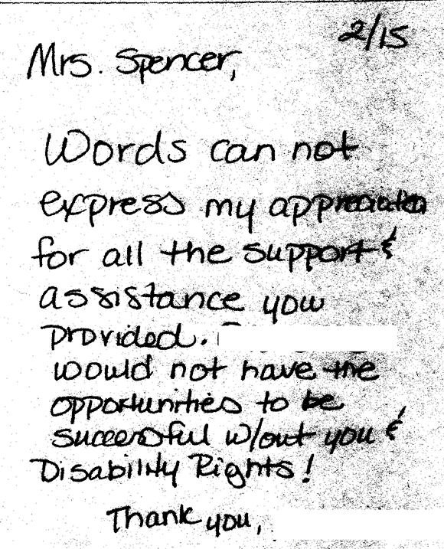

Mrs. Spencer, Words cannot express my appreciate for all the support & assistance you provided. _____ would not have the opportunities to be successful w/out you & Disability Rights! Thank you.

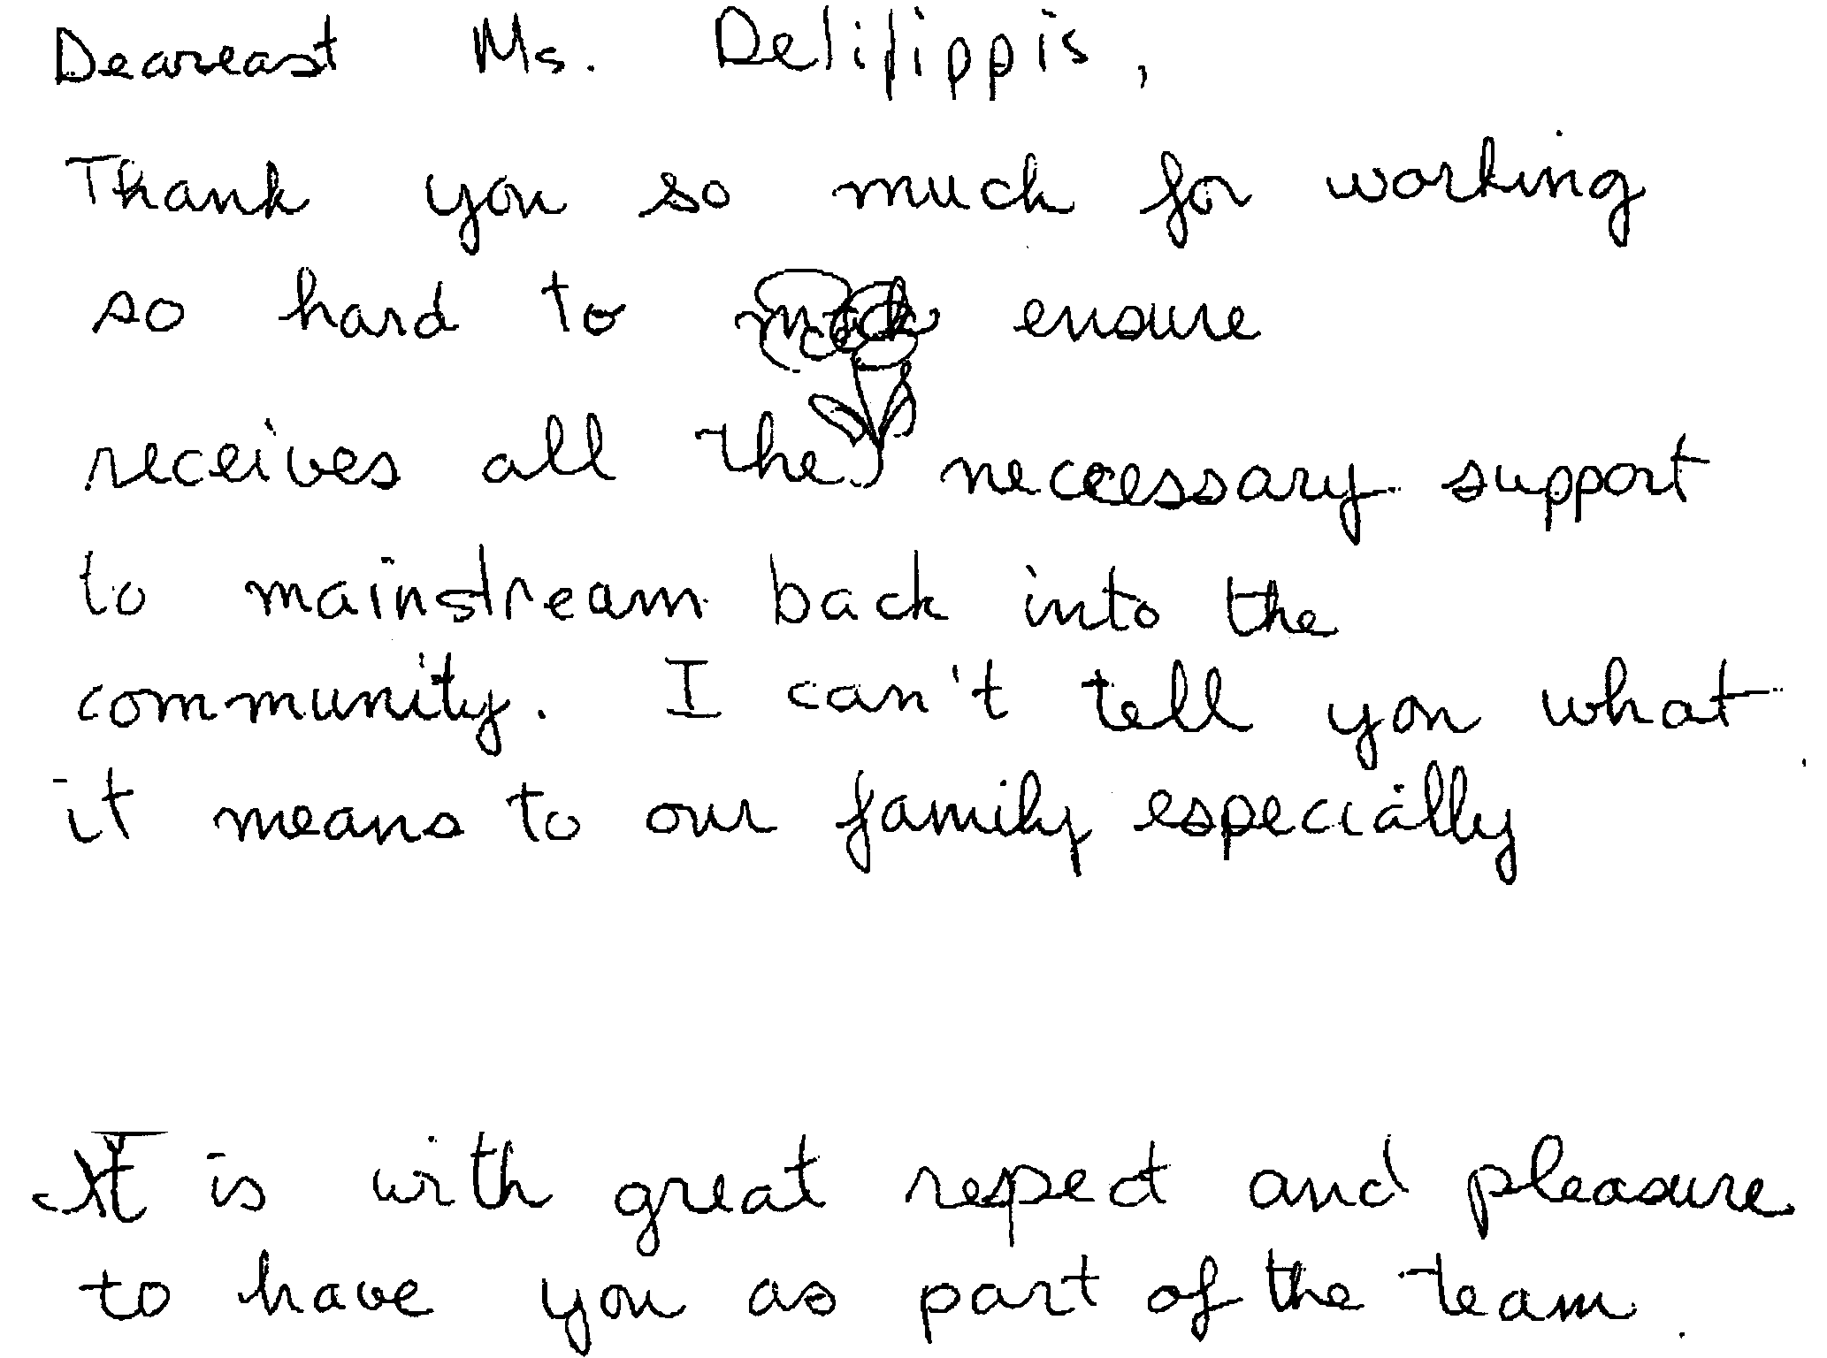

Dearest Ms. DeFilippis, Thank you so much for working so hard to ensure ____ receives all the necessary support to mainstream back into the community. I can’t tell you what it means to our family especially _____. It is with great respect and pleasure to have you as part of the team.

Dear Mr. Leiner:
I am writing you to express my gratitude for the competence, dedication and integrity that Yulahlia Hernandez and Annie Breuer give to the clients at North Bay Regional Center. As you know the economy is doing poorly which effects the population we serve. SSI redetermination and budget cuts have put many of my clients out of work, homeless, and depressed. My caseload is at an all-time high and the advocacy that I used to be able to do myself has become nearly impossible. Each time that I contact Ms. Hernandez or Ms. Breuer they quickly return my call or email and immediately get on the case or refer me to someone else who can help. They have been successful on several occasions with helping my clients regain their SSI and SSDI benefits. To battle with social security and deal with the countless paperwork is a challenging mind numbing and arduous and they do this all the time. They have helped clients apply for college programs, and jobs. They have counseled families regarding their rights and services. Ms. Hernandez and Mrs. Breuer have always been huge problem solvers, showing reliability and compassion throughout their careers. I appreciate all of their hard work and dedication.
Respectfully,
Clients Program Coordinator
North Bay Regional Center

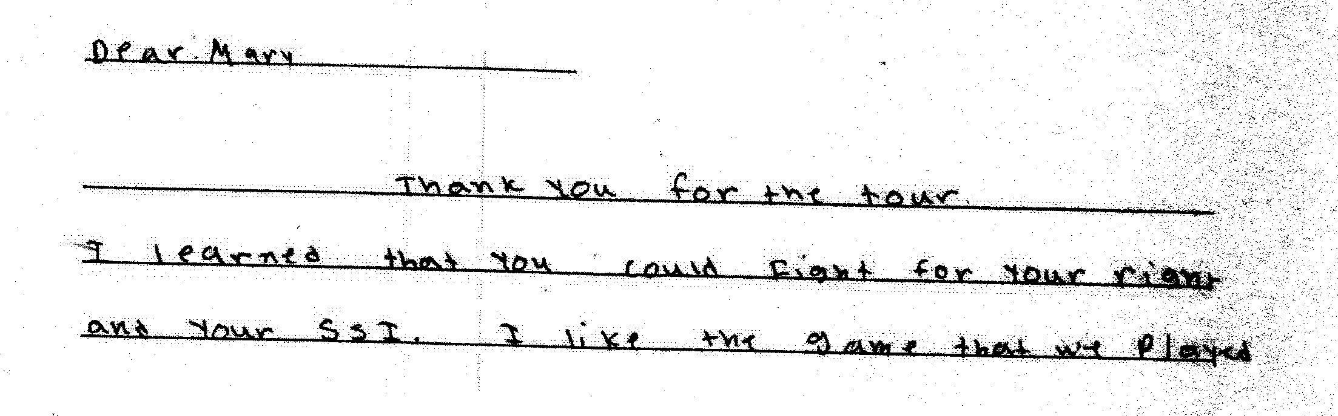

Dear Mary, Thank you for the tour. I learned that you could fight for your rights and your SSI. I like the game that we played.

3) Cases will be handled in a timely manner.
Consumers and families contact OCRA because something has gone wrong for them. It may be that they are losing a government benefit, are being forced to move to a new more restrictive environment, or are facing another urgent situation. Therefore, it is important that OCRA staff be responsive. For this reason, OCRA has, since its establishment, had a policy that all calls will be returned as soon as possible, but not later than the close of the next business day. OCRA staff often note this policy on the outgoing voicemail message that callers hear when reaching the office voicemail.
OCRA measures its performance in this area by use of its consumer satisfaction survey; see Exhibit G, discussed more fully above. OCRA statistics shows that 88 percent of all callers to OCRA received a call back within two days during the last fiscal year. This is lower than last year, but higher than the previous year’s 85 percent. This is also higher than the 84 percent reported in our most recent semi-annual report. OCRA continues to use a Bilingual ACRA for Southern California to assist with overflow intake and when staff are absent. During this fiscal year, OCRA has also hired a Bilingual ACRA for Northern California. We hope this will ensure that people receive timely callbacks throughout the state. OCRA will also begin to use the electronic call log feature in our new case management system, starting later in this fiscal year, to ensure that all calls are tracked and monitored appropriately. With these changes, we are optimistic that we can increase our timeliness of serving clients.

The provision of clients’ rights advocacy services is coordinated in consultation with the DDS contract manager, stakeholder organizations, and persons with developmental disabilities and m their families representing California’s multi-cultural diversity.
OCRA works through the OCRA Advisory Committee to ensure that this performance outcome is achieved. Attached as Exhibit H is a list of the members of the Disability Rights California Board of Director’s OCRA Advisory Committee effective June 30, 2015.
Public members of the Advisory Committee are appointed by the Board of Directors. In the selection process, the Board considers geographical diversity, both rural and urban and north and south, type of developmental disability represented, and ethnic background, in addition to the qualifications of the individual applicants.
The OCRA Advisory Committee provides valuable insight to the OCRA staff. A wide variety of topics are addressed at the meetings and board members become better self-advocates as a result of having been on the committee. Minutes for the meeting held on September 19, 2014, were provided with the Semi Annual Report. The minutes for the March 6, 2015, meeting are included as Exhibit H. DDS staff is invited and encouraged to participate in the next meeting, which is set for September 18, 2015, in Santa Ana.

F. Self-advocacy training is provided for consumers and families at least twice in each fiscal year.
Welfare and Institutions Code, Section 4433(d)(5), requires that the contractor providing advocacy services for consumers of regional center services provide at least two self-advocacy trainings for consumers. Disability Rights California’s contract with DDS mirrors this language. OCRA strongly believes in the importance of self-advocacy and requires each of its offices to provide at least one self-advocacy training for consumers per year, far exceeding the two mandated trainings. Many offices provide more than one training per year. This fiscal year, OCRA staff provided 24 self-advocacy presentations statewide.
Staff may present from any of the approved self-advocacy trainings. To date, OCRA has developed six separate packets of information for OCRA staff to use in the mandated trainings in addition to the DDS Consumer Safety materials and the living arrangement options materials developed by DDS. Our Outreach Coordinators and Peer Advocates continue to work on a new self-advocacy training on Denials of Rights.
Samples of the OCRA self-advocacy packets (all are in both English and Spanish), were provided separately in a binder marked OCRA Training Materials with the 2007-2008 Annual Report. In discussions with DDS’s Contract Manager, it was decided that OCRA should not submit duplicate training packets in this year’s annual report. As always, OCRA welcomes comments from DDS on any training packets.
OCRA is required to report in its Annual Report an evaluation of the self-advocacy trainings. OCRA has randomly selected consumer training satisfaction evaluations for inclusion in this Annual Report. Almost without exception, consumers are pleased with OCRA trainings. A list of Self-Advocacy Trainings held last year are in Exhibit I.

III. TITLE 17 COMPLAINTS
CCR, Title 17, Section 50540, sets forth a complaint procedure whereby a regional center consumer, or his or her authorized representative, who believes a right has been abused, punitively withheld or improperly or unreasonably denied, may file a complaint with the Clients’ Rights Advocate. The Complaint process is similar to that established by Welfare & Institution Code, Section 4731. However, the later law offers more consumer protections. There were no Title 17 Complaints filed during the last fiscal year, as noted on Exhibit J.

IV. DENIAL OF CLIENTS’ RIGHTS
CCR, Title 17, Section 50530, sets forth a procedure whereby a care provider may deny one of the basic rights of a consumer if there is a danger to self or others or a danger of property destruction caused by the actions of a consumer. The Clients’ Rights Advocate must approve the procedure and submit a quarterly report to DDS by the last day of each January, April, July, and October. OCRA is including the reports concurrently with the contractual date to provide OCRA’s reports. If this is not acceptable to DDS, OCRA will submit duplicate reports as requested. Attached as Exhibit K is the current log of Denials of Rights from the OCRA offices.

V. CONSUMER GRIEVANCES
Exhibit A, Paragraph 12, of the contract between DDS and Disability Rights California requires OCRA to establish a grievance procedure and to inform all clients about the procedure. DDS has approved the grievance procedure developed by OCRA. The procedure is posted prominently in both English and Spanish at each office. Additionally, the grievance procedure is offered in all letters to consumers or others who contact OCRA, when an office declines to provide the requested service to that person.
During the past fiscal year, OCRA handled 10,509 matters. There were twelve first level grievances filed by consumers or their families. Four of the twelve signed one letter as a group grievance and we learned that one of those grievants had never even called OCRA. Nonetheless, the one group grievance was treated as four separate grievances and OCRA responded to all four by offering additional services and trainings. Four of those twelve proceeded to the second level to be heard by the Disability Rights California Board of Directors. This was despite providing additional assistance in three of the four matters. No grievances were sent on to DDS for review. Information concerning each grievance has previously been submitted to DDS. Attached as Exhibit L is a chart detailing the grievances filed against OCRA during this period.

VI. COLLECTION OF ATTORNEYS FEES
OCRA does not charge consumers, their families or advocates fees for services nor does OCRA seek to recover costs from these individuals. Clients’ Rights Advocates who are licensed to practice law in California, or Assistant , Associate, or unlicensed Clients’ Rights Advocates, all of whom work under the supervision of an attorney, can collect attorney’s fees and costs similar to those collected by private attorneys or advocates for special education cases or other cases where there are statutory attorney’s fees. OCRA collects fees only in special education cases or Writs of Mandamus. Fees and costs may be negotiated at mediation or can be received in those cases where an Administrative Law Judge has made a determination that the petitioner is the prevailing party. Fees are collected from the opposing party, which is normally a school district. Costs include any expenses to the Petitioner or OCRA for suing, such as filing fees or costs of expert evaluations. Neither Disability Rights California nor OCRA ever collect attorney’s fees from consumers.
OCRA collected $7,000 in attorney’s fees from a special education matter this fiscal year, see Exhibit M.

VII. RECOMMENDATIONS FOR ENHANCEMENT OF SERVICES
The contract between DDS and Disability Rights California requires that on an annual basis Disability Rights California make recommendations to DDS as to potential methods of enhancing the services that OCRA provides for regional center consumers.
The support of DDS through the years has made it possible for OCRA to effectively and efficiently serve consumers. However, the demand for OCRA services continues to increase along with the increased number of cases involving people living in restrictive settings. OCRA must continue to look at providing additional staffing to better serve all clients, given the continuing increase in cases that we handle each year. For those individuals at IMDs and developmental centers, OCRA has hired one additional CRA to assist this special population in addition to the one hired last year. With the closure of Sonoma Developmental Center, this need will continue to grow. The importance of the Peer Advocate will also increase as the peer perspective is a unique one and often very helpful. As such, OCRA would appreciate additional resources to increase staffing to meet these unique needs while continuing to provide the high level of service to those consumer already living in the community.

VIII. CONCLUSION
OCRA has continued to provide exceptional service to people with developmental disabilities throughout the state. OCRA handled 10,509 cases last year, an increase over the previous year. Additionally, OCRA provided 419 trainings to over 14,711 consumers, family members, regional center staff and vendors, and interested community members - all while meeting each of its performance objectives. OCRA looks forward to continuing to work with people with developmental disabilities and helping access the services and supports they need to live the most independent and productive lives in the least restrictive environment.

