OCRA SEMI-ANNUAL REPORT

(July 1, 2015 – December 31, 2015)

TABLE OF CONTENTS
PAGE

I. INTRODUCTION 3
II. PERFORMANCE OBJECTIVES 4
A. Services are provided in a manner that maximizes staff and operational resources. 5
1) Advocacy Reports. 5
2) Analysis of Consumers Served. 6
3) Analysis of Consumers Assisted with Moving to a Less Restrictive Living Arrangement. 7
4) Outreach/Training. 9
B. Issues and complaints are resolved expeditiously and at the lowest level of appropriate intervention. 11
C. Collaborative and harmonious working relationships are fostered. 11
1) Memorandums of Understanding. 12
2) Meeting with Association of Regional Center Agencies (ARCA). 12
D. Consumers and families are satisfied with the services provided. 12
1) Consumer Satisfaction Survey. 12
2) Letters of Appreciation. 13
3) Cases will be handled in a timely manner. 18
E. The provision of clients’ rights advocacy services is coordinated in consultation with the DDS contract manager, stakeholder organizations, and persons with developmental disabilities and m their families representing California’s multi-cultural diversity. 18
F. Self-advocacy training is provided for consumers and families at least twice in each fiscal year. 19
III. TITLE 17 COMPLAINTS 19
IV. DENIAL OF CLIENTS’ RIGHTS 20
V. CONSUMER GRIEVANCES 20
VI. COLLECTION OF ATTORNEYS FEES 20
VIII. CONCLUSION 21

EXHIBIT LIST

EXHIBIT A OCRA Staff Roster
EXHIBIT B OCRA Statistics
EXHIBIT C Advocacy Report
EXHIBIT D Outreach and Training Report
EXHIBIT E Report by Service Level
EXHIBIT F Memorandums of Understanding
EXHIBIT G Consumer Satisfaction Surveys
EXHIBIT H OCRA Advisory Committee and Meeting Minutes
EXHIBIT I Self-Advocacy Trainings
EXHIBIT J Title 17 Complaints
EXHIBIT K Denial of Rights
EXHIBIT L Consumer Grievance Report
EXHIBIT M Attorneys Fees

I. INTRODUCTION
Disability Rights California provides state-wide clients’ rights advocacy services for regional center consumers pursuant to a multi-year contract, HD119002, with the Department of Developmental Services (DDS) through the Office of Clients’ Rights Advocacy (OCRA). The contract was renewed effective July 1, 2011, for a 5-year period ending June 30, 2016. OCRA is currently in the fifth year of a five year contract. This semi-annual report covers July 1, 2015, through December 31, 2015.
Between July 1, 2015 and December 31, 2015 OCRA resolved 5,120 issues for 3,611 consumers, which continues to be well over the 30 per month, per office required by contract. OCRA staff continue to handle a variety of legal issues with positive results. OCRA also participated in 178 trainings during the 6-month period, presenting to approximately 6,840 people. This number is slightly lower than our semi-annual report from last year because, as reported in our annual reports, we are counting trainings and attendee numbers differently than in the past. See section II.A.4 for details.
OCRA continues to employ two full-time CRAs who directly handle or provide technical assistance to staff with the important, time-intensive cases that help consumers move from restrictive settings into the community. In addition to these two “community integration CRAs,” other OCRA staff have represented consumers directly in these cases, navigating all the challenges and then participating in all the successes.
In addition to the emphasis on community living, OCRA has continued to work to best serve consumers from traditionally underserved communities. We do so through a combination of outreach, education, and direct advocacy. For example, OCRA’s outreach coordinator for the Asian community has been assisting individual OCRA offices to identify new ways to reach out to the Asian and Pacific Islander (API) communities in their catchment areas, including OCRA involvement in a statewide API conference for consumers with disabilities and their family members. Other offices have looked at OCRA data and have chosen different groups to target. Some OCRA staff are serving on disparity or diversity committees and have worked with their regional centers to identify ways to better serve those from underserved communities.

OCRA staff also serve on their regional centers’ Self-Determination Program Local Advisory Committees as required by Welfare & Institutions Code Section 4685.8(x)(1) and attend regular meetings. Some OCRA staff have partnered with regional centers to provide trainings to help interested parties better understand this new service delivery method. OCRA will be participating for the second year in a two-day Self-Determination Program conference in southern California and will continue to work with DDS, the State Council on Developmental Disabilities and regional centers on this program.
OCRA currently operates offices throughout the state, most of which are staffed by one CRA and one Assistant CRA. This enables our staff to be accessible and best understand the local community. OCRA recently closed the Ukiah office which serves consumers of Redwood Coast Regional Center (RCRC), so we now have one office in Eureka to serve consumers in all four RCRC counties. We hired a second CRA in the Eureka office, who started in September 2015. Staff in that OCRA office have already provided outreach and trainings to regional center staff and the Native American community in Klamath. We also hired a new CRA for Alta California Regional Center consumers who started in August 2015. The former CRA for Westside Regional Center transferred to our Inland Regional Center office during this review period, so we have a new CRA for WRC as well. We also plan to hire a second Peer Advocate in Northern California to compliment the work of our Peer Advocate in Southern California. A list of the current staff and office locations is attached as Exhibit A.

II. PERFORMANCE OBJECTIVES
Disability Rights California’s contract with DDS requires performance objectives as established in Exhibit A, Page 14, Paragraph M, of the contract. Each of the specific required outcomes is discussed in the following Sections A through F. The contract does not set specific numbers for the performance outcomes.

Services are provided in a manner that maximizes staff and operational resources.
OCRA continues its tradition of serving a large number of people with developmental disabilities. OCRA handled 5,120 issues for regional center consumers during this 6-month period. OCRA successfully represented and educated people on many different legal issues and helped to remedy systemic problems. The statistics, attached as Exhibit B and discussed below, show the wide variety of issues and the large number of cases handled by OCRA staff. The advocacy report, covering July through December, 2015, included as Exhibit C, tells the stories and the impact our work has had on consumers’ lives.

1) Advocacy Reports.
OCRA’s wonderful service to the community and the impact of that work is best demonstrated in the stories of direct advocacy. Advocates regularly submit summaries of cases or outreaches that have practical value and demonstrate a good outcome or teach a lesson. In an effort toward brevity, the stories are just a brief summary to reflect a sampling of the types of cases that OCRA handled. A longer Advocacy Report is available upon request. OCRA summarized cases for the last fiscal year in the Advocacy Report section of the 2014-2015 Annual Report. The summaries from July 2015, through December 2015 are compiled and attached as Exhibit C.
These advocacy stories show the extraordinary value and diversity of OCRA’s work. Many of these cases reflect resolution of systemic problems through direct representation while others demonstrate resolution through collaborative relationships. During this reporting period, we had a large number of IHSS cases. These cases are important, as we noticed a trend with consumer and family member concern about the new overtime rules and the implementation of parent provider regulations. As consumers and family members call our office about these issues, we help them with their individual legal issue, provide trainings to the community, and identify patterns which we work to resolve with county.
We post all of our advocacy reports and other success stories on our website at least weekly, often daily. These stories are a quick and easy way for DDS and the public to see summaries of our work and better understand the rights of people with disabilities.

2) Analysis of Consumers Served.
OCRA handled 5,120 cases from July 1, 2015, through December 31, 2015. Exhibit B contains the complete compilation of data for the fiscal year.

The data has been compiled by:
1. Age
2. County
3. Disability
4. Ethnicity
5. Race
6. Gender
7. Living Arrangement
8. Type of Problem (Problem Codes)
9. Service Level

Please note that the reports included here are in non-table format so that they are accessible to individuals who use screen-readers. Although the data is still contained in grids, each row of the table is self-explanatory as read from left to right and does not require the navigational reference of a table header row for context.
38.5 percent of individuals served by OCRA were in the 4-to-17 years-old age group. This is the largest percentage of consumers served by age during this time period. The next largest was the 23-40 age group with 24.2 percent. These data are consistent with previous semi-annual and annual reports. For those cases where gender is recorded, as in the past OCRA served more males than females, with 64 percent of the consumers served being male and 36 percent being female in this reporting period. These numbers continue to coincide with the percentage served by regional centers, according to the DDS Fact Book, 12th Edition. The Fact Book attributes the growing gender imbalance, in large part, to the growing Autism population, which is currently over 80 percent male.
The percentage of consumers residing in the parental or other family home remains by far the largest number of service requests for consumers served by OCRA, with 3,629 service requests showing consumers living in the family home or almost 71 percent of the cases handled. This percentage is lower than the 74 percent from OCRA’s last annual report. The next largest group served is those living independently, with 644 service requests or just over 12.5 percent with this living arrangement. This is higher than the 10 percent in OCRA’s last annual report. Given our increased involvement with people transitioning from developmental centers and other restrictive settings into the community, we expect this number will continue to grow. See section below on consumers assisted with moving to a less restrictive living arrangement.
OCRA’s statistics on the ethnicity of consumers served for the year show OCRA’s continuing commitment and success in serving underserved communities. For example, 38 percent of consumers served by OCRA identified as Hispanic/Latino. This is about the same percentage that OCRA served last year, and higher than the 36.1 percent of regional center consumers identified as Hispanic/Latino in January 2014, taken from the DDS Fact Book, 12th Edition.
African-American and Asian consumer data is under the report for “race,” which has been separated from “ethnicity” in our reporting system. African-American consumers represent 9.4 percent of regional center consumers, but a slightly higher 9.6 percent of consumers served by OCRA. Asian consumers make up 6.4 percent of regional center consumers, but a higher 7.2 percent of consumers served by OCRA. To further the goal to successfully serve all underserved communities, see section 4 below, OCRA staff continue to do targeted outreach. More OCRA offices have targeted the Asian and African-American communities in their two-year outreach plans than in previous years in an effort to continue the relationship building that has enabled us to serve those communities well. See section A.4 for more details on outreach plans. OCRA also carefully reviews the Purchase of Service (POS) Data collected by regional centers under Welfare & Institutions Code Section 4519.5.

3) Analysis of Consumers Assisted with Moving to a Less Restrictive Living Arrangement.
Given the regional center notifications to OCRA about people living in restrictive settings such as Developmental Centers, IMDs, and MHRCs, the planned closures of Developmental Centers, and OCRA involvement in reviewing comprehensive assessments and attendance at IPP meetings, it is important to review OCRA’s work in this area.
During this 6-month period, three consumers were placed at the Acute Crises Unit at Sonoma Developmental Center. OCRA is directly representing two of the three. The third person declined assistance, but OCRA is monitoring his stay. The Northern California CRA also learned that regional centers had referred two additional clients to Sonoma, but unfortunately we did not learn of their admission from the regional centers as required by Welfare & Institutions Code Section 4418.7(a)(2). OCRA will continue to work with regional centers to ensure they understand their notification requirements. For those two clients who were referred to Sonoma, OCRA attended meetings to explore options, and neither were ultimately admitted. OCRA knows of two consumers who were admitted into the Acute Crises Unit at Fairview Developmental Center this review period, and represented both of those consumers. Sadly, one of those consumers passed away on December 30, 2015.
Both the Northern and Southern California Community Integration CRAs have been involved in many cases, meetings, and hearings for clients who were already living in Sonoma and Fairview Developmental Centers, respectively. Other OCRA staff continue to be involved in many cases, meetings, and hearings for clients who are or were long-time residents at Porterville, Fairview and Sonoma Developmental Centers. In total, OCRA staff have assisted over 89 consumers residing in developmental centers by reviewing assessments, attending IPP and other types of meetings, and attending hearings. OCRA staff have assisted over 39 clients who are in IMDs and MHRCs such as College Hospital, California Psychiatric Transitions, and Lakewood Health Center. OCRA works internally to determine which IPP meetings to attend and which clients to represent.
Assistance or representation in these cases can include reviewing records, interviewing and developing a relationship with the consumer, attending meetings, negotiating through phone calls, drafting and filing documents for court, attending court dates, special education advocacy, and continuous advocacy for movement back to the community. One example of advocacy where several entities worked together to achieve community integration for a consumer is highlighted:
A Determined Team Helps M.V. Move Into the Community.
M.V. is an adult with cerebral palsy, a seizure disorder, intellectual disability and daily nursing needs. Last year, following an inpatient stay in the psychiatric unit of a large university hospital, he was admitted to an Acute Crises Unit at a Developmental Center (DC). M.V. had significant behavior problems including aggression causing injury to others. Once notified of M.V.’s admission to the DC, OCRA attended M.V.’s IPP meetings to help advocate for the supports he needed while at the DC and later in a community placement closer to his family.
M.V.’s treatment team at the DC worked with him to decrease his aggressive behaviors. In tracking his behaviors, staff learned that there was often an increase in these problematic behaviors when M.V. was sick. DC staff closely monitored M.V.’s medical condition and made appropriate referrals to medical specialists in the community.
After M.V. made significant progress, his IPP team recommended community placement. The regional center identified and contracted with a vendor to develop a specialized group home and provide services for M.V. in the community. Group home staff met with M.V., attended several IPP meetings, observed him in his programs, and got to know him. Although M.V.’s team set a date for him to move to his new group home, the renovations, licensing, DDS health and welfare exemption process and transition planning still needed to be finalized. The regional center, DDS, DC, the vendor, Community Care Licensing, and the local housing corporation all collaborated to get M.V.’s new group home and supports ready by his move-in date.
In October 2015, M.V. finally moved to his group home in the community and began attending a public school special education program. To care for his daily nursing needs, the regional center contracted with a nursing agency in the community. At a recent visit, M.V. proudly gave OCRA staff a tour of his home, showing off his bedroom and chalk drawings outside the home. M.V.’s communication skills are improving daily through the use of sign language and a communication board. M.V. enjoys taking walks, playing soccer, going on van rides in the community and stopping by local fast food restaurants for a soft drink. M.V. often displays his great sense of humor. He loves to listen to music on the homes van radio and will tease staff by changing the radio stations.

4) Outreach/Training.
Outreach and Training serve two important purposes: 1) notifying people about the availability of OCRA assistance and 2) educating people about their rights. OCRA provides training on numerous issues to a wide variety of people. Training audiences include direct consumers, family members, regional center staff and vendors, and community members. These trainings include but are not limited to: consumers’ rights; abuse and neglect issues; IHSS; Medi-Cal; special education; voting rights; SSI; rights in the community; and alternatives to conservatorships.
During the last fiscal year, OCRA presented at 178 trainings with a total attendance of approximately 6,840 people at the various trainings. This is a slight decrease from last year’s semi-annual report. As noted in the outreach and training report at Exhibit D, the slight decrease could be because OCRA is trying to more accurately count the number of individuals we speak to at large events.
OCRA continues to have a Peer Advocate. This is a person with a developmental disability who provides community trainings, coaching and advocacy to clients, and assists staff in developing consumer friendly trainings. The Peer Advocate has also met with consumers in restrictive settings in Southern California to learn their wishes and discuss community integration options with them. OCRA plans to hire another Peer Advocate for northern California to help develop new and innovative trainings.
In order to provide assistance to individuals from traditionally underserved communities, OCRA has developed target outreach plans. Each OCRA office targets at least three outreaches per year to a specific group of persons who are underrepresented in the office’s catchment area. Mary Melendrez and Christine Hager continue to serve as the Outreach Coordinators. They advise staff in implementation of their target outreach plans. These are two-year plans based upon an evaluation of prior outreach plans’ results, new census data, a review of regional center purchase of service data and information from DDS regarding the ethnicity of consumers served by each regional center. This semi-annual report covers the first six months of a new two-year outreach cycle.
Jackie Dai continues to serve as the Outreach Coordinator for the Asian community in an effort to improve our services to this community. She is organizing the participation of several OCRA offices in a statewide conference for Asian and Pacific Islander consumers with disabilities and their families. Also, more OCRA offices have identified the Asian community as their target for outreach. A detailed report on outreach and training is included as Exhibit D.

Issues and complaints are resolved expeditiously and at the lowest level of appropriate intervention.
From July 1, 2015, through December 31, 2015, OCRA resolved 5,120 issues for consumers. Of those, all but 9 were resolved informally. More than 99 percent of all the matters that OCRA handled were resolved without using administrative hearings or court proceedings. Data showing this is attached as Exhibit E.

Collaborative and harmonious working relationships are fostered.
OCRA staff continue to collaborate with local regional centers, stakeholders, and community members. Some examples of collaboration include serving on Behavioral Modification Review Committees, Risk Assessment Committees, County Coordinating Councils, Supported Life Training Planning Committees, county customer service and appeals and hearings meetings, DDS Taskforce Implementation Workgroup, State Hearings Division Stakeholder meeting, Fiesta Educativa, diversity committees, and many others. All CRAs are participating in meetings with their regional centers’ Self-Determination Program Local Advisory Committees. Some OCRA staff provide training to regional center staff. Some regional centers ask CRAs to train new vendors as part of their orientation and make meeting with OCRA a part of the new service coordinator orientation. Many OCRA staff meet regularly with regional center staff and community partners to share ideas and expertise on many subjects. Many regional center staff have made OCRA their primary contact any time one of their clients has a legal issue.
This philosophy of collaboration is not only incorporated into Disability Rights California’s contract with DDS, but is also a recognition that some of the most effective advocacy takes place because of interpersonal relationships and informal advocacy. The success of this philosophy is demonstrated by the number of calls OCRA receives from varied sources, by its ability to resolve matters informally, and by its recognition as an excellent resource for people with developmental disabilities and their families.

1) Memorandums of Understanding.
OCRA has established Memorandums of Understanding (MOUs) with each regional center that address that center’s individual needs, concerns, and method of operation. Generally, MOUs are updated as needed. However, changes to the law mean that MOUs may be reviewed and meetings held or scheduled. These meetings have been productive and positive. OCRA has very good working relationships with many regional centers. During this review period, the MOU was updated with North Los Angeles County Regional Center. OCRA has forwarded copies of all MOUs to DDS. The status of each revised MOU is listed in Exhibit F.

2) Meeting with Association of Regional Center Agencies (ARCA).
ARCA and OCRA meet regularly to discuss various issues. To this end, Katie Hornberger, OCRA Director, and DRC’s Executive Director, Catherine Blakemore met with ARCA one time during this review period, on 10/30/15. We also serve on committees together and regularly phone and email each other. OCRA staff attended a conference put on by ARCA regarding forensic client issues. We will participate on the ARCA Equity Committee beginning in January 2016. We also co-trained with regional center staff about strategies to foster participation in stakeholder meetings regarding purchase of service disparity data.

D. Consumers and families are satisfied with the services provided.
Disability Rights California recognizes the importance of consumer satisfaction. OCRA is committed to serving consumers and family members in a manner and with results that ensure consumer and family satisfaction with the services provided. Survey results show positive consumer satisfaction over the past fiscal year.

1) Consumer Satisfaction Survey.
OCRA measures consumer satisfaction by use of a survey developed jointly by staff, the OCRA Consumer Advisory Committee, and DDS. Seven hundred and fifty-eight (758) surveys were mailed out. One hundred and four (104) people returned the surveys. This represents a 14 percent return rate, which is lower than previous review periods. OCRA will consider sending more surveys in order to get a higher number back.
Of those responding to the questions, 95 percent felt they were treated well by the staff. 90 percent believed their call was returned within two days, which is an increase compared to 88 percent from the last annual report. 94 percent of the respondents reported that they understood the information they received. 95 percent felt they were listened to. 89 percent of respondents felt they were helped with their question/problem, which is an increase from 88 percent last reported. 93 percent of respondents said they would ask their Clients’ Rights Advocate for help again, which shows an increase from the 91 percent in the last annual report. See Exhibit G, which discusses the results of OCRA’s survey.
A member of the OCRA management team calls back all responders who request a call back and those with any negative responses who supplied contact information. In this way, we are able to remedy any concerns and provide additional support to callers. OCRA is pleased with the increases in positive responses to several questions on the survey, particularly the increase to 90% of respondents who indicated their call was returned within two days. Most offices have fully implemented the use of an electronic phone call log, which OCRA managers and other staff can access. This type of call log helps ensure calls are logged and returned, and if staff are unexpectedly out of the office, another staff person can return those calls timely. OCRA has hired a Bilingual ACRA for both Northern California and Southern California, to help with Spanish callers, high call volume offices, and when staff are out.

2) Letters of Appreciation.
OCRA consumers and family members often take the time to write letters of appreciation. These kind words and the time it takes to send them represent the high value of the work performed by OCRA staff. Below is just a sampling of the many letters received. OCRA is providing the letters of appreciation with the wording from the originals, including any grammatical errors, unless otherwise indicated. We have also redacted client names.

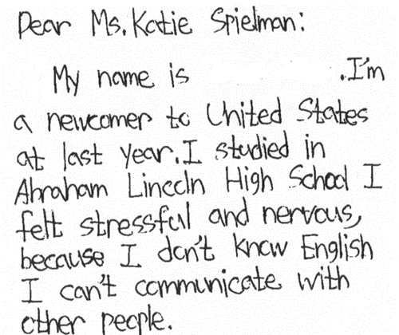

Dear Ms. Katie Spielman:
My name is ___. I’m a newcomer to United States at last year. I studied in Abraham Lincoln High School I felt stressful and nervous, because I don’t know English I can’t communicate with other people.

Now, I got the Cantonese-speaking paraprofessional aid. I’m very happy and enjoy to learn English. Thank you for your help.
Best regards,

Aimee,
You are a true blessing to us. I am ever so grate, for all you have done and taught me through this journey. May the Lord abundantly bless you. Love,

Kendra,
Thank you for your presentation on SSI – we are so grateful! We look forward to next one. (smile)

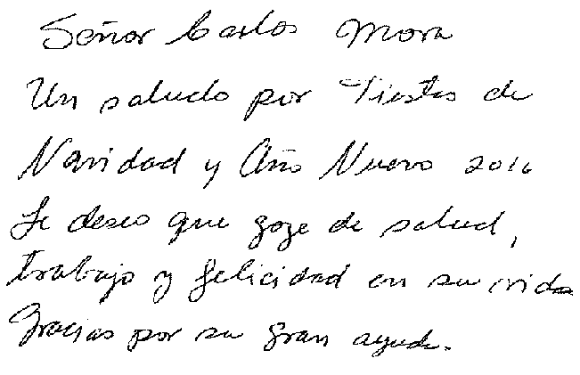
Señor Carlos Mora. Un saludo por Fiestas de Navidad y Ano Nuevo 2016. Le deseo que goce de salud, trabajo y felicidad in su vida. Gracias por su gran ayuda. (Mr. Carlos Mora. Greetings for Christmas and New Year 2016. I wish you enjoy health, work and happiness in your life. Thank you for your great help.)

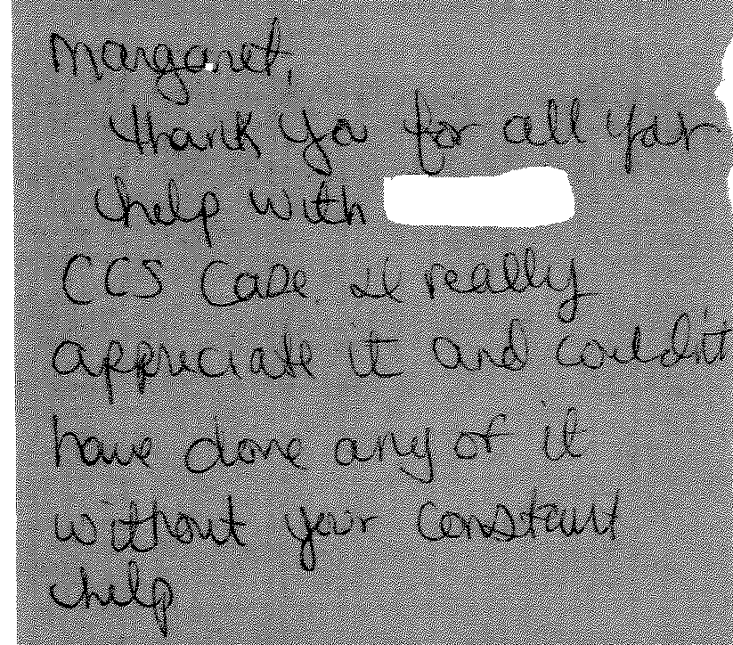

Margaret,
Thank you for all your help with ___ CCS case. I really appreciate it and couldn’t have done any of it without your constant help.

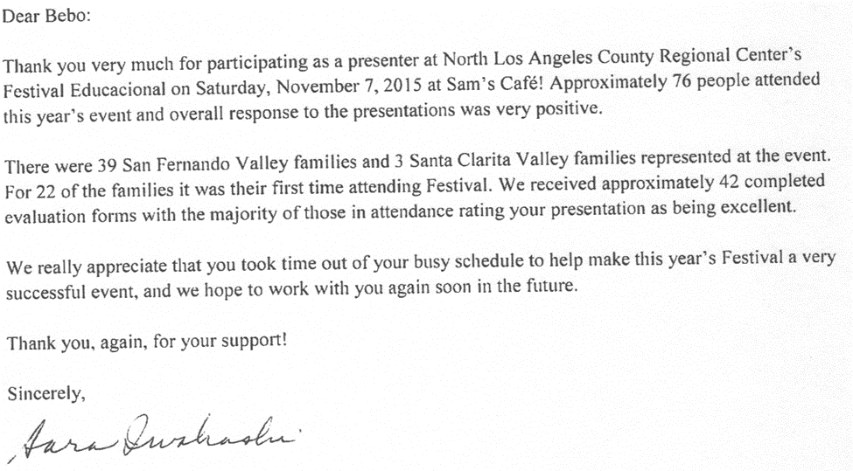
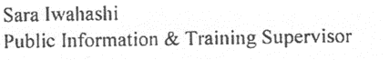
Dear Bebo:
Thank you very much for participating as a presenter at North Los Angeles County Regional Center’s Festival Educacional on Saturday, November 7, 2015 at Sam’s Café! Approximately 76 people attended this year’s event and overall response to the presentations was very positive.
There were 39 San Fernando Valley families and 3 Santa Clarita Valley families represented at the event. For 22 of the families it was their first time attending Festival. We received approximately 42 completed evaluation forms with the majority of those in attendance rating your presentation as being excellent.
We really appreciate that you took time out of your busy schedule to help make this year’s Festival a very successful event, and we hope to work with you again soon in the future.
Thank you again, for your support.
Sincerely,
Sara Iwahashi
Public Information & Training Supervisor

3) Cases will be handled in a timely manner.
Consumers and families contact OCRA because something has gone wrong for them. It may be that they are losing a government benefit, are being forced to move to a new more restrictive environment, or are facing another urgent situation. Therefore, it is important that OCRA staff be responsive. For this reason, OCRA has, since its establishment, had a policy that all calls will be returned as soon as possible, but not later than the close of the next business day. OCRA staff often note this policy on the outgoing voicemail message that callers hear when reaching the office voicemail.
OCRA measures its performance in this area by use of its consumer satisfaction survey; see Exhibit G, discussed more fully above. OCRA statistics shows that 90 percent of all callers to OCRA received a call back within two days during the last fiscal year. This is higher than last year, and much higher than the 84 percent reported in our last semi-annual report. OCRA will continue to use the electronic call logs and the extra Bilingual Assistant CRA support to preserve the positive timeliness and satisfaction responses by clients.

The provision of clients’ rights advocacy services is coordinated in consultation with the DDS contract manager, stakeholder organizations, and persons with developmental disabilities and m their families representing California’s multi-cultural diversity.
OCRA works through the OCRA Advisory Committee to ensure that this performance outcome is achieved. Attached as Exhibit H is a list of the members of the Disability Rights California Board of Director’s OCRA Advisory Committee effective December 31, 2015.
Public members of the Advisory Committee are appointed by the Board of Directors. In the selection process, the Board considers geographical diversity, both rural and urban and north and south, type of developmental disability represented, and ethnic background, in addition to the qualifications of the individual applicants.
The OCRA Advisory Committee provides valuable insight to the OCRA staff. A wide variety of topics are addressed at the meetings and board members become better self-advocates as a result of having been on the committee. Minutes for the meeting held on September 18, 2015, are included as Exhibit H. DDS staff is invited and encouraged to participate in the next meeting, which is set for March 11, 2016, in San Diego.

F. Self-advocacy training is provided for consumers and families at least twice in each fiscal year.
Welfare and Institutions Code, Section 4433(d)(5), requires that the contractor providing advocacy services for consumers of regional center services provide at least two self-advocacy trainings for consumers each year. Disability Rights California’s contract with DDS mirrors this language. OCRA strongly believes in the importance of self-advocacy and requires each of its offices to provide at least one self-advocacy training for consumers per year, far exceeding the two mandated trainings. Many offices provide more than one training per year. During this 6-month review period, OCRA staff provided 23 self-advocacy presentations statewide.
Staff may present from any of the approved self-advocacy trainings. To date, OCRA has developed six separate packets of information for OCRA staff to use in the mandated trainings in addition to the DDS Consumer Safety materials and the living arrangement options materials developed by DDS. The Peer Advocate, who provides self-advocacy training to consumers in restrictive settings like Canyon Springs, will continue to develop new self-advocacy training ideas. When OCRA hires the northern California Peer Advocate, this will be a joint effort. The Peer Advocate is also collaborating with members of OCRA’s training committee to provide an interactive “how-to” training on OCRA’s various self-advocacy trainings, including skits and acting. This will be a learning refresher for most OCRA staff, but new guidance to several new OCRA staff.
Samples of the OCRA self-advocacy packets (all are in both English and Spanish), were provided separately in a binder marked OCRA Training Materials with the 2007-2008 Annual Report. In discussions with DDS’s Contract Manager, it was decided that OCRA should not submit duplicate training packets in this year’s annual report. As always, OCRA welcomes comments from DDS on any training packets. A list of Self-Advocacy Trainings held last year are in Exhibit I.

III. TITLE 17 COMPLAINTS
CCR, Title 17, Section 50540, sets forth a complaint procedure whereby a regional center consumer, or his or her authorized representative, who believes a right has been abused, punitively withheld or improperly or unreasonably denied, may file a complaint with the Clients’ Rights Advocate. The Complaint process is similar to that established by Welfare & Institution Code, Section 4731. However, the later law offers more consumer protections. There were no Title 17 Complaints filed during this review period, as noted on Exhibit J.

IV. DENIAL OF CLIENTS’ RIGHTS
CCR, Title 17, Section 50530, sets forth a procedure whereby a care provider may deny one of the basic rights of a consumer if there is a danger to self or others or a danger of property destruction caused by the actions of a consumer. The Clients’ Rights Advocate must approve the procedure and submit a quarterly report to DDS by the last day of each January, April, July, and October. OCRA is including the reports concurrently with the contractual date to provide OCRA’s reports. If this is not acceptable to DDS, OCRA will submit duplicate reports as requested. Attached as Exhibit K is the current log of Denials of Rights from the OCRA offices.

V. CONSUMER GRIEVANCES
Exhibit A, Paragraph 12, of the contract between DDS and Disability Rights California requires OCRA to establish a grievance procedure and to inform all clients about the procedure. DDS has approved the grievance procedure developed by OCRA. The procedure is posted prominently in both English and Spanish at each office. Additionally, the grievance procedure is offered in all letters to consumers or others who contact OCRA, when an office declines to provide the requested service to that person.
During the 6-month review period, OCRA handled 5,120 matters. There were two first level grievances filed by consumers or their families. Neither of the grievances proceeded to the second level to be heard by the Disability Rights California Board of Directors. Attached as Exhibit L is a chart detailing the grievances filed against OCRA during this period.

VI. COLLECTION OF ATTORNEYS FEES
OCRA does not charge consumers, their families or advocates fees for services nor does OCRA seek to recover costs from these individuals. Clients’ Rights Advocates who are licensed to practice law in California, or Assistant , Associate, or unlicensed Clients’ Rights Advocates, all of whom work under the supervision of an attorney, can collect attorney’s fees and costs similar to those collected by private attorneys or advocates for special education cases or other cases where there are statutory attorney’s fees. Neither Disability Rights California nor OCRA ever collect attorney’s fees from consumers.
OCRA collected $1,200 in attorney’s fees from an ADA Title III complaint this fiscal year, see Exhibit M.

VIII. CONCLUSION
OCRA has continued to provide exceptional service to people with developmental disabilities throughout the state. OCRA handled 5,120 cases for 3,611 different clients. Additionally, OCRA provided 178 trainings to over 6,840 consumers, family members, regional center staff and vendors, and interested community members - all while meeting each of its performance objectives. OCRA looks forward to continuing to work with people with developmental disabilities and helping access the services and supports they need to live the most independent and productive lives in the least restrictive environment.

