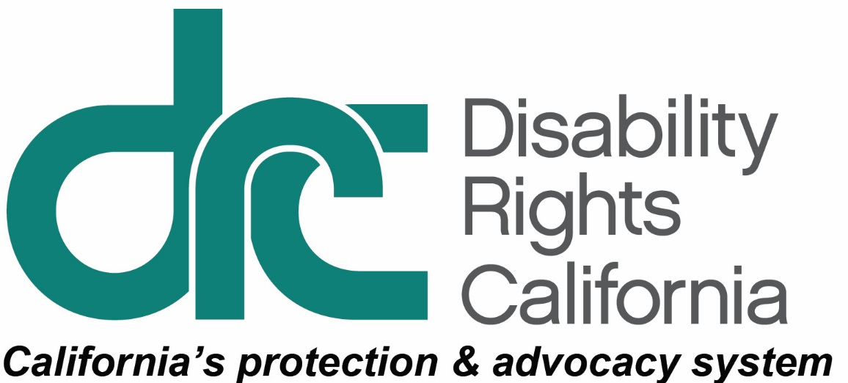

Request for Proposal:

Translate DRC Publications into American Sign Language (ASL) Videos

www.disabilityrightsca.org
RFP #2018-1
Released:
May 25, 2018
Deadline for Submission:
June 15, 2018 - 5pm, PST
RFP Table of Contents
Tentative Schedule of Events 3
About Disability Rights California 4
Overview 5
Expectations & Deliverables 5
Proposal Guidelines 6
Vendor Registration/Questions 6
Deadline for Submission 6
Withdrawal or Amendment of Proposal 7
Irrevocable 7
Subcontracting 7
Limitation 7
Vendor Presentations 7
Proposal Format 8
Proposal Sections 8
Section 1. Vendor Information 8
Section 2: Project Implementation Approach 9
Section 3: Additional Comments by Vendor 10
Section 4: Proposal Fixed Pricing Summary 10

Tentative Schedule of Events
RFP released: 5/25/2018
Vendor Registration/Questions submittal: 6/1/2018
DRC Response to vendor Questions: 6/6/2018
Proposals due back to DRC by 5pm, PST: 6/15/2018
Selected vendor presentations: 6/25/2018
Contract in Place by: 6/29/2018

About Disability Rights California
Disability Rights California (DRC) is a California non-profit, tax-exempt 501(c)(3) organization working since 1978 to advocate, educate, investigate and litigate to advance and protect the rights of Californians with disabilities. DRC is California’s federally mandated protection and advocacy system with an annual budget of 25 million dollars.
Disability Rights California has five regional offices located in Sacramento, Los Angeles, Oakland, Ontario, and San Diego, as well as 27 satellite offices throughout the State of California. Disability Rights California has over 200 employees.
Disability Rights California invites you to present a proposal to translate five DRC publications into American Sign Language (ASL) videos.
Disability Rights California is committed to providing individuals with disabilities information about their legal rights and services through our publications. To make sure our publications are accessible to people who do not speak English or are Deaf or Hard of Hearing, we translate our self-advocacy materials into other languages, formats and American Sign Language.
As a disability rights organization, it is critical that selected vendors comply with Section 508 & W3C 2.0 AAA web guidelines (these guidelines can be found at http://www.w3.org/consortium/) and provide materials that are fully accessible in both web and print formats. In addition, all vendor office locations must meet state and federal disability architectural access requirements (Americans with Disabilities Act and California Building Code).
This RFP does not commit Disability Rights California to award the fixed price contract to any entity that responds, or to pay any costs incurred in the preparation or mailing of a respondent’s response, or in participating in this RFP process. Disability Rights California expressly reserves the right to negotiate with some, all, or none of the respondents with respect to any term or terms of the responses.
The RFP proposals will be evaluated for consistency with our specifications for cost, scope of work and proposed time line/delivery. We will consider a number of other factors including price, quality, and customer service. Vendors must be licensed, bonded, insured, and not on the federal debarment and suspension list. Consideration will be given to past performance and financial and technical resources.
Additional consideration will be given to small business concerns, small disadvantaged business concerns, minority-owned or women-owned small business firms, HUB Zone small business concerns, veteran-owned small business concerns, and small businesses owned by persons with disabilities (OMB 2 CFR 200.321).

Overview
The purpose of this document is to solicit proposals from qualified vendors to translate five DRC publications into American Sign Language (ASL) videos. The chosen vendor will provide supervision, equipment, materials, and supplies required to perform the making and translating of the following five publications into ASL videos:
- Disability Rights California Brochure (5001.01)
- Client Assistance Program Brochure (5474.01)
- SSI Overpayments (5421.01)
- Department of Rehabilitation Service (5401.01)
- Disability Discrimination Fact Sheet (F109.01)

Evaluations of proposals will be performed by DRC staff. Based on information provided in the proposal responses, qualified vendors will be selected for on-site or live webinar presentations. Upon completion of the presentation, DRC expects to proceed with negotiation of a fixed price contract with the selected vendor whose proposal best meets our needs and budget. The selected vendor must sign a confidentiality agreement upon commencement of negotiations. If DRC is unable to successfully negotiate with the vendor, DRC reserves the right to begin negotiations with another vendor and maintains the right to not select any vendor.

Expectations & Deliverables
We expect the contractor to coordinate resources and manage the project to completion. We want a vendor with demonstrated ability to develop high quality translations into ASL videos. Completed videos will be exclusive property of Disability Rights California.
Anticipated vendor tasks include translating five DRC publications into ASL. Translated videos will include the following parameters:
  - Closed Captioning that can be turned on and off
  - Frontal Lighting
  - Black backdrop
  - Interpreters will wear solid black shirts
  - Interpreters will wear no jewelry
  - Final product can be uploaded on YouTube and DRC’s website
  - Individuals featured in ASL translation videos will be Certified Deaf Interpreters (CDI)

Statement for CDI:
Certified Deaf Interpreters (CDI) are deaf or hard of hearing individuals nationally certified by the Registry of Interpreters for the Deaf (RID). Holders of this certification are deaf or hard of hearing and have demonstrated knowledge and understanding of interpreting, deafness, the Deaf community, and Deaf culture. This is to provide accessible information interpreted in ASL for our Deaf communities in the state of California. When you interpret, keep in mind this is to reach a variety of Deaf members in the community to ensure they understand their resources that are available to them.

Proposal Guidelines

Vendor Registration/Questions
Vendors may pre-register by sending an email to alicia.mendoza@disabilityrightsca.org. Registration is not a requirement. DRC will only respond to emailed questions if submitted before the vendor question(s) deadline date. Questions must be emailed to alicia.mendoza@disabilityrightsca.org.
Any vendor that registers their email address in advance will be sent a copy of all of the questions and their answers. DRC will do its best to answer questions. However, we reserve the right not to answer any question.

Deadline for Submission
The deadline for RFP submission is referenced above. In the interest of a timely and demonstrably fair process, late submissions will not be accepted. Incomplete, qualified or conditional responses will not be accepted. However, DRC reserves the right to request clarification where the vendor’s response is unclear.

Withdrawal or Amendment of Proposal
A vendor (or designated representative) may withdraw or amend the proposal at any time prior to the specified proposal due date. The withdrawal must be requested via email.

Irrevocable
Responses must be submitted on a fixed price basis and shall remain irrevocable for 120 days following the deadline for RFP submission, except if there is a material decrease in price approved by DRC.

Subcontracting
The proposal must indicate whether the vendor plans to use subcontractors for any aspect of the work and must identify the proposed subcontractor in sufficient detail. The vendor remains fully liable for all work under its contract with DRC regardless of any subcontract and regardless of DRC’s approval of any subcontractor.

Limitation
DRC will not furnish remuneration for preparation of proposals or participation in presentations. Receipt of proposals from vendors in no way obligates DRC to the vendor. DRC reserves the right to reject any and all proposals.

Vendor Presentations
After we review proposals, DRC will select qualified vendors for a web or in person presentation. These presentations will occur during the time period above.
The presentations can be done in person or online and are expected to last 1-2 hours and must include:
- The vendor’s company overview and examples of its completed projects
- The vendor’s experience created ASL videos
- DRC staff questions about the vendor’s RFP proposal

Proposal Format
Submittal: 1 e-copy and 2 paper copies of the proposal formatted on 8 1/2" & 11" in a minimum font of Arial 14 point. The proposal must be signed by an individual authorized to bind the company and follow the same heading and format as outlined in the Proposal Sections below.
Paper copies are to be mailed to:
Disability Rights California
Alicia Mendoza-RFP #2018-1
1831 K St.
Sacramento, CA 95811
An electronic copy emailed to: Alicia.Mendoza@disabilityrightsca.org

Proposal Sections
Vendor is to use the heading and sections format below and explain how they will meet or address each of the following sections:

Section 1. Vendor Information
- Company history: Please provide a description of your company, organization, history, qualifications (copies of business licenses, insurance, and other certifications) and experience in translating into ASL and creating ASL videos. Please describe the kinds of service and support provided by your company and all of its certifications. Provide summary resumes of key technical staff who will be assigned to the project, including their relevant certification(s) (including CDI) length of employment, and who would most likely be responsible for initial and ongoing project coordinator. Please describe what differentiates your company from those of your competitors. Please describe any future changes in your organization that are planned such as mergers, acquisition, consolidation, change in key management, or any other factors that may affect this contract.
- Annual Reports: Please provide annual financial reports from the previous two years, or a comparable document, including detailed current profit and loss, assets and liabilities, and other relevant financial data. These statements will be reviewed by DRC’s Finance Director and be kept confidential.
- References: Provide (3) references for whom you have completed a similar ASL translation video. Provide the names, titles, e-mail address, and telephone numbers of contacts for each reference. DRC will contact references.
- Video Examples: Please provide Samples of at least 3 ASL videos you developed to demonstrate your work.
- Conflict of Interest: Please describe in detail any possible conflict of interest you know of that you or your firm may have with DRC, its key employees and board members (DRC board members are currently listed on DRC’s website).
- Minimum Vendor Business Qualifications: To be considered the vendor must demonstrate how it meets the following minimum requirements:
- The proposed vendor must have been in business for three years providing ASL translation.
- The vendor must possess all required business licenses, professional certifications or other credentials and evidence that, vendor, if a corporation, is in good financial standing and qualified to conduct business in California and with the Federal government.
- The vendor must have adequate liability and workers compensation insurance.

Section 2: Project Implementation Approach
Vendors must describe and demonstrate how their methodology and approach can successfully be applied to this project.
Vendor Deliverable
- The vendor must provide a proposed plan and timeline for each video completion. The vendor must take into account DRC’s requirement to review draft videos before they are finalized.
- Describe your process for change control, including process for recommending changes, participating in the decision process, and for documenting and implementing the approved changes within vendor’s proposed budget.

Section 3: Additional Comments by Vendor
Vendor Deliverable
This section is provided for the vendor to explain anything that may have been overlooked or not adequately addressed in this RFP that would or could affect the implementation of this system within DRC’s offices and culture. This section should also be used if you do not agree with, or do not understand items within this RFP, including the items outlined in the Proposal Guidelines section. Otherwise DRC assumes that you agree with and understand everything stated in the RFP.

Section 4: Proposal Fixed Pricing Summary
Vendor Deliverable
Include the following items (and any additional items) in the fixed pricing summary. Please be very specific:
- Video pre-production
- Certified Deaf Interpreters
- Production
- Video taping
- Editing
- Other costs (necessary for the successful creation of ASL videos)

