LEGISLATION & PUBLIC
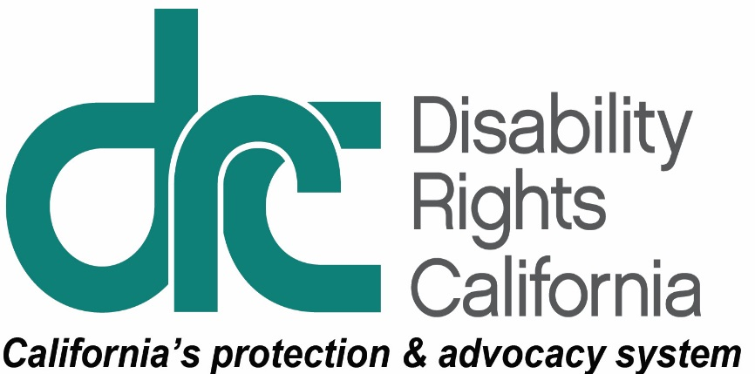
INFORMATION UNIT
1831 K Street
Sacramento, CA 95811-4114
Tel: (916) 504-5800
TTY: (800) 719-5798
Intake Line: (800) 776-5746
Fax: (916) 504-5807
www.disabilityrightsca.org
June 11, 2018

Summary of Selected Provisions of Interest to Persons with Disabilities in the 2018-19 Budget Agreement as Outlined in the Legislative Budget Conference Committee Close Out Agenda

Introduction
On June 8, the Governor issued a press release that he and Senate President pro Tempore Toni Atkins and Assembly Speaker Anthony Rendon have reached an agreement on the 2018-19 state budget. The Legislative Budget Conference Committee is reviewing the details later in the day. The Governor noted that this budget balances fiscal responsibility with social responsibility by significantly expanding the Rainy Day Fund and also making record levels of investment in education funding–both K-12 and higher education–child care access, and funding to fight homelessness and to protect children from living in deep poverty. Despite the legislature’s offers of significant additional spending on health care, human services programs, and housing and homelessness the Governor largely held to his insistence on increasing reserves and one-time funding.
The Conference Committee completed its work early Saturday morning taking the action that reflects many of the details in the announced budget agreement. The final budget and accompanying trailer bills are being prepared and will be taken up by the Legislature to meet the June 15 constitutional deadline. Subject to change, these are some of the relevant highlights of the Conference Committee actions:

SSI/SSP

CalFresh Cashout:
Eliminates the SSI/SSP cashout policy that denied CalFresh food benefits to SSI recipients and holds harmless current recipients who would otherwise lose benefits due to the change and appropriates $200 million one-time for the reversal.

COLA:
Reinstates the SSI/SSP cost-of-living adjustment for the grants beginning 2022-23.

IHSS/LTSS

Electronic Visitation Verification:
Adopts Budget Bill Language (BBL) providing the Department of Social Services up to $1 million spending authority once it provides the plan for the system, a description of stakeholder engagement activities, implementation timing and cost estimates. The BBL also specifies principles that the Administration must adhere to in implementing the system.

IHSS:
Adopts trailer bill language requiring the Department of Social Services to convene a sick leave workgroup for IHSS providers and appropriates $15.4 million to partially fund a shortfall in county administration.

Personal Care Services Waiver:
Appropriates $3.0 million General Fund ongoing and includes trailer bill language to establish county public authorities and nonprofit consortia as the employers of record for providers of waiver personal care services (WPCS) and adopts related changes to establish parity between WPCS and In-Home Supportive Services (IHSS) providers.

Long-Term Care Ombudsman
Approves $2.3 million ongoing for the Long-Term Care Ombudsman with a revised funding formula.

LTSS Data Request
Includes $6 million in one-time funding to collect and analyze data on access and needs for long-term services and supports through the California Health Interview Survey. Half of the funding will come from the state’s General Fund and the other half will be federal matching funds.

Developmental Disabilities

Suspension of Social Recreation and Camping:
Does not remove the suspension of social recreation and camping and does not fund these programs.

Uniform Holiday Schedule:
Funds all 14 days of the uniform holiday schedule with $29.3 million General Fund one-time, until 6/30/19.

Respite:
Requires that regional centers make available on their websites protocols and assessment tools to be used to determine need for respite services.

Self Determination:
Requires DDS, in consultation with its advisory group, to prioritize using state funds resulting from moving San Diego pilot participants prioritized to meet the needs of participants and implementation, including costs associated with: independent facilitators to assist with participants’ initial person-centered planning meetings; the development of the participants’ initial individual budgets; joint training of consumers, family members, regional center staff, and members of the local volunteer advisory committees; and regional center operations for case load ratio enhancement and to offset the costs to the regional centers in implementing the Self-Determination Program.

Safety Net Funding:
Rejected an additional $5.6 million for additional Community Safety Net services, which would have funded local mobile crisis services, assessment, planning and services to provide supports, intensive monitoring and case management with reduce service coordinator caseloads, and development of intensive wrap-around services for persons with developmental disabilities.

Acute Crisis Services:
Clarifies the procedural protections for consumers admitted to Porterville Developmental Center, requiring the regional center to notify the regional resource development project, the regional center clients’ rights advocate, the consumer, or the consumer’s legal guardian, or conservator, of a potential admission.

Institutes for Mental Disease (IMD)
Rejected costs associated with additional staffing to ensure department review of IMD emergency placement language protections for individuals in IMDs by requiring regional center to prepare a report justifying admission and DDS to review and discuss with regional center.

Health Care/Medi-Cal

Universal Coverage Task Force:
Includes $5 million one-time funding for a task force and language stating an intent to accomplish universal coverage and a unified publicly financed health care system.

Aged & Disabled (A & D):
Does not close the Aged & Disabled (A & D) Medi-Cal eligibility gap, to allow seniors and people with disabilities who are not otherwise eligible to get free Medi-Cal. A & D eligibility includes a $600 (approximate) share of cost, forcing many seniors and people with disabilities to choose whether to pay rent or get health care.

Pediatric Day Health Care Services:
Augments funding by $8.9 million for 2018-19 with additional increases through 2021-22.

Healthcare Workforce:
Includes various healthcare workforce proposals approved by both houses and proposed by the Governor, including funding for workforce programs at OSHPD and Graduate Medical Education programs at the University of California.

Mental Health

Incompetent to Stand Trial:
Approves trailer bill to establish an Incompetent to Stand Trial (IST) mental health diversion program that requires approval of county plans by both the Department of State Hospitals and the Council on Criminal Justice and Behavioral Health. Provides $150,000 (Prop 63 State Admin) per year for 3 years and adds one position to the Council.

Proposition 63:
Approves a Proposition 63 State Administration Fund Cap Package that includes increased funding for suicide hotlines, veterans’ mental health services, mentally ill individuals in the criminal justice system and others.

Public Safety

Youth Investment Fund:
Appropriates $37.3 million for the Assembly’s Youth Reinvestment Fund and for the following purposes: $26.3 million for Youth Diversion Programs; $10 million for social workers in public defender offices; and $1 million for Native Youth Diversion.

Reentry and Wrap:
Appropriates $50 million for the Reentry and Wraparound Services and budget bill language to specify the use of the funds.

Housing and Homelessness

Emergency Aid Block Grants:
Includes $500 million ($250 million above May Revision) one-time General Fund for emergency aid for local governments to respond to homelessness. The funding would be allocated as follows: $250 million as proposed in the May Revision allocated to Continuums of Care; $150 million direct allocation to a city or city and county with a population over 330,000; and $100 million allocated based on homeless population to the Continuums of Care.

Housing and Homelessness Trailer Bill Language:
Includes trailer bill language that would ask the voters to approve No Place Like Home program at the 2018 November election.

Education

K-12:

Proposition 98:
Provides $3.67 billion ongoing Proposition 98 funding for the Local Control Funding Formula, $407 million above the Governor’s proposed level.

Low-performing Students:
Allocates $300 million one-time funding for low-performing students.

Mental Health:
Includes $44 million to, in part, expand access to physical and mental health care school health centers.

Family Empowerment Centers:
Does not include federal IDEA funding for Family Empowerment Centers.

Willful Defiance:
Eliminates the sunset date, thereby extending the law that disallows the use of school suspension for acts of willful defiance provisions for K-3 students, but excludes charter schools.

Special Education:
Does not include any new funding for special education equalization.

Braille Institute Library
Appropriates $500,000 one-time General Fund to support operations at the Braille Institute Library in Los Angeles to backfill reductions in federal funding.

California Community Colleges

Online College:
Appropriates $100 million one-time and $20 million ongoing to create a new online community college to be administered by the Board of Governors and includes trailer bill language to ensure that students with disabilities who use the new college will have the same disabled student services that exist on the other campuses.

Mental Health:
Appropriates $20 million one-time for campus mental health services.

CalWORKs

Safety Net Reserve:
Creates a Safety Net Reserve with a CalWORKs subaccount and transfers $200 million to the account.

Child Poverty:
Provides $90 million beginning April 1, 2019 and $360 million on going as the first of three steps to get children and families to 50 percent of the Federal Poverty Level.

Deaf Access
Appropriates $4 million ongoing for the deaf access program which provides deaf and hard of hearing individuals with the communication services they need to access the state and local programs to which they are legally entitled. Funding for the DAP reached $5.8 million in Fiscal Year (FY) 1998-99. In FY 2008-09, funding for the program decreased by $0.6 million to $5.2 million and has remained at that level since.

Earned Income Tax Credit (EITC)
Expands the EITC to taxpayers who were previously ineligible due to their age, adjusts the credit to compensate for a rising minimum wage, and provides $10 million for outreach and tax preparations services.

Equal Access Fund
Provides for $10 million in ongoing funding in the Equal Access Fund beginning fiscal year 2019-20 making temporary funding permanent. DRC is a recipient of EAF funding which it uses to provide legal services to individuals with disabilities.

CDCR Janitorial Services
The Governor’s budget proposed to transition a contract held by a private contractor to civil service positions. Over 125 of the impacted employees are persons with disabilities who could be displaced. The proposed action would transition 50% of the employees to civil service and 50% of the positions would be maintained by the private contractor. Those remaining with the contractor would be the people with disabilities.

