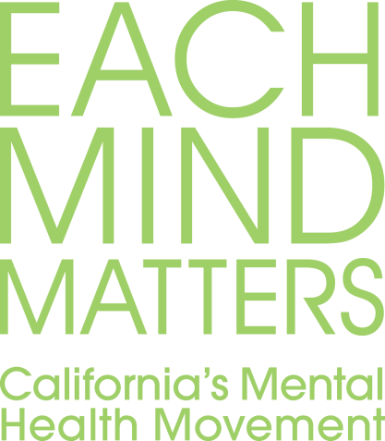
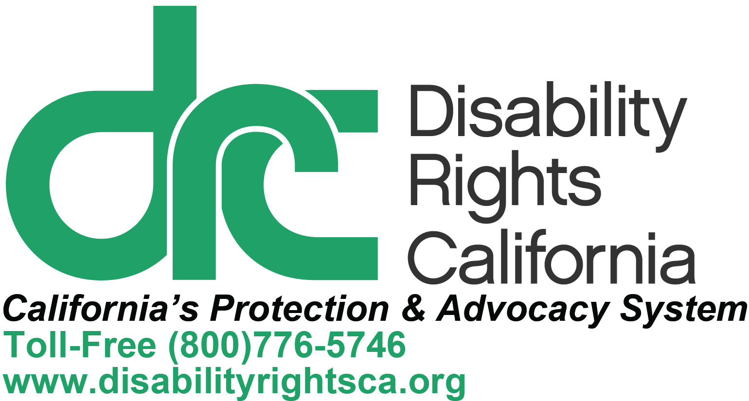
Legislative Filter to Help Spot Mental Health Stigma and Discrimination
June 2014, Publication #CM48.01
Here is a tool to help figure out if a bill or statute is discriminatory or stigmatizing towards Californians with mental health disabilities, thereby diminishing their opportunities and rights. It looks for language or content based on stereotypes that might tend to perpetuate stigma and lead to discriminatory consequences. If potential stigma or discrimination is identified through the use of this tool, we encourage changes to the bill or statute or a consultation with an attorney about possible legal implications. We encourage policy makers, advocates and mental health stakeholders to use this filter so as to reduce stigma and discrimination against people with mental health disabilities.
To use the tool, review each question and select the best answer. After answering all questions, review your answers in order to understand if the bill has a potential stigmatizing or discriminatory intent or impact. This will help identify where changes need to be made to eliminate the stigma and discrimination. Reducing stigma and discrimination ensures that people with mental health disabilities can lead productive lives in communities of their choice—something we all want.

1. Is mental health, disability or services a primary or secondary focus of the bill?
- No. Mental health / disability / services not mentioned at all.
- Secondary focus. Mentions mental health / disability / services, but is not the primary theme.
- Primary focus. The bill is focused on mental health / disability / services.

2. Does the bill use People First or stigmatizing language?
- People First Language: This refers to wording such as “individuals with mental health disabilities” or “an individual with a mental health challenge.” Do not use this category when terms like “mentally ill individuals” or “the insane” are used.
- Term as Adjective: Check this category if the bill uses the mental illness label as an adjective such as “mentally ill individuals” or “seriously emotionally disturbed (SED) children.”
- People defined or identified by their disorders: Check this category for bills that refer to people by their psychiatric diagnostic labels such as “the seriously mentally ill” or “schizophrenics.”
- Slang terms: Check this category for bills that use slang terms for mental illness, such as “abnormal,” “mentally defective,” “feeble-minded” or “deranged.” This includes the terms “insane” or “insanity” when it is NOT used in a clearly legal sense (i.e., Not Guilty By Reason Of Insanity).
- None of the above: Specify how bill relates to people with mental health challenges. __________________________________________________

3. Does the bill make assumptions about the characteristics or value of people with mental health challenges based on stereotypes such as:
- People pose a threat of danger or violence: __ Yes __ No
- People are unpredictable: __ Yes __ No
- People are incompetent / incapable of making decisions: __ Yes __ No
- People have poor judgment: __ Yes __ No
- People lack insight into their condition: __ Yes __ No
- People are to blame for their situation: __ Yes __ No
- Other: __ Yes __ No; if yes, specify: ______________

4. Does any aspect of the bill limit or deny the rights and liberty of individuals with mental health challenges, such as through:
- Increase in use of restraint (e.g., physical, chemical):
__ Yes __ No __ Can’t Tell
- Increase in use of seclusion (e.g., placement in an isolated, padded room): __ Yes __ No __ Can’t Tell
- Increase in use of involuntary treatment: __ Yes __ No __ Can’t Tell
- Increase in use of institutional confinement (e.g., jail, prison, or institution for people with mental health challenges): __ Yes __ No __ Can’t Tell
- Other: __ Yes __ No; if yes, specify: ______________

5. Does any aspect of the bill specify or result in a denial, reduction or elimination of resources or services for individuals with mental health challenges or a sub-group of individuals with mental health challenges?
__ Yes __ No __ Can’t Tell

6. Does any aspect of the bill specify or result in a denial, reduction or elimination of rights or protections for individuals with mental health challenges or a sub-group of individuals with mental health challenges with regard to the following:
- Decision-making about personal mental health services:
__ Yes __ No __ Can’t Tell
- Personal privacy: __ Yes __ No __ Can’t Tell
- Mental health information or records confidentiality:
__ Yes __ No __ Can’t Tell
- Personal property or belongings: __ Yes __ No __ Can’t Tell
- Housing opportunity: __ Yes __ No __ Can’t Tell
- Employment opportunity: __ Yes __ No __ Can’t Tell
- Family law interests (e.g., parental rights, divorce):
__ Yes __ No __ Can’t Tell
- Guardianship / conservatorship interests (e.g., hire attorney, select representative): __ Yes __ No __ Can’t Tell
- Personal ability to handle one’s own finances (e.g., representative payee):
__ Yes __ No __ Can’t Tell
- Ability to vote: __ Yes __ No __ Can’t Tell
- Ability to contract: __ Yes __ No __ Can’t Tell
- Ability to possess a driver’s license: __ Yes __ No __ Can’t Tell
- Ability to possess a firearm: __ Yes __ No __ Can’t Tell
- Other: __ Yes __ No; if yes, specify: ______________

7. Does any aspect of the law target denial, reduction or elimination of liberties, resources or services, or rights and protections based on an assumption or perceived characteristic of people with psychiatric disabilities?
__ Yes __ No __ Can’t Tell
The bill potentially has a discriminatory intent or impact against people with mental health disabilities if you answered “yes” to ANY questions between three and seven.

We want to hear from you! Please take a short survey to give us your feedback.

English version: http://fs12.formsite.com/disabilityrightsca/form54/index.html
Spanish version: http://fs12.formsite.com/disabilityrightsca/form55/index.html
Disability Rights California is funded by a variety of sources, for a complete list of funders, go to http://www.disabilityrightsca.org/
Documents/ListofGrantsAndContracts.html.

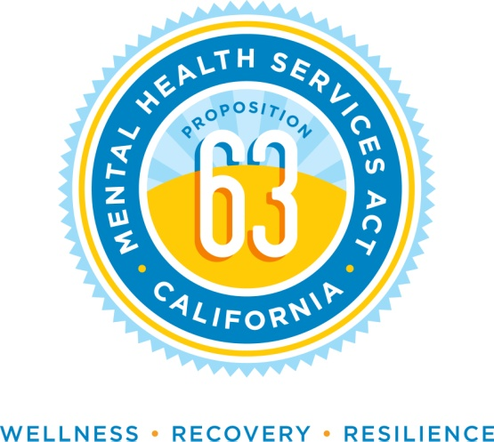
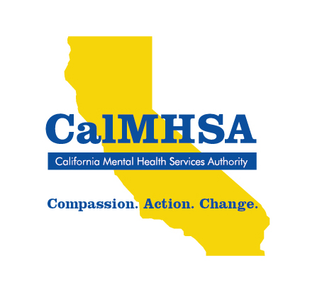
The California Mental Health Services Authority (CalMHSA) is an organization of county governments working to improve mental health outcomes for individuals, families and communities. Prevention and Early Intervention programs implemented by CalMHSA are funded by counties through the voter-approved Mental Health Services Act (Prop 63). Prop. 63 provides the funding and framework needed to expand mental health services to previously underserved populations and all of California’s diverse communities.

