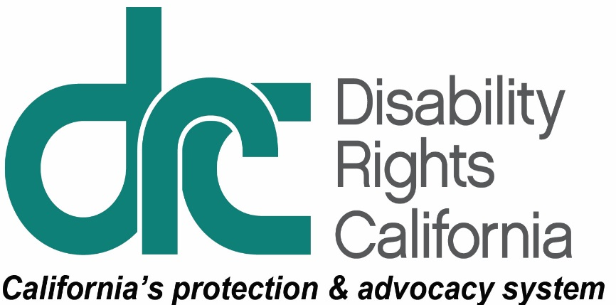
Office of Clients’ Rights Advocacy
1321 I Street, Suite 3
Modesto, CA 95354
Tel: (209) 242-2127
TTY: (877) 669-6023
Toll Free: (800) 390-7032
Fax: (209) 462-7020
Christine.Hager@disabilityrightsca.org
Serving Consumers of Valley Mountain Regional Center www.disabilityrightsca.org

MEMORANDUM

TO: Katie Hornberger, Director

FROM: Jazmin Romero, Outreach Coordinator South
Christine Hager, Outreach Coordinator North

RE: Annual OCRA Outreach Report
July 2015 – June 2016

DATE: August 11, 2016

OCRA’s commitment to educating communities, building long lasting relationships of trust and developing on-going connections with the people we serve is accomplished by providing outreach and training. Each office develops plans with objectives to reach goals in the areas of General, Target, and Self-Advocacy outreach trainings. During the 2015-2016 fiscal year, OCRA presented 488 outreach presentations impacting approximately 16,039 consumers, families, service providers, and community members. This is a 16.46% increase in the number of trainings from the previous year and 9% increase in the number of people attending these presentations. OCRA’s commitment to networking and building relationships with new target communities and continuing to strengthen existing relationships is demonstrated in the increase of outreach trainings and number of people served through outreach.

Self-Advocacy Trainings
OCRA has a continued commitment to self-advocacy and has both a peer-advocate and a peer-trainer on staff who educate and empower clients and are available to collaborate on cases and assist with outreach for all 21 OCRA offices. As well, each OCRA office is required to provide at least one self-advocacy outreach presentation per year. During this outreach plan year OCRA provided 42 self-advocacy presentations. This is an 82% increase in the number of self-advocacy presentations provided during this year. The purpose of a self-advocacy outreach is to educate and encourage consumers directly on their individual rights in areas such as fair hearings, emergency preparedness, clients’ rights, voting rights, money management, and community living options. Below are descriptions of self-advocacy presentations provided by OCRA:

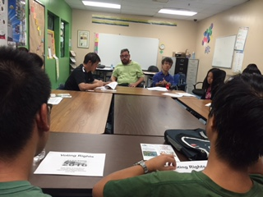
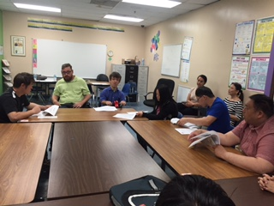
Voting Rights. On Saturday June 25, 2016 Scott Barron, Peer Advocate, was joined by regional office Voting Rights Advocate to prepare the Chinese SAGE self-advocacy group for the upcoming presidential election in November. The Chinese SAGE group is a self-advocacy group of young Chinese regional center consumers from across the Los Angeles area. The Vice President of Chinese Sage, Alex White, wrote the following statement: “We have spent time getting to know each other, attending trainings, and social events. We think it is important for Chinese SAGE members to now become good citizens in our community. Our project idea is to help train Chinese SAGE members to vote. A lot of our members don’t know what voting is. This year is a very important election year because President Obama is almost done as the President of the United States of America.” OCRA has agreed to provide two additional trainings in the future with one for the parents and the second to Sage members in order to discuss voting experiences. OCRA looks forward to continue building this ongoing relationship with Chinese Sage and watching them become stronger self-advocates.

Where to Live. The Community Integration Clients’ Rights Advocate, Stephen Zollman, presented a “Where to Live” self-advocacy training in Building 7 of Sunrise Industrial Services in early June 2016. Sunrise is a day program on-site at Sonoma Developmental Center. Consumers were presented options on the different living arrangements in the community that they can choose from as they prepare to leave the developmental center. As part of the training, consumers described their plans to move into the community placement of their own choice. Consumers left the training with more understanding of their options.

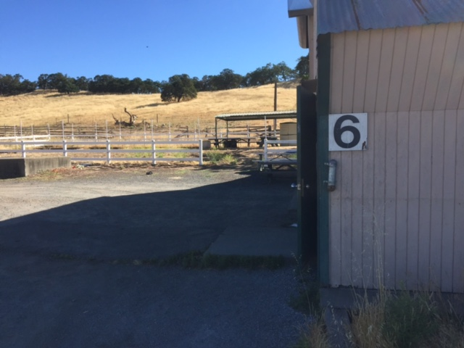
Just a few weeks after the training at Sunrise, OCRA conducted another “Where to Live” self-advocacy training in Building 6. Consumers’ faces lit up as they listened to their community living options. In order to continue building relationships and spreading the word about community living options, more self-advocacy trainings are being scheduled at Sonoma Developmental Center.

Statewide Outreach Presentations (General Outreach)

This year, general outreach counted for 280 of 488 outreach presentations. This is an 8.5% increase from the previous outreach year. General outreach can be introductory, What is OCRA?, or on a substantive legal topic and it’s provided to our regional center catchment communities which enables us to establish a network of referral sources and contributes to the development and maintenance of our community contacts. Below are two examples of general outreach:

OCRA Provides Negotiations Skills Training to Regional Center Staff.
OCRA was honored to be invited by a regional center to train 130 service coordinators and other staff as part of an all-day training held in August 2015. OCRA prepared and presented a well-received 90-minute training entitled: Effective Negotiation: Tips & Techniques for Every Negotiation Setting.

Service coordinators negotiate daily in many different settings, including informal meetings and more formal circumstances such as IHSS assessments or IEP meetings. OCRA began with some basics about effective negotiation, the Three Rs: 1. Respect: always treat one’s negotiation opponents with respect. Give them room to pivot (change their position without feeling backed against a wall) and a reason to do so (new information or a new perspective). 2. Reputation: maintain a reputation for integrity and honesty by only providing accurate information and always approaching any negotiation with a pleasant attitude and a professional demeanor. 3. Relationship: build trust and repair damaged relationships.

OCRA emphasized that effective negotiations focus on the problem rather than personalities. We acknowledge that if we enter into negotiations acting “as if” the folks on the other side will act in good faith, chances increase that they will. Further: we need to identify interests in common as well as to acknowledge genuine obstacles facing the other side. Educate gently. Be a willing team member, with the aim of a true collaboration. Ask: how can we fix this problem together? What can I do to help us get to solution?

OCRA, knowing that 90 minutes is a long time to listen to one primary voice, arranged to intersperse this material with short vignettes. Regional center staff were invited ahead of time to conceive and role play three different vignettes highlighting common negotiation settings. The vignettes were amusing, as the service coordinators hammed it up, but also instructive. They provided a good vehicle to demonstrate the challenges and rewards of effective negotiation. Anonymous written evaluations of this training affirmed regional center staff found it very helpful and intended to employ the tips and techniques shared.

WESTSIDE JAM. The Westside Jam is an annual self-advocacy fair for individuals served by Westside Regional Center, which celebrates consumers and encourages self-advocacy by providing a fun evening of food, socializing, awareness and client recognition. This year’s jam brought dozens of vendors throughout Los Angeles together in one place, which gave clients the opportunity to learn more about services and providers available to them, including OCRA. In keeping with the Westside Jam’s 2016 theme of “In Unity There is Strength,” the entire event was MC’d by WRC consumers, provided a wonderful opportunity to showcase their individual talents, and also highlighted local heroes who exemplify the themes principle by nominating and awarding clients with the “Hero in Me” Award.

OCRA staff shared in the occasion by hosting a table where clients could meet-and-greet their local CRA, ACRA and Peer Advocate, ask questions about their legal rights, and take publications that interested them. Most importantly, clients and potential clients were given the opportunity to discover OCRA as a resource for advocacy and legal services in the future.
Target Outreach

OCRA focuses target outreach on underserved communities identified in each offices’ outreach plan. These communities include: the Latino community, the Asian community including Chinese, Japanese, Korean, Vietnamese, Hmong, Filipino and Polynesian; the African American community and the Native American community. Target outreach is intended to inform and educate people with developmental disabilities and their families about their rights and the availability of services from OCRA. This year OCRA conducted 166 target outreach presentations, a 20% increase from the previous outreach year. Below are three examples of target outreach presentations:

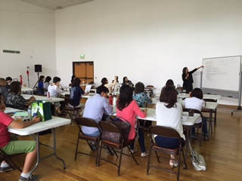
Japanese Families Learn of an Exciting New Opportunity to Save for Their Children’s Future Under the New ABLE Act. The exciting new federal law titled the Stephen Beck Jr., Achieving a Better Life Experience Act of 2014 (“ABLE Act”), is well on its way to being implemented in California in the next few months. For far too long, persons with disabilities have been unable to accumulate savings for much-needed expenses without jeopardizing eligibility for public benefits. This disadvantage will soon change with the implementation of the ABLE Act. On Saturday, May 14, 2016, a group of 14 regional center Japanese families and consumers gathered in the Boyle Heights area of Los Angeles at the Rissho Kosei Kai Buddhist Church to learn more about this new law and how it could help regional center consumers save for their future and their disability-related expenses. OCRA used professional services from a Japanese-speaking interpreter to provide a training on this important piece of legislation. They explained the ABLE Act and how SSI beneficiaries and their family members can use this new financial planning tool to have a better future with some savings in the bank that will not affect their SSI eligibility. So far this summer, the state of Ohio has been first in the nation to begin implementation of the ABLE Act, but California is likely to follow soon. OCRA looks forward to conducting additional trainings in other languages on the ABLE Act to help consumers and their families understand this important new legislation.

Transition to Adulthood for Spanish Speaking Parent Group
All families must be prepared for their child to transition from the public school system into the adult world. The goal for any family is to ensure that their child is prepared for the future. For families with children with developmental disabilities it is very important to have the knowledge of what transition to adulthood means and what resources are available to help the child become as independent as possible. For parents that speak Spanish, it can be more difficult to understand when to start planning, how to determine appropriate goals, and what resources, supports and services are available before, during, and after transitioning occurs.
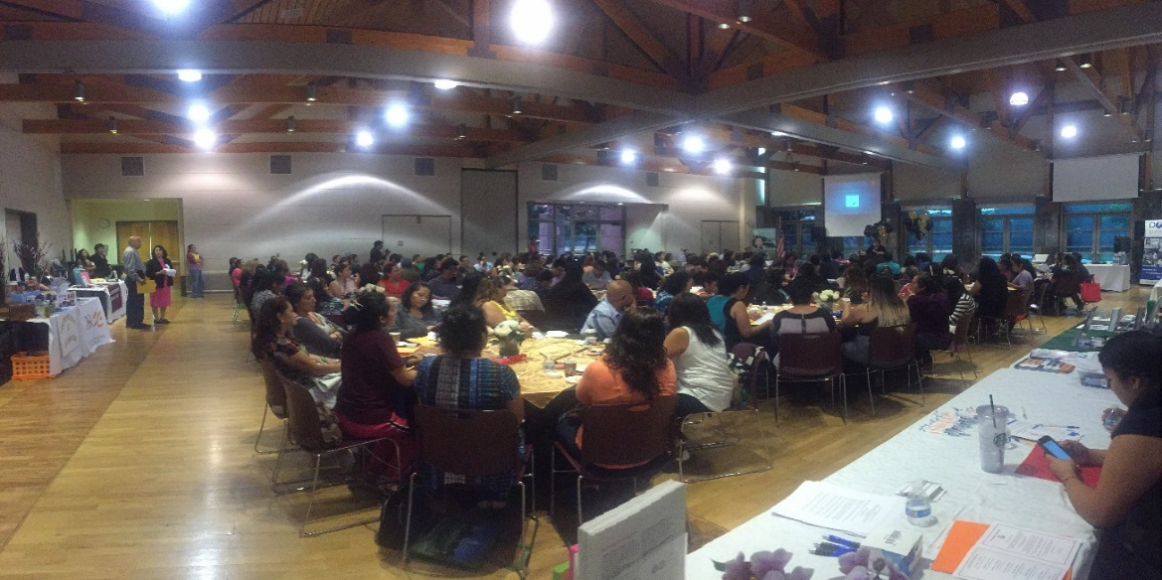
On September 28, 2015, OCRA presented a workshop in Spanish on transition to adulthood to the Orange County Spanish speaking parent group, Fiesta Educativa. OCRA presented an overview of what an Individualized Transition Plan was and how to assist their child in being an active participant in creating their goals and individualized plan for the future. Post-secondary education, integrated employment, SSI, independent living and community participation were some of the topics discussed with the parents. During the discussion, parents were provided answers to their many questions about different aspects of transition planning. Parents expressed that they had obtained information they needed to help their child to prepare for the future. Parents were also happy to know that they could call OCRA and speak to a Spanish speaking advocate regarding any future questions.

OCRA Does a Series of Trainings for Asian-American Family Support Group. After several years of successfully targeting Spanish-speaking parent groups, the Office of Clients’ Rights Advocacy (OCRA) that serves Regional Center of the East Bay (RCEB) consumers turned its attention to the Asian-American community, which is unfortunately underrepresented. OCRA set out with an ambitious goal to work with a local parent support group called Friends of Children with Special Needs (FCSN) to do three different trainings within a three month period. Although the Asian-American community was a new target group for the RCEB OCRA office, the Clients’ Rights Advocate had already established a relationship with FCSN, having done several trainings for the group in the past.

First, OCRA met with the group to give a training on the always-popular topic of special education. They included a discussion of “What is OCRA” and even touched on “Self-Determination.” OCRA brought lots of handouts in both English and Chinese. It was a potpourri of topics, but the audience was lively and engaged throughout. The next training covered transition services. OCRA saw a mixture of new and familiar faces as he covered what happens when children become young adults. For the final training, OCRA once again covered multiple subjects and this time the topics were the “DD Waiver” and the “Affordable Care Act.” More trainings are sure to come.

Conclusion

As an organization it is exciting to see OCRA offices continue to exceed outreach goals and collaborate with the Peer Trainer and Peer Advocate. We have high expectations that we will end the 2016-2017 Outreach plan year with outreach goals met and new relationships developed.

We appreciate the opportunity to assist OCRA in the important work of outreach. Thank you for this opportunity.

