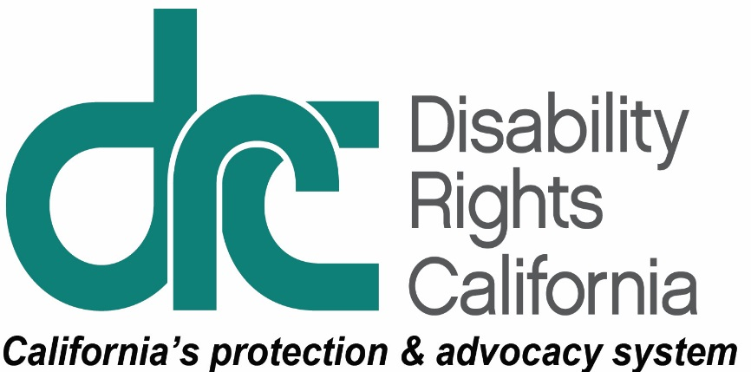**Office of Clients’ Rights Advocacy**

1321 I Street, Suite 3

Modesto, CA 95354

Tel: (209) 242-2127

TTY: (877) 669-6023

Toll Free: (800) 390-7032

Fax: (209) 462-7020

Christine.Hager@disabilityrightsca.org

Serving Consumers of Valley Mountain Regional Center www.disabilityrightsca.org

MEMORANDUM

TO: Katie Hornberger, Director

FROM: Mary Melendrez, Outreach Coordinator South and Christine

Hager, Outreach Coordinator North

RE: Annual OCRA Outreach Report, July 2014 – June 2015

DATE: August 17, 2015

OCRA’s commitment to educating the communities we serve in the areas of General, Target, and Self-Advocacy trainings is an important part of our work. During the 2014-2015 fiscal year, OCRA has presented 419 outreach presentations impacting approximately 14,711 consumers, families, service providers, and community members. This is a 7.7% decrease in the number of trainings from the previous year and 26.22% decrease in the number of people attending these presentations. The decrease is based on the development of a more accurate reporting system in which the total number of consumers, families, service providers, and community members that OCRA comes in contact with at large events is reported versus reporting the total number of attendants. This ensures that our count accurately reflects the number of people we spoke to at an event. OCRA staff continues to provide quality trainings that have a positive impact on the lives of the consumers and community members.

# Self-Advocacy Trainings

OCRA has a continued commitment to self-advocacy. Currently, OCRA has a Peer Advocate who educates and empowers clients and is available to collaborate on cases and assist with outreach. Additionally, although the goal of each OCRA office is to conduct at least one self-advocacy outreach presentation per year, many offices exceed this requirement. During this outreach plan year OCRA provided 45 self-advocacy presentations. The purpose of a self-advocacy outreach is to educate and encourage consumers directly on their individual rights in areas such as emergency preparedness, clients’ rights, voting rights, money management, community living options and the right to integrated competitive employment. Below is a description of some of the presentations provided by OCRA:

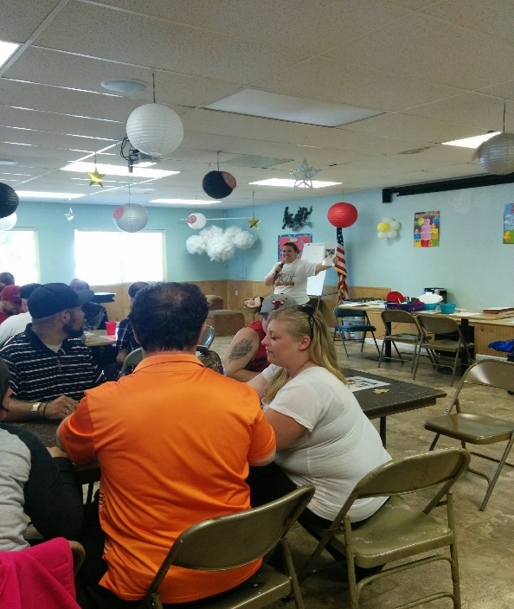

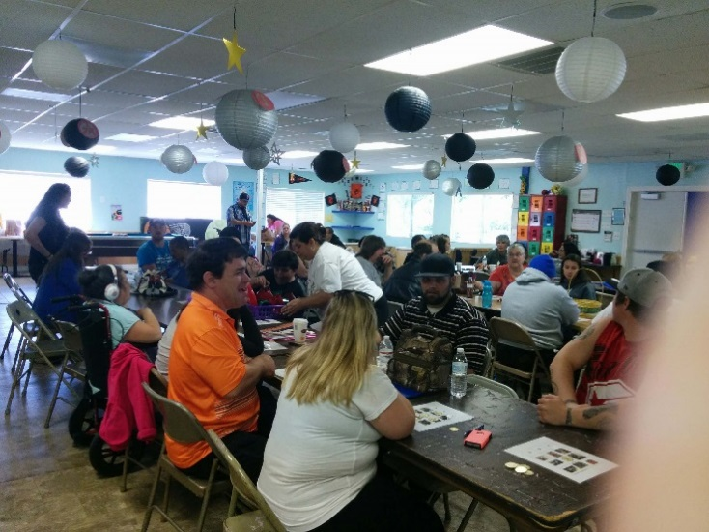

***Youth Center Clearlake Bingo game and winner announced!***

***Clients’ Rights Bingo.***The OCRA office that serves consumers of Redwood Coast Regional Center, organized a self-advocacy training at Youth Center Clearlake. Several different local day programs and other members of the community were invited by the Association of Behavior Consultants. Association of Behavior Consultants provides programs and services to adults with physical and developmental disabilities in the community.

The training consisted of a game called, “Clients’ Rights Bingo.” Before the game started, we briefly talked about basic rights. Bingo cards were given to each person. The bingo cards display photographs of people with disabilities, engaging in activities such as gardening, dating, cooking, shopping, and more. We held up each image, one at a time, and asked what the person was doing, and what right was being displayed. The consumers were very excited as they yelled out the answers. The winners of the game received a variety of bingo prizes including pens, rulers, keychains and other small items with OCRA information imprinted on them.

Everyone was given the opportunity to speak about their personal experiences throughout the game. The ultimate goal was to teach people through examples of their rights and how to know if their rights are being violated. It was a huge success! Several members of the community expressed an interest in future trainings. We were told that there were not enough seats to invite all local day program groups, so they requested that we come back in a few months to train other groups.

***Clients’ Rights.***On July 14, 2015, Peer Advocate Scott Barron and Assistant Clients Rights’ Advocate Cynthia Salomón-Ponce were invited to provide a Clients’ Rights training to a group of 27 individuals at South Bay Vocational Center, a day program located in Carson. After a warm welcome from the staff, they used the “Clients’ Rights Bingo” game to inform clients of their rights. As the game progressed, clients enjoyed the candy prizes and began to actively share with the group what they learned from our game of bingo. Individuals shared rights that they learned such as the right to unopened mail, the right to attend a church of their choice, and the right to use the phone. We discussed the importance of knowing our rights and as well as the IPP process and how it could also play an important role in preserving our rights. The group seemed to be well-informed and showed strong self-advocacy skills.

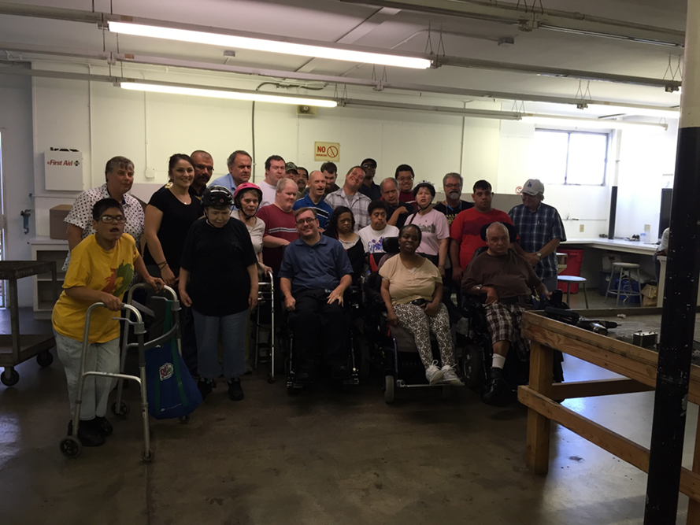

***Self-Advocacy Conference session attendees.***

# Statewide Outreach Presentations (General Outreach)

This year, OCRA presented 236 general outreach presentations. General outreach can be introductory or substantive and it’s provided to our Regional Center catchment community which enables us to establish a network of referral sources and contributes to the development and maintenance of our community contacts. Below are two examples of general outreach:

***My Self-Advocacy Journey and My Rights!*** On May 5, 2015, Christine Hager of the Office of Clients’ Rights Advocacy in Modesto and Kristina Franzone of the Self-Advocacy Council VI in Stockton collaborated to provide a session at the Supported Life Institute’s Annual Self Advocacy Conference in Sacramento. “My Self-Advocacy Journey and My Rights” focused on the power of a self-advocate using Think, Plan, Do, a publication from DDS to achieve goals, exercise rights and live their dream. Approximately 43 people attended the session and the questions and comments after the session clearly indicated the audience appreciated hearing the story of one self-advocates’ journey through the ups and downs of life including one attendee who is now going to become a self-advocate.

***Transition Night 2015.*** It was an exciting night for young adults and family members of persons with disabilities at the 2015 Transition Night, sponsored by the School of Continuing Education (SCE). SCE is a college program for individuals with disabilities. Transition Night is very popular, and this year several hundred people attended. Some students prepared and participated in a fashion show that helped the audience learn about appropriate work attire. There were several service providers on hand to discuss options for students for living arrangements, and supports and services for education, mobility training, and independent living. The Department of Rehabilitation and other service providers discussed supported employment service options. Disability Rights California Regional Office, Office of Clients’ Rights Advocacy (OCRA) and the Clients’ Assistance Program advocates met several young adults and discussed employment and education rights. OCRA also met several persons interested in regional center eligibility.

# Target Outreach

OCRA offices focus target outreach on traditionally underserved communities. These communities of color are defined in each OCRA office’s outreach plan. Target outreach is intended to inform and educate people with development disabilities about their rights and the availability of services from OCRA. This year OCRA conducted 138 target outreach presentations. Below are two examples of target outreach presentations:

***IHSS Training for Spanish Speaking Parent Group.***In-Home Supportive Services (“IHSS”) is an essential service to many of our clients. IHSS helps individuals with disabilities remain safely in their homes while trusted providers – often family members – are paid to assist them with everyday tasks, such as grocery shopping, bathing, grooming, and housework.

Many non-native English speakers find it difficult to navigate the IHSS system to learn more about whether their family members are eligible for IHSS or how they can help them obtain increased service hours through the program. With this in mind, OCRA’s office serving Far Northern Regional Center and six monolingual Spanish-speaking parents of consumers gathered on a Friday evening in May 2015 to eat dinner and learn about IHSS. This event was held in collaboration with Far Northern Regional Center and Rowell Family Empowerment Center. Rowell hosted the event at its Redding center, providing childcare and dinner.

OCRA staff began with an overview of OCRA, explaining the free legal and advocacy services that OCRA provides for consumers and their families. Next, OCRA provided information about IHSS, employing a Spanish-language PowerPoint presentation. The presentation provided basic information about eligibility and rights to IHSS, focusing on personal care assistance hours as well as protective supervision. An overview of the appeal process was also provided, including the critical importance of timely filing of paperwork to preserve one’s rights. Families were encouraged to access OCRA services for advocacy support as needed with IHSS and other agencies. The presentation ended with a lively question and answer session. Each attendee went home with several Spanish-language Disability Rights California publications on IHSS to use as reference materials for the future.

***Social Security Legal Clinic.*** On March 23, 2015, OCRA coordinated a target outreach/legal clinic at Frank D. Lanterman Regional Center about social security issues. Spanish-speaking parents met with OCRA staff one at a time with specific and general questions about SSI and SSDI. This type of event was a first for Frank D. Lanterman Regional Center and OCRA. The feedback was that parents found it helpful to have individual time with an advocate. OCRA and Regional Center are planning a follow-up outreach/legal clinic about IHSS questions. Next time, OCRA will host the event.

# Conclusion

As an organization it is exciting to see OCRA offices continue to exceed their outreach goals. With new plans developed for the coming years we look forward to all OCRA can do.

We appreciate the opportunity to assist OCRA in the important work of outreach. Thank you for this opportunity.