LEGISLATION & PUBLIC
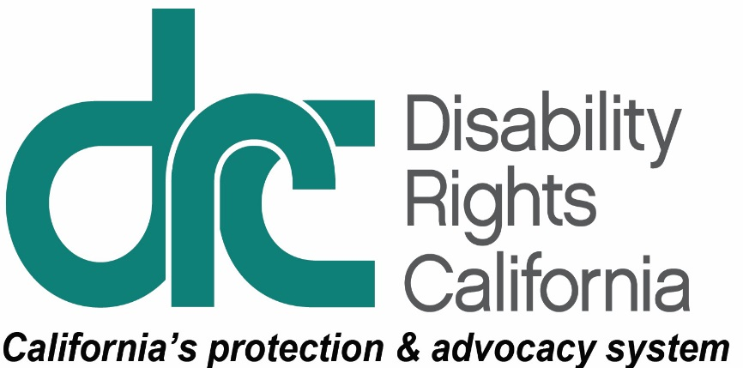
INFORMATION UNIT
1831 K Street
Sacramento, CA 95811-4114
Tel: (916) 504-5800
TTY: (800) 719-5798
Intake Line: (800) 776-5746
Fax: (916) 504-5807
www.disabilityrightsca.org
March 29, 2018
Honorable Lorena Gonzalez Fletcher
Chair, Appropriations Committee
California State Assembly
Capitol Building, Room 2114
Sacramento, CA 95814

RE: AB 2244 (ACOSTA) – SUPPORT
Dear Assembly Member Gonzalez Fletcher:
Disability Rights California (DRC), a non-profit advocacy organization that advances and protects the rights of Californians with disabilities, supports AB 2244. This bill is scheduled for hearing in the Assembly Appropriations Committee on April 4, 2018.
AB 2244 creates an expedited review process of a health and safety waiver request in the Department of Developmental Services (DDS) system. The expedited health and safety waiver review applies in circumstances where there is an imminent and serious threat to the health and safety of a consumer, such as when an individual is in crisis and at risk of more restrictive placement or placement in a less integrated setting.
In other circumstances where there is not an imminent and serious threat to the health and safety of the individual, the bill deems an individual waiver request approved if the department does not act within 30 calendar days of receipt, unless the director determines that additional time is necessary to evaluate the request. In that instance, AB 2244 allows the department an additional 30 calendar days to act on the request and authorizes additional extensions of time only upon agreement of all parties.
To ensure accountability, the bill also: 1) requires the department to provide receipt of requests and the contact information of the representative handling the request to the regional center; 2) authorizes the consumer or the regional center to request a meeting with the representative handling the request; and 3) requires DDS to annually report to the Legislature the age of each health and safety waiver request as specified in the bill, and to make that information available on its website.
Further, AB 2244 requires DDS: 1) to adopt a review process in regulations to address systemic issues with provider rates; and 2) to render a decision on the requested review no later than 60 calendar days after receipt of the request, unless the director determines that additional time is necessary to evaluate the request and notifies the regional center.
The current health and safety waiver process is cumbersome, lengthy and delayed. Waiting multiple months for approval of a health and safety waiver where an individual is in crisis and at risk of placement in a more restrictive, less integrated setting, simply does not work. Creating timelines, processes, and accountability in the review of health and safety waiver requests, including allowing for an expedited review process in those circumstances where there is an imminent and serious threat to the health and safety of a consumer, will ensure that consumers get the services they need to remain in the community. These changes will also do much to address current problems in the system, which is inundated with requests. Finally, developing a review process to deal with ongoing systemic issues with provider rates will also strengthen the community-based system that is now the safety net for regional center consumers. For these reasons, DRC supports the bill.
Sincerely,
Evelyn Abouhassan
Senior Legislative Advocate
Disability Rights California
cc: Honorable Dante Acosta, California State Assembly
Matthew Easley, Legislative Director, Office of Assembly Member Acosta
Honorable Members, Assembly Appropriations Committee
Jennifer Swenson, Principal Consultant, Assembly Appropriations Committee

