OCRA ANNUAL REPORT

JULY 1, 2019 – JUNE 30, 2020

TABLE OF CONTENTS
PAGE
OCRA ANNUAL REPORT 1
JULY 1, 2019 – JUNE 30, 2020 1
I. INTRODUCTION 2
II. PERFORMANCE OBJECTIVES 3
A. Services are provided in a manner that maximizes staff and operational resources. 4
1) Advocacy Reports. 5
2) Analysis of Consumers Served. 7
3) Analysis of Consumers Assisted with Moving to a Less Restrictive Living Arrangement. 9
4) Outreach/Trainings. 12
B. Issues and complaints are resolved expeditiously and at the lowest level of appropriate intervention. 13
C. Collaborative and harmonious working relationships are fostered. 13
1) Memorandums of Understanding. 14
2) Meeting with Association of Regional Center Agencies (ARCA). 14
D. Consumers and families are satisfied with the services provided. 15
1) Consumer Satisfaction Survey. 15
2) Letters of Appreciation. 16
3) Cases will be handled in a timely manner. 19
E. The provision of clients’ rights advocacy services is coordinated in consultation with the DDS contract manager, stakeholder organizations, and persons with developmental disabilities and their families representing California’s multi-cultural diversity. 19
F. Self-advocacy training is provided for consumers and families at least twice in each fiscal year. 20
III. TITLE 17 COMPLAINTS 23
IV. DENIAL OF CLIENTS’ RIGHTS 23
V. CONSUMER GRIEVANCES 24
VI. COLLECTION OF ATTORNEY’S FEES 24
VII. RECOMMENDATIONS FOR ENHANCEMENT OF SERVICES 25
VIII. CONCLUSION 26

  - EXHIBIT LIST
EXHIBIT A OCRA Staff Roster
EXHIBIT B OCRA Statistics
EXHIBIT C Advocacy Report
EXHIBIT D Outreach and Training Report
EXHIBIT E Report by Service Type
EXHIBIT F Memorandum of Understanding
EXHIBIT G Consumer Satisfaction Surveys
EXHIBIT H OCRA Advisory Committee and Meeting Minutes
EXHIBIT I Self-Advocacy Trainings
EXHIBIT J Title 17 Complaints
EXHIBIT K Denial of Rights
EXHIBIT L Consumer Grievance Report
EXHIBIT M Annual Attorney Fees Report
  - (Under Separate Cover)
  - OCRA SELF-ADVOCACY TRAINING EVALUATION SAMPLES

I. INTRODUCTION
Disability Rights California provides state-wide clients’ rights advocacy services for regional center consumers, under a multi-year contract with the Department of Developmental Services (DDS), through the Office of Clients’ Rights Advocacy (OCRA). The contract was renewed effective July 1, 2016, for a 5-year period ending June 30, 2021. OCRA completed the fourth year of this five-year contract. This annual report covers July 1, 2019, through June 30, 2020.
During the past year, OCRA resolved 9,620 issues for 6,168 consumers, which represents a slight decrease from last year in clients served (6,721 last year) and issues handled (10,032 last year), but still much higher than the required amount (7,560 per year). OCRA also participated in 473 trainings during the last fiscal year, presenting to approximately 17,766 people. Both decreases in numbers could be due to the COVID-19 pandemic and staff vacancies as they moved to other positions within OCRA. See section II.A.4 for details. OCRA staff continue to achieve positive results for clients with a variety of legal issues as evidenced in the attached statistics and Advocacy Report. OCRA clients also reported high satisfaction with OCRA services. See section 11.D for more information.
OCRA operates offices throughout the state, which are staffed by at least one Clients’ Rights Advocate (CRA) and one Assistant Clients’ Rights Advocate (ACRA). Our staff are accessible and strive to understand the needs of the local community. During the past fiscal year, OCRA created a new unit dedicated solely to outreach and training. This new outreach unit has a Peer Advocate, Outreach Coordinator, Supervising Attorney, and Managing Attorney. OCRA also hired two new “floating” CRAs who will help busier offices and handle community integration work. A list of the current staff and office locations is attached as Exhibit A.
All OCRA offices operate under the same core advocacy principles and standards. Staff in each individual office remain flexible to meet the needs of the local regional center’s consumers. Some hold office hours inside regional center offices to be accessible to consumers and regional center staff at those locations. Others travel to meet with consumers, family member, or groups in remote locations. OCRA staff listen and learn about the needs of regional center client communities and try to meet those unique needs.

II. PERFORMANCE OBJECTIVES
Disability Rights California’s contract with DDS requires performance objectives as established in Exhibit A, Page 14, Paragraph M, of the contract. Each of the specific required outcomes is discussed in the following Sections A through F. The contract does not set specific numbers for the performance outcomes.

Services are provided in a manner that maximizes staff and operational resources.
OCRA continues its tradition of serving many people with developmental disabilities. OCRA handled 9,620 issues for regional center consumers during the past fiscal year. OCRA served slightly fewer clients with fewer issues than last year. This is likely due to the COVID-19 pandemic. OCRA saw a significant decrease in calls at the beginning of the COVID-19 pandemic. While clients, families, and providers were scrambling to keep everyone safe and meet basic needs, they were not thinking about legal issues. Of the calls that did come in, most were about basic needs such as food and shelter, for the first two months. Though often not legal issues, OCRA staff took time to research food and shelter options and become familiar with changes in the law about people’s rights to food and shelter. The management team instructed staff, who eagerly obliged, to go above and beyond for each caller, given the pandemic. OCRA staff also performed “wellness checks” by calling past clients who may be struggling during the pandemic, to tell them OCRA is fully functional and offer them help.
OCRA’s Information Technology staff worked around the clock to provide laptops and other technology so staff could work from home, starting before the official state of California shelter-in-place order. OCRA’s existing phone system, Skype for Business, rings in through staff computers, rather than an actual telephone inside an office. This technology allowed little to no interruption in calls once staff began working solely from home. Because of the technology gap, with many clients and families missing wi-fi, email, printers, scanners, or fax machines, OCRA staff found creative ways to send and receive client documents. Since staff could not meet clients in person, they would mail documents and ask people to “sign” them by emailing or texting that this constitutes their signature. Clients could also sign and text a photo of their signed document to a member of the OCRA management team, who could then upload it into the client’s electronic file.
OCRA also had vacancies this review period, some of which resulted from staff transitioning into new roles within OCRA, such as staff who joined the new outreach unit within OCRA. Although OCRA uses floating, often bilingual, CRAs ad ACRAs when staff are out of the office, vacancies can be hard for clients and family members who trust the previous staff person. This can result in fewer calls to the office, until the new staff in the office make connections, build trust, perform outreach, and continue helping all people who do call. The statistics, attached as Exhibit B and discussed below, show the wide variety of issues and the many cases handled by OCRA staff. The advocacy report, attached as Exhibit C, covers January through June 2020, and tells the stories and impact of individual cases.

1) Advocacy Reports.
OCRA’s client case work is best exemplified in the advocates’ written stories about cases or outreaches with practical value that demonstrate a good outcome, explain the law, or teach a lesson. In an effort toward brevity, the stories are just a summary to reflect a sampling of the cases that OCRA handled. A longer Advocacy Report is available upon request. Cases for the first half of the fiscal year were summarized in the summer and fall 2019 Advocacy Report, which was previously submitted in the Semi-Annual Report. The summaries from January 2020 through June 2020 are compiled and attached as Exhibit C. The report uses fictional first names of clients to improve readability while maintaining confidentiality.
Advocacy stories show the extraordinary value and diversity of OCRA’s work. Many cases reflect resolution of systemic problems through direct representation, involvement on committees, or the effective relationships OCRA has with regional center and other agencies. The variety of cases OCRA staff handle are typically in response to the calls the office receives from a client or someone calling on behalf of a client.
During this reporting period, OCRA staff provided direct representation in a range of different problem areas such as public benefits, regional center services, community placement, and special education. During the last four months of the review period, clients were feeling the effects of the COVID-19 pandemic, and OCRA responded to these issues from callers. We highlight four COVID-19-related cases here.
Chase Gets a Distance Learning Plan and Live Remote Speech Therapy.
Chase’s mother contacted OCRA for help reviewing his IEP and had questions about who was responsible for providing educational services, given the COVID-19 pandemic. Chase’s mother had been trying to obtain a distance learning plan and live remote speech therapy services for him, with no success. While the school offered to review Chase’s recorded videos and provide feedback, this did not account for Chase’s struggle to focus without a live person to look at and listen to. OCRA advised Chase’s mom of his rights to educational services, given COVID-19, his right to a distance learning plan, and to have that plan reviewed every two weeks. OCRA reviewed Chase’s records and advised his mother as to the best arguments for obtaining his needed services remotely. Chase’s mother called back with tears of joy expressing that using those strategies, she obtained a distance learning plan for Chase and live remote speech therapy sessions with a speech pathologist.
Homeless Client Receives Emergency Transitional Housing During
COVID-19 Pandemic.
Athena was homeless and desperately needed a place to live. Local non-profits have been helping people with emergency housing options during the COVID-19 crisis. Athena was having trouble understanding the transitional housing process and connecting with the non-profit agency organizing transitional housing in her county. With Athena’s permission, OCRA contacted the agency to explain she is a client of the regional center and needs additional support to navigate the transitional housing process. The non-profit was thankful for the information about Athena’s need for support, since they had not understood why she was calling so frequently and why it was hard for her to understand information they provided. The agency provided extra help to Athena to finalize the application process for emergency transitional housing. Within a week, Athena obtained emergency housing at a hotel. Having a place to live increases Athena’s chances of remaining healthy during the COVID-19 pandemic.
Adam Sees His Mother After a Total Visitor Ban Due to COVID-19.
Adam’s mother contacted OCRA for help with visitation rights for Adam to see her at his group home. Mother and son had not seen each other for three months because his residential provider instituted a total ban on visitation due to COVID-19. Adam’s Zoom calls with his mother fell short because he missed her dearly and wanted to see her in person. After Adam and his mother could not reach a resolution with the provider, OCRA contacted the provider and discussed ideas with him for safe visits. OCRA recommended a revised visitation policy where residents can meet with their family one at a time in the backyard of the group home, provided everyone wears masks and observes the six-foot social distancing rule per CDC guidelines. OCRA contacted the county government where Adam is located and confirmed OCRA’s proposal would be lawful. The provider adopted OCRA’s proposal and less than a week later, Adam was reunited with his mother again, from a distance.
OCRA Makes a $10,800 Phone Call.
During the COVID-19 public health crisis, OCRA staff called past clients to check in to see how they were doing. OCRA spoke with an adult client, Juan, and his mother, Rosa, who live together. Juan and Rosa reported they were having a hard time being home all the time. Rosa, who is Juan’s IHSS provider, mentioned that Juan’s authorized IHSS hours were not covering the increased need for care during this time. OCRA agreed to call IHSS with Juan and Rosa on the phone. Upon reviewing the case, the IHSS social worker explained they could add nine extra hours per month to account for these new circumstances. In reviewing the case, the IHSS social worker realized that the county had made a significant error – Juan was only receiving a third of the hours to which he was entitled. The county explained it would make this right by retroactively paying for those missed hours over the past ten months. Rosa completed new timesheets and within the month, the family received a check for $10,800. Rosa and Juan were very thankful for the OCRA call.

2) Analysis of Consumers Served.
OCRA handled 9,620 cases from July 1, 2019, through June 30, 2020. Exhibit B contains the complete compilation of data for the fiscal year.
The data has been compiled by:
1. Age
2. County
3. Disability
4. Ethnicity
5. Race
6. Gender
7. Living Arrangement
8. Type of Problem (Problem Codes)
9. Service Type
The reports included here are in non-table format so they are accessible to individuals who use screen-readers. Although the data is still contained in grids, each row of the table is self-explanatory as read from left to right and does not require the navigational reference of a table header row for context.
Consistent with previous years, the largest number of consumers OCRA served by age during this time period, 2,392 out of 6,168, were individuals in the 4-to-17 years-old age group. 38.8 percent of OCRA’s clients are in this age group. The next largest was the 23-40 age group with 1,525 people served or 25.7 percent of OCRA’s clients. This is three percentage points higher than last year’s 22.7% for this age range.
For cases where gender is recorded, OCRA has traditionally served more males than females, with 65.0 of the consumers served being male and 35.0 percent being female in this reporting period. The percentage is the same as the percentage served by regional centers, according to the DDS Fact Book, 16th Edition, revised July 2019. As of January 2018, regional centers served 65.0 percent male compared to 35.0 percent female.
OCRA’s statistics also include the client’s disability. The options are the developmental disabilities defined by state law (autism, cerebral palsy, epilepsy, intellectual disability, or the 5th category). There is an option for people to identify as, or be identified as, having a “dual diagnosis” which is any disability defined by state law, plus a co-occurring mental health disability. Almost half of OCRA’s clients are people with autism, whether alone or dually-diagnosed, at 47.4 percent. As of January 2018, 37.6 percent of the regional centers’ clients have autism. People with autism are over-represented as OCRA clients. 718 OCRA clients have a dual diagnosis, or 11.6 percent. This number may be lower than the actual number of OCRA clients who have both a developmental disability and a mental health disability. First, there is stigma associated with having a mental health disability, so people may not disclose. Second, almost half of OCRA’s clients are minors. Mental health diagnoses are often given once people are older. The DDS Fact Book has statistics for people having two or more developmental disabilities, but has no statistics on dual diagnoses.
Statistics on the ethnicity of consumers served for the year show OCRA’s continuing commitment and success in reaching traditionally underserved communities. For example, 41.2 percent of consumers served by OCRA identified as Hispanic/Latino. This is higher than the 38.9 percent of regional center consumers identified as Hispanic/Latino in January 2018, taken from the DDS Fact Book, 16th Edition. This is reported under “ethnicity.” Some callers to OCRA do not want to state whether they are Hispanic/Latino or non-Hispanic/Latino. If a caller declines to state, they are still included in overall numbers of clients, but not included in the Hispanic/Latino count.
African-American and Asian consumer data is under the report for “race” in this annual report. 8.47 percent of consumers served by OCRA identify as African-American. This is slightly lower than the 8.9 percent of regional center consumers according to the Fact Book. Asian consumers make up 6.9 percent of regional center consumers, and a higher 8.1 percent of consumers served by OCRA. Some callers to OCRA do not want to state their race. If a caller declines to state, they are still included in overall numbers of clients, but not included in any particular race count. OCRA also has an option for clients to identify as “two or more races,” which would not capture clients who identify as one particular race. Many OCRA offices have chosen the African-American and Asian communities as their population to target with outreach. OCRA’s goal is to serve all underserved communities, is especially important as we continue to carefully review the Purchase of Service (POS) Data collected by regional centers under Welfare & Institutions Code Section 4519.5. OCRA staff attended local stakeholder meetings, joined local committees, and held internal discussions to further study and impact possible changes to reduce disparities again this year.
The percentage of consumers residing in the parental or other family home remains by far the largest number of service requests for consumers served by OCRA, with 6,784 service requests showing consumers living in the family home or 70.5 percent of the cases handled. This is a percentage slightly lower than last year. The next largest group served is those living independently, with 1,115 service requests or 11.6 percent with this living arrangement. This is about the same as last year. Almost every OCRA office had a case where the client was homeless. Most offices had between 5 and 10 during this review period, with one office having 14. OCRA had 112 service requests where the client was homeless during this period.

3) Analysis of Consumers Assisted with Moving to a Less Restrictive Living Arrangement.
For the past several years, developmental centers were the most common restrictive setting from which a consumer would move into the community. The law requires regional centers to notify OCRA about people living in restrictive settings such as developmental centers, IMDs, and MHRCs, and people whose community placements are at risk of failing. Because most consumers have moved out of developmental centers, OCRA receives fewer notifications overall, and very few about clients who have lived many decades in restrictive settings. The law also requires administrators of Enhanced Behavioral Support Homes (EBSHs) and Community Crisis Homes (CCHs) to send notifications about its residents to OCRA. Statewide, OCRA staff have participating in clients’ Individual Behavior Support Team (IBST) meetings, reviewing clients’ behavior plans as part of the team, and ensuring clients’ rights are respected. It is important to maintain a relationship with the administrators and staff of these homes now serving clients formerly in restrictive settings for much of their lives.
Effective at the start of this annual review period, the law was amended to require regional centers to notify OCRA about additional situations: clients whose 6500 commitments are expiring or have a hearing scheduled; clients under a 5250 or higher-level commitment; clients for whom a petition is filed for a Lanterman Petris-Short (LPS) conservatorship; and clients referred to Porterville Developmental Center for any reason or commitment.
OCRA staff review comprehensive assessments for clients in Porterville Developmental Center, IMDs, and MHRCs, and 4418.7 assessments when a client’s community placement is at risk of failing. OCRA staff also regularly review Individual Behavior Supports Plans (IBSPs) for clients who live in EBSHs and CCHs. During this review period, OCRA staff reviewed 196 assessments and IBSPs.
OCRA staff attend a variety of meetings – Individual Program Plan meetings, Semi-Annual Review meetings, Transition Planning Meetings, Transition Review Meetings, 5-day and 30-day meetings held after a client is placed in the community, deflection meetings, meetings with potential providers, Individual Education Program meetings, Individual Behavior Support Plan meetings for clients in EBSHs and CCHs, among others. During a single “case,” OCRA staff may attend each IPP and transition meeting for a client in an acute crisis unit at a developmental center, and then attend one or more meetings once they move into their new home in the community. During this review period, OCRA staff attended 410 meetings on behalf of clients in developmental centers, IMDs, MHRCs, or acute crisis units, or clients at risk of losing their community placements, or who had moved into EBSHs and CCHs. OCRA staff have attended 28 court hearings for clients in restrictive settings during this review period.
Assistance or representation in cases involving restrictive settings can include reviewing records, interviewing and developing a relationship with the client, attending a variety of meetings, negotiating through phone calls, drafting and filing documents for court, attending court dates, and advocacy for movement back to the community or additional services to stay in the community.
Assistance or representation for the new notifications to OCRA about 5250 holds or 6500 commitments include speaking with the client about their wishes, reviewing records, and speaking with the client’s public defender, service coordinator, family members, or home administrators about possible living arrangements and services, attending discharge planning meetings, or attending court. OCRA staff often educate about and advocate for the least restrictive environment. OCRA received only three notifications during this period about LPS conservatorships. OCRA handled 57 cases where a regional center consumer was held under a 5150 or 5250 commitment. Though OCRA received some 6500, 5250, and LPS notifications, not all regional centers have sent them. OCRA created a chart for regional centers to use as a quick guide about notifications to send, including the newer requirements, and will continue working with regional centers about this responsibility.
Several OCRA staff members have cultivated relationships with judges and other court staff through trainings and being available for consultation when difficult cases come into their courtrooms. Many judges and court personnel have called OCRA to get involved in regional center consumers’ cases that OCRA would not have otherwise known about. Building these relationships and trust over time is crucial to better serve consumers in restrictive settings, at risk, or who require OCRA advocacy to get regional center eligibility or services. During the end of this review period, because of the COVID-19 pandemic, court hearings have been via Zoom videoconferencing. OCRA staff have participated in court hearings for clients to assist the public defender or criminal attorney with technical assistance for the regional center or placement issues. Judges have said they appreciate OCRA’s presence and recently asked for trainings for the court on regional center clients’ rights to services and placement. OCRA plans to give these trainings.
Claire’s Team Works Together So She Can Leave a State Hospital.
The regional center referred Claire’s mother to OCRA for help. Claire served her time in jail and was supposed to move into a regional center group home. When the group home staff arrived to pick her up, they learned she was transferred to a state hospital due to a severe behavioral outburst. OCRA contacted Claire at the state hospital, and she was happy to receive OCRA’s help to live in the community. OCRA provided technical assistance to Claire’s public defender to support Claire’s right to have behavioral treatment in the least restrictive environment in the community. The regional center secured a group home for her and the court scheduled a placement hearing. OCRA attended the hearing and spoke about community placement, services, and supports. Claire was released from the state hospital. OCRA attended her first IPP meeting at the new group home, where she is living with supportive staff.

4) Outreach/Trainings.
Outreach and Training serve two important purposes: 1) notifying people about the availability of OCRA assistance and 2) educating people about the law and their rights. OCRA provides training on many issues to a wide variety of people. Attendees include direct consumers, family members, regional center staff and vendors, and community members. Training topics include but are not limited to, consumers’ rights, abuse and neglect issues, IHSS, Medi-Cal, regional center issues, special education, voting rights, SSI, rights in the community, alternatives to conservatorship, and self-determination.
During the last fiscal year, OCRA presented 473 outreach trainings, reaching approximately 17,766 consumers, families, service providers, regional center staff, and community members. OCRA had to cancel 54 trainings because of the COVID-19 pandemic. This is a decrease in trainings from the previous outreach year, but without the cancellations, would have been more than the year before. OCRA purchased several Zoom accounts with large capacity to hold trainings and conferences meant to be held in person, and scheduled as such, but changed to virtual due to the pandemic. OCRA staff also received training on how to present via Zoom. OCRA hopes this new platform will reach more clients, family members, vendors, regional center staff, and community members than before.
To assist individuals from traditionally underserved communities, each OCRA office develops a target outreach plan. Each office targets at least six outreaches per year to a specific group of persons who are underrepresented in the office’s catchment area. OCRA formed a new unit within OCRA during this fiscal year to focus solely on outreach and training. This new unit is supervised by a Managing Attorney, and includes a Peer Advocate, Outreach Coordinator, and Supervising Attorney. This Outreach Team advises staff in implementation of their target outreach plans, which are two-year plans each office creates based on prior outreach plans’ results, new census data, and information from DDS about the ethnicity of consumers served by each regional center. This fiscal year is the first year of a two-year cycle. In June 2019, OCRA staff completed outreach plans for July 2019 – June 2021.
OCRA creates and presents new trainings for the disability community in English, Spanish, and other languages. For example, OCRA’s Outreach Team planned an all-day, in-person conference for the Spanish-speaking regional center community. The sessions throughout the day were to be presented solely in Spanish, as opposed to other conferences that are in English and offer Spanish translation. Due to the COVID-19 pandemic this conference was postponed and then turned into a virtual conference. Another way OCRA tries to reach the ethnic- and language-diverse communities is by using publications from the DRC website as part of the training. DRC translates all new self-help publications posted online into the California threshold languages. Participants have commented it was nice to have guidance and materials in their language.
With Zoom and the new Outreach Unit within OCRA, we expect an increase in the number of trainings given, and the number of people reached, for the next annual report. A detailed report on outreach and training is included as Exhibit D.

Issues and complaints are resolved expeditiously and at the lowest level of appropriate intervention.
From July 1, 2019, through June 30, 2020, OCRA resolved 9,620 issues for consumers. Of those, all but 25 were resolved informally. These numbers are consistent with previous years, in that 99 percent of all the matters that OCRA handled were resolved without using hearings or court. Data showing this is attached as Exhibit E.

Collaborative and harmonious working relationships are fostered.
OCRA staff continue to collaborate with the local regional centers, stakeholders, and community members. Some examples of collaboration include serving on regional center diversity committees, disparity task force meetings, Bioethics Committees, Behavioral Modification Review Committees, Risk Assessment Committees, County Coordinating Councils, Supported Life Training Planning Committees, meetings with counties about benefits, services, and appeals issues, IHSS Statewide Advocates’ Meetings, DS Taskforce and Implementation Workgroups, UCEDD CAC, State Hearings Division Stakeholder meetings, Fiesta Educativa planning committees, Health & Wellness Committee-Forensic Task Force, Criminal Justice Task Force, Multi-Agency Advisory Board (MAAB), Plain Language at DDS, Healthcare Task Force, Adult Transition Task Force, Resident Transition Advisory Group, Quality Management Advisory Group, and liaison meetings for the developmental center closures/transition, among others. All CRAs participate in meetings with their regional centers’ Self-Determination Program Local Advisory Committees. Many also provided trainings on self-determination.
Many OCRA staff also provide training to regional center staff and vendors and meet regularly with regional center staff and community partners to share ideas and expertise on many subjects. When OCRA staff notice trends in legal issues of regional center consumers, they offer training to regional centers on that problem area. For example, at the start of the COVID-19 shelter-in-place order, OCRA provided a series of four trainings to one regional center’s staff on IHSS Assessments, IHSS Appeals, Medi-Cal Programs and Managed Care, and Medi-Cal Grievances and Appeals by video using Zoom.
Most OCRA offices meet regularly with regional center management to resolve systemic and individual client issues informally rather than through a hearing or complaint, when possible. This philosophy of collaboration is not only required by Disability Rights California’s contract with DDS, but also recognizes that some of the most effective advocacy takes place because of interpersonal relationships and informal advocacy. The success of this philosophy is demonstrated by the number of calls OCRA receives from varied sources, by its ability to resolve matters informally, and by its recognition as an excellent resource for people with developmental disabilities and their families.

1) Memorandums of Understanding.
OCRA has established Memorandums of Understanding (MOUs) with each regional center that address that center’s individual needs, concerns, and method of operation. Generally, MOUs are updated as needed, including when the law changes. Meetings to review MOUs have been productive and positive. OCRA has very good working relationships with most regional centers. During this fiscal year, OCRA and these regional centers updating their MOUs: Central Valley, Eastern Los Angeles, Inland, South Central Los Angeles, and San Gabriel Pomona. OCRA has forwarded copies of all MOUs to DDS. The status of each revised MOU is listed in Exhibit F.

2) Meeting with Association of Regional Center Agencies (ARCA).
ARCA and OCRA meet regularly to discuss various issues. Katie Hornberger, OCRA Director, and often DRC’s Executive Director, met with ARCA often during this fiscal year, including virtually during the COVID-19 pandemic. ARCA and OCRA also serve on committees together and keep regular phone and email contact with each other to discuss issues.

Consumers and families are satisfied with the services provided.
Disability Rights California recognizes the importance of consumer satisfaction. OCRA is committed to serving consumers and family members in a manner and with results that ensure consumer and family satisfaction with the services provided. Survey results show positive consumer satisfaction over the past fiscal year. Members of the OCRA management team call back all responders who requested a call back, whether their responses were positive or negative. They also call all responders who gave a negative response and their contact information. OCRA takes negative responses seriously by remedying concerns or providing additional support to consumers.

1) Consumer Satisfaction Survey.
OCRA measures consumer satisfaction by a survey developed jointly by staff, the OCRA Consumer Advisory Committee, and DDS. Eighteen hundred and fifteen (1,815) surveys were mailed out. Three hundred and ninety-three (393) people returned surveys. This represents a 22 percent return rate, which is higher than last year’s 14 percent.
Of those responding to the questions, 96 percent felt they were treated well by the staff. This is higher than last year’s 95 percent. One respondent wrote, “Ms. Gillespie and Ms. Tellez treated us very well. Both are very educated on children’s rights and we felt comfortable talking to them.” 86 percent of the respondents believed their call was returned within two days. This is lower than last year’s 89 percent, and the same as two years ago. One person wrote, “Vanessa Juarez – She always call back follow up properly and very helpful. Priscilla Ankrah – Personally meet with us and helpful. She oFFer to do whatever to could. We appreciate all.” 91 percent of the respondents reported that they understood the information they received, which slightly lower than last year at 93 percent. One respondent said, “Filomena is always responsive & thorough in her explanations. I have spoken with her several times & she is very knowledgeable & helpful.”
94 percent of respondents felt their Clients’ Rights Advocate listened to them, which is the same as last year. One person wrote, “I was impressed by the genuine report that I rec’d during my call. In the midst of Covid, having gotten sick w/ sever flu – these women were authentic and empathetic to my needs & did not make me feel like they read from script.” Another said, “OCRA is an amazing group of folks that are always very kind and thoughtful, great listeners and oh so helpful every time I work with them. (smile face).” 85 percent of respondents felt they were helped with their question or problem which is lower than last year’s 90 percent. One respondent wrote, “Jacqueline and Maria are very knowledgeable and professional. They have been an invaluable resource for me. Many thanks to them and the excellent work that they do. I am more than satisfied.” 91 percent said they would ask their Clients’ Rights Advocate for help again, the same as last year. One respondent said, “I received great services from OCRA, and I would like for them to help me again in the near future if any problem is arise again.” See Exhibit G, which discusses these survey results in more detail.
From the survey results and the positive written comments, which are uncorrected and reflect exactly what consumers and their families wrote, most consumers are satisfied with the services OCRA has provided to them. OCRA hopes to improve the percentage of people who feel helped. The OCRA management team will continue working to improve satisfaction, including finding ways for staff to provide a higher level of service and better explaining to clients the services that OCRA staff can and cannot provide to help them.

2) Letters of Appreciation.
OCRA consumers and family members often take the time to write letters of appreciation. These kind words come in cards, letters, notes, and emails. The time they took to send them represents the high value of the work performed by OCRA staff. Below is just a sampling of the many letters received. OCRA is providing the letters of appreciation with the wording from the originals, including any grammatical errors, unless otherwise indicated. We have also edited client names.

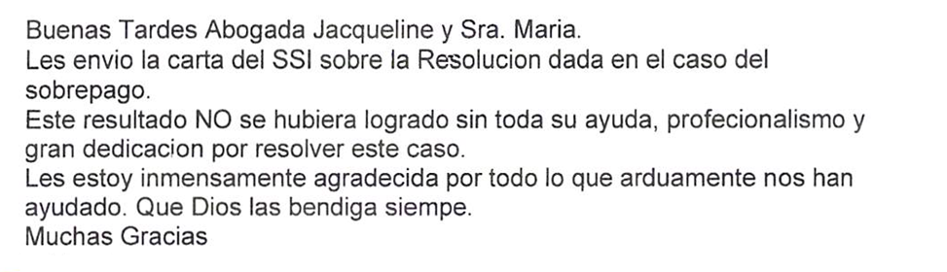
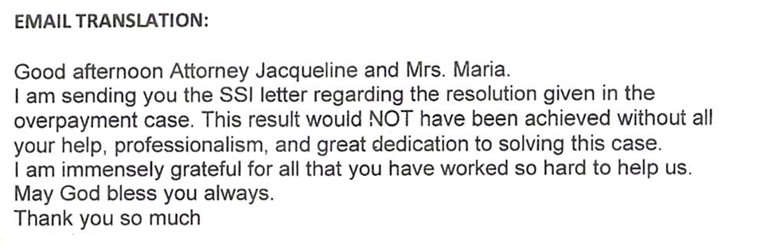
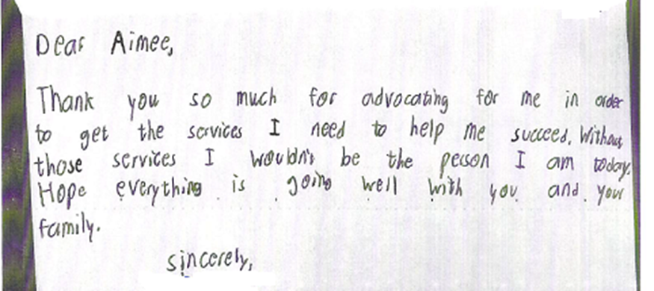

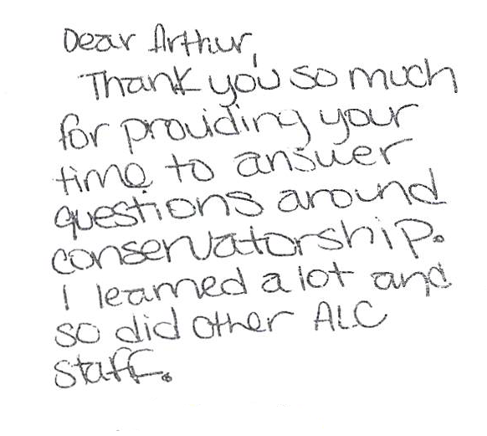

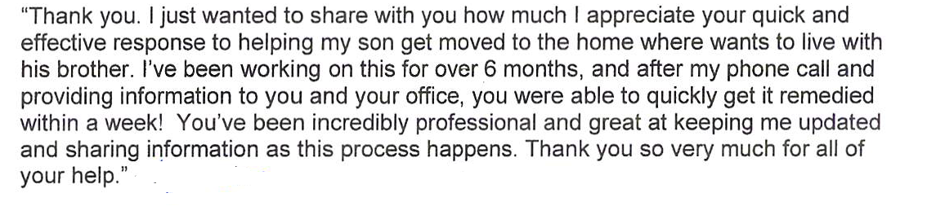
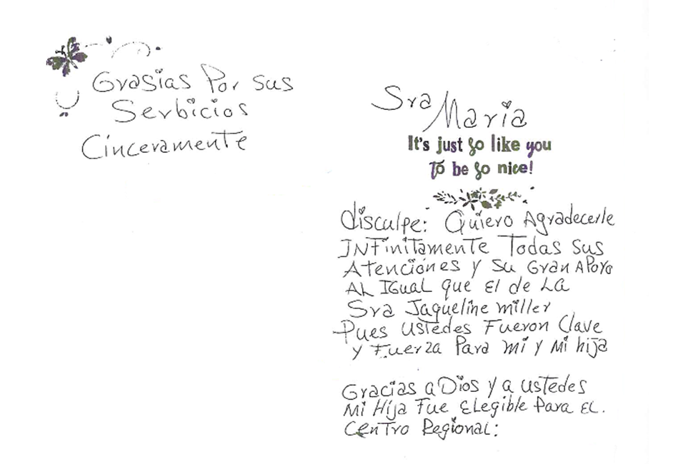
Gracias por sus serbicios cinceramente. Sra. Maria disculpe: Quiero agradecerle infinitamente todas sus atenciones y su gran apoyo al igual que el de la sra Jaqueline Miller pues ustedes fueron clave y fuerza para mi y mi hija. Gracias a Dios y a ustedes mi hija fue elegible para el Centro Regional.
(Thank you for your services sincerely. Mrs. Maria excuse me: I want to thank you infinitely for all your attentions and your great support as well as that of Mrs. Jaqueline Miller because you were key and strength for me and my daughter. Thank God and you, my daughter was eligible for the Regional Center.)

3) Cases will be handled in a timely manner.
Consumers and families usually contact OCRA because something has gone wrong for them. Maybe they are losing a government benefit or their housing, or are facing another urgent situation. They may be worried about their rights and need information. OCRA staff must be responsive. OCRA has, since its establishment, had a policy that all calls will be returned as soon as possible, but not later than the close of the next business day. OCRA staff note this policy on the outgoing voicemail message that callers hear when reaching the office voicemail. OCRA staff also note in the intake record if a client has a deadline or a timeline they must follow for their legal issue, such as a deadline to file an appeal. By noting this in the intake, advocates advise clients of timelines, and prioritize cases with a closer deadline.
OCRA also measures its performance in this area through its consumer satisfaction survey; see Exhibit G, discussed more above. OCRA statistics show that 86 percent of all callers to OCRA received a call back within two days during the last fiscal year. This percentage is lower than last year’s 89 percent, but the same as two years ago. During this review period, OCRA also used temporary CRAs and ACRAs in offices with higher volume to ensure timely service. OCRA uses “floating CRAs” to help high volume offices around the state or offices with a vacancy that need to be staffed during the hiring process. During the COVID-19 pandemic, OCRA staff worked hard to set up workspace in their homes to meet the needs of callers, while also caring for themselves and their family members also struggling with shelter-in-place orders, fear, and anxiety. The OCRA management team continues to discuss ways to increase this percentage and will continue to recruit extra staff to meet the needs of callers.

The provision of clients’ rights advocacy services is coordinated in consultation with the DDS contract manager, stakeholder organizations, and persons with developmental disabilities and their families representing California’s multi-cultural diversity.
OCRA works through the OCRA Advisory Committee to ensure this performance outcome is achieved. Attached as Exhibit H is a list of the members of the Disability Rights California Board of Director’s OCRA Advisory Committee effective June 30, 2020.
Public members of the Advisory Committee are appointed by the Board of Directors. In the selection process, the Board considers geographical diversity, both rural and urban and north and south, type of developmental disability represented, and ethnic background, in addition to the qualifications of the individual applicants.
The OCRA Advisory Committee provides valuable insight to the OCRA staff. At the meetings, members and OCRA staff discuss a wide variety of topics. Board members become better self-advocates because of having served on the Committee. The Committee is not recruiting new members at this time. Minutes for the meeting held on December 12, 2019, were provided with the Semi-Annual Report. The minutes for the May 29, 2020 meeting are included as Exhibit H. DDS staff is invited to attend the next meeting, in December 2020, either virtually or in Sacramento.

Self-advocacy training is provided for consumers and families at least twice in each fiscal year.
Welfare and Institutions Code, Section 4433(d)(5), requires that the contractor providing advocacy services for consumers of regional center services provide at least two self-advocacy trainings for consumers. Disability Rights California’s contract with DDS mirrors this language. OCRA strongly believes in the importance of self-advocacy and requires each of its 21 offices to provide at least one self-advocacy training for consumers per year, far exceeding the two mandated trainings. Many offices provide more than one training per year. This fiscal year, OCRA staff provided 28 self-advocacy trainings statewide. More were planned, but had to be canceled due to the COVID-19 pandemic.
During the pandemic, one OCRA office held a self-advocacy training by Zoom videoconferencing on Emergency Preparedness for participants of a local day program. OCRA sent the day program staff prizes to give to people who attended virtually. Here is feedback from that vendor.
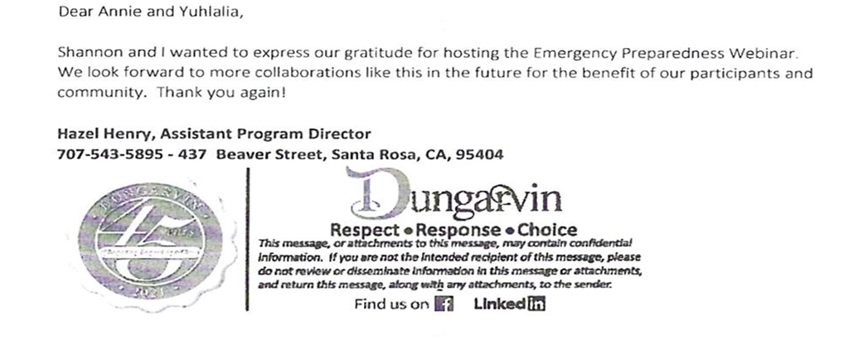
Staff may present any of the approved self-advocacy trainings. To date, OCRA has developed seven separate packets of information for OCRA staff to use in the mandated trainings in addition to the DDS Consumer Safety materials and the living arrangement options materials developed by DDS. Samples of the OCRA self-advocacy packets (all are in both English and Spanish), were provided separately in a binder marked OCRA Training Materials with the 2007-2008 Annual Report. In past discussions with DDS’s Contract Manager, it was decided that OCRA should not submit duplicate training packets in this year’s annual report. As always, OCRA welcomes comments from DDS on any training packets.
OCRA must report in its Annual Report a sample of the self-advocacy training surveys. OCRA has randomly selected consumer training satisfaction evaluations to include with this Annual Report. Almost without exception, consumers are pleased with OCRA trainings. A list of Self-Advocacy Trainings held last year is in Exhibit I.
Here is a sampling of consumers’ comments on the self-advocacy training satisfaction evaluations. OCRA is providing the comments with the wording from the originals, including any grammatical errors, unless otherwise indicated.
Clients’ Rights Bingo
How did this training meet your needs?
I like Bingo very nice very helpful

Hands Off My Money
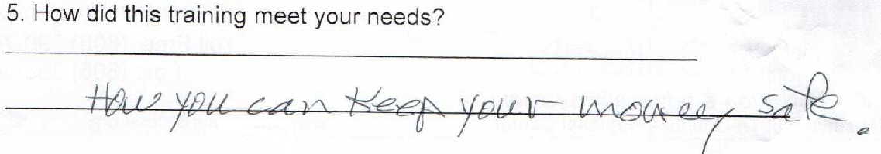

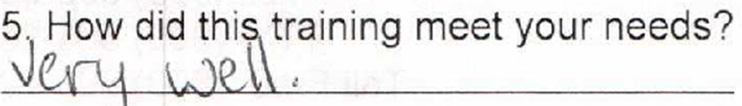

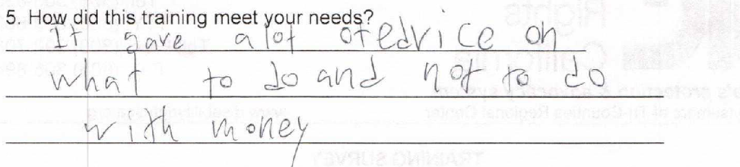

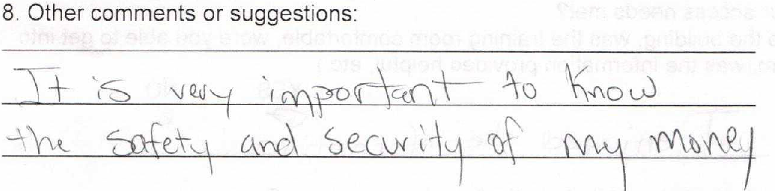

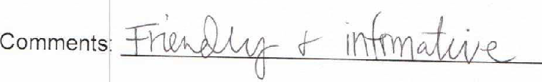

III. TITLE 17 COMPLAINTS
CCR, Title 17, Section 50540, sets forth a complaint procedure whereby a regional center consumer, or his or her authorized representative, who believes a right has been abused, punitively withheld or improperly or unreasonably denied, may file a complaint with the Clients’ Rights Advocate. The Complaint process is similar to that established by Welfare & Institution Code, Section 4731. There were no Title 17 Complaints filed during the last fiscal year, as noted on Exhibit J.

IV. DENIAL OF CLIENTS’ RIGHTS
CCR, Title 17, Section 50530, sets forth a procedure whereby a care provider may deny one of the basic rights of a consumer if there is a danger to self or others or a danger of property destruction caused by the actions of a consumer. The Clients’ Rights Advocate must approve the denial and submit a quarterly report to DDS by the last day of each January, April, July, and October. OCRA is including the reports concurrently with the contractual date to provide OCRA’s reports. If this is not acceptable to DDS, OCRA will submit duplicate reports as requested. Attached as Exhibit K is the current log of Denials of Rights from the OCRA offices.
OCRA presented a well-received training to providers of Enhanced Behavioral Support and Community Crisis Homes organized by DDS on the denial of rights process. Trainings in the community were also performed by OCRA staff to regional center staff, providers, consumers and family members.

V. CONSUMER GRIEVANCES
Exhibit A, Paragraph 12, of the contract between DDS and Disability Rights California requires OCRA to establish a grievance procedure and to inform all clients about the procedure. DDS has approved the grievance procedure developed by OCRA. The procedure is posted prominently in both English and Spanish at each office. The grievance procedure is also available in Arabic, Armenian, Chinese (Simplified), Farsi, Hmong, Japanese, Khmer, Korean, Laotian, Russian, Tagalog, Thai, and Vietnamese. OCRA staff offer the grievance procedure in all letters to consumers or others who contact OCRA, when an office declines to provide the requested service to that person.
During the past fiscal year, OCRA handled 9,620 matters. There were seven first-level grievances filed by consumers or family members. Attached as Exhibit L is a chart detailing the grievances filed against OCRA during this period.

VI. COLLECTION OF ATTORNEY’S FEES
OCRA does not charge consumers, their families or advocates fees for services nor does OCRA seek to recover costs from these individuals. Clients’ Rights Advocates who are licensed to practice law in California, or Assistant, Associate, or unlicensed Clients’ Rights Advocates, all of whom work under the supervision of an attorney, can collect attorney’s fees and costs similar to those collected by private attorneys or advocates for special education cases or other cases where there are statutory attorney’s fees. OCRA collects fees only in special education cases or Writs of Mandamus. Fees and costs may be negotiated at mediation or can be received where an Administrative Law Judge has determined that the petitioner is the prevailing party. Fees are collected from the opposing party, which is normally a school district. Costs include any expenses to the Petitioner or OCRA for suing, such as filing fees or costs of expert evaluations. Neither Disability Rights California nor OCRA ever collect attorney’s fees from consumers.
OCRA received $3,000 in attorney’s fees for a special education matter during the annual reporting period. See Exhibit M.

VII. RECOMMENDATIONS FOR ENHANCEMENT OF SERVICES
The contract between DDS and Disability Rights California requires that annually Disability Rights California make recommendations to DDS on potential methods of enhancing the services that OCRA provides for regional center consumers.
The support of DDS through the years has made it possible for OCRA to effectively and efficiently serve consumers. We appreciate the positive relationships and ability to contact DDS when we have a concern about a client or facility. We enjoy serving on committees and sharing the feedback of our clients and their experiences in the system. We look forward to continued collaboration.
However, the demand for a higher level of OCRA service, such as direct representation, continues to increase. OCRA has also noticed a substantial increase in the number of cases involving people living in restrictive settings, losing their placements, coming out of jail, or stuck in a medical hospital setting, with no place to go. These cases require a lot of staff time. OCRA must continue to look at providing additional staffing to better serve all clients, if we want to continue increasing the higher-level cases we handle each year. Across the state, OCRA offices are reporting having more cases that require direct representation or limited scope representation, and fewer cases that could be handled with information or advice. OCRA has also heard from the regional center and the community that OCRA staff should handle more higher-level cases. In offices that handle fewer cases, staff have an enhanced outreach plan, where they participate in more outreach events in the community and conducting more trainings, to increase the number of callers. OCRA recently created the Outreach Unit to help with outreach goals. OCRA staff found creative ways to reach clients during the pandemic to help with legal issues and to reach the community by doing outreach and training by videoconferencing.
OCRA also recognizes the need to serve diverse communities with varying language needs, which means continuing to recruit and hire staff who speak diverse languages. OCRA strives to provide the highest level of service possible, given our resources. We can better do this with additional bilingual support and “floating” staff to provide coverage for vacancies and to provide support to enable staff can take on cases when we otherwise may not have had the resources. OCRA also hopes to increase its disability diversity in staffing by finding qualified candidates for open positions who can bring unique, personal disability perspectives to the unit.
To ensure that we can continue to provide high quality services, OCRA would appreciate additional resources to increase staffing to meet these unique needs while continuing to provide the high level of service to consumers already living in the community and consumers in restrictive settings and hoping to transition into the community.

VIII. CONCLUSION
OCRA provides exceptional service to many people with developmental disabilities throughout the state. OCRA handled 9,620 cases for 6,168 clients last year. And OCRA provided 473 trainings to approximately 17,766 consumers, family members, regional center staff and vendors, and interested community members - all while meeting each of its performance objectives and improving consumer satisfaction. OCRA found creative ways to adapt, reach clients, and provide trainings during the COVID-19 pandemic. OCRA looks forward to continuing to work with people with developmental disabilities and helping them access services and supports they need to live the most independent and productive lives in the least restrictive environment. People with developmental disabilities have benefitted from OCRA’s legal assistance at no cost to them and it is an honor for OCRA to continue to provide.

