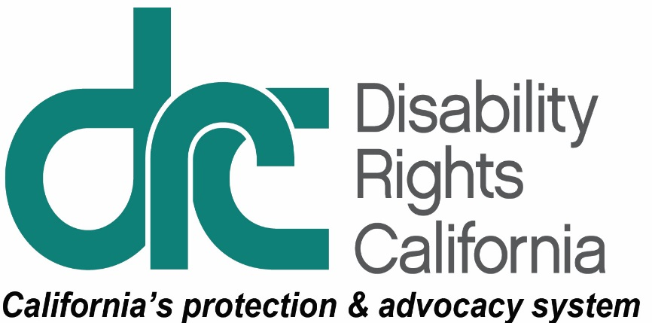
Office of Clients’ Rights Advocacy
1831 K Street
Sacramento, CA 95811
Tel: (916) 504-5820
TTY: (877) 669-6023
Toll Free: (800) 390-7032
Fax: (916) 504-5821
www.disabilityrightsca.org

MEMORANDUM
TO: Katie Hornberger, Director
FROM: Ibrahim Saab, Supervising Attorney for Outreach, and Paula Sandoval, OCRA Outreach Coordinator
RE: Annual OCRA Outreach Report July 1, 2019 - June 30, 2020
DATE: August 31, 2020
OCRA has committed to increase awareness of OCRA services among organizations, regional center consumers, parent support groups, hospital physicians, social workers, and other professionals working with consumers. OCRA strives to network and build relationships with underrepresented target communities to reach parity with the communities served by the regional center. This report is about OCRA’s outreach efforts between July 2019 and June 2020. During the fiscal year, OCRA staff conducted 473 outreach activities and trainings to 17,766 attendees. This is a 7.09% decrease from the same reporting period between July 2018 and June 2019 in attendees. The reduction in the number of outreach activities and trainings corresponds to the shelter-in-place order issued in March 2020. Since then, staff have transitioned to exclusively offering virtual trainings. Some training topics include the impact of the COVID-19 on special education, Medi-Cal, and In-Home Supportive Services. OCRA also created an Outreach Team during this fiscal year. A Managing Attorney oversees a Peer Advocate, Outreach Coordinator, and Supervising Attorney whose sole focus is outreach and training.
Below are some of the experiences advocates have created throughout the year by facilitating in-person and virtual self-advocacy trainings directly with consumers, the general community, and target communities.

Self-Advocacy Trainings
Each OCRA office conducts at least one self-advocacy training per contract year. Self-Advocacy topics include emergency preparedness, self-advocacy, client’s rights, rights to money management, voting rights, community living options, and employment rights and options. Here are examples.
Day Program Participants Learn About Emergency Preparedness During the COVID-19 Pandemic.
OCRA partnered with Dungarvin Day Program in Santa Rosa to provide a presentation about Emergency Preparedness in June 2020 to North Bay Regional Center consumers. OCRA provided the training remotely by Zoom because of the COVID-19 pandemic. Yulahlia Hernandez, Clients’ Rights Advocate, and Annie Breuer, Assistant Clients’ Rights Advocate, led the presentation.
Before the training, OCRA delivered materials and small gifts to Dungarvin staff, who then brought those items to homes of the regional center clients who attend their day program. Everyone joined the training remotely from their home and learned about Emergency Preparedness.
OCRA helped participants start their emergency plan and kits, using the process of: Think, Plan, Do. Everyone talked about what an emergency is and the importance of being prepared. Since OCRA staff were presenting from their homes, they took the opportunity to show off their own personal emergency kits. Consumers enjoyed seeing the visuals, when OCRA staff held up items like a flashlight, water, and radio.
After the training, Dungarvin Day Program staff thanked OCRA. Staff said the training was not only enjoyable by day program participants, but a great refresher for staff about emergency preparedness.

General Outreach
OCRA Connects with CASA via Zoom!
Even during the COVID-19 pandemic and stay-at-home orders, OCRA kept developing relationships. In May 2020, new staff from the Office of Clients’ Rights Advocacy provided members of San Diego and Riverside Court-Appointed Special Advocates (CASA) with a thorough overview of OCRA services. OCRA’s Outreach Coordinator, Paula Sandoval, collaborated with CASA volunteers and CASA Voices for Children to provide insight into DRC as an agency, and a new scope of understanding about OCRA services. While OCRA would usually have held an in-person training, the CASAs agreed to attend using the Zoom video conferencing platform.
Maria Salas, Assistant Clients’ Rights Advocate, attended as a newly-hired staff supporting San Diego Regional Center consumers. As Paula gave the “What is OCRA?” presentation, she explained the support OCRA can provide to regional center clients. Many CASAs have regional center clients as their own clients. Because the CASAs had questions about regional center eligibility, the training flowed into an introduction to the regional center eligibility criteria. For OCRA, it was a successful outreach that brought about a flood of questions and requests for more trainings. OCRA and CASA will continue their collaboration and strengthen relationships within the community.
OCRA Attends Educational Resource Fair for Youth Transitioning into Adulthood.
OCRA recently participated in an informative resource fair for transition-age youth throughout the Fullerton Joint High School District. The event was held on February 28, 2020 at California State University Fullerton’s Titan student union. Peer Advocate, Scott Barron, staffed OCRA’s resource table and distributed useful publications in English and Spanish to approximately 50 people. These publications included a variety of advocacy topics such as discrimination, public benefits, transition services for students, and competitive integrated employment. Scott also encouraged the attendees to contact their local OCRA office if they have additional questions. OCRA plans to return to this important event next year.
OCRA Collaborates with Harbor Regional Center on Alternatives to Conservatorship Webinar.
OCRA was invited to host a webinar on alternatives to conservatorship and services for students aging out of high school for Harbor Regional Center consumers and their families. Originally, OCRA was scheduled to host this meeting in person at the Harbor Regional Center’s Torrance location. Because of the COVID-19 pandemic, the over 50 participants turned to Zoom videoconferencing. OCRA provided participants information about educational decision-making, supported living, independent living services, and consent forms. This proved to be a good timing since many older students were left without appropriate services due to the school closures.
Many participants texted in the chat. The private messaging option allowed others to feel safe to also ask questions. OCRA staff followed up with parents who needed more information on this topic. Having an open dialogue with families and encouraging parents to consider alternatives proved successful. The regional center advertised the training on their website, and a recording is available on the regional center’s website.
OCRA Draws a Crowd at a Medi-Cal Waivers Zoom Training.
An energetic crowd could barely contain their comments and questions at a Medi-Cal Waiver training put on by OCRA on June 29, 2020. OCRA regularly puts on trainings for parent support groups in the South Central Los Angeles area. During the last few months, OCRA tried something new to get parents more information during the state’s stay-at-home orders.
OCRA contacted parent groups to offer trainings on a myriad of topics. Using Zoom, Clients’ Rights Advocate, Megan Buckles, and Assistant Clients’ Rights Advocate, Heiser Lopez, were pleased to meet and engage with the Spanish-speaking parent group, Living Inside the Puzzle. OCRA reviewed the different Medi-Cal Waivers in Spanish to help parents understand who is eligible, how to apply, and what services are offered with the Medi-Cal Home- and Community-Based Services Developmental Disabilities Waiver (DD Waiver) and other ways to access Medi-Cal through Waivers. It was a jam-packed, hour-long Zoom training, with over 75 participants. The presentation also offered time for discussion. It was a great opportunity for OCRA to interact with consumers and family members, and for them to meet the new OCRA staff. Many people asked for OCRA’s contact information for future help. OCRA answered so many questions from enthusiastic parents they hosted a follow-up session to expand the conversation around who is eligible for different Medi-Cal programs. OCRA and Living Inside the Puzzle parent group hope for even more participants for the next training.
Regional Center Hosts a Marathon of Information.
OCRA and San Diego Regional Center (SDRC) recently collaborated on IHSS and Medi-Cal trainings. With so much information to cover, OCRA hosted four separate webinars for the staff of SDRC. Over the course of four webinars, OCRA connected with close to 450 SDRC staff members to provide IHSS and Medi-Cal information. Since SDRC staff were working from home because of the COVID-19 pandemic, and did not have to travel, they had the time to join these educational sessions and ask questions. Similarly, OCRA had the means to reach more people using Zoom. On April 29, 2020, Ibrahim Saab, Supervising Attorney, reviewed IHSS eligibility criteria, services, and home assessments for IHSS part one. On May 6, 2020, he wrapped up with IHSS appeals and preparing for fair hearings. Mario Espinosa, Clients’ Rights Advocate and Katie Meyer, Supervising Clients’ Rights Advocate, covered Medi-Cal eligibility and programs, including managed care plans, on May 13, 2020. They followed this with Medi-Cal appeals and grievances on May 20, 2020. OCRA received much praise and appreciation for presenting these training topics.
GGRC Families Learn about their Regional Center, IHSS, and Special Education Rights during COVID-19.
In May 2020, OCRA presented on the impacts of the COVID-19 pandemic on various services and supports used by Golden Gate Regional Center (GGRC) clients. Due to the shelter-in-place order, Opening Doors PTA organized a Zoom meeting and successfully advertised the event. OCRA was lucky to present to over 50 individuals and their families directly affected by the pandemic. OCRA’s Alex Gastelum and Lourdes Carreno explained clients’ rights in the areas of IHSS, regional center, and special education during the pandemic. Alex and Lourdes kept track of the many questions and comments and responded to all concerns. OCRA developed connections with these families during the training and made time to discuss families’ individual issues afterward. OCRA clarified people still maintained their rights, even during a pandemic, to help them be strong self-advocates. For more complicated issues, several attendees contacted OCRA immediately after the training and Alex and Lourdes conducted intakes about their issues.
OCRA Introduces Itself at an Annual Regional Center Conference.
In February 2020, OCRA introduced itself at an annual regional center conference for the Vietnamese community. The attendees included family members of consumers of the San Andreas Regional Center. OCRA staff used a Vietnamese interpreter to explain OCRA services and the ways OCRA can help regional center clients. The 150 attendees were pleased to learn about OCRA and the services it provides. Each attendee received a copy of the OCRA brochure and the Clients’ Rights Advocate’s business card. OCRA also saw familiar faces who approached the Clients’ Rights Advocate, Cherri Alcantara, after the conference, to say how much they appreciated OCRA’s assistance when they needed it.
OCRA Presents at EPU Children’s Center.
OCRA collaborated with the Client Assistance Program in presenting to regional center consumers and their parents at EPU Children’s Center on March 6, 2020. EPU Children’s Center is located in Fresno and its mission is strengthening and empowering children and families facing extraordinary medical, developmental, and parenting challenges. Clients’ Rights Advocate, Maitria Moua, provided a brief “What is OCRA?” presentation and explained the role of the regional center. Attendees were grateful and many remained for an hour after the presentation to discuss various topics ranging from special education to Early Start eligibility. For OCRA, this was a great opportunity to interact with consumers and parents face-to-face and to meet staff from EPU. Attendees took OCRA brochures for future reference and said they found the presentation helpful.
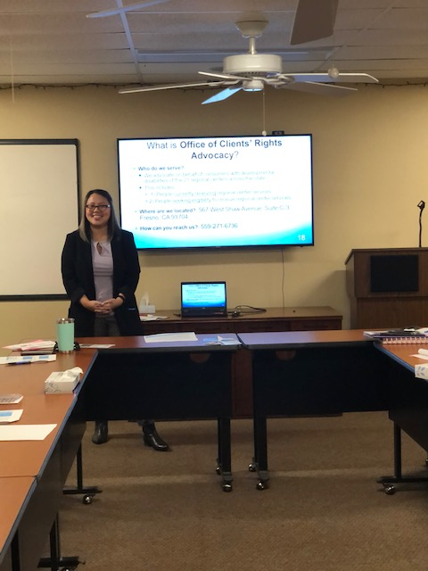
Photo: Clients’ Rights Advocate Maitria Moua presents to consumers and parents about the role of the Regional Center during the transition period.

Target Outreach
Each OCRA office targets a community to ensure that we are supporting them at parity. OCRA’s target communities include the Latino community, the Asian community including Chinese, Japanese, Korean, Vietnamese, Hmong, Filipino, and Polynesian, the African-American community, and the Native American community. Of the 473 outreaches completed during this reporting period, approximately 34% of the activities and trainings were directed to the multi-ethnic and linguistically diverse communities that had been targeted. Here are highlights of target activities and trainings.
ACRC Parents Learn about Section 504 Plans.
On April 23, 2020, OCRA presented a bilingual training on student rights under Section 504. Yuba City Family Soup and OCRA originally planned an in-person training to educate English and Spanish-speaking parents on their children’s educational rights. However, due to the statewide shelter-in-place order, the training became virtual. Parents called in to the training from their kitchen tables, home offices, and their cars. Brittnee Gillespie, Clients’ Rights Advocate, and Clara Torres, Assistant Clients’ Rights Advocate, worked in tandem to present information in both English and Spanish. Family Soup monitored the chat box to relay questions and comments to the group. The group discussion and questions flowed well, considering the new virtual format. Despite the physical distance, all attendees participated with great attentiveness and enthusiasm.
Regional Center Service Providers Learn About Social Security Benefits.
In 2020, OCRA led a training about Social Security benefits at Family Works Parenting & Life Skills Center. Yulahlia Hernandez, Clients’ Rights Advocate, and Annie Breuer, Assistant Clients’ Rights Advocate, led the presentation for Family Works staff. Family Works provides independent living and family support services to regional center consumers who are parents. Many Family Works consumers are Spanish-speaking. Staff at Family Works often help with Social Security benefits. OCRA provided information about the different programs Social Security administers for children and adults. The presentation covered Social Security benefit eligibility, parental deeming, income, resources, and appeal procedures. Throughout the training, Family Works staff were highly engaged. The discussion was lively and OCRA provided practical advocacy tips for staff to use when their clients need help with their benefits. When asked what they learned from the training, one participant said, “How to better advocate for our clients about Social Security.” They added that the training, “Gave more insights about Social Security benefits for my clients.” OCRA was happy the training was a success, since the information provided will benefit many regional center consumers for years to come.
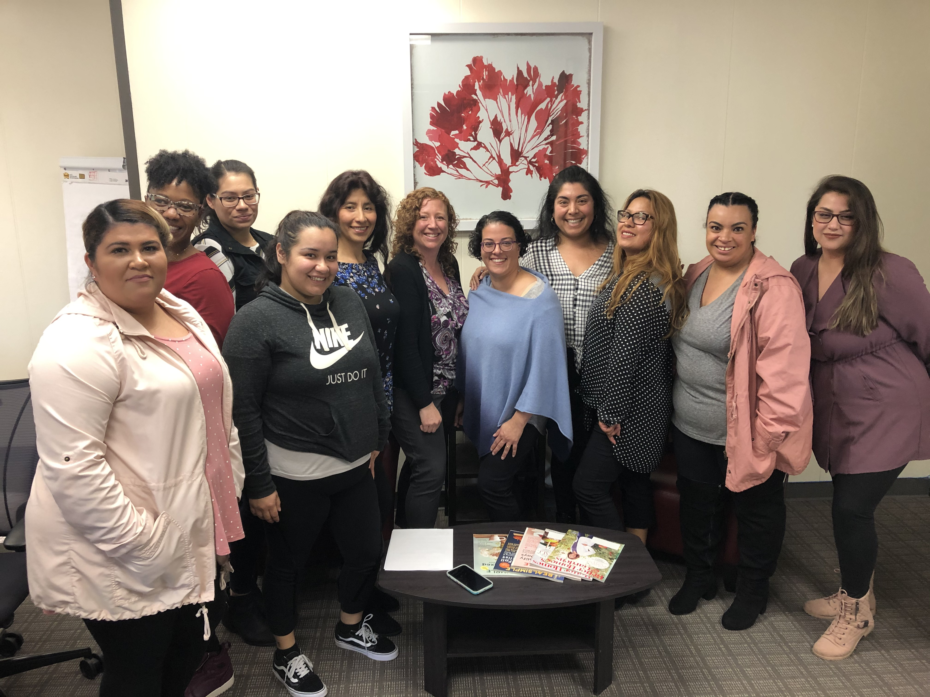Photo: CRA Yulahlia Hernandez and ACRA Annie Breuer surrounded by training participants.
Community Meeting on Purchase of Service Disparity Data Presented to Korean Parent Group.
The San Gabriel Pomona Regional Center has continued to be a leader in active outreach to the Asian communities to share data on funding disparities of services. Disparity data was presented to a full room of parents. An exciting dance activity was simultaneously scheduled for the children of the parent group so parents could attend the presentation. Presenters gave information on the history of funding disparity, annual expenditure data, and summaries of important points from the 2018-2019 data. The presentation was in English with interpretation in Korean. Information on different community resources was also available in a variety of languages for parents to take home. OCRA attended the meeting, provided OCRA brochures in English, Korean and Chinese, and visited with many parents following the presentation.
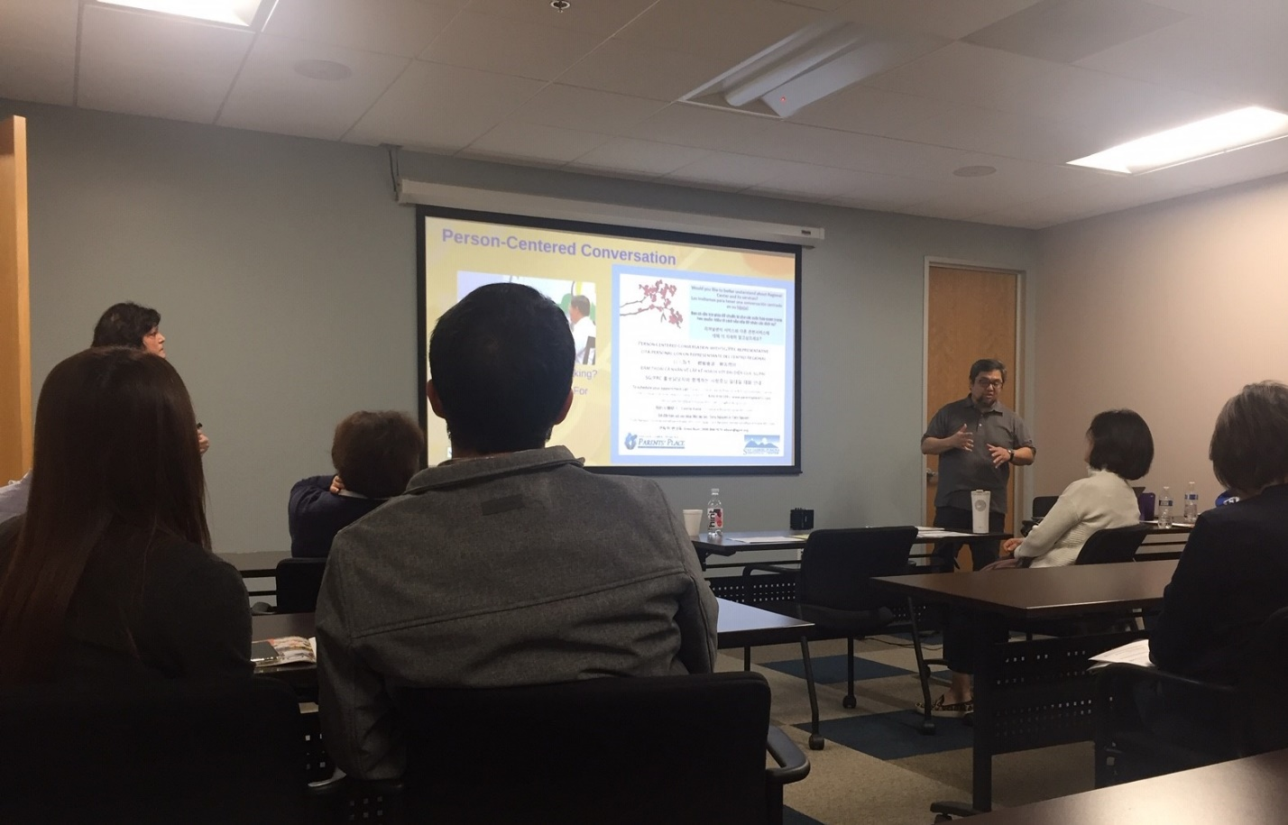
Photo: Audience looking at screen and interpreter to learn about disparities in purchase of services funding for Asian consumers of the San Gabriel Pomona Regional Center.
Underserved Communities Receive Life-Saving Personal Protective Equipment.
OCRA collaborated with the Department of Developmental Services (DDS) to coordinate the distribution of urgently needed masks, hand sanitizer, and gloves to communities that have limited access to these essential items. OCRA immediately went to work and contacted numerous community leaders and organizations for help to distribute thousands of personal protective equipment (PPE) provided by DDS. Many groups found creative ways to publicize and safely distribute PPE, including setting up drive-through pickup locations. PPE recipients were grateful for the positive outcome of OCRA’s partnership with DDS to fight the spread of COVID-19 within traditionally marginalized communities.
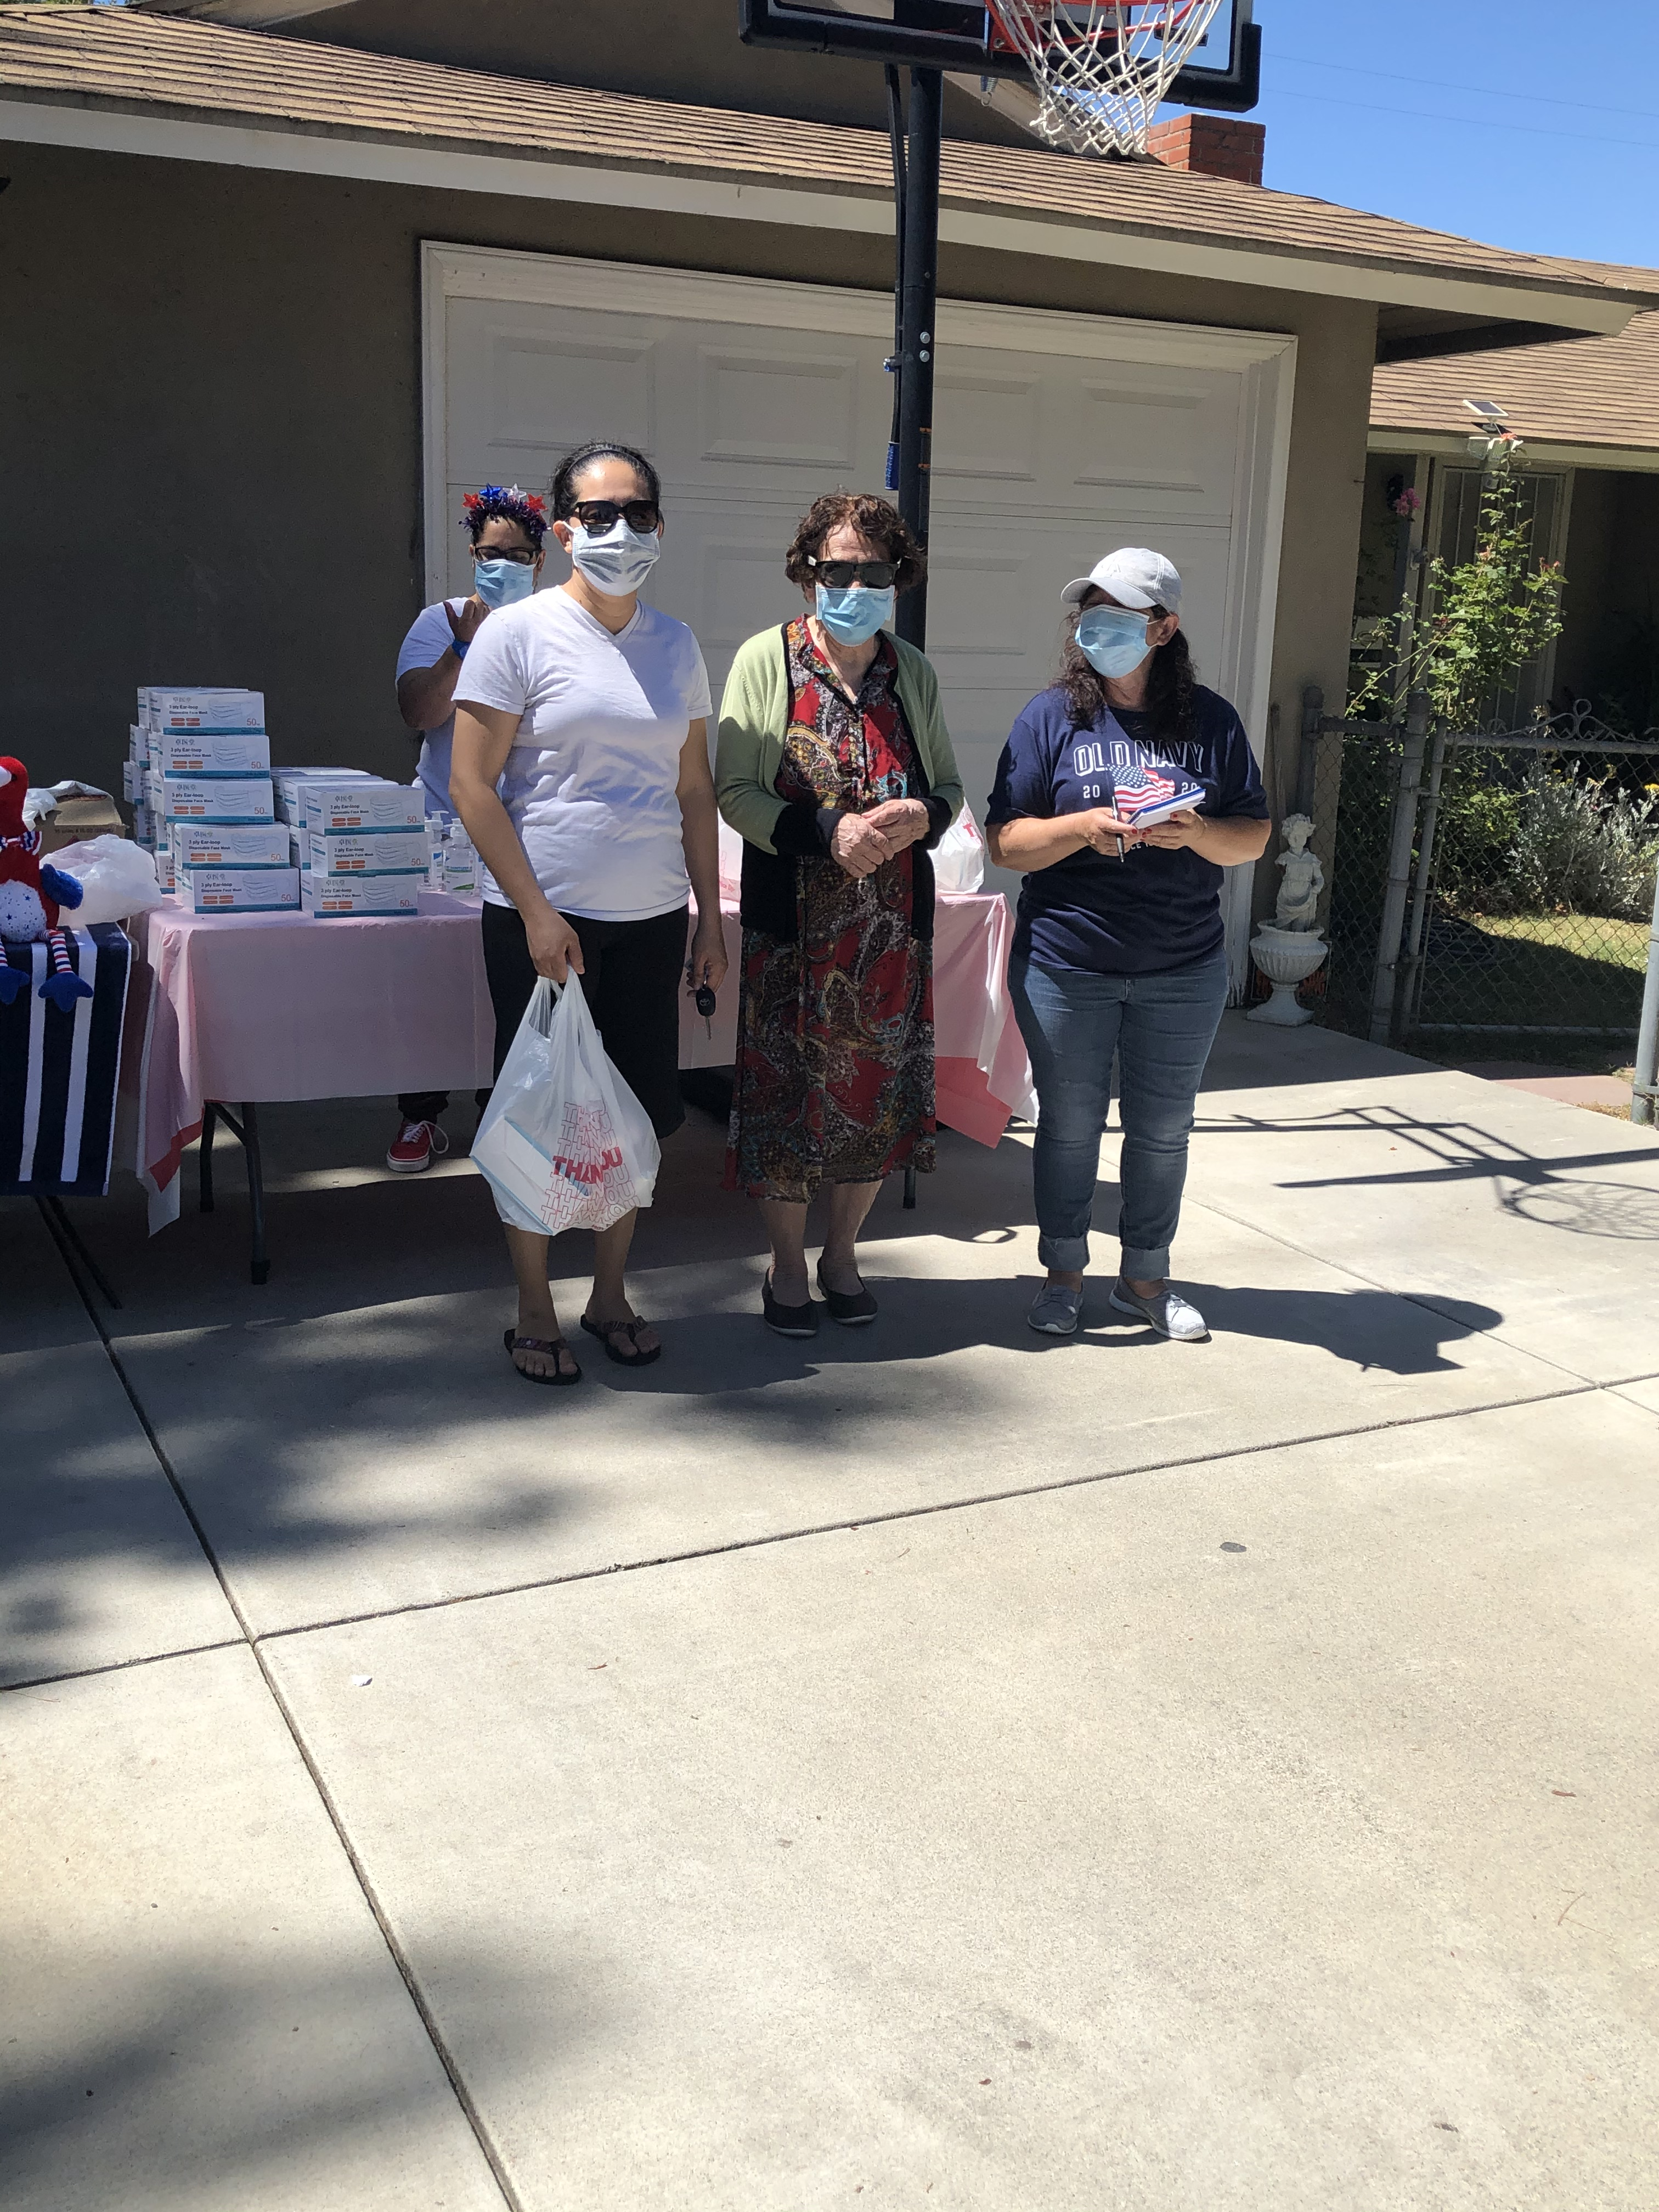
Photo: Three women standing in front of a table with personal protective equipment.

Conclusion
OCRA continues to build relationships within the community by networking and providing trainings to persons served by the regional center system. OCRA strives to connect with target communities to close the gap in disparity. This is particularly important during the pandemic. During this uncertain time, staff will continue to educate regional center clients and their families about their rights and changes to programs and services that improve the lives of individuals OCRA serves. OCRA’s Outreach Unit appreciates the opportunity to coordinate virtual outreach presentations and trainings statewide during the public health crisis.

